Name : Akaire Precious Chiamaka
Mat no : U2022/5570081
Course: CSC493
Tasks:
1. Submit screenshots and code demonstrating a working form.
2. Explain the difference between GET and POST methods.
3. Validate user input using HTML attributes.
Solution
- Screenshots and code demonstrating my working form:
form.html
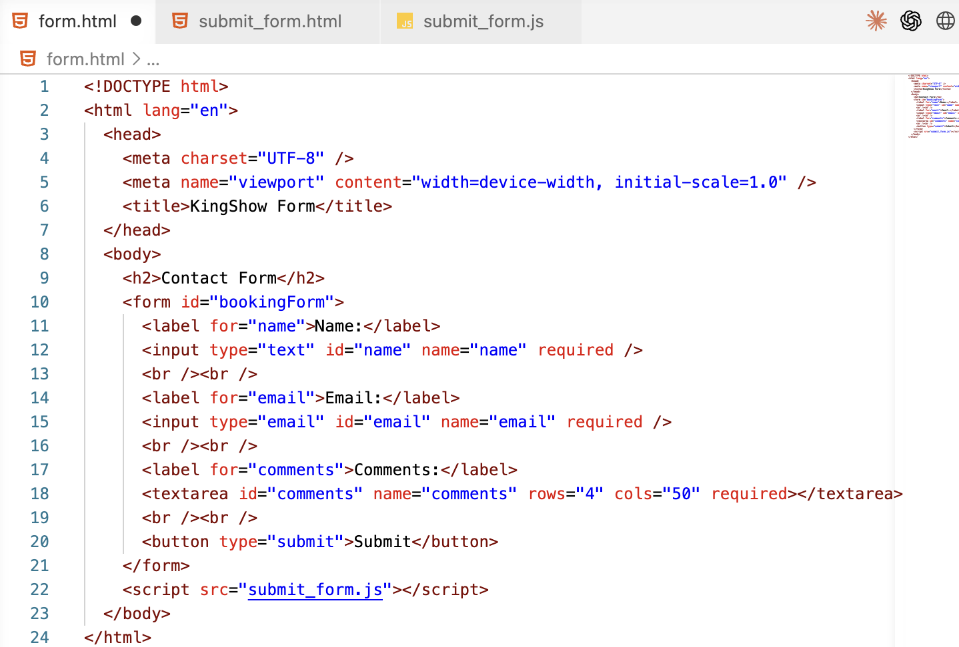
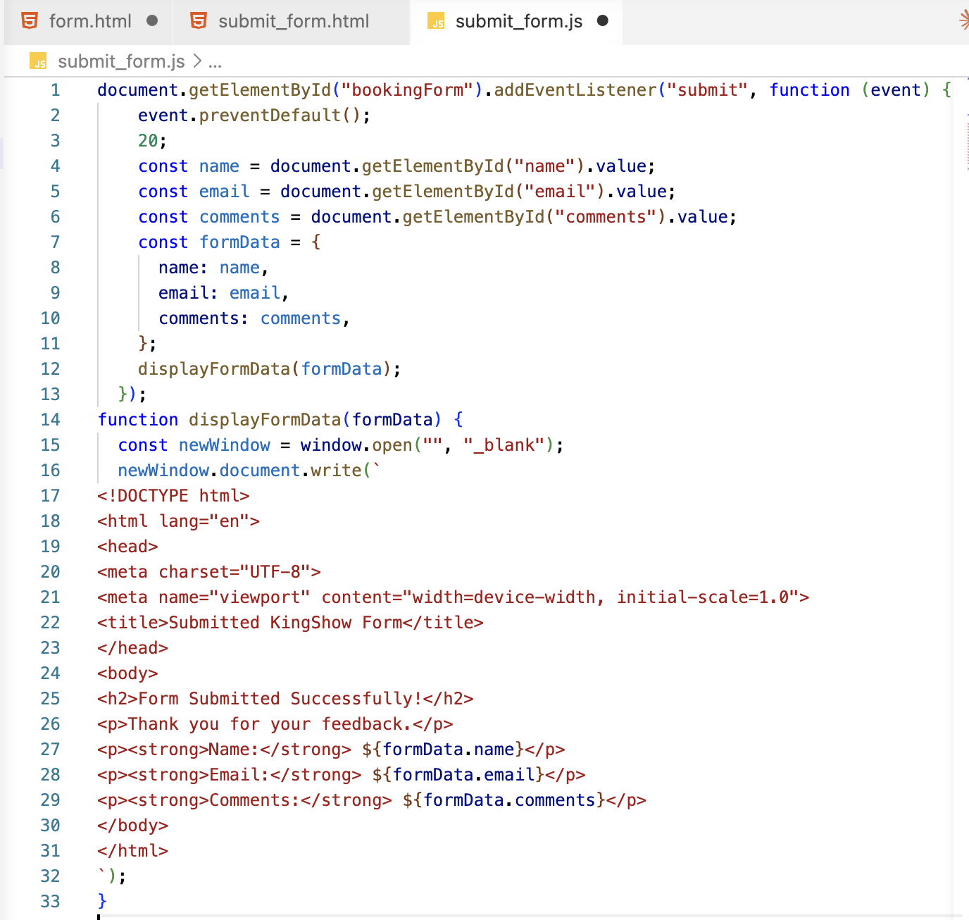

- Difference between GET and POST methods:
GET Method is used to request/retrieve data from a server, with the data visible in the URL while POST Method is used to send/submit data to a server and its data is not normally visible in the URL.

- Validate user input using HTML attributes.
Yes, I validated the user inputs on the form by using the following HTML attributes : required and type.

