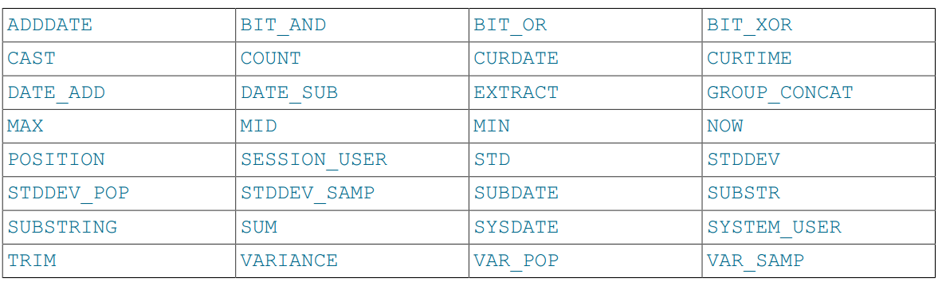
To enable the IGNORE_SPACE SQL mode, use this statement:
SET sql_mode = 'IGNORE_SPACE';
IGNORE_SPACE is also enabled by certain other composite modes such as ANSI that include it in their
value:
SET sql_mode = 'ANSI';

