# angular数据交互

## angular get请求数据

1、在app.module.ts中引入HttpClientModule并注入

import { HttpClientModule } from '@angular/common/http';

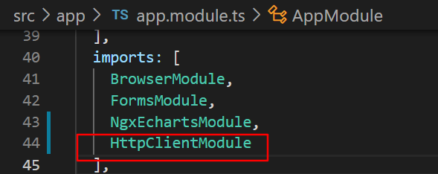

2、在用到get方法的组件中引入HttpClient

import { HttpClient } from '@angular/common/http';

在构造函数中声明对象：

  constructor(public http:HttpClient) { }

3、get方法请求数据

getData(){

    let api = "http://a.itying.com/api/productlist";

    this.http.get(api).subscribe((response:any)=>{

      console.log(response);

      this.list = response.result;

    });

  }

4、页面渲染数据

<ul>

    <li *ngFor="let item of list">{{item.title}}</li>

</ul>

效果：

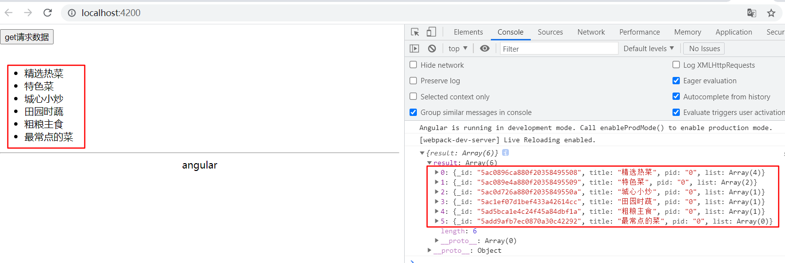

## angular post提交数据

1、在app.module.ts引入HttpClientModule

import { HttpClientModule } from '@angular/common/http';

imports: [

    HttpClientModule

  ],

2、在要使用的组件中引入HttpHeaders

data-interaction.component.ts

import { HttpClient, HttpHeaders } from '@angular/common/http';

post提交数据的方法：

  doLogin(){

    //手动设置请求的类型

    const httpOptions = {headers:new HttpHeaders({'Content-Type':'application/json'})};

    let api = "http://127.0.0.1:3000/doLogin";

    this.http.post(api,{'username':'张三','age':20},httpOptions).subscribe((response)=>{

      console.log(response);

    });

  }

3、页面调用

<button (click)="doLogin()">post提交数据</button>

在本地使用nodejs启动http服务，监听3000端口

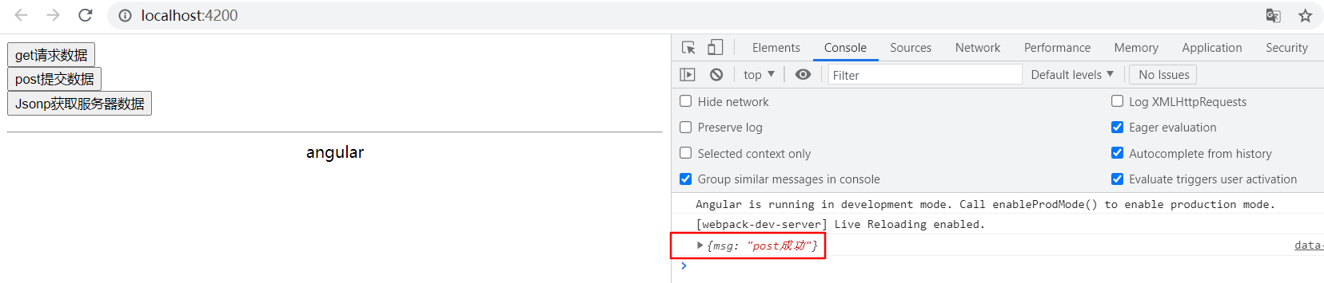



## angular jsonp请求数据

1、在app.module.ts引入HttpClientJsonpModule

import { HttpClientModule, HttpClientJsonpModule } from '@angular/common/http';

imports: [

    HttpClientModule,

    HttpClientJsonpModule

  ],

2、在要使用的组件中引入HttpClient

import { HttpClient } from '@angular/common/http';

定义jsonp调用方法

  getJsonpData(){

    //jsonp请求，服务器必须支持jsonp,如下：

    /*

    http://a.itying.com/api/productlist?callback=xxx

    http://a.itying.com/api/productlist?cb=xxx

    */

    let api = "http://a.itying.com/api/productlist";

    this.http.jsonp(api, 'callback').subscribe((response)=>{

      console.log(response);

    });

  }

3、页面调用

data-interaction.component.html

<button (click)="getJsonpData()">Jsonp获取服务器数据</button>

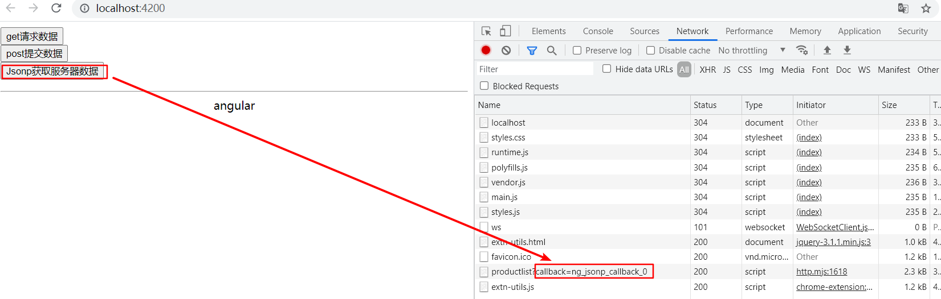

## angular使用第三方模块axios请求数据

1、安装axios

npm install axios --save

2、创建服务

ng g service services/httpservice

3、在httpservice.service.ts引入axios

import axios from 'axios';

封装axios get请求

  axiosGet(api:any){

    return new Promise((resolve,reject)=>{

      axios.get(api).then(function(response){

        resolve(response);

      });

    });

  }

4、在app.module.ts引入服务并配置服务

import { HttpserviceService } from './services/httpservice.service';

providers: [

    HttpserviceService

  ],

5、在组件data-interaction.component.ts中引入服务

import { HttpserviceService } from '../../services/httpservice.service';

构造方法中声明服务对象：

constructor(public http:HttpClient, public httpService:HttpserviceService) { }

6、调用服务中的方法

  getAxiosData(){

    let api = "http://a.itying.com/api/productlist";

    this.httpService.axiosGet(api).then((data)=>{

      console.log(data);

    });

  }

7、页面显示

<button (click)="getAxiosData()">使用第三方模块获取服务器数据</button>

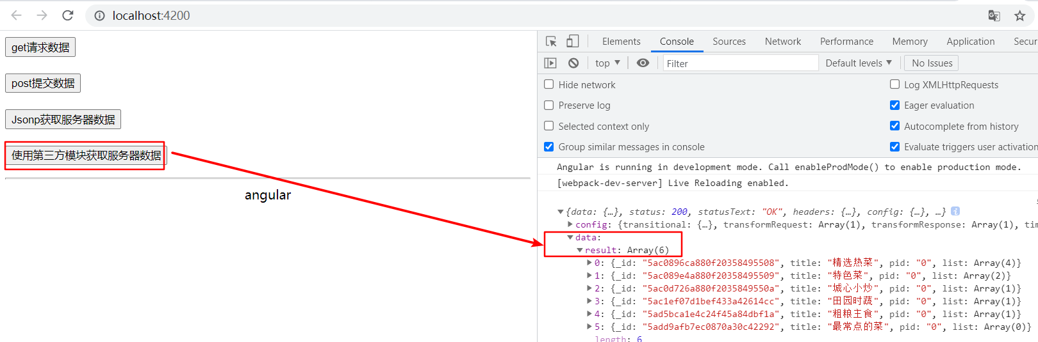

# 提交记录

git仓库：<https://github.com/Angeliau/angular-demo.git>

