Лабораторная работа № 1.2
7 февраля 20223

Установка на VDS

Параметры VDS

root@194-67-121-228:~# sudo apt-get update
root@194-67-121-228:~# sudo apt-get upgrade
Ставим Julia
root@194-67-121-228:~# sudo apt-get install julia
julia> using Pkg
julia> Pkg.add("IJulia")

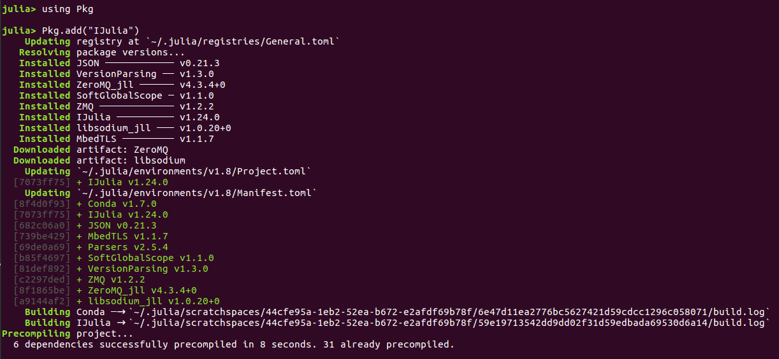

julia> Pkg.add("DataFrames")
julia> Pkg.add("CSV")
julia> Pkg.add("Plots")
julia> Pkg.add("PyPlot")
julia> Pkg.add("Plots")
root@194-67-121-228:~# sudo apt install python3-pip python3-dev

Установка виртуального окружения
root@194-67-121-228:~# sudo -H pip3 install --upgrade pip
root@194-67-121-228:~# sudo -H pip3 install virtualenv

root@194-67-121-228:~# sudo pip3 install scipy
root@194-67-121-228:~# sudo pip3 install pandas
root@194-67-121-228:~# sudo pip3 install sympy
root@194-67-121-228:~# sudo pip3 install matplotlib nose

Создать директорию под виртуальное окружение:
root@194-67-121-228:~# mkdir ~/my_project_dir
root@194-67-121-228:~# cd ~/my_project_dir

Создать виртуальное окружение:
root@194-67-121-228:~/my_project_dir# virtualenv my_project_env
created virtual environment CPython3.8.10.final.0-64 in 1236ms
creator CPython3Posix(dest=/root/my_project_dir/my_project_env, clear=False, no_vcs_ignore=False, global=False)
seeder FromAppData(download=False, pip=bundle, setuptools=bundle, wheel=bundle, via=copy, app_data_dir=/root/.local/share/virtualenv)
added seed packages: pip==23.0, setuptools==67.1.0, wheel==0.38.4
activators BashActivator,CshellActivator,FishActivator,NushellActivator,PowerShellActivator,PythonActivator

root@194-67-121-228:~/my_project_dir# ls
my_project_env

Активация виртуальной среды:
root@194-67-121-228:~/my_project_dir# source my_project_env/bin/activate
(my_project_env) root@194-67-121-228:~/my_project_dir#

Устанавливаем Jupiter в виртуальную среду:
(my_project_env) root@194-67-121-228:~/my_project_dir# pip3 install jupyter
(my_project_env) root@194-67-121-228:~/my_project_dir# ip addr
1: lo: <LOOPBACK,UP,LOWER_UP> mtu 65536 qdisc noqueue state UNKNOWN group default qlen 1000
link/loopback 00:00:00:00:00:00 brd 00:00:00:00:00:00
inet 127.0.0.1/8 scope host lo
valid_lft forever preferred_lft forever
inet6 ::1/128 scope host
valid_lft forever preferred_lft forever
2: eth0: <BROADCAST,MULTICAST,UP,LOWER_UP> mtu 1500 qdisc fq_codel state UP group default qlen 1000
link/ether 52:54:00:fe:d2:09 brd ff:ff:ff:ff:ff:ff
inet 194.67.121.228/24 brd 194.67.121.255 scope global eth0
valid_lft forever preferred_lft forever
inet6 2a00:f940:2:4:2::2d99/64 scope global
valid_lft forever preferred_lft forever
inet6 fe80::5054:ff:fefe:d209/64 scope link
valid_lft forever preferred_lft forever
3: eth1: <BROADCAST,MULTICAST> mtu 1500 qdisc noop state DOWN group default qlen 1000
link/ether 52:54:00:c8:27:7c brd ff:ff:ff:ff:ff:ff

Запускаем Jupiter Notebook под root-ом
(my_project_env) root@194-67-121-228:~/my_project_dir# jupyter notebook --ip 194.67.121.228 --port 8888 --allow-root
[I 15:13:13.722 NotebookApp] Serving notebooks from local directory: /root/my_project_dir
[I 15:13:13.723 NotebookApp] Jupyter Notebook 6.5.2 is running at:
[I 15:13:13.723 NotebookApp] http://194.67.121.228:8888/?token=3dc2697b5d5dfb55c0c0c3d7ee2c73f03ee0d8a705807117
[I 15:13:13.723 NotebookApp] or http://127.0.0.1:8888/?token=3dc2697b5d5dfb55c0c0c3d7ee2c73f03ee0d8a705807117
[I 15:13:13.723 NotebookApp] Use Control-C to stop this server and shut down all kernels (twice to skip confirmation).
[W 15:13:13.730 NotebookApp] No web browser found: could not locate runnable browser.
[C 15:13:13.730 NotebookApp]

To access the notebook, open this file in a browser:
file:///root/.local/share/jupyter/runtime/nbserver-9030-open.html
Or copy and paste one of these URLs:
http://194.67.121.228:8888/?token=3dc2697b5d5dfb55c0c0c3d7ee2c73f03ee0d8a705807117
or http://127.0.0.1:8888/?token=3dc2697b5d5dfb55c0c0c3d7ee2c73f03ee0d8a705807117

Запускаем в браузере:

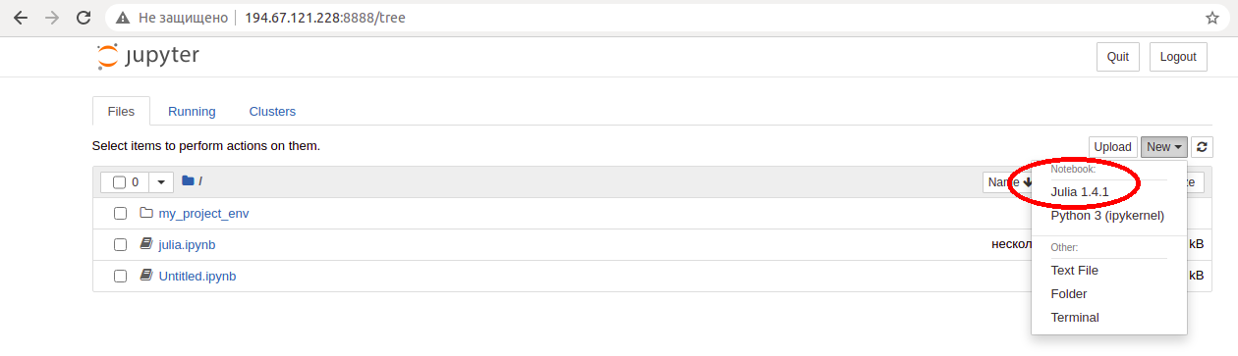
Пример построения графиков

using Plots
x = range(0, 10, length=100)
y = sin.(x)
z = cos.(x)
plot(x, y, z)

Результат

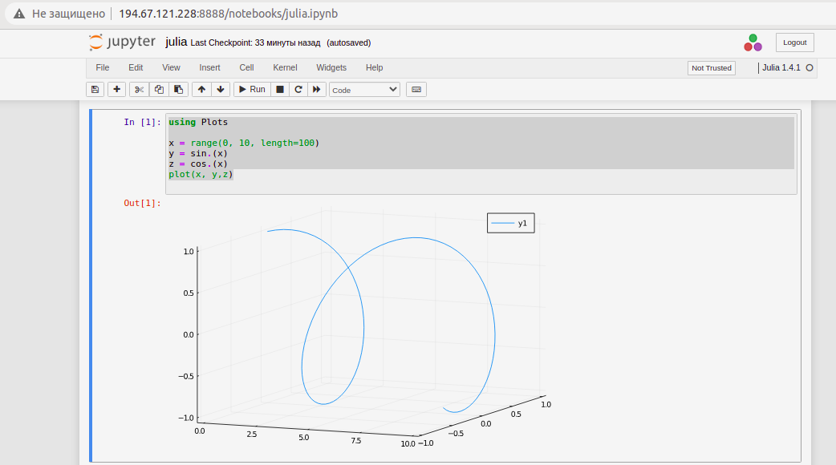
Дополнительная информация

- Добавить Julia в Jupyter
https://datatofish.com/add-julia-to-jupyter/

- Версия ядра:
root@194-67-121-228:~# uname -r
5.4.0-137-generic

- Версия дистрибутива
root@194-67-121-228:~# lsb_release -r
Release: 20.04

- Настройка Jupyter Notebook с помощью Python 3 в Ubuntu 20.04 и подключение через туннель SSH: https://www.digitalocean.com/community/tutorials/how-to-set-up-jupyter-notebook-with-python-3-on-ubuntu-20-04-and-connect-via-ssh-tunneling-ru

- Запуск на заданном IP
https://stackoverflow.com/questions/39155953/exposing-python-jupyter-on-lan
jupyter notebook --ip <your_LAN_ip> --port 8888

- Скачать файл утилитой wget
wget -O conda.sh https://repo.anaconda.com/archive/Anaconda3-2022.10-Linux-x86_64.sh

