

Assignment 1

Data Management and Business Intelligence

20/12/2015

Group PT010 (Galateia Melenikou, Aggeliki Chatzimoschou)

Table of Contents
INTRODUCTION 3
DESCRIPTION- ASSUMPTIONS 4
DATABASE SCHEMA 6
TABLE OVERVIEW 6
TABLE DETAILS 7
EER MODEL 11
GENERAL COMMENTS 12
TASKS 1- 2 12
TASKS 3-7 14
TASKS 8 14
TASKS 9 14

INTRODUCTION
This report represents the results of the first assignment for the course of Database Management and Business Intelligence.
In order to complete the Assignment, the following tools were used:
-VM through Okeanos (OS: Ubuntu Server LTS, No GUI)
- PuTTY (SSH, Telnet and Rlogin client)
-MemSQL Community Edition (MemSQL Ops 4.1.9)
-MySQL Workbench 6.3 (Version 6.3.5)
- MySQL Server 5.7
-Java SE Development Kit 8u65
-IntelliJ community edition 15.0.2
-Visual Studio Community Edition 2015

Our server’s credentials are:
  - IP: 83.212.116.222
  - Username: user
  - Password: TFnSK5sb3C

DESCRIPTION- ASSUMPTIONS
The Assignment requests the design of a database for a system which facilitates the operation of a mental health institute. Its main use is to serve as a case tracking system.
Each case has the following information:
- The date the patient first contacted the institute about this specific case. It doesn't necessarily have to be the same date the first therapy session took place.
- Who knows about the problem. Possible values are {Nobody, My Partner, My parents, My Siblings, My Friends, My Co-workers}. More than one value could be true.
- Each case is associated with one patient. One patient may be associated with more than one case.*
- Each case is associated with a list of prescribed drugs. You will find the list of all the possible drugs in the .zip file of the assignment. One case may be associated with more than one drug. Each drug is prescribed for a certain timeframe (Has a Start/Stop Date).**
- Each case is associated with a list of diagnoses. You will find the list of all the possible diagnosis values in the .zip file of the assignment. One case may be associated with more than one diagnosis.***
- Each case is associated with a list of therapy sessions. One case may be associated with more than one therapy session.
Each therapy session has the following information:
- Duration (minutes).
- The date it took place.
- The outcome. Possible values are {Healed, Improved, Worsened, Stabilized}.
Each patient has the following information:
- Gender.
- Date of birth.
- Address (Based on the street he/she lives in).****
- Current Marital Status (Married, Single, Divorced, In a relationship).
- Weight (in kg).
- Height (in cm).
- Hours of work per week.
- Income per month.
Each patient may have children. Each child has the following information:
- Gender.
- Date of birth.
* One patient may be associated with more than one case. These are treated as totally separate cases. Say for example that one patient was diagnosed with depression when he/she was a teenager. The same person could have visited the institute again when he/she got married, because of marital problems. These are considered as two totally different cases associated with the same patient.
** You should store the drug’s brand name as well as its description. The description contains keywords that will be used later.
*** The diagnosis should be stored in the database along with the category it belongs to.
**** The available street values should be stored in the database along with the towns they belong to. The towns should be stored in the database along with the regions they belong to.
Further Assumptions:
- Each case may be associated with more than one diagnosis.
-Each case can be associated with none, one or multiple Therapy Sessions.
-One patient may have been recorded as a case, but he didn’t attempt any Therapy Session yet.

DATABASE SCHEMA
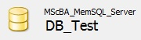
Schema Details
Default Collation: | utf8_general_ci
Default Characterset: | utf8
Table Count: | 16
Database Size (rough estimate): | 1,42 GB

TABLE OVERVIEW
Name | Engine | Version | Row_Format | Rows | Avg_row_length | Data_length | Create_time | BuffMgr Memory Use
Addresses | MemSql | 10 | Uncompressed | 440328 | 145 | 64062080 | 2015-12-09 12:03:54 | 64062080
Diagnosis | MemSql | 10 | Uncompressed | 159 | 3403 | 541232 | 2015-12-09 12:04:25 | 541232
Diagnosis_Categories | MemSql | 10 | Uncompressed | 17 | 30931 | 525832 | 2015-12-09 12:04:25 | 525832
Drugs | MemSql | 10 | Uncompressed | 210 | 2551 | 535792 | 2015-12-09 12:04:25 | 535792
Drugs_Description | MemSql | 10 | Uncompressed | 61 | 8720 | 531952 | 2015-12-09 12:04:26 | 531952
Drugs_Prescribed | MemSql | 10 | Uncompressed | 5000000 | 158 | 794952528 | 2015-12-09 12:04:26 | 794952528
Marital_Status | MemSql | 10 | Uncompressed | 5 | 78718 | 393592 | 2015-12-09 12:16:19 | 393592
Outcome | MemSql | 10 | Uncompressed | 4 | 98380 | 393520 | 2015-12-09 12:16:19 | 393520
Patient_Case | MemSql | 10 | Uncompressed | 10000000 | 150 | 1503697184 | 2015-12-09 12:16:19 | 1503697184
Patients | MemSql | 10 | Uncompressed | 4980589 | 186 | 929449200 | 2015-12-09 12:36:13 | 929449200
Patients_Childrens | MemSql | 10 | Uncompressed | 756461 | 136 | 103162240 | 2015-12-09 12:56:12 | 103162240
Region | MemSql | 10 | Uncompressed | 6 | 65616 | 393696 | 2015-12-09 12:59:40 | 393696
Street | MemSql | 10 | Uncompressed | 138727 | 149 | 20739160 | 2015-12-09 12:59:57 | 20739160
Therapy_Sessions | MemSql | 10 | Uncompressed | 8217230 | 129 | 1061725056 | 2015-12-09 13:00:43 | 1061725056
Town | MemSql | 10 | Uncompressed | 1237 | 501 | 620008 | 2015-12-09 13:36:06 | 620008
Who_Knows | MemSql | 10 | Uncompressed | 6 | 65613 | 393680 | 2015-12-09 13:36:26 | 393680

TABLE DETAILS
Table: Addresses
Field | Type | Null | Key | Default | Extra
ID | bigint(11) | NO | PRI |  | auto_increment
PostalCodeName | varchar(20) | NO
StreetID | int(11) | NO
TownID | int(11) | NO

Table: Diagnosis
Field | Type | Null | Key | Default | Extra
ID | bigint(11) | NO | PRI |  | auto_increment
Code | varchar(10) | NO
DiagnosisName | varchar(100) | NO
Diagnosis_CategoriesID | int(11) | NO

Table: Diagnosis_Categories
Field | Type | Null | Key | Default | Extra
ID | bigint(11) | NO | PRI |  | auto_increment
CategoryName | varchar(100) | NO

Table: Drugs
Field | Type | Null | Key | Default | Extra
ID | varchar(7) | NO | PRI
Brand_Name | varchar(250) | NO
Drugs_Description_ID | int(11) | NO
Table: Drugs_Description
Field | Type | Null | Key | Default | Extra
ID | bigint(11) | NO | PRI |  | auto_increment
Description | varchar(250) | NO

Table: Drugs_Prescribed
Field | Type | Null | Key | Default | Extra
ID | bigint(11) | NO | PRI |  | auto_increment
DrugID | varchar(7) | NO
PatientCaseID | varchar(10) | NO
PatientID | int(11) | NO
StartDate | date | NO
StopDate | date | NO
DurationDays | int(5) | NO

Table: Marital_Status
Field | Type | Null | Key | Default | Extra
ID | int(11) | NO | PRI
Description | varchar(100) | NO

Table: Outcome
Field | Type | Null | Key | Default | Extra
ID | int(11) | NO | PRI
Description | varchar(100) | NO

Table: Patient_Case
Field | Type | Null | Key | Default | Extra
ID | bigint(11) | NO | PRI |  | auto_increment
FirstContactDate | date | NO
WhoKnowsIDs | varchar(20) | NO
PatientID | int(11) | NO
DiagnosisIDs | varchar(50) | NO

Table: Patients
Field | Type | Null | Key | Default | Extra
ID | bigint(11) | NO | PRI |  | auto_increment
Name | varchar(100) | NO
LastName | varchar(100) | NO
Gender | tinyint(2) | NO
BirthDate | date | NO
Height_CM | int(11) | NO
AddressID | int(11) | NO
Weight_KG | decimal(4,2) | NO
Income | decimal(10,2) | NO
Marital_StatusID | int(2) | NO
HPW | decimal(3,1) | NO
Table: Patients_Childrens
Field | Type | Null | Key | Default | Extra
ID | bigint(11) | NO | PRI |  | auto_increment
Gender | tinyint(2) | NO
BirthDate | date | NO
ParentIDs | varchar(150) | NO
Table: Region
Field | Type | Null | Key | Default | Extra
ID | bigint(11) | NO | PRI |  | auto_increment
RegionName | varchar(8) | NO
Table: Street
Field | Type | Null | Key | Default | Extra
ID | bigint(11) | NO | PRI |  | auto_increment
StreetName | varchar(100) | NO
TownID | int(11) | NO
Table: Therapy_Sessions
Field | Type | Null | Key | Default | Extra
ID | bigint(20) | NO | PRI |  | auto_increment
Duration | int(3) | NO
TherapyDate | date | NO
OutcomeID | tinyint(2) | NO
CaseID | int(11) | NO

Table: Town
Field | Type | Null | Key | Default | Extra
ID | bigint(11) | NO | PRI |  | auto_increment
TownName | varchar(50) | NO
RegionID | int(11) | NO

Table: Who_Knows
Field | Type | Null | Key | Default | Extra
ID | int(11) | NO | PRI
Description | varchar(100) | NO

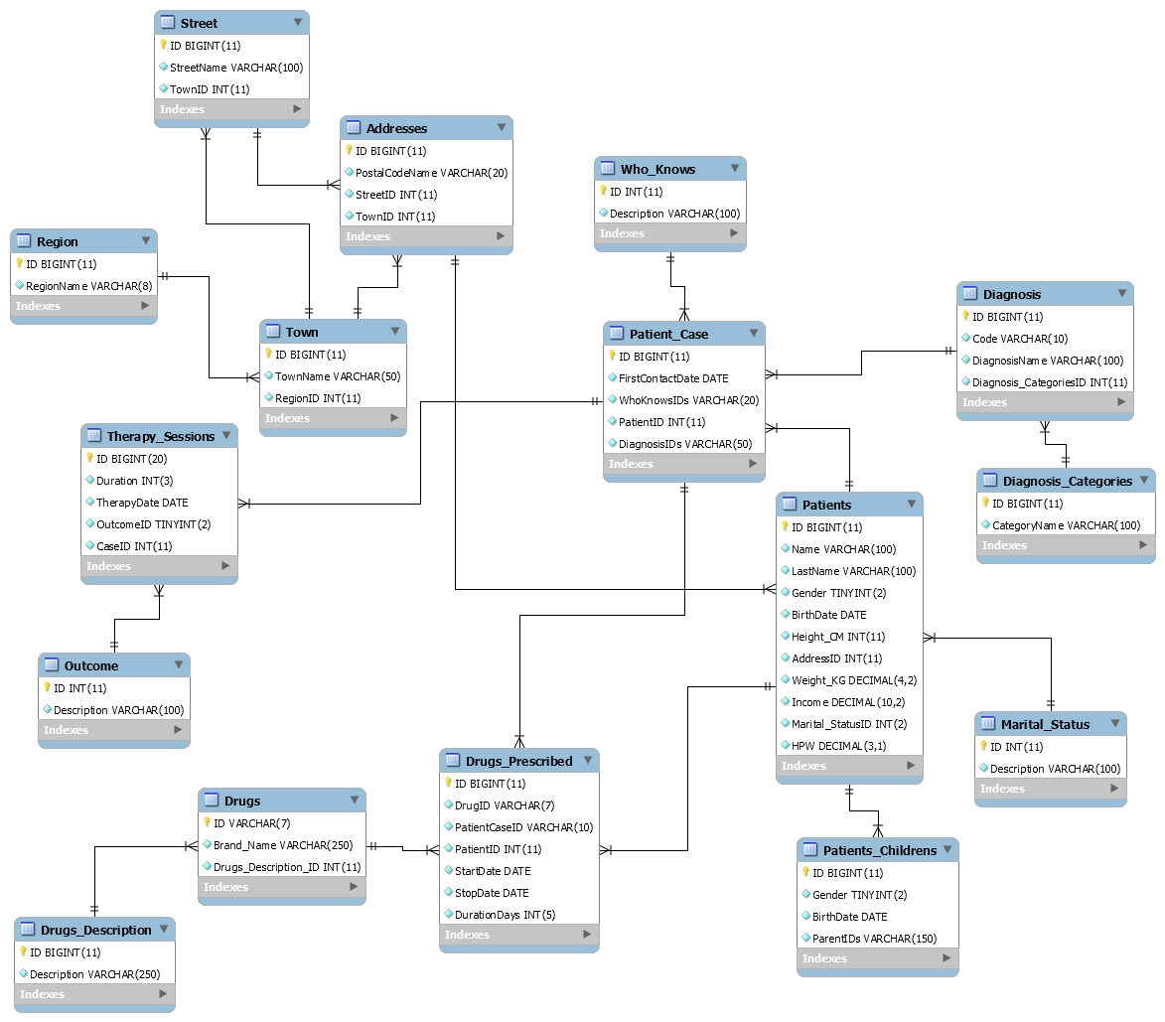
EER MODEL

GENERAL COMMENTS

TASKS 1- 2
As it was our first Tasks, we completed them successfully inserting to the database 10M different cases (the change of 10M to 5M came after). You can see the dump file (DB_Test.zip) in the folder Task_1. We send it as zip file due to its big size.
Concerning the automatically generation and insert of the data, we wrote a program in C# which executes the following functions:
  - Insert Patients randomly (including automatically generation of names and last names)
  - Insert Children randomly
  - Insert Cases randomly
  - Insert Therapy Sessions randomly
  - Insert Drugs Prescribed randomly
  - Migration from Excel to database, for:
    - Drugs
    - Regions
    - Towns
    - Streets
    - Addresses
    - Diagnosis
    - Diagnosis Categories
  - Create new database, including all the tables above

In particular, the insert of the data in each table is not actually totally random, but it has been done with specific conditions.
For the execution, the console program contains a menu with different options for the functions described above.
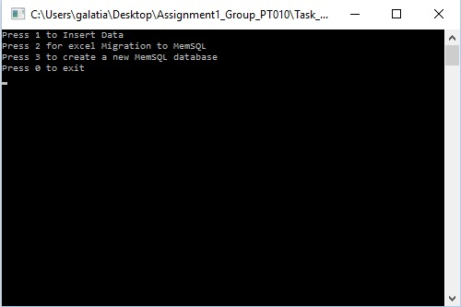

Due to lack of time and knowledge, and for our convenience, we decided to create a C# console application which executes all the functions above, even though it wasn’t included in Assignment’s requirements.
The console application is located :
- source code “…\Assignment1_Group_PT010\Task_2\ConsoleApplication1\ConsoleApplication1”
- .exe file “…\Assignment1_Group_PT010\Task_2\ConsoleApplication1\ConsoleApplication1\bin\Debug\ConsoleApplication1.exe”

After inserting the data above, we decided, on purpose, to create another database with limited data, in order to avoid leaf memory error, for testing our queries:
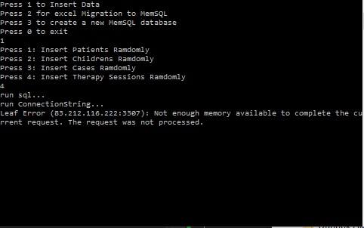
Database Status with limited data:
Name | Rows | Avg_row_length | Data_length
Addresses | 440328 | 146 | 64455296
Diagnosis | 159 | 14120 | 2245168
Diagnosis_Categories | 17 | 100322 | 1705480
Drugs | 210 | 2551 | 535792
Drugs_Description | 61 | 17315 | 1056240
Drugs_Prescribed | 1848 | 363 | 672128
Marital_Status | 5 | 78718 | 393592
Outcome | 4 | 98380 | 393520
Patient_Case | 4869 | 4926 | 23989000
Patients | 350 | 1548 | 541824
Patients_Childrens | 696 | 2904 | 2021760
Region | 6 | 65616 | 393696
Street | 138727 | 149 | 20739160
Therapy_Sessions | 3348 | 7110 | 23807232
Town | 1237 | 501 | 620008
Who_Knows | 6 | 65613 | 393680

In the folder Task_1 is also included the dump file DB_Test_for_Queries.zip.

TASKS 3-7
The SQL scripts are included on the corresponding name folders.

TASKS 8*
The java program receives an input and executes a certain SQL query.
- In the SQL query, we used years 2005-2015, instead 2005- 2010 of your statement, because we didn’t have any data between these years and in order to get a result (for DB_Test_for_Queries.zip, db with limited data)

TASKS 9*
The java program receives an input, executes multiple SQL queries, cache the results into ListArray Object, in order to avoid creation of new tables in our database (because MemSQL doesn’t support temporary tables).
- To get a result, please use as input of a code region the “REG_005” (for DB_Test_for_Queries.zip, db with limited data)
* Tasks 8 and 9 are included in the same java program (path: Assignment1_Group_PT010\Task_8 and Task_9\Java_Task8_Task9\MEMSql\src\com\Main.java)

