Tickets说明文档

151250132 唐鑫

# 一、数据库设计

## ER图

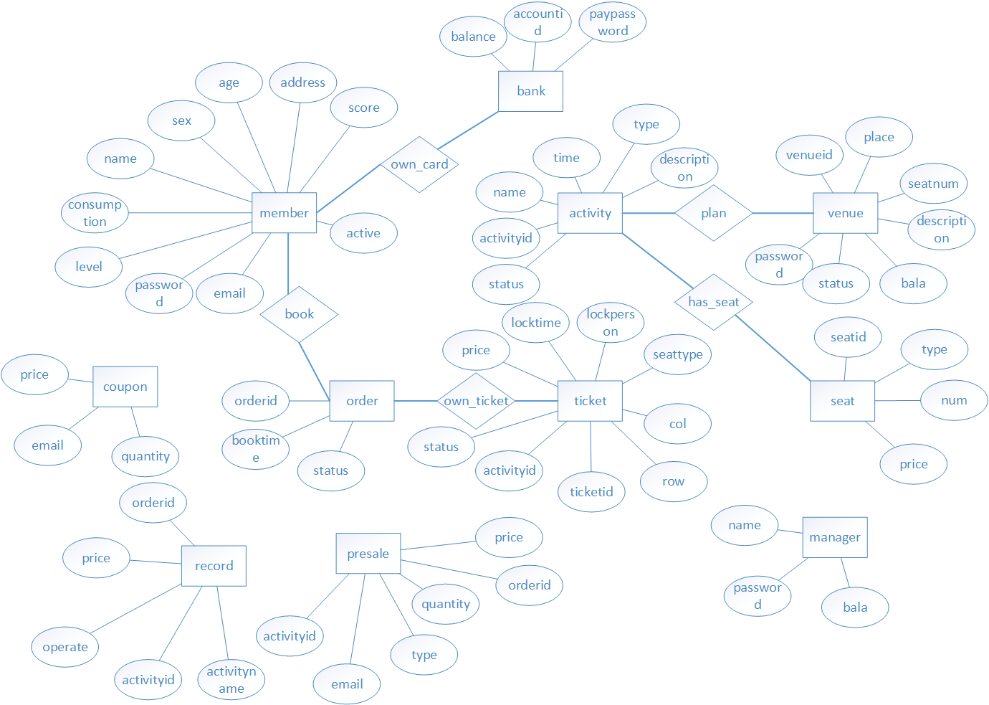

## 数据库表（表名，各列名及数据类型，外键关系）

|  |  |  |
| --- | --- | --- |
| member | | |
| email | varchar(255) |  |
| name | varchar(255) |  |
| password | varchar(255) |  |
| sex | int |  |
| age | int |  |
| address | varchar(255) |  |
| consumption | double |  |
| score | int |  |
| level | int |  |
| active | int |  |
| order | | |
| orderid | int |  |
| booktime | datetime |  |
| status | int |  |
| activity | | |
| activityid | int |  |
| name | varchar(255) |  |
| time | datetime |  |
| type | int |  |
| description | varchar(255) |  |
| status | int |  |
| venue | | |
| venueid | int |  |
| place | varchar(255) |  |
| description | varchar(255) |  |
| password | varchar(255) |  |
| seatnum | int |  |
| status | int |  |
| bala | double |  |
| bank | | |
| accountid | int |  |
| paypassword | varchar(255) |  |
| balance | double |  |
| ticket | | |
| ticketid | int |  |
| activityid | int | pk-activity |
| seattype | int |  |
| row | int |  |
| col | int |  |
| price | double |  |
| status | int |  |
| locktime | datetime |  |
| lockperson | varchar(255) |  |
| seat | | |
| seatid | int |  |
| type | int |  |
| price | double |  |
| num | int |  |
| record | | |
| activityid | int |  |
| activityname | varchar(255) |  |
| orderid | int |  |
| price | double |  |
| operate | int |  |
| presale | | |
| email | varchar(255) |  |
| orderid | int |  |
| activityid | int |  |
| type | varchar(255) |  |
| quantity | varchar(255) |  |
| price | varchar(255) |  |
| coupon | | |
| email | varchar(255) |  |
| price | double |  |
| quantity | int |  |
| manager | | |
| name | varchar(255) |  |
| password | varchar(255) |  |
| bala | double |  |
| own_card | | |
| email | varchar(255) | pk-member |
| accountid | int | pk-bank |
| own_ticket | | |
| orderid | int | pk-order |
| ticketid | int | pk-ticket |
| has_seat | | |
| activityid | int | pk-activity |
| seatid | int | pk-seat |
| book | | |
| email | varchar(255) | pk-member |
| orderid | int | pk-order |
| plan | | |
| venueid | int | pk-venue |
| activityid | int | pk-activity |

# 二、架构设计

## 工程的项目结构截图

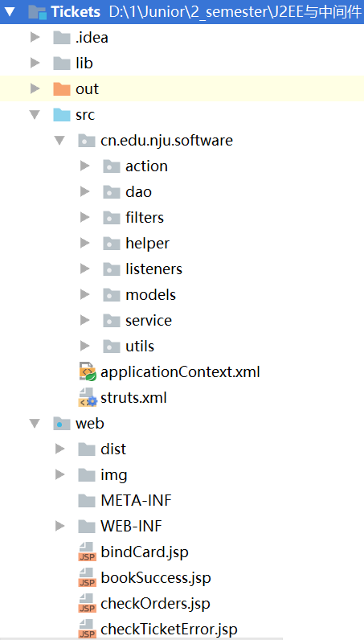

## 后台框架

使用Spring+Hibernate架构。

## 前端框架

前端使用bootstrap框架。

# 三、类设计

## 各包的类：名称及职责

|  |  |
| --- | --- |
| cn.edu.nju.software.action | |
| BaseAction | 所有Action类的父类 |
| BindCardAction | 绑定银行卡 |
| BookTicketsAction | 订票 |
| CancelQualificationAction | 取消会员资格 |
| CheckInfoAction | 审核场馆信息 |
| CheckOrdersAction | 确认订单 |
| CheckTicketAction | 检票 |
| CheckTicketsAction | 检票前 |
| ConfirmOrderAction | 付款 |
| ExchangeCouponAction | 兑换优惠券 |
| FinanceStatisticsAction | 财务统计 |
| GetActivitiesByTypeAction | 根据类型返回活动列表 |
| GetPlanByAidAction | 根据活动号返回计划 |
| LockSeatAction | 锁定座位 |
| LogInManagerAction | 经理登录 |
| LogInMemberAction | 用户登陆 |
| LogInVenueAction | 场馆登录 |
| ManageAccountAction | 用户管理账户 |
| ManageVenueAction | 场馆管理账户 |
| MemberStatisticsAction | 用户数据统计 |
| OnsellTicketsAction | 在线选座 |
| PassVenueAction | 审核场馆信息通过 |
| PayAction | 支付 |
| PlanActivitiesAction | 计划活动 |
| PublishActivitiesAction | 发布活动计划 |
| QueryRecordAction | 查询订单记录 |
| QuitAction | 退订 |
| RegisterMemberAction | 注册用户 |
| RegisterVenueAction | 注册场馆 |
| SettleAction | 结算前 |
| SettleFinanceAction | 结算 |
| ShowActivitiesAction | 展示所有活动 |
| StartAction | 主页 |
| SubmitOrder1Action | 提交选座订单 |
| SubmitOrderAction | 提交预售订单 |
| SystemStatisticsAction | 系统数据统计 |
| UnlockSeatAction | 解锁座位 |
| UpdateMemberAction | 更新用户信息 |
| UpdateVenueAction | 更新场馆信息 |
| VenueRecordAction | 场馆订单记录 |
| VenueStatisticsAction | 场馆数据统计 |
| VerifyAction | 邮箱验证 |
| cn.edu.nju.software.dao.impl | |
| ActivityDaoImpl | 与数据库相关 |
| BankDaoImpl |
| BaseDaoImpl |
| BookDaoImpl |
| CardOwnDaoImpl |
| CouponDaoImpl |
| ManagerDaoImpl |
| MemberDaoImpl |
| OrderDaoImpl |
| PlanDaoImpl |
| PresaleDaoImpl |
| RecordDaoImpl |
| SeatDaoImpl |
| SeatHavingDaoImpl |
| TicketDaoImpl |
| TicketOwnDaoImpl |
| VenueDaoImpl |
| cn.edu.nju.software.dao | |
| ActivityDao | 与数据库相关 |
| BankDao |
| BaseDao |
| BookDao |
| CardOwnDao |
| CouponDao |
| ManagerDao |
| MemberDao |
| OrderDao |
| PlanDao |
| PresaleDao |
| RecordDao |
| SeatDao |
| SeatHavingDao |
| TicketDao |
| TicketOwnDao |
| VenueDao |
| cn.edu.nju.software.filters | |
| EncodingFilter | 字符编码过滤 |
| cn.edu.nju.software.helper | |
| AutoTask | 自动任务 |
| cn.edu.nju.software.listeners | |
| AutoTaskListener | 自动任务的监听 |
| cn.edu.nju.software.models | |
| Activity | 与数据库相关 |
| Bank |
| Book |
| BookPrimaryKey |
| CardOwn |
| CardOwnPrimaryKey |
| Coupon |
| CouponPrimaryKey |
| Manager |
| Member |
| Order |
| OrderInfo |
| Plan |
| PlanPrimaryKey |
| Presale |
| PresalePrimaryKey |
| Record |
| RecordPrimaryKey |
| Seat |
| SeatHaving |
| SeatHavingPrimaryKey |
| Ticket |
| TicketOwn |
| TicketOwnPrimaryKey |
| Venue |
| cn.edu.nju.software.service.impl | |
| ActivityServiceImpl | 和活动相关的接口实现 |
| AutoServiceImpl | 和自动运行的任务的接口实现 |
| BankServiceImpl | 和支付相关的接口实现 |
| MemberServiceImpl | 和用户相关的接口实现 |
| RecordServiceImpl | 和记录相关的接口实现 |
| TicketServiceImpl | 和票相关的接口实现 |
| VenueServieceImpl | 和场馆相关的接口实现 |
| cn.edu.nju.software.service | |
| ActivityService | 和活动相关的接口 |
| AutoService | 和自动运行的任务的接口 |
| BankService | 和支付相关的接口 |
| MemberService | 和用户相关的接口 |
| RecordService | 和记录相关的接口 |
| TicketService | 和票相关的接口 |
| VenueServiece | 和场馆相关的接口 |
| cn.edu.nju.software.utils | |
| ActivityStatus | 活动状态 |
| ActivityType | 活动类型 |
| Operate | 对订单的操作 |
| OrderStatus | 订单状态 |
| SeatType | 座位状态 |
| TicketStatus | 票状态 |
| VenueStatus | 场馆状态 |

## 前端的各页面：名称及功能

|  |  |
| --- | --- |
| bindCard | 绑定银行卡 |
| bookSuccess | 订票成功 |
| checkOrders | 检查订单 |
| checkTicketError | 检票失败 |
| checkTickets | 检票 |
| checkVenueInfo | 审核场馆信息 |
| chooseCard | 预定时选择银行卡 |
| chooseCard1 | 选座时选择银行卡 |
| confirmOrder | 确认订单 |
| financeStatistics | 财务统计 |
| inChecking | 审核中 |
| index | 主页 |
| logInError | 登录失败 |
| mailSent | 发送邮箱 |
| manageMember | 管理用户 |
| managerPage | 经理主页 |
| manageVenue | 管理场馆 |
| memberHasCancelled | 用户注销 |
| memberHasExist | 用户已存在 |
| memberPage | 用户主页 |
| memberStatistics | 用户数据统计 |
| notEnoughMoney | 金额不足 |
| notMoreThanSix | 选票数多于六张 |
| planActivities | 发布计划 |
| queryRecords | 用户查询记录 |
| queryRecords1 | 场馆查询记录 |
| registerError | 注册失败 |
| registerMemberSuccess | 注册用户成功 |
| registerVenueSuccess | 注册场馆成果 |
| settleFinance | 结算财务 |
| showActivities | 展示所有活动 |
| showActivityOnselling | 展示正在销售的活动 |
| showActivityPostsale | 展示售后的活动 |
| showActivityPresale | 展示预售的活动 |
| updatingVenue | 更新场馆信息 |
| venuePage | 场馆主页 |

## 四、其他

## 开发环境

数据库：MySQL

服务器：Tomcat

## 开发心得体会

这次的开发用了structs2+spring+hibernate的框架，更好地了解了框架底层的实现。相对于当初软工二时对框架原理一窍不通，出现错误不知从和解决，有了很大的进步。