QUIZ GAME WITH HIGH SCORE
A Mini Project Presentation presented to the
College of Information Technology Education
PHINMA - University of Iloilo
Iloilo City
Submitted in partial fulfillment of the requirements for
ITE 260 Computer Programming 1
MANGASANG, ANGELICA B.
Solo Member
October 2026

Introduction

Description
The Quiz Game with High Score is a Python-based mini project designed to provide an interactive multiple-choice quiz about basic computer and Python programming concepts. The program presents ten questions with four choices for each question and allows the player to enter an answer using A, B, C, or D. It checks each response immediately and tells the player whether the answer is correct or incorrect. At the end of the quiz, the program calculates the total score and percentage and gives feedback based on the player’s performance. It also keeps the highest score during the current program session and allows the player to repeat the quiz to try to improve the result.

Objectives of the Study

General Objective
To develop a Quiz Game with High Score using Python fundamentals and functions.

Specific Objectives
• To create an interactive multiple-choice quiz that accepts and validates the player’s answers.
• To automatically check answers, calculate the total score and percentage, and provide performance feedback.
• To use Python functions, lists, dictionaries, loops, conditional statements, variables, and input/output operations in an organized program.
• To track the highest score achieved during the current program session.
• To allow the player to repeat the quiz and attempt to improve the high score.

Scope and Limitations
The project focuses on a terminal-based quiz game created in Python. Its scope includes ten multiple-choice questions related to basic computer and Python programming concepts, answer validation, immediate feedback, score computation, percentage calculation, performance feedback, high-score tracking, and a replay option. The program is intended for one player at a time and is operated through keyboard input in the Python console. The high score is stored only while the program is running and is reset when the program is closed because no external file or database is used. The project also uses a fixed set of questions, so the player cannot add or edit questions from inside the program.

Definition of Terms
Function: A reusable block of Python code that performs a specific task. The project uses functions for displaying questions, checking answers, running the quiz, showing results, and controlling the main program.
List: A Python collection used to store multiple items. The program uses a list to store the quiz questions.
Dictionary: A Python data structure that stores information using key-value pairs. Each quiz item stores its question, choices, and correct answer in a dictionary.
Loop: A programming structure that repeats instructions. The project uses loops to go through the questions, validate input, and allow the player to play again.
Conditional Statement: A decision-making structure such as if, elif, and else. It is used to determine whether an answer is correct and what performance message to display.
High Score: The highest score achieved by the player during the current run of the program.
Input Validation: The process of checking whether the player entered an allowed answer before the program continues.

Flow of the Data
The program begins by displaying the title and asking for the player’s name. It initializes the high score, presents each question and its choices, and validates the player’s input. A correct answer adds one point to the score, while an incorrect answer displays the correct option. After all questions have been answered, the program shows the score, percentage, and performance feedback, then compares the score with the current high score. Finally, the player chooses whether to play again; choosing yes restarts the quiz, while choosing no ends the program.
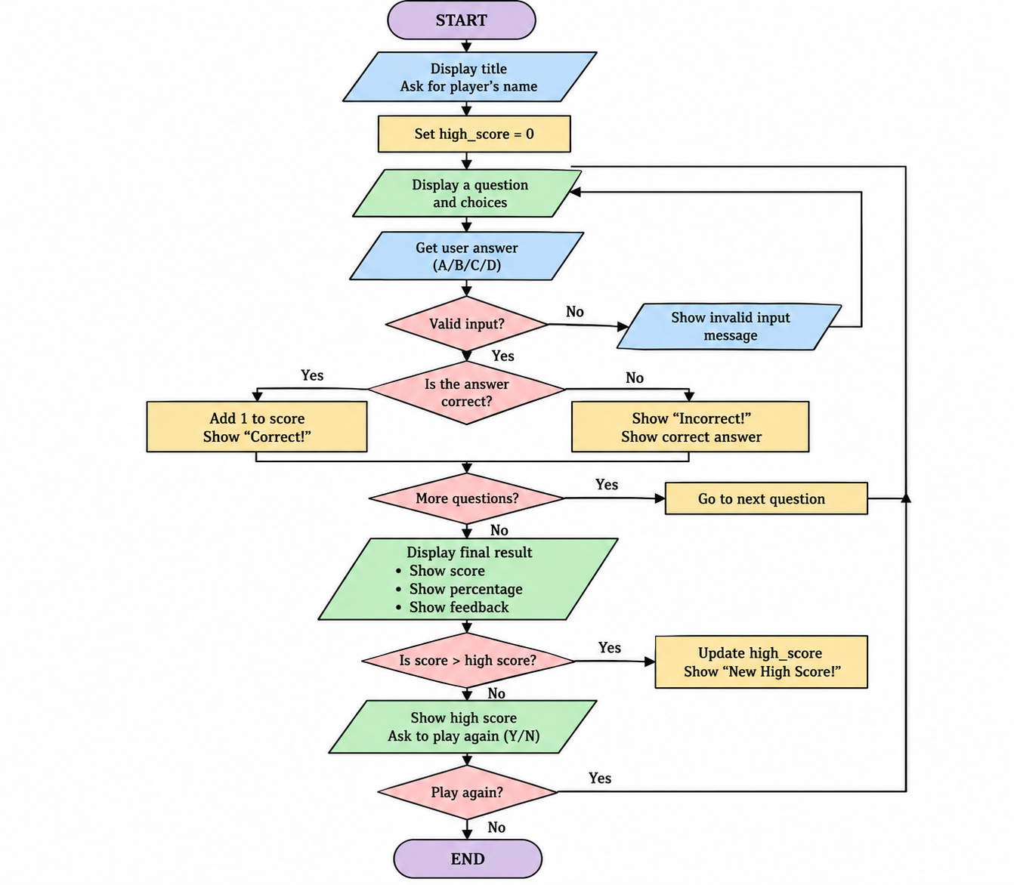
Figure 1. Flowchart of the Quiz Game with High Score

Key Features
Player Identification: The program asks for the player’s name and displays it in the final result.
Ten Multiple-Choice Questions: The quiz contains ten questions with four answer choices each.
Input Validation: Only A, B, C, or D is accepted as a valid answer, preventing invalid entries from being processed.
Automatic Answer Checking: The program immediately determines whether the selected answer is correct.
Score and Percentage Calculation: The program calculates the player’s total correct answers and percentage score.
Performance Feedback: The player receives an Excellent, Good Job, or Keep Practicing message based on the percentage.
High-Score Tracking: The highest score achieved during the current session is displayed and updated when beaten.
Replay Option: The player can repeat the quiz without restarting the Python program.

Source Code
# QUIZ GAME WITH HIGH SCORE

questions = [
{
"question": "What does CPU stand for?",
"choices": ["A. Central Processing Unit", "B. Computer Personal Unit",
"C. Central Program Utility", "D. Control Processing User"],
"answer": "A"
},
{
"question": "Which symbol is used for comments in Python?",
"choices": ["A. //", "B. #", "C. /*", "D. --"],
"answer": "B"
},
{
"question": "Which function is used to display output in Python?",
"choices": ["A. input()", "B. display()", "C. print()", "D. output()"],
"answer": "C"
},
{
"question": "Which data type stores whole numbers?",
"choices": ["A. float", "B. str", "C. bool", "D. int"],
"answer": "D"
},
{
"question": "Which keyword is used to create a function in Python?",
"choices": ["A. function", "B. create", "C. def", "D. func"],
"answer": "C"
},
{
"question": "Which loop is commonly used to repeat through a list?",
"choices": ["A. for", "B. switch", "C. case", "D. select"],
"answer": "A"
},
{
"question": "Which function is used to get input from the user?",
"choices": ["A. print()", "B. input()", "C. write()", "D. read()"],
"answer": "B"
},
{
"question": "Which operator checks if two values are equal?",
"choices": ["A. =", "B. !=", "C. ==", "D. >="],
"answer": "C"
},
{
"question": "Which data type stores text?",
"choices": ["A. str", "B. int", "C. float", "D. bool"],
"answer": "A"
},
{
"question": "What does the break statement do?",
"choices": ["A. Starts a loop", "B. Stops a loop",
"C. Prints a message", "D. Creates a function"],
"answer": "B"
}
]

def show_question(question_data):
print("\n" + question_data["question"])
for choice in question_data["choices"]:
print(choice)
while True:
answer = input("Enter your answer (A/B/C/D): ").upper()
if answer in ["A", "B", "C", "D"]:
return answer
else:
print("Invalid input. Please enter A, B, C, or D.")

def check_answer(user_answer, correct_answer):
if user_answer == correct_answer:
print("Correct!")
return 1
else:
print("Incorrect!")
print("Correct answer:", correct_answer)
return 0

def run_quiz():
score = 0
print("\n==============================")
print(" QUIZ GAME")
print("==============================")
for question in questions:
user_answer = show_question(question)
score += check_answer(user_answer, question["answer"])
return score

def show_result(player_name, score, total_questions):
percentage = (score / total_questions) * 100
print("\n==============================")
print(" QUIZ RESULT")
print("==============================")
print("Player:", player_name)
print("Score:", score, "/", total_questions)
print("Percentage:", percentage, "%")
if percentage >= 80:
print("Excellent performance!")
elif percentage >= 60:
print("Good job!")
else:
print("Keep practicing!")

def main():
print("==============================")
print(" QUIZ GAME WITH HIGH SCORE")
print("==============================")
player_name = input("Enter your name: ")
high_score = 0
while True:
score = run_quiz()
show_result(player_name, score, len(questions))
if score > high_score:
high_score = score
print("\nNew High Score!")
print("Current High Score:", high_score, "/", len(questions))
play_again = input("\nDo you want to play again? (Y/N): ").upper()
if play_again != "Y":
print("\nThank you for playing,", player_name + "!")
print("Final High Score:", high_score)
break

main()

