

Yenepoya Institute of Arts Science Commerce and Management

Project – High Level Design
On

IDENTITY SECURITY FRAMEWORK FOR MANUFACTURING

Student Name: Angelica Alex

Industry Mentor: | Vikyath Shetty | Guided by: | Shashank

Table of Contents+

- Introduction. 6
  - Scope of the document. 6
  - Intended Audience 6
  - System overview. 6
- System Design. 6
  - Application Design 6
  - Process Flow. 6
  - Information Flow. 7
  - Components Design 8
  - Key Design Considerations 8
  - API Catalogue. 8
- Data Design. 8
  - Data Model 8
  - Data Access Mechanism 9
  - Data Retention Policies 9
  - Data Migration 9
- Interfaces 9
- State and Session Management 10
- Caching 10
- Non-Functional Requirements 10
  - Security Aspects 10
  - Performance Aspects 10
- References 11

- INTRODUCTION
A manufacturing system is used to manage inventory and production processes within an organization. With the increasing use of digital systems in industries, ensuring secure access and proper user management has become very important. One of the key challenges in such systems is maintaining identity security, where only authorized users can access specific functionalities. This project implements an Identity Security Framework for a manufacturing application using Flask and SQLite. The system allows users to register and log in securely, with passwords stored using hashing techniques to protect sensitive information. Once authenticated, users can view inventory details, update stock, and record production activities. The system also introduces role-based access control, where different roles such as staff, manager, and admin have different permissions. Staff can update inventory and record production data, while managers can monitor system activities. An admin has full control over managing users, inventory items, and system operations. Additionally, the system includes an audit logging feature where all actions performed by users are recorded. This helps in tracking system activities and maintaining accountability. Sessions are used to track logged-in users and manage their access throughout the system. Overall, this project demonstrates the concepts of authentication, authorization, secure data handling, and controlled workflow in a simple manufacturing environment.

1.1 SCOPE OF THE DOCUMENT
This document describes the design and implementation of an identity security framework for a manufacturing system. It provides detailed information about the system architecture, data flow, components, and technologies used, including Flask, HTML, CSS, and SQLite. The document focuses on secure authentication, role-based authorization, inventory management, production tracking, and audit logging within the application.

1.2 INTENDED AUDIENCE
This document is intended for:
- Students developing similar web-based projects

- Developers working on secure manufacturing applications
- Beginners learning authentication and authorization in Flask

1.3 SYSTEM OVERVIEW
The system overview provides a general understanding of how the manufacturing application works. The system allows users to register and log in securely using their credentials. After successful authentication, users can access the dashboard where they can view inventory details and perform operations based on their roles. The system is designed with role-based access control, where different users have different functionalities. Staff members can view inventory, update stock levels, and record production activities. Managers can monitor inventory and view production logs. An admin is responsible for managing users, controlling inventory items, and overseeing system operations, ensuring controlled and secure system management. The system also includes a production and inventory management mechanism. When stock is updated or production is recorded, the system stores and updates the data accordingly. Additionally, all user actions are recorded in audit logs, which helps in tracking activities and maintaining accountability. All user activities are managed using session handling, which maintains the login state and controls access to different parts of the system. The frontend is developed using HTML and CSS (with Tailwind), while the backend is implemented using Python Flask and SQLite for data storage.

2. SYSTEM DESIGN

2.1 APPLICATION DESIGN
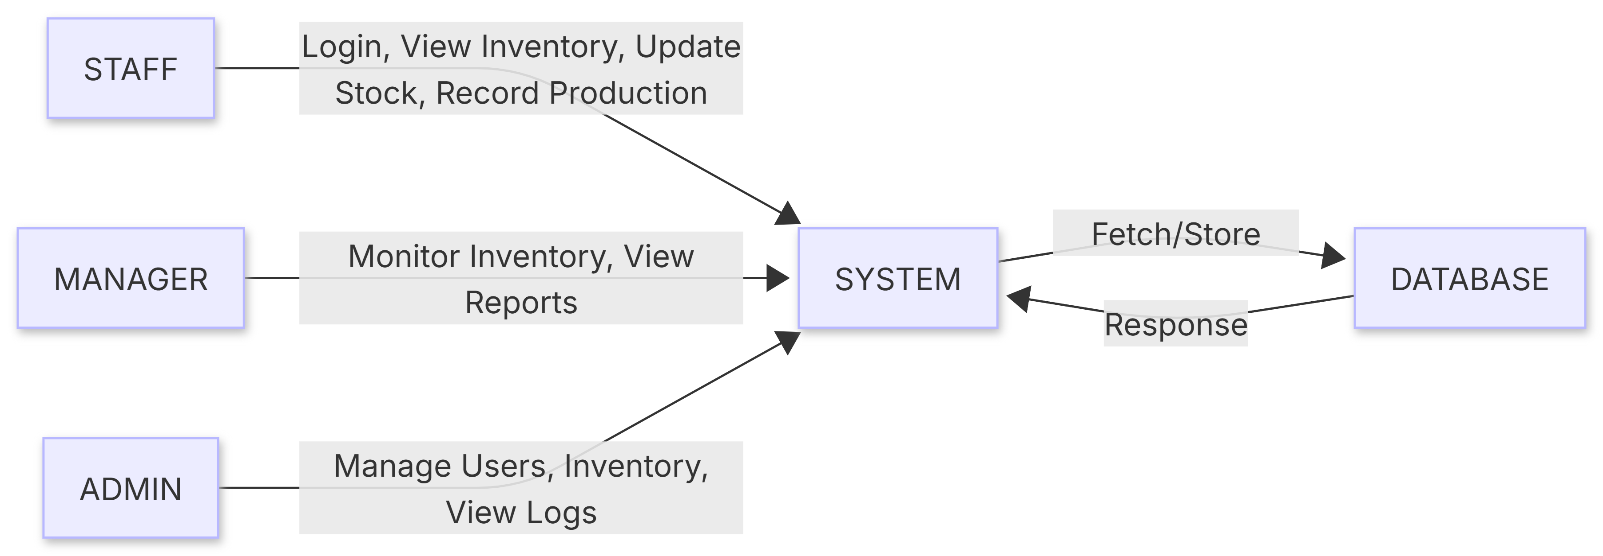

This diagram shows the complete architecture of the E-commerce system with an identity security framework. It explains how the user, frontend, backend, and database interact with each other to provide secure and controlled functionality.The process starts with the User (Client), who uses a web browser to interact with the system. Depending on their role (user, shopkeeper, or admin), they can perform different actions such as registering, logging in, viewing products, adding products, placing orders, or approving products.These actions are handled by the Frontend UI, which is built using HTML and CSS (Tailwind). The frontend provides different pages such as login, register, dashboard, product listing, and admin panel. It sends user requests to the backend using HTTP methods. The Backend Server (Python Flask) acts as the core component of the system. It handles authentication (login and registration), manages user sessions, and enforces authorization using role-based access control. It processes all requests such as adding products, approving products, and placing orders.
The backend also implements important business logic. When a shopkeeper adds a product, it is stored with a "pending" status. The admin reviews and updates the status to "approved" or "rejected". Only approved products are made visible to users. Additionally, when a user

places an order, the backend checks the available stock and updates the product quantity accordingly.
The system interacts with the Database (SQLite), which stores all necessary data such as user details, product information, and order records. The backend retrieves and updates this data as required, ensuring consistency and secure access. Overall, the architecture ensures a clear separation between frontend, backend, and database, while maintaining secure authentication, controlled access, and proper data management. The system also interacts with the Database, which stores important data such as user details, preferences, and ratings. The backend fetches and updates this data when needed.

2.2 PROCESS FLOW
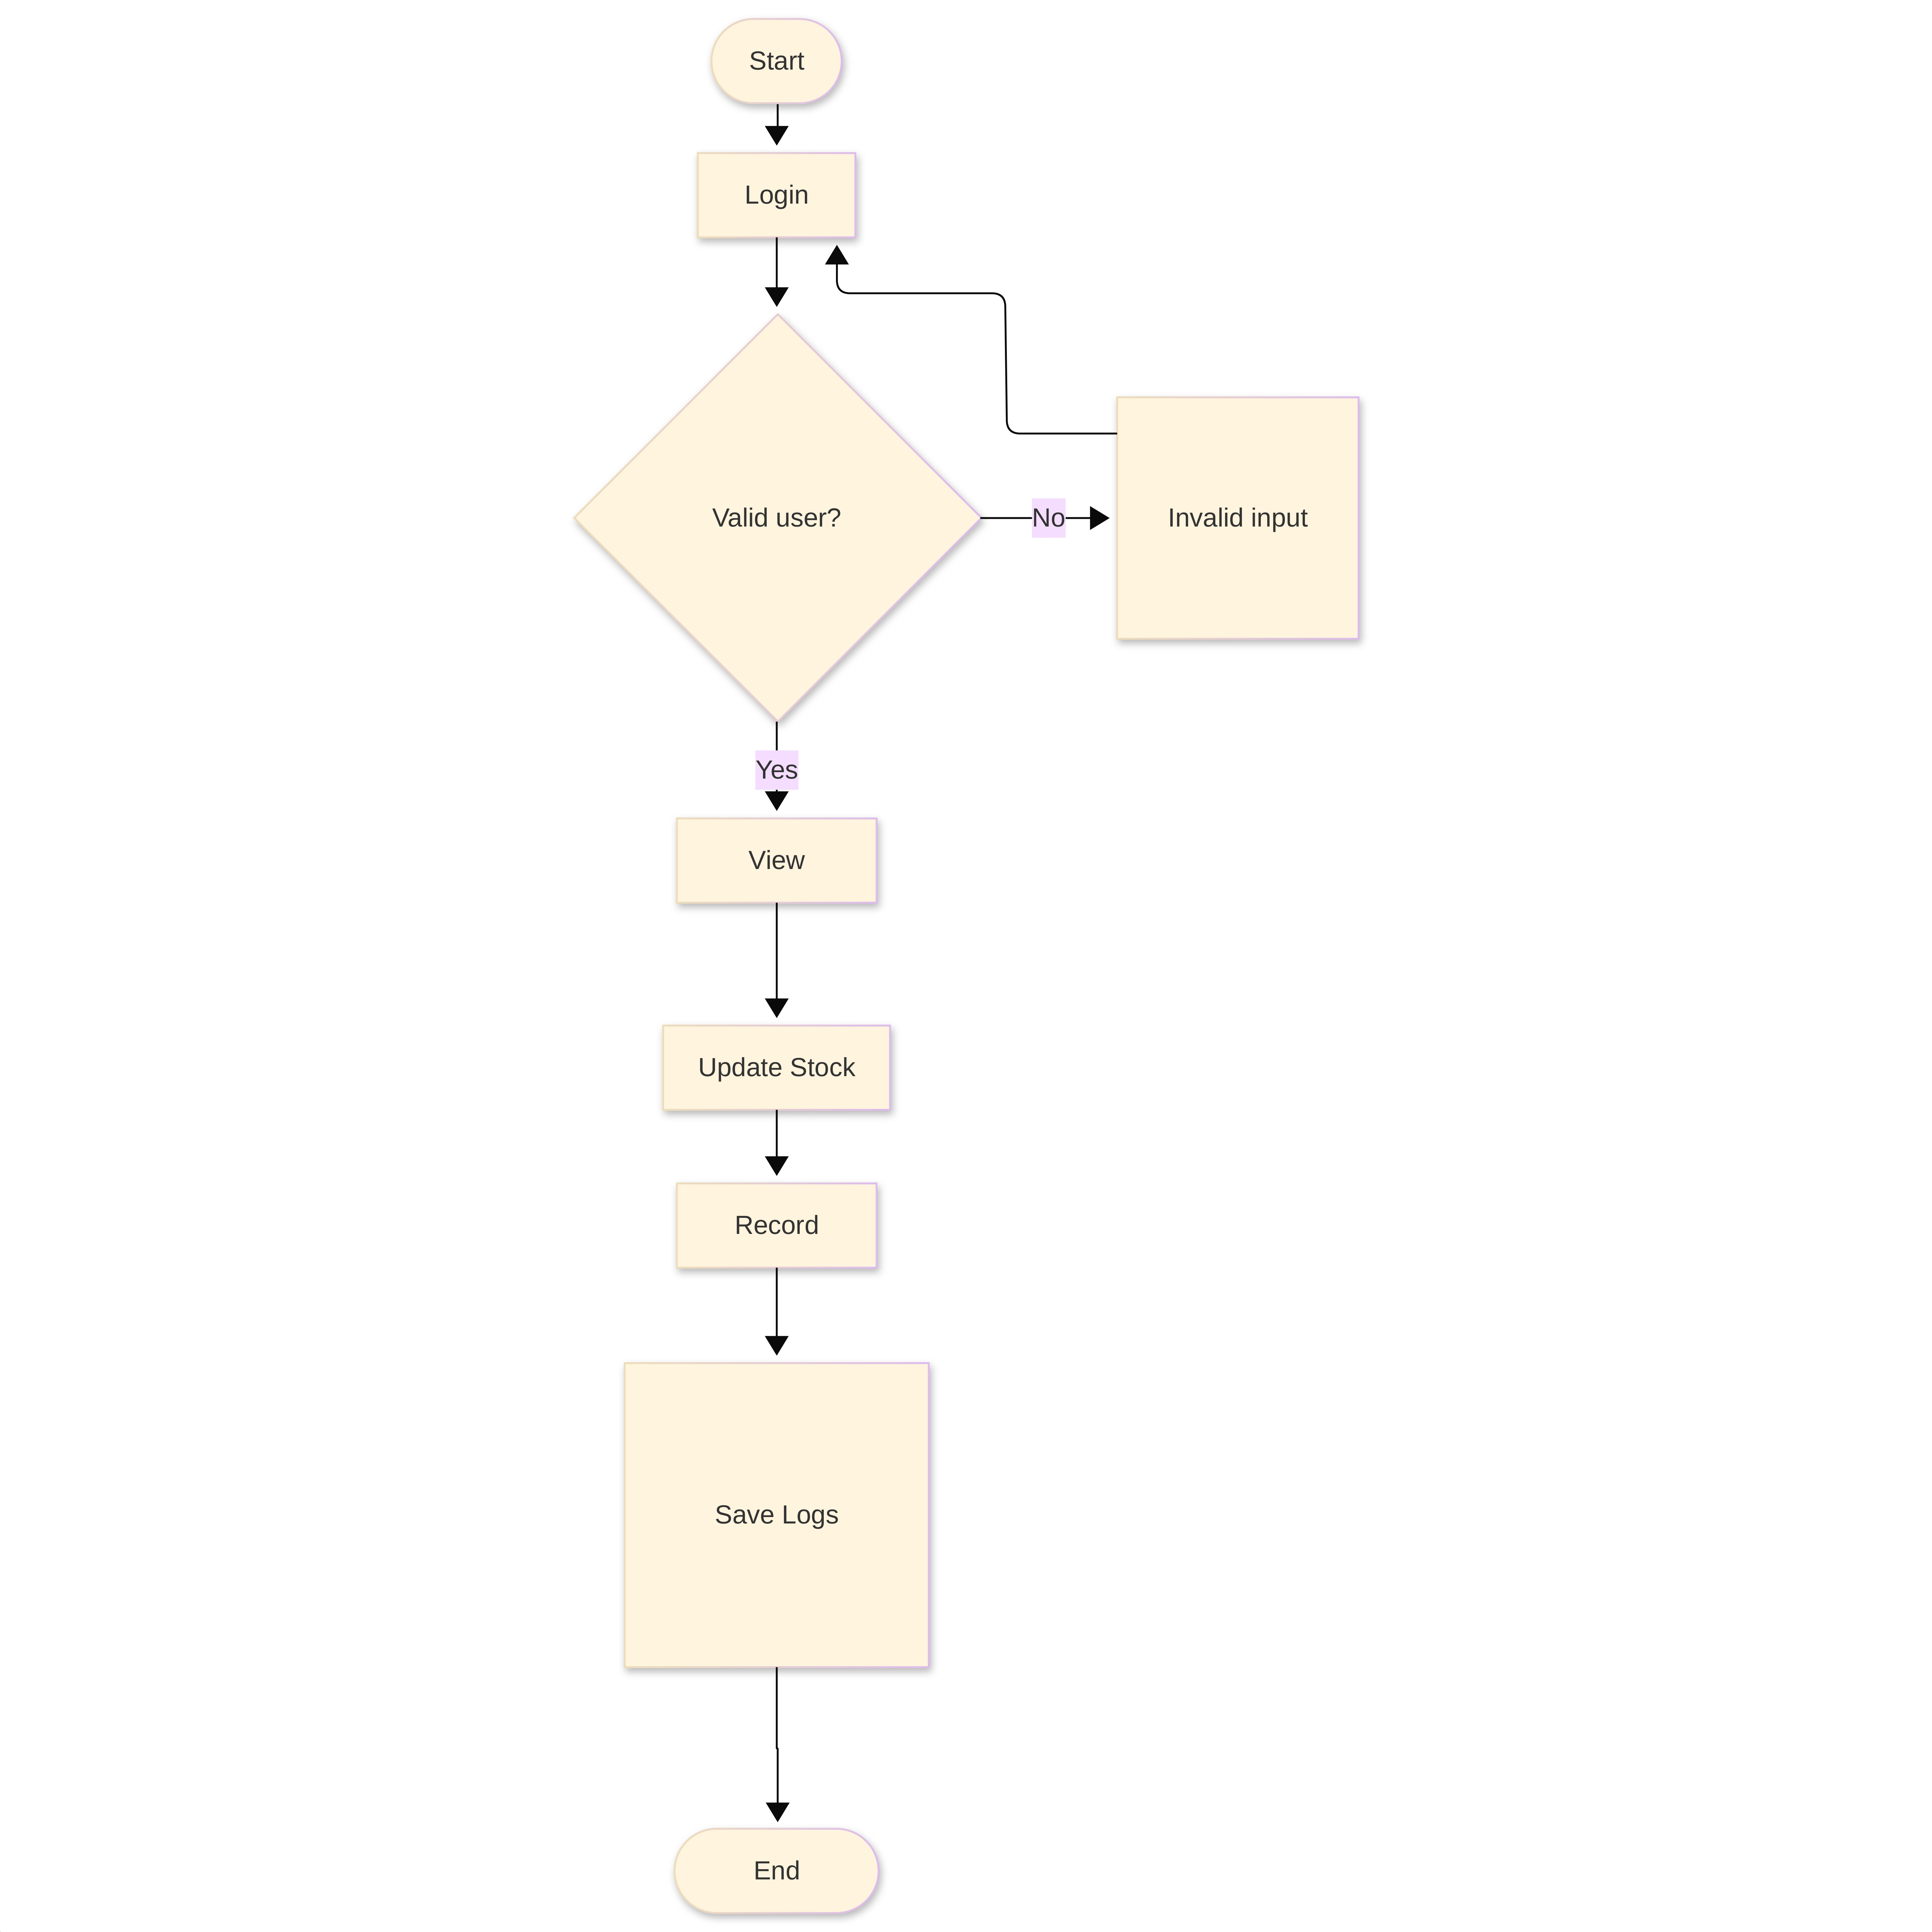

The process starts with the user accessing the system. First, the user needs to register by creating an account with an username and password. After successful registration, the user logs in using their credentials. The system verifies the login details, and if the credentials are incorrect, an error message is displayed and the user is asked to try again. This process continues until valid credentials are provided.
Once the user is authenticated, a session is created to maintain the user’s login state. Based on the role of the user (user, shopkeeper, or admin), the system provides access to different functionalities. If the user is a shopkeeper, they can add new products by providing details such as name, price, description, and quantity. These products are initially stored with a "pending" status. The admin then reviews these products and either approves or rejects them. Only approved products are made visible to users.
A normal user can view the list of approved products. When placing an order, the system checks the available stock for the selected product. If sufficient quantity is available, the order is processed and the product quantity is reduced accordingly. If not, an appropriate message is displayed. The admin can manage users, monitor products, and control the system through the admin dashboard. Throughout the process, all actions are controlled using session-based authentication and role-based authorization to ensure secure access.

2.3 INFORMATION FLOW
Information flows between different components of the manufacturing system in a structured manner. User input is first captured through the frontend interface, which includes pages such as login, inventory view, and dashboard. These inputs are sent to the backend server using HTTP requests. The backend (Flask application) processes the received data and performs necessary operations such as authentication, authorization, inventory management, and production tracking. It interacts with the database to store and retrieve information like user details, inventory data, production records, and logs.
When staff update inventory or record production, the data is stored in the database and updated accordingly. Managers and admins can access this data to monitor system activities. All actions performed by users are recorded in logs, which helps in tracking system operations and maintaining accountability. The updated information is stored in the database and reflected in the frontend.
All responses from the backend are sent back to the frontend and displayed to the user. The session mechanism ensures that user identity and role information are maintained throughout the interaction, enabling secure and controlled access to the system.

2.4 COMPONENTS DESIGN
The system has the following components:

STAFF
• Register/Login: This module allows staff to create an account and securely log in to the system. User credentials such as username and password are stored in the database, with passwords protected using hashing techniques.
• View Inventory: Staff can view the list of available inventory items and their quantities.
• Update Stock: This module allows staff to update stock levels when materials are added or used.
• Record Production: Staff can record production details such as number of items produced.
• View Production Logs: Staff can view records of production activities.

MANAGER
• Login: Manager can log in to monitor system activities.
• Monitor Inventory: Manager can view inventory levels and ensure proper stock management.
• View Production Logs: Manager can monitor production records.

ADMIN
• Login:
Admin can log in to access the system with full control over all modules.

• Manage Users:
Admin can add, block, or delete staff accounts.
• Manage Inventory:
Admin can add, update, or delete inventory items.
• View Production Logs:
Admin can monitor all production activities.
• Audit Logs:
Admin can track all system actions to ensure accountability.

2.5 KEY DESIGN CONSIDERATIONS
- Security:
The system uses login and role-based access so only authorized users can perform actions.
- Simple Design:
The system is easy to use with a simple interface.
- Data Accuracy:
Product quantity is updated after each order to avoid mistakes.
- Controlled Access:
Admin controls product approval, and users have limited access.

2.6 API CATALOGUE
The system uses APIs such as:
• Login API
• Register API
• Inventory API
• Production API
• Admin Control API

3. DATA DESIGN
Data design explains how data is stored, organized, and used in the manufacturing system. It is an important part of the system because all operations such as user login, inventory management, and production tracking depend on stored data. The system stores different types of data such as user details, inventory items, production records, and logs. All data is stored in a structured database (SQLite) so that it can be easily accessed and updated. Proper data design helps the system work efficiently and ensures accurate processing of user requests. For example, when a user logs in, the system checks the stored user data. When stock is updated or production is recorded, the system updates the inventory and production data accordingly.
3.1 DATA MODEL
Users Table
SL.no | Column name | Data type | Size | Constraints | Description
1 | id | INT | 11 | Primary Key | User ID
2 | username | VARCHAR | 200 | Not Null | Username
3 | password | VARCHAR | 200 | Not Null | Hashed Password
4 | role | VARCHAR | 50 | Not Null | User Role (staff/manager/admin)

Inventory Table
SL.no | Column name | Data type | Size | Constraints | Description
1 | id | INT | 11 | Primary Key | Item ID
2 | item_name | VARCHAR | 200 | Not Null | Item Name
3 | quantity | INT | - | Not Null | Available Stock

Production Table
SL.no | Column name | Data type | Size | Constraints | Description
1 | id | INT | 11 | Primary Key | Production ID
2 | item_id | INT | - | Not Null | Item ID
3 | produced_count | INT | - | Not Null | Produced Quantity
4 | user_id | INT | - | Not Null | Staff ID

Logs table
SL.no | Column name | Data type | Size | Constraints | Description
1 | id | INT | 11 | Primary Key | Log ID
2 | user_id | INT | - | Not Null | User ID
3 | action | TEXT | - | - | Action Performed
4 | timestamp | TEXT | - | - | Time of Action

3.2 DATA ACCESS MECHANISM
Data is accessed using Flask routes that handle operations such as login, viewing inventory, updating stock, and recording production. The backend uses SQL queries to interact with the SQLite database. It retrieves data like user details and inventory items when needed and updates records when stock changes or production is recorded. The system also stores log entries for each action performed by users, ensuring proper tracking of activities. This helps maintain accurate and controlled data access within the system.

3.3 DATA RETENTION POLICIES
User data, inventory details, production records, and logs are stored securely in the database. This data is retained to support system operations such as tracking stock levels and monitoring production activities. Logs are also maintained to ensure accountability of user actions. If required, outdated or unnecessary data can be removed or archived by the admin to maintain system performance.

3.4 DATA MIGRATION
If the system is upgraded or deployed in a different environment, the database can be migrated without data loss. Since SQLite is used, the database file can be easily transferred and reused. This ensures that all important data such as user accounts, inventory records, production data, and logs remain consistent and available after migration.
4. INTERFACES
Interfaces define how users and system components interact with the application. In this project, the main interface is the user interface (UI) developed using HTML and CSS (Tailwind). It includes pages such as login, registration, dashboard, product listing, and admin panel. These pages are designed to be simple and user-friendly so that users can easily navigate the system.
The system also uses API interfaces to connect the frontend and backend. The frontend sends requests (like login, adding products, or placing orders) to the Flask backend using HTTP methods such as GET and POST. The backend processes the request and sends a response back to the frontend. All interfaces work together to ensure smooth communication and proper functioning of the system.
5. STATE AND SESSION MANAGEMENT
State and session management are used to maintain user information during interaction with the manufacturing system. When a user logs in, a session is created on the server using Flask. This session stores important data such as user ID and role (staff, manager, or admin).
The session ensures that the user remains logged in while navigating between pages like inventory view, stock update, and production logs. It also helps in controlling access to system functionalities based on user roles. For example, staff can update stock, while admins have full control over the system.
Secure session handling is important to protect system data. Techniques like session timeout and secure cookies help prevent unauthorized access. Proper session management ensures both security and smooth operation of the system.
6. CACHING
Caching is used to improve system performance by storing frequently accessed data temporarily. Instead of processing the same request repeatedly, cached data can be quickly retrieved when required.
In this system, inventory data and frequently accessed records can be cached. This reduces the load on the database and improves response time when multiple users access inventory details or logs.
Caching can be implemented using simple methods if needed. It helps maintain better system performance and ensures faster access to important data.

7. NON-FUNCTIONAL REQUIREMENTS
Non-functional requirements define how the system performs rather than what it does. These include performance, security, usability, and scalability.
The system should be reliable and available to users. It should handle multiple users without issues. The interface should be simple and easy to use.
The system should also be scalable, meaning it can support more users and data as needed. Proper design ensures the system continues to work efficiently.

Security Aspects: Security is important because the system handles user data. The system uses authentication to allow only valid users to log in. Passwords are stored securely using hashing techniques. Role-based access control ensures users can only access allowed features. Session management is also secured to prevent unauthorized access.

Performance Aspects: Performance refers to how fast and efficiently the system works. The system provides quick responses when users perform actions like viewing products or placing orders. Database queries are simple and optimized to fetch data quickly.

8.REFERENCES
[1] Flask Documentation – https://flask.palletsprojects.com
[2] SQLite Documentation – https://www.sqlite.org
[3] Werkzeug Security (Password Hashing) – https://werkzeug.palletsprojects.com
[4] Inventory Management Systems Basics
[5] Secure Data Handling and Logging Concepts

