Course: MGS 4701
Team Members: Yingqi Liu 1308077, Wenqian Li 1307966, Sitong Guo 1308384
GitHub repository: https://github.com/AngelicaLiu/MGS4701-Track1-BA-labor-china-2026

1. Question and Audience
Current Research Question:
What Business Analytics-related roles are being advertised in China's first-tier and new-tier cities in 2026, and what core technical and AI-related skills do they require across different role families?
Audience:
WKU BA students deciding on their 2027 internship and job targets. The report informs them of prioritization of skill development (e.g., SQL and AI integration) to align with current market demands.
Relative to the change in A1:
Our core research questions are basically consistent with those of A1. In A2, we made some revisions to the research based on the professor's feedback and carried out more refined processing of the data set. A2 is a continuation of A1.
- A2 has refined the measurement of skills. We will categorize the “AI-related skills” into different subcategories. This approach will not only enable us to investigate whether these BA-related occupations require candidates to possess AI skills but also allow us to measure the specific type of AI capabilities that are being sought.
- The adjustment of data collection. We have expanded the scope of data collection even further. The issue we are studying still involves salary, but our main analytical focus is on the roles and skill requirements.
- Clearly defines the target audience. The feedback mentioned that our target audience was too vague, so we have clearly defined the target group as the BA students at WKU for their career preparation in 2027.
2.Dataset
Inclusion rules:
- The job titles and descriptions include clear keywords such as "data analysis", "business analysis", and "operational analysis".
- The job position requires the work location to be in one of China's first-tier cities or new first-tier cities.
- Maintain accurate records that include the company name, industry, salary range, educational requirements, and the complete job description text.
Exclusion Rules:
- Manually eliminate occupations that have the word "data" on their names, but whose actual work content has nothing to do with it.
- Exclude job postings that lack crucial information (such as missing salary information) and completely identical and repetitive job postings.
Record Count: Our analysis is based on job postings collected from BOSS Zhipin website(Zhipin.com).
Our group collected 234 row postings in total. After applying our exclusion rules, our final analysis-ready dataset contains 194 eligible postings.
Collection Period: Data was collected between September 27, 2026, and November 2, 2026.
Coverage: The dataset covers both first-tier cities (Beijing, Shanghai, Guangzhou, Shenzhen) and new first-tier cities (Hangzhou, Chengdu, Wuhan, Nanjing, Suzhou, Xiamen).
What is missing: Some of the positions have overly vague descriptions of the requirements for recruiters, or the job postings lack of accurate salary ranges(“Negotiable”).
This data was all collected manually from BOSS Zhipin. However, such websites may lack data on recruitment by state-owned enterprises.
3.Validation
To ensure the trustworthiness of our automated text extraction, we constructed a manually validated gold set of 150 postings to benchmark the machine's performance
Automated Extraction vs. Gold Set:
Compared with the gold standard of manual annotation, our automatic extraction performed poorly in identifying AI skills.

Automated Extraction vs. Human Gold Set:
- Results: The automated extraction achieved a Precision of 0.375, a Recall of 0.462, and an F1-score of 0.414.(Confusion Matrix: TP=6, FP=10, FN=7, TN=127).
- Where they disagree: The primary error was False Positives (10 cases). The machine falsely identified AI skills because its simple keyword matching (e.g., searching for "AI", "LLM") failed to understand the context. For example, the machine coded a posting as 1 if it mentioned "AI industry research" as a market trend, or if it was a "company background" statement (e.g., "We are an AI company") without requiring the candidate to have AI skills. False Negatives (7 cases) occurred when JDs used synonyms not included in our initial dictionary.
- Implication for findings: Due to the inability to handle negation and context, simple keyword matching is insufficient for market analysis recruitment. Therefore, our "Research Findings" section mainly relies on the descriptive statistical information extracted from a 150-hand-coded gold dataset. Although the overall proportions are numerically similar, the composition is wrong. The machine flags 10 false positives and misses 7 true positives. Thus, the machine's 17 flags do not represent the true 'hard requirement market.”
Inter-coder Agreement:
Two coders (Coder A:Sitong, Coder B: Wenqian) of our group independently coded a subsample of 50 postings without seeing each other's labels.
- Results: We achieved Cohen’s Kappa of 0.408 with a percent agreement of 90%.
- Where they disagree: The confusion matrix shows that Coder A coded only 2 postings as having AI skills, while Coder B coded 7.
- This discrepancy reveals an ambiguity in interpreting AI requirements: Coder B tended to code 1 when AI tools were mentioned as an optional skill or soft requirement (e.g., "Familiarity with ChatGPT is a plus"), and Coder A strictly applied our codebook rule (coding 0 for "preferred/plus" mentions).
- Implication for findings: This means that the assessment of the demand for AI skills in these occupations heavily depends on how precisely the job descriptions are interpreted. Due to such ambiguities, our research should only focus on those positions where AI skills are explicitly listed as mandatory requirements.
4.Findings
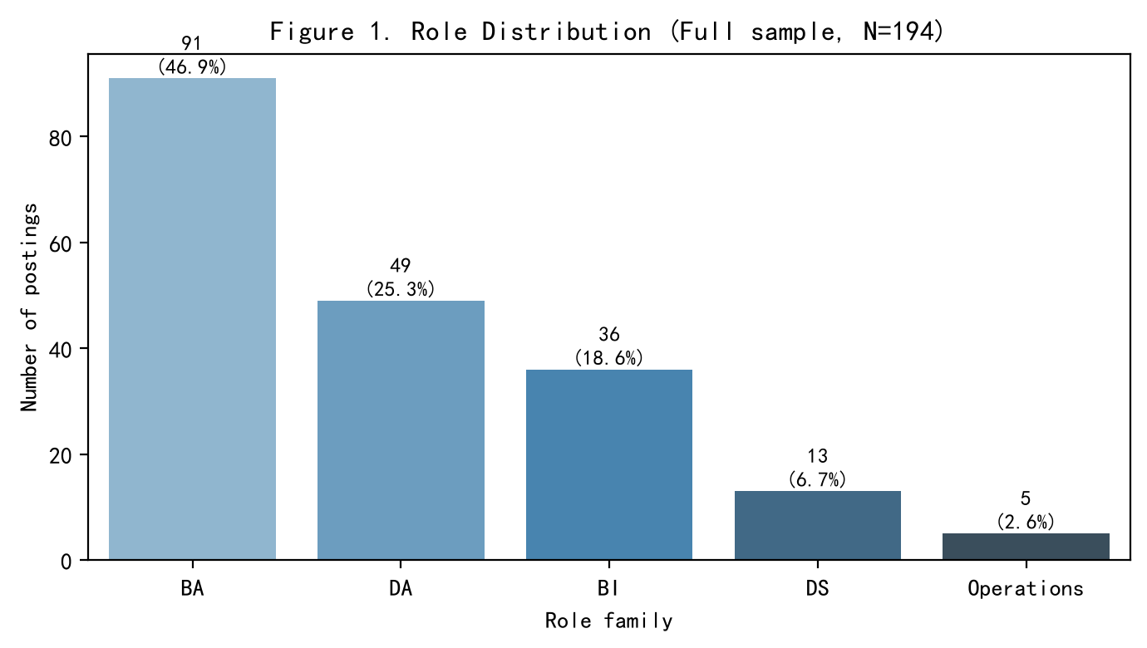
Figure 1. Role Distribution (Full sample, N=194)
As shown in Figure 1, the Chinese BA job market in our sample is heavily dominated by Business Analysts (BA, 46.9%) and Data Analysts (DA, 25.3%), which together account for over 70% of the postings. Specialized roles like Data Scientists (DS) account for only 6.7%. This suggests that for WKU students in BA, focusing on general BA or DA foundational skills aligns with most market demands.
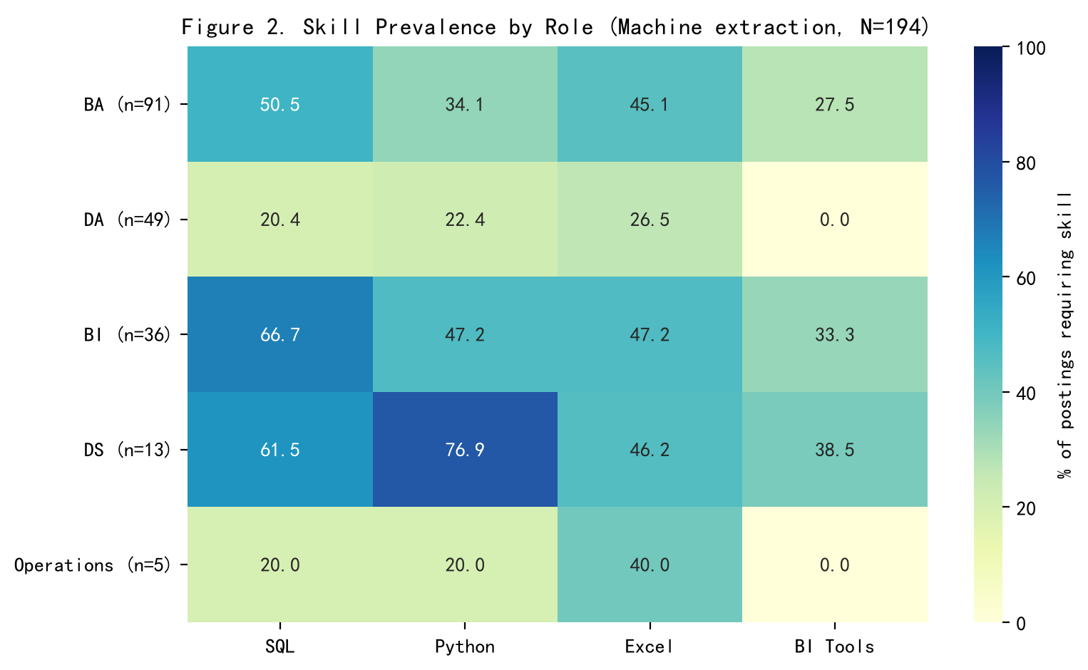Figure 2 Skill Prevalence by Role(Machine extraction, N=194)
- Data Scientists (DS) represent the most technically demanding track, with an overwhelming 76.9% requiring Python and 61.5% requiring SQL.
- BI Analysts prioritize database and visualization capabilities, showing the highest demand for SQL (66.7%) and a notable 33.3% requirement for BI Tools.
- Business Analysts (BA) rely heavily on traditional office tools (Excel: 45.1%) and SQL (50.5%), and 34.1% mentioning Python.

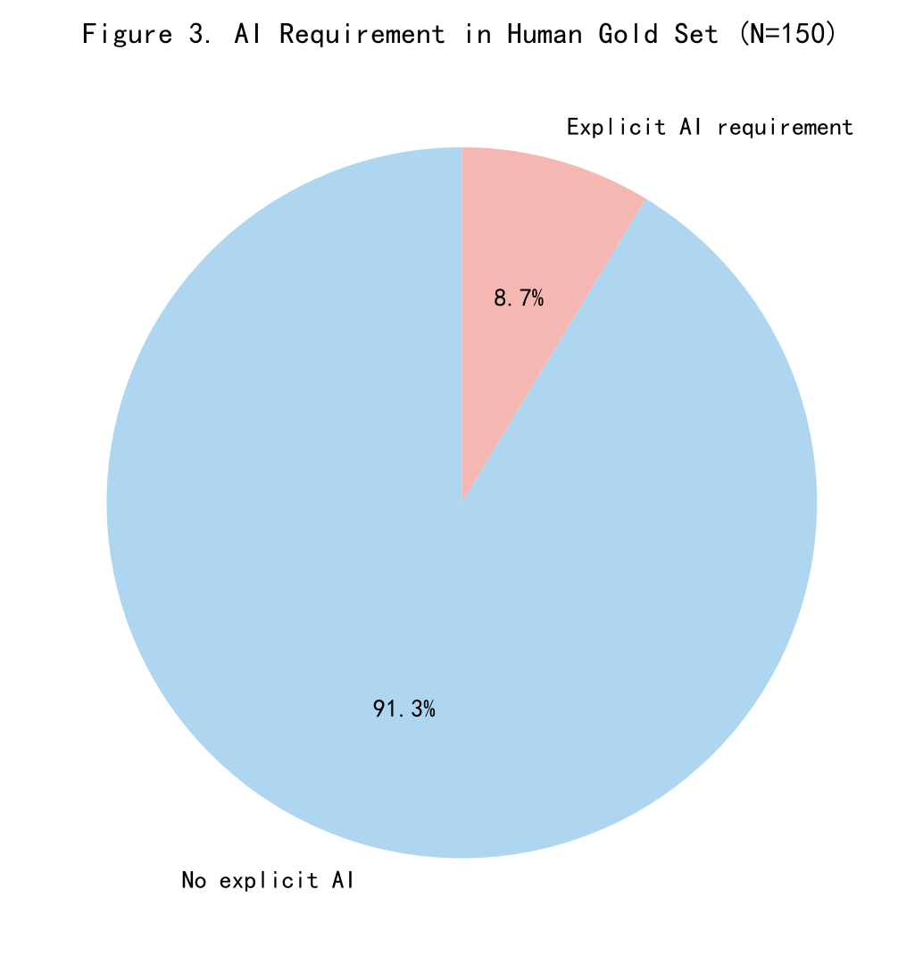
Figure 3. AI Requirement in Human Gold Set（N=150）
Despite the industry hype surrounding generative AI, our validated human-coded data tells a different story. As shown in Figure 3, only 8.7% of job postings explicitly require AI skills. The vast majority (91.3%) do not treat AI as a hard requirement. This strongly indicates that for the Chinese BA job market, foundational competencies (SQL, Excel, business acumen) remain the decisive factors for employment. At present, mastering AI is more of an "enhancement factor" rather than a core requirement.

5.Working answer
Current Conclusion:
Based on our validated dataset, we currently believe that while generative AI is a prominent topic in the Chinese job market related to BA, it is not yet a strict prerequisite for most BA roles. The market remains highly segmented and fundamentally traditional:
- Core Skills Dominate: SQL, Excel, and BI tools (e.g., Tableau, Power BI) remain the absolute baseline requirements for DA and BI roles.
- AI is an advantage, but not a necessity：Hard requirements for AI skills are surprisingly low (around 8.8% in the full dataset, and likely lower due to machine extraction overestimating "nice-to-have" mentions). When AI is requested, it is often expected of Business Analysts to improve daily productivity, rather than demanding heavy coding or model training.
Evidence that would prove us wrong:
Our conclusion is limited by the cross-sectional data from 2026, the data volume, and the limitations of manual collection. Our conclusion will be overturned if the following circumstances occur:
- The shift in the AI landscape: Future time series analysis reveals that the demand for BA positions to possess AI skills(e.g., Prompt Engineering or Large Model API Integration) has suddenly skyrocketed.
- Sample is Heavily Biased: Among the data we have collected, there is a lack of understanding of the demand for positions in traditional industries, including those in state-owned enterprises. The demand for AI skills in these enterprises may be higher or lower than is currently known from our sample. All of this will lead to problems with the conclusion.
- Technical Validation Failure: If a more advanced NLP model (e.g., zero-shot LLM classification) applied to the same JDs reveals that our Regex-based F1 score (0.414) missed a massive number of actual AI requirements, indicating our current 8.8% estimate is vastly underestimated.

AI use log：
Tool | Task | What the AI produced | Verification
DeepSeek | Discussing the limitations of our Regex-based extraction and exploring how a "Zero-shot LLM classification" could perform differently in future studies | (Section5) Explanations of why Regex struggles with semantics (e.g., failing to understand negation like "AI is a plus") and how LLMs could better capture implicit AI requirements that our dictionary missed. | We cross-referenced the AI's theoretical explanation with our empirical data. Specifically, we checked if the AI's description of Regex limitations matched our actual False Positive cases and our computed F1-score of 0.414.

