Group 3
Ambition and consequences

In-game Animations

General Information

- You might see some Toe markers wobble; the shoes were a bit long on both actors, so we have some natural wobbles.
- In gameplay shots, Itm_Thrw_Improv and Itm_Rngd_Improv, the item that's being thrown would have a different range based on the in-game target, so the item in our shot is “cut” at set frames as it is not relevant.

Cinematic

Shot_5
Just wanted to mention we weren’t sure how the rule of no cleaning objects that aren’t in camera view worked in this particular shot, since there’s technically an invisible wall in the frame that blocks said object (Pelle standing cross-armed in another room waiting for Ray) were it to be an actual rendered cinematic. But we tried our best cleaning Pelle anyways.
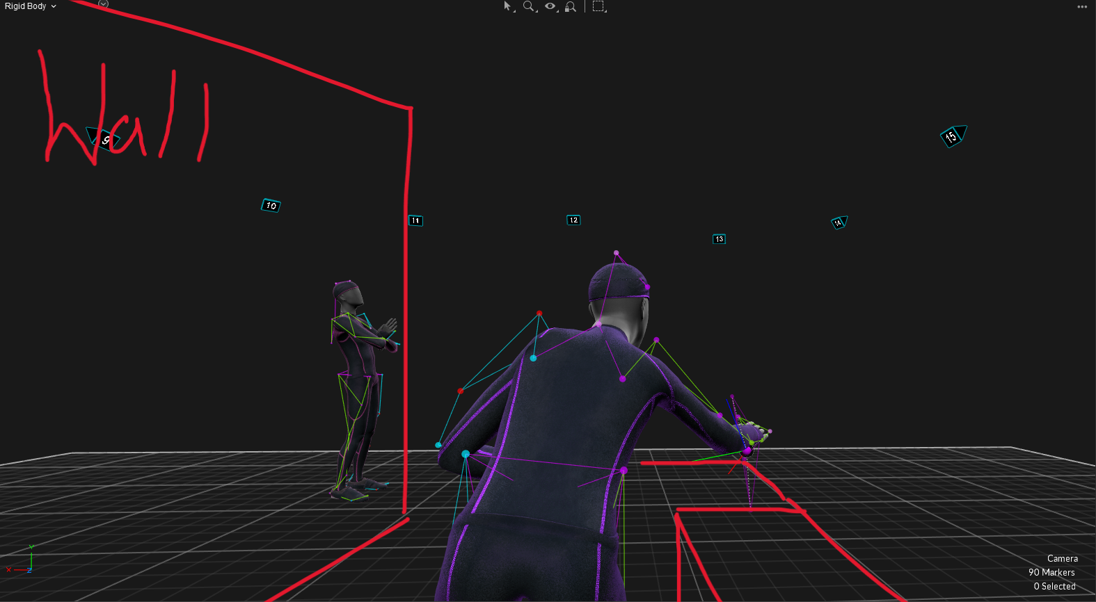

Shot_17 - Alex A.
Recap: It is the last shot in the cinematic, where the MC lands on the ground, gets up, and tries to escape the facility/event. We made a lot of mistakes with that shot, considering our knowledge and experience at the time. Overall, it took around 6 to 7 hours of cleaning and reconstructing.
What went wrong: We decided to use a red mat to simulate the bushes the actor fell onto and to make the experience more comfortable for the actor on a soft surface. Using the red mat was not a good idea at all, not only because it is already hard to film while the actor is on their back and the cameras cannot see the markers, but also because of the height and softness of the mat, which meant the software (Motive) couldn't calculate the correct depth of the markers and the actor. The back waist markers (both right and left), the back markers (both right and left), and the left leg markers (LShin and LKneeOut) got occluded or were not visible at all, so they were nearly impossible to reconstruct.
Solution: By manually restoring frame by frame using “Set Key”, I got an okay result, so that at least the software could tell where the markers belong. I used 3 steps to do it better:
- Find a missing marker - Set Key, and check if that location corresponds to reality
- When I was done with Setting keys, I deleted some posts to use pattern-based reconstruction to give an idea where markers should go
- I was repeating step 2 with other markers that were missing if needed
  - Used both 20Hz and 6Hz smoothing.
What we could do better: We could have used a blue mat or just the floor if the actor was comfortable with that. With a bit more time, we could have reshot it and/or recorded more takes to choose from. We did film several takes, and Shot_17_002 was the best compared to the others.
Shot_8
Ray LUArmHigh likes to move around 1593 after reconstruction. I tried the available methods, I managed to get it to a more acceptable level, but it still moves a bit.

In the future, we would reshoot this scene in a way where the actor has less floor time and ask him to move his arms slightly so the cameras can see it better.

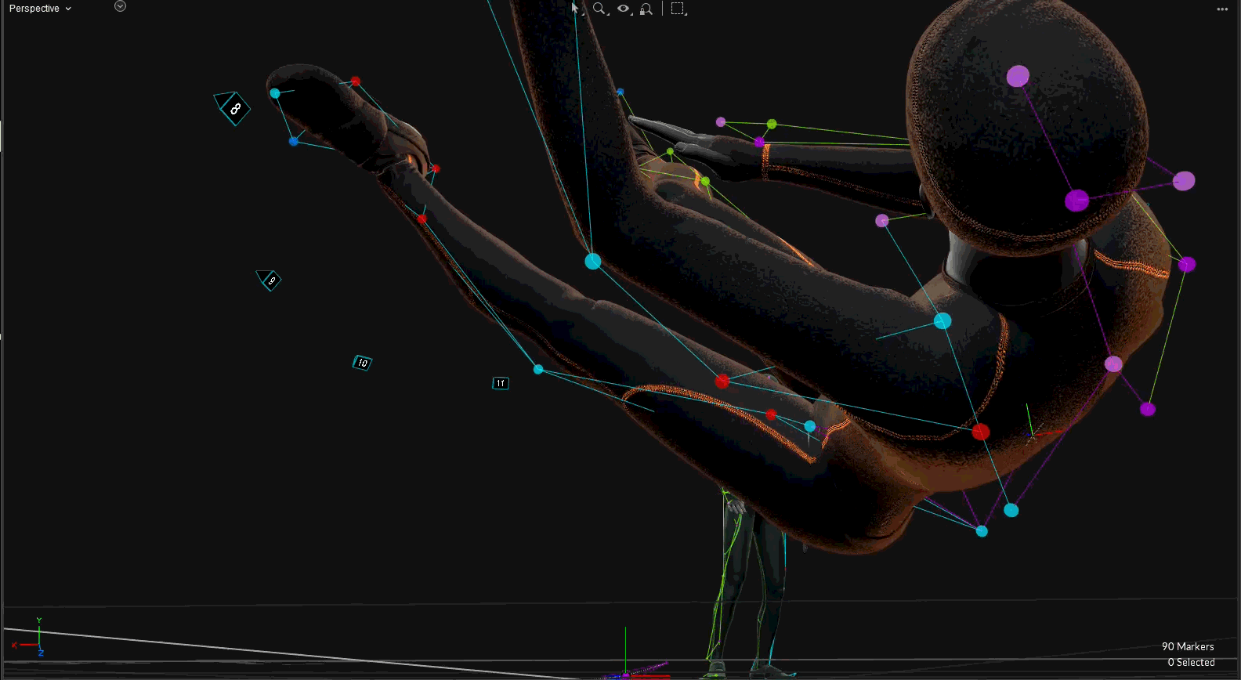

Shot_12
Ray WaistLFront and LThigh are awful, I think there is a point where they are mislabeled and mistaken for one another, but they don't want to reconstruct well.

Waist reconstruction seems to put the markers too far down but since both front markers and the thigh is gone it reconstructs quite badly from pattern based and there is impact in the movement so cubic ends up drifting a lot.

I would also reshoot this and just have the actors stand up quickly instead of doing more actions from a kneeling position.



