|  |  |
| --- | --- |
| Static Polymorphism | Dynamic Polymorphism |
| 1. Static polymorphism is a type of polymorphism that collects the information to call a method during compile time | **1. Dynamic polymorphism is a type of polymorphism that collects information to call a method at run time** |
| 2. Synonyms of static polymorphism are static binding and early binding as the compiler knows at compile time which method is to be executed. | **2. Dynamic binding and late binding are synonyms of dynamic polymorphism as JVM determines the method to be executed at runtime instead of compile time.** |
| 3. Static polymorphism occurs at compile time because overloaded method calls get resolved at compile time by the compiler on the basis of the argument list and the reference on which we are calling the method. | **3. Dynamic polymorphism occurs at run time** |
| 4. The execution speed is high in static polymorphism because the method that needs to be executed is known early at the compile time. | **4. Execution speed is low in dynamic polymorphism because the method that needs to be executed is known at the runtime.** |
| 5.Compile time polymorphism is less flexible as all things execute at compile time. | **5. Run time polymorphism is more flexible as all things execute at run time.** |
| 6. Inheritance not involved for static polymorphism as  it happens in the same class. | **6. Inheritance involved for dynamic polymorphism as happens between different classes.** |
| 7. Method overloading is an example of static binding | **7.  method overriding is an example of dynamic binding.** |

**Static Polymorphism:**

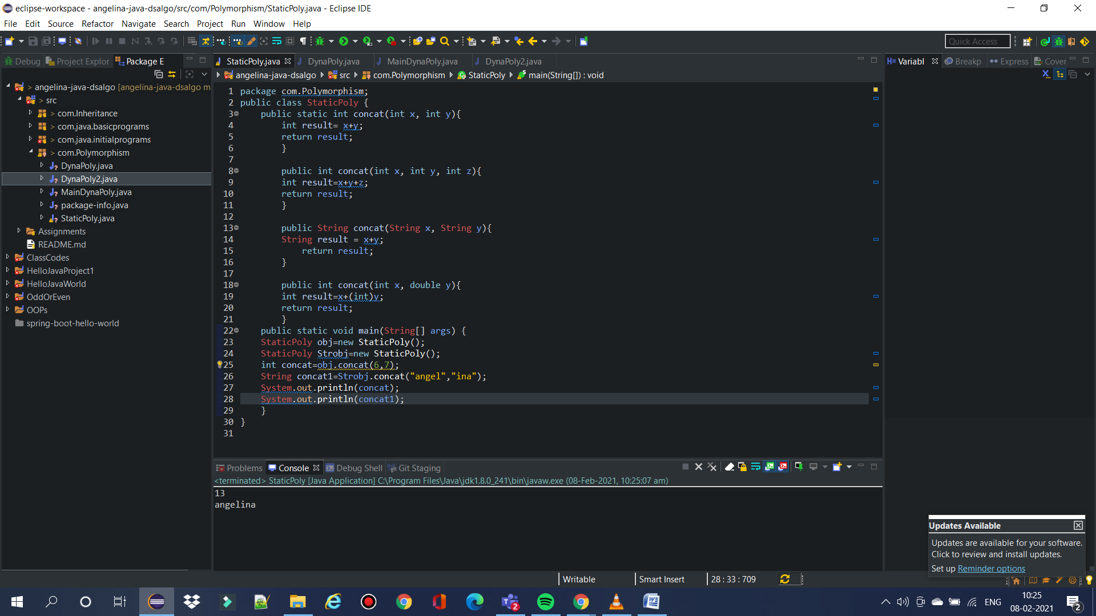

**Dynamic Polymorphism:**

