Project 2 – Website Proposal

Client and Topic
My final website project will be a website for a fictional small business called Happy Tails Dog Daycare & Boarding in Stafford, Virginia. The business will provide dog daycare, overnight boarding, and grooming services for local pet owners. The website will explain the services offered, provide pricing and admission requirements, display photos of the facility, answer common questions, and provide a Contact & Booking page where customers can request services or ask questions.

Development Process and Engagement
I am creating this website for a fictional business rather than an actual client. To develop realistic content, I will research existing dog daycare and boarding businesses to learn what services, policies, and information customers commonly expect to find. I will compare their websites to identify effective navigation, page organization, and design choices. I will also research common vaccination requirements, intake procedures, boarding policies, grooming services, and pricing structures. Since I have experience owning dogs, I can also use my own knowledge of the concerns pet owners may have when choosing a daycare or boarding facility. This research will help me create useful and believable content for the website.

Testing
Before launching the website, I will ask family members and friends who own dogs to review it and provide feedback. I will have them complete common tasks, such as finding daycare prices, reviewing admission requirements, locating contact information, and submitting the Contact & Booking form. I will ask whether the website feels trustworthy, whether the navigation is easy to understand, and whether the information on each page answers the questions they would have as pet owners. I will also review all links, images, buttons, and form fields to make sure they work as expected. The website will be tested in Chrome, Microsoft Edge, Firefox, and Safari to confirm that the layout and features work consistently across browsers.

Description
Happy Tails Dog Daycare & Boarding is a fictional small business located in Stafford, Virginia. It provides dog daycare, overnight boarding, and grooming services. The purpose of the website is to introduce the business, explain its services, provide pricing and policy information, answer common questions, and provide a Contact & Booking page where customers can request services or ask questions.
The target audience is adult dog owners in Stafford and nearby communities. This includes working professionals who need daytime care, pet owners who need boarding while away, and elderly or disabled individuals who may need assistance grooming their dogs. These users will likely want clear information about safety, services, prices, requirements, and how their dogs will be cared for.
The audience will influence the website’s design by encouraging simple navigation, readable text, clear page headings, and easy access to pricing and the Contact & Booking page. The design will use friendly images and a welcoming appearance to help the business seem trustworthy.
I will create the written content and layout. I will create the written content and page layout. Royalty-free images and publicly available information about dog daycare services will be used when needed and credited when required. The website will be updated whenever services, prices, hours, policies, or contact information change.

Growth and Maintenance
As the business grows, the website can grow with it by adding new services, customer testimonials, seasonal promotions, or additional photo galleries. If the business expands to another location or offers online appointment scheduling in the future, those features can be added without redesigning the entire website.
While developing the website, I will use a consistent page layout, navigation menu, file naming system, and CSS stylesheet. Organizing files and using reusable styles will make it easier to update the website later without having to edit every page individually.
Maintaining the website will include checking for broken links, missing images, and ensuring the Contact & Booking form functions correctly on a monthly basis. Business information, such as services, pricing, business hours, and contact information, will be updated whenever changes occur. New photos, promotions, and other content can be added every few months or as needed to keep the website current and engaging.

Organization
The website will use a hierarchical organization with a consistent navigation menu displayed at the top of every page. The main navigation will include Home, About Us, Services, Pricing, Gallery, FAQ, and Contact & Booking. The Services menu will contain separate pages for Dog Daycare, Boarding, and Grooming. Organizing the services under a single menu keeps the navigation clean while making it easy for visitors to find the information they need. The website map and wireframes below illustrate the planned navigation structure and page layouts for the website.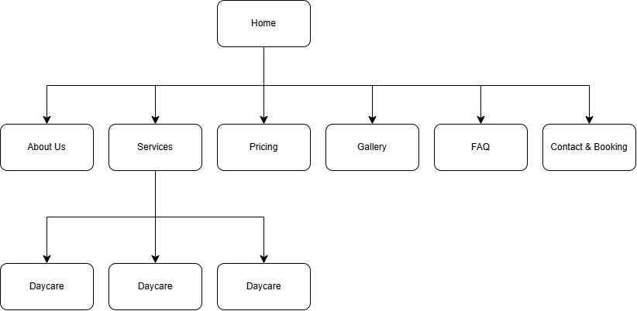Sitemap
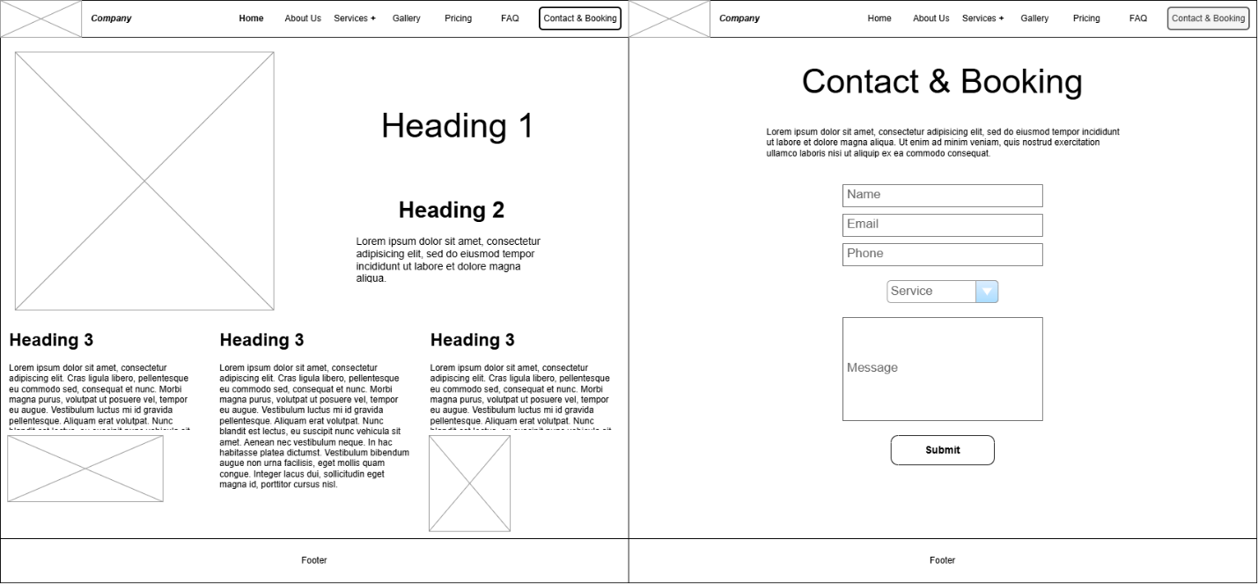
Wireframe: Homepage and Contact & Booking Page

Security
The website will not include an e-commerce component because customers will not make payments online. The Contact & Booking form will only allow visitors to request a service or ask a question. No content will be password protected because the website is intended to provide public information about the business, services, pricing, and policies. Users will also not need to create accounts because bookings will be reviewed and confirmed directly by the business.
As the website developer, I can help secure the site by using HTTPS, validating form input, adding spam protection, keeping files and software updated, and limiting access to submitted customer information. Customer contact information should only be accessed by authorized employees and should not be shared with third parties. A privacy policy will explain how information is collected, used, and protected.

Web Hosting
I will compare a few web hosting providers based on price, reliability, security, customer support, and storage. Since this is a small business website, I want a host that is affordable but also has good uptime and includes an SSL certificate. I'll also look at reviews and make sure the host has enough storage for images and other website files. The website will need an SSL certificate to protect information submitted through the Contact & Booking form. It will also need form processing and basic spam protection. Since customers won't pay online, the website won't need a shopping cart or payment system.
The website will use HTML, CSS, and JavaScript, so the web host will need to support those technologies. If the contact form uses a server-side language like PHP, the host should support that as well.
A domain name like HappyTailsStafford.com would work well because it includes the business name and location, making it easy for customers to recognize and remember. I would check that it is available before registering it.

Marketing
The website will be marketed through social media platforms such as Facebook and Instagram, where the business can share photos of dogs, promotions, and updates. The business could also create a Google Business Profile so local pet owners can easily find it through Google Search and Google Maps. Flyers, referrals, and customer reviews could also help attract new customers.
To improve SEO, the website will use descriptive page titles, headings, and keywords related to dog daycare, boarding, and grooming in Stafford, Virginia. Images will include alt text, and the website will have clear navigation and fast-loading pages. Keeping the content updated and using a descriptive domain name will also help improve search engine rankings.

