# Angular: Getting Started

# By Deborah Kurata

## Introduction

Angular is a JavaScript framework for building clint-side applications.

Angular advantages:

- Expressive HTML;

- Powerful Data Binding;

- Modular by Design;

- Build-in Back-End Integration.

In Angular an application is comprised of a set of components and services that provide functionality across those components.

Component = template (UI view) + class (properties and methods) + metadata (additional information about the component for Angular).

## First Things First

What we need to install:

- node.js, which also installs npm;

- Angular CLI.

ng new my-first-project //create new project

dir //see the list of created files

code . //to open in vs code

ng add lint or npm install bootstrap//to add package

ng serve -o //to build and open in browser

In package.json you can see scripts

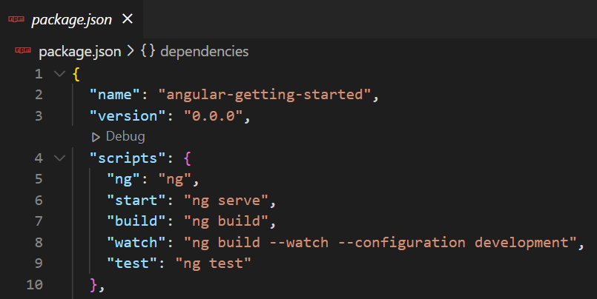

If you’ll write npm start it will execute ng serve.

## Introduction to Components

Metadata is extra data for Angular and is defined with decorator.

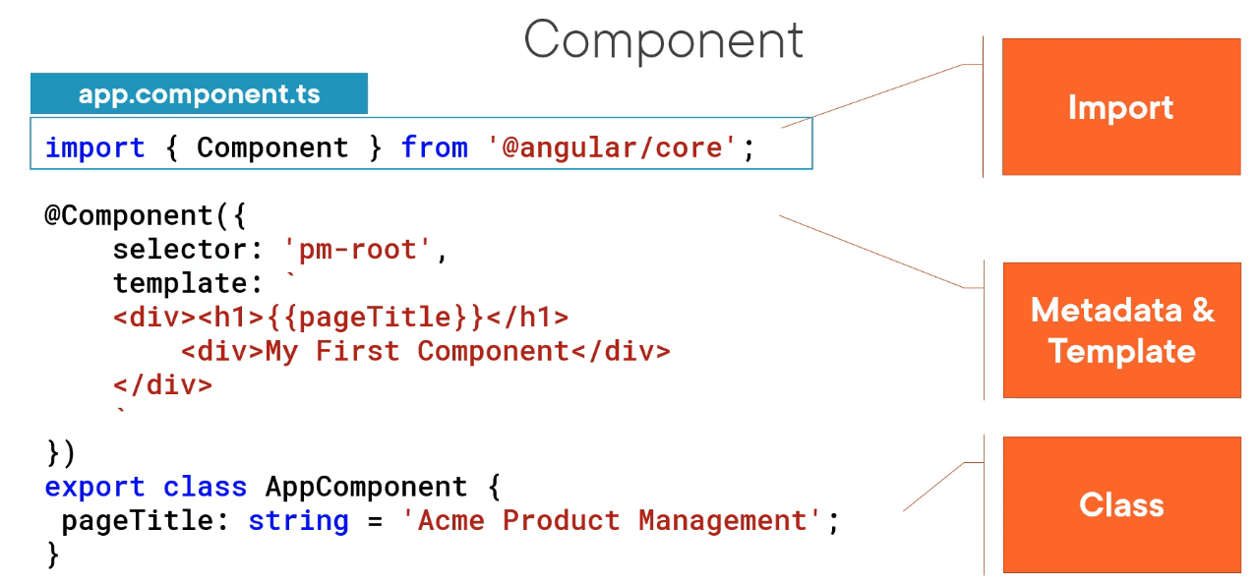

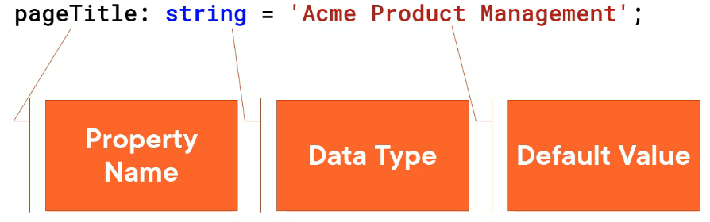

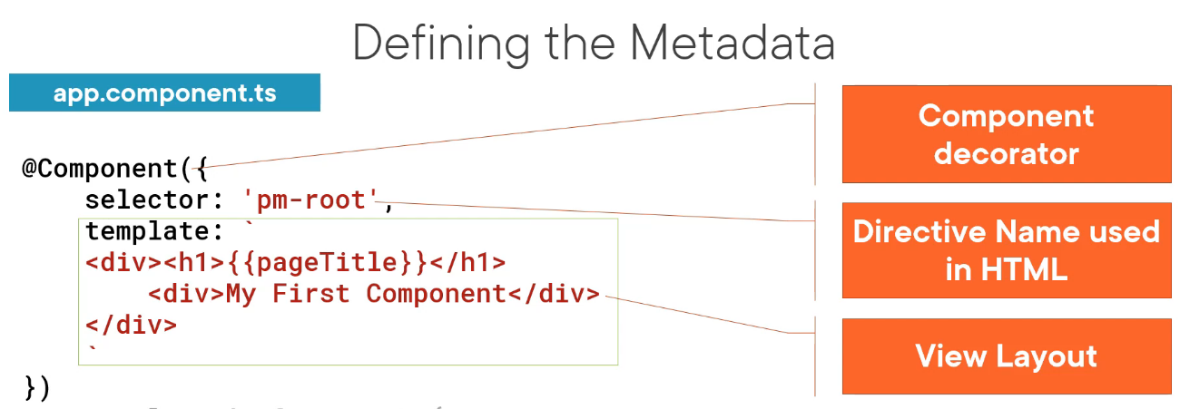

Decorator – a function that adds metadata to a class, its members, or its method arguments. Has prefix @. Angular provides build-in decorators @Component().

An Angular application is often called a Single Page Application (SPA).

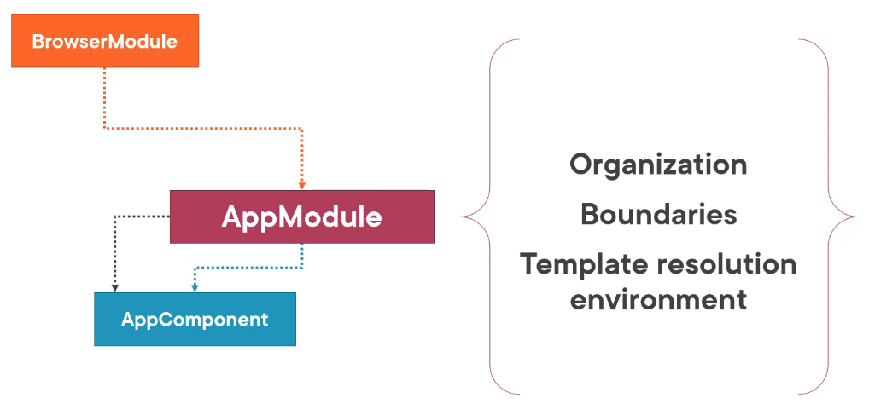

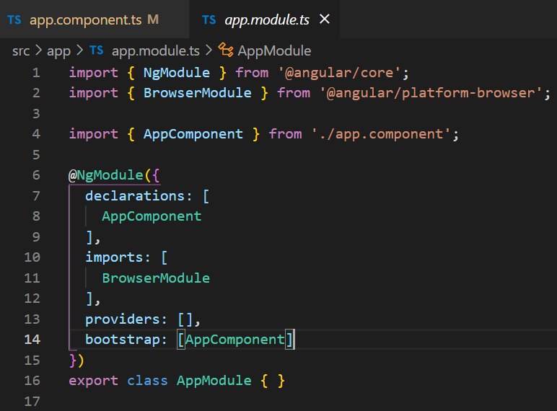

Bootstrap array lists AppComponent as the starting component for application.

## Templates, Interpolation, and Directives

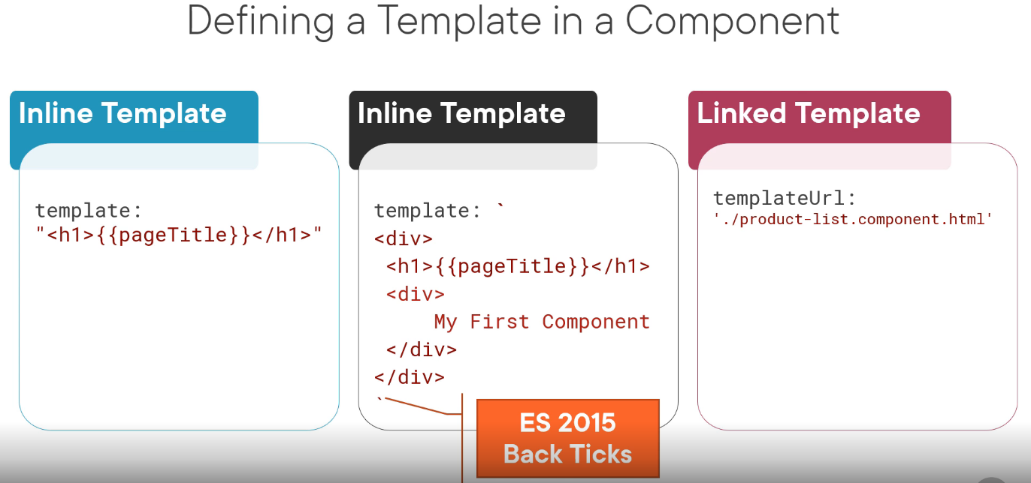

In src folder there are global html and css files.

Binding coordinates communication between the component’s class and its template and often involves passing data.

Interpolation is one-way binding.

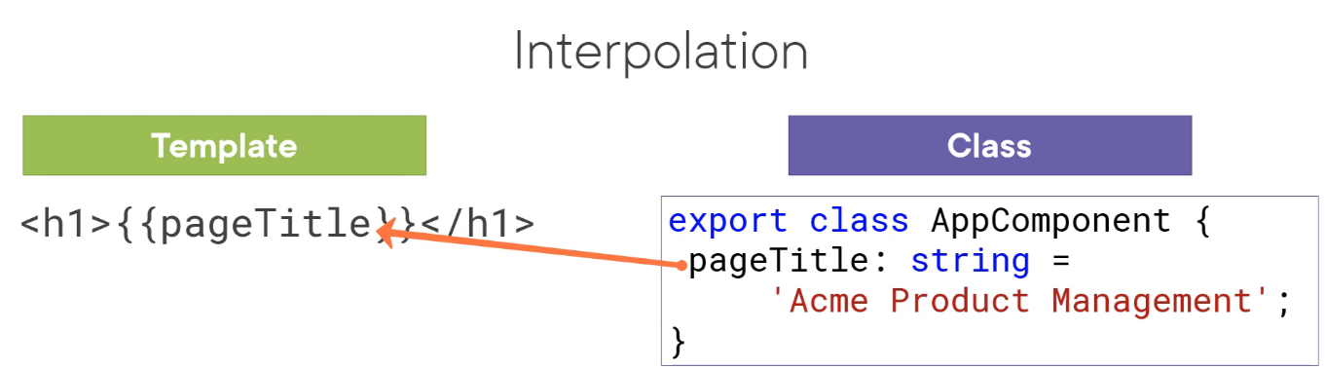

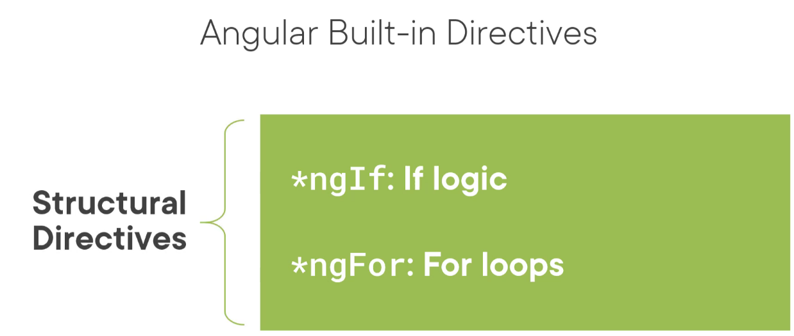

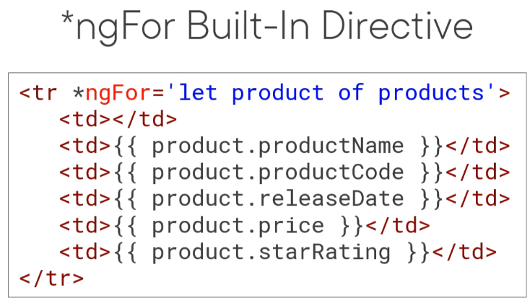

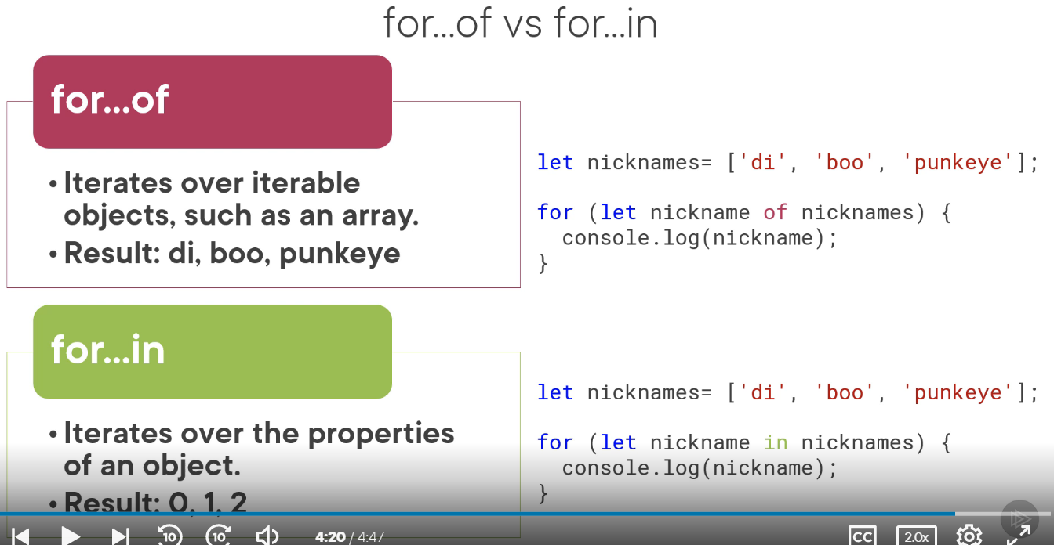

## Data Binding & Pipes

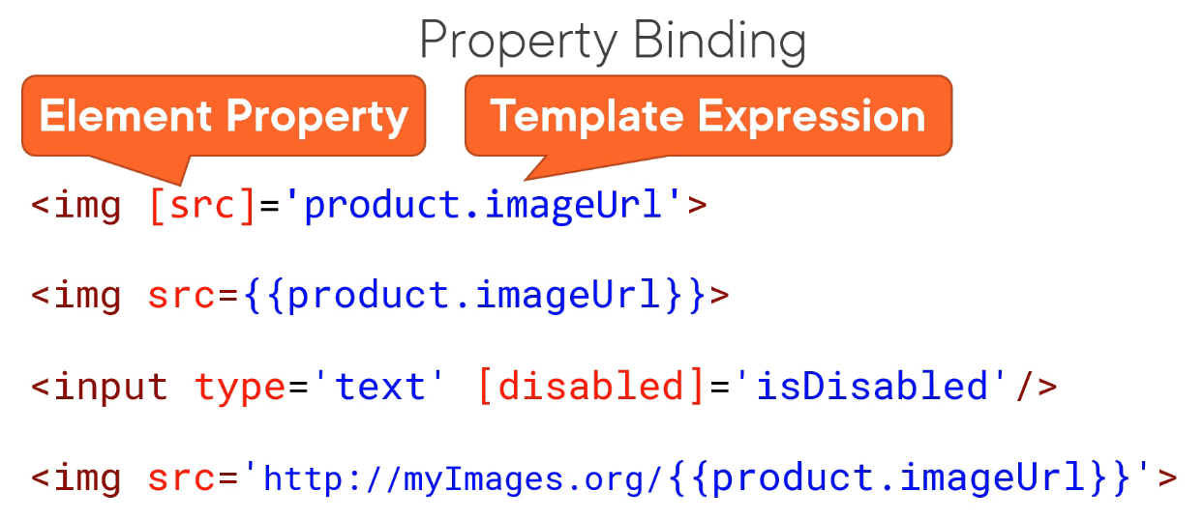

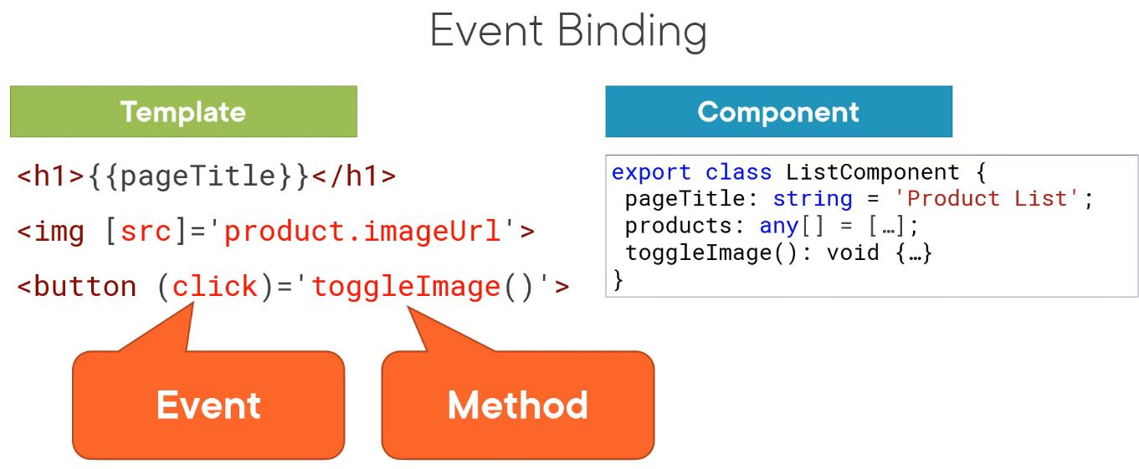

All events are listed here: <https://developer.mozilla.org/en-US/docs/Web/Events>.

We enclose ngModel in square brackets to indicate property binding from the component to the input element and parentheses to indicate event binding to send a notification of the user-entered text back to the component.

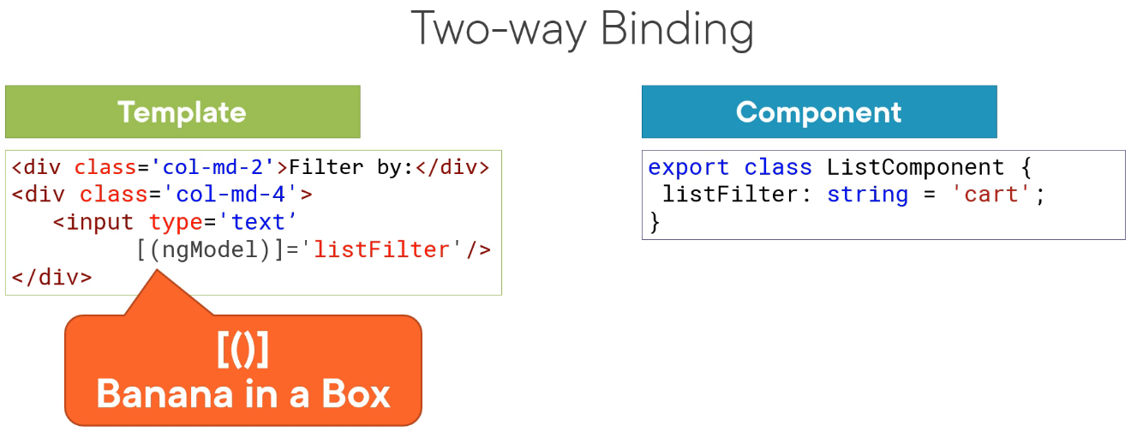

!!! For ngModel you must import { FormsModule } from '@angular/forms'; and write it to imports in app.module.ts.

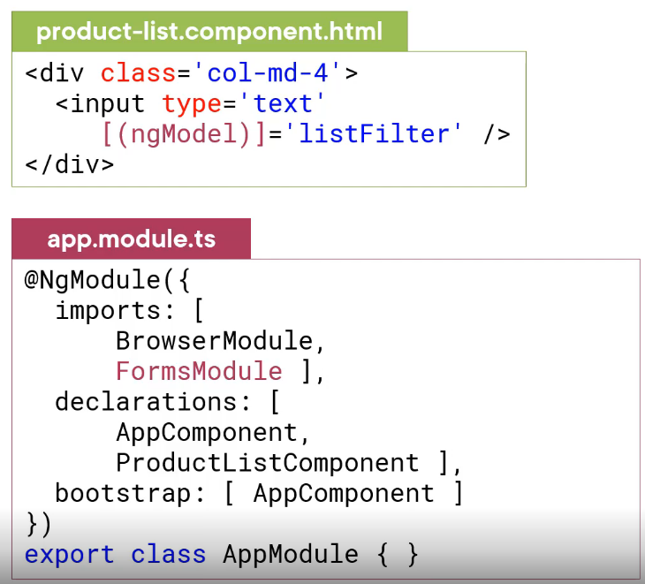

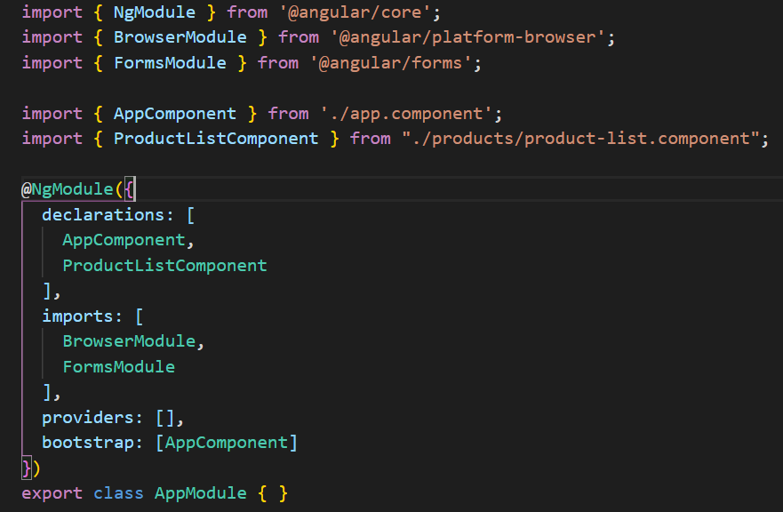

Declarations – our

Imports – other sources

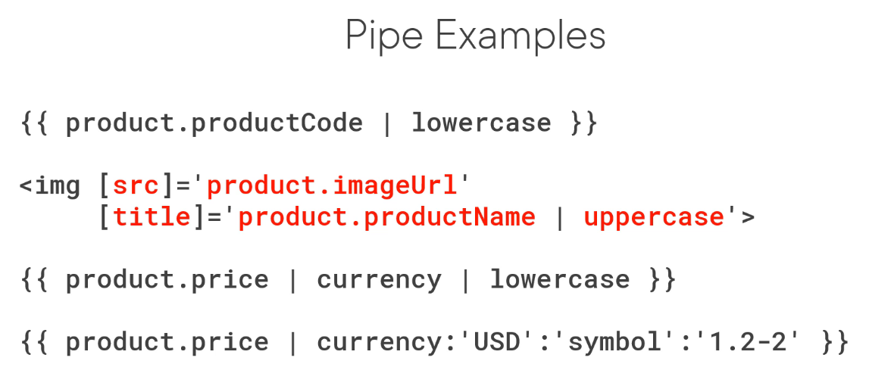

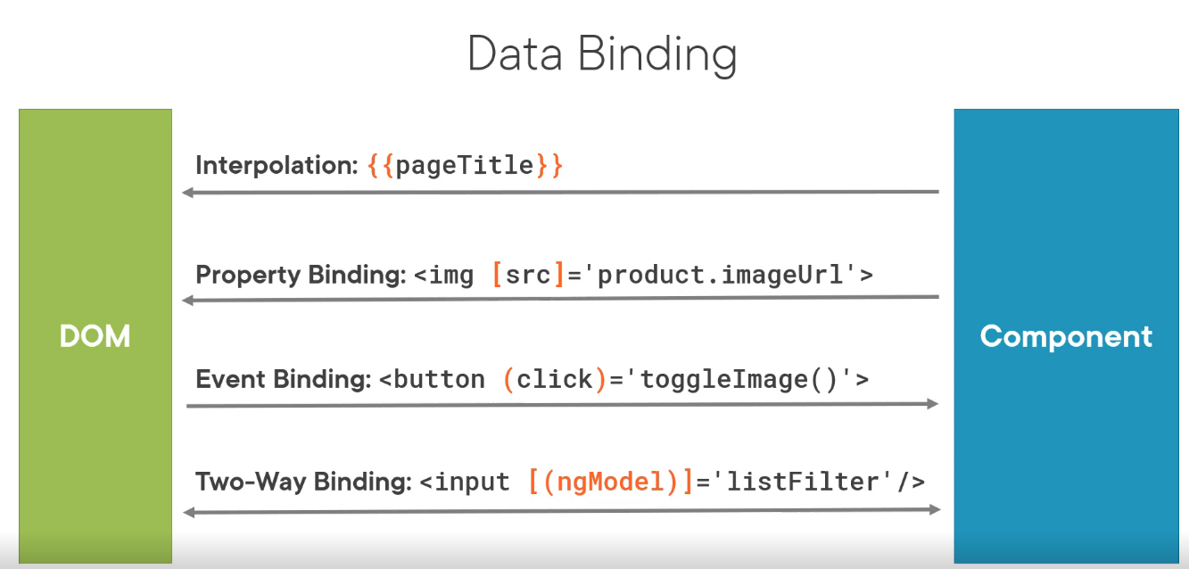

## More on Components

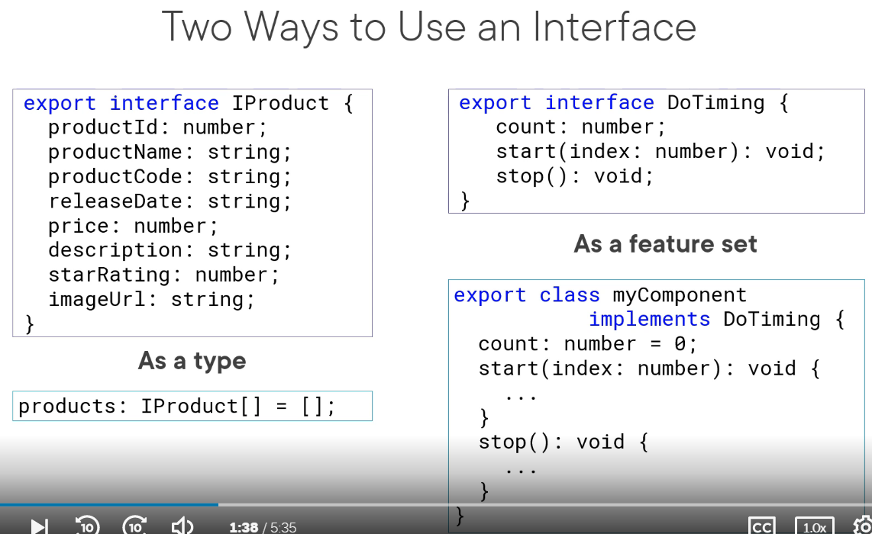

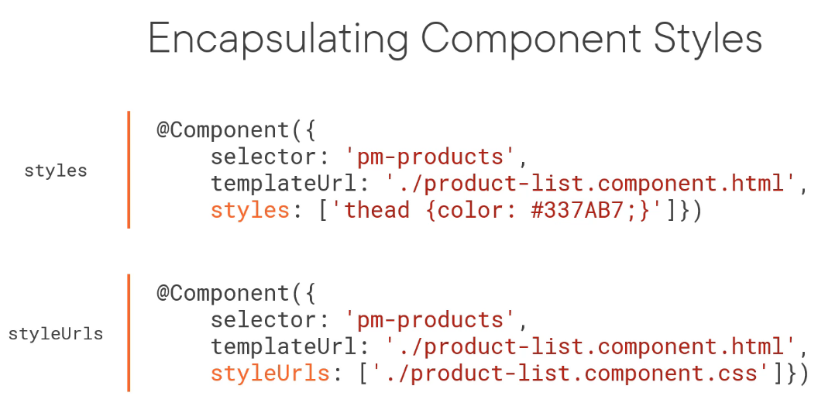

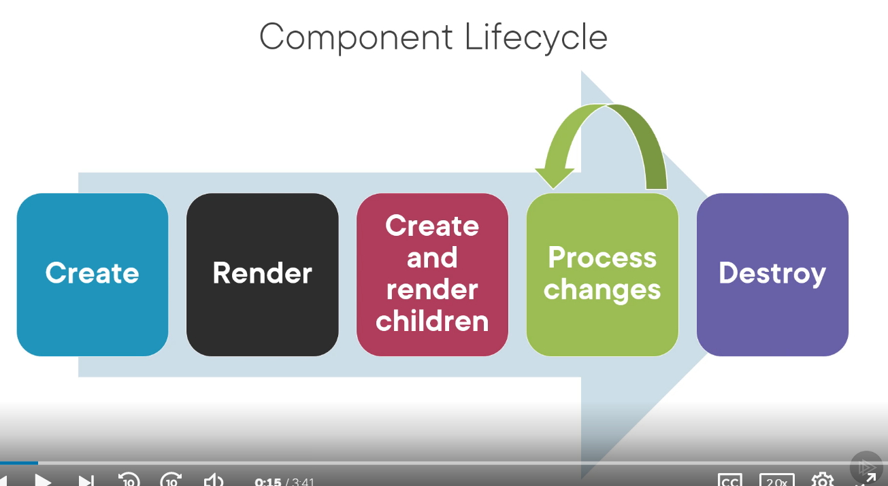

A lifecycle hook is an interface we implement to write code when a component lifecycle event occurs.

