Run 1:

      epochs: 50,

      learningRate: 0.2,

      hiddenUnits: 8,



Run 2:

      epochs: 50,

      learningRate: 0.2,

      hiddenUnits: 8,

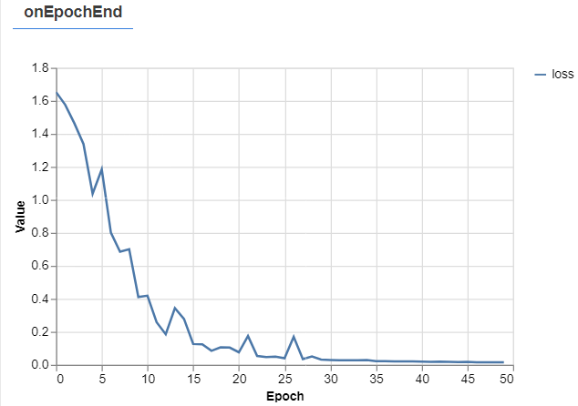



Run 3:

      epochs: 50,

      learningRate: 0.2,

      hiddenUnits: 8,

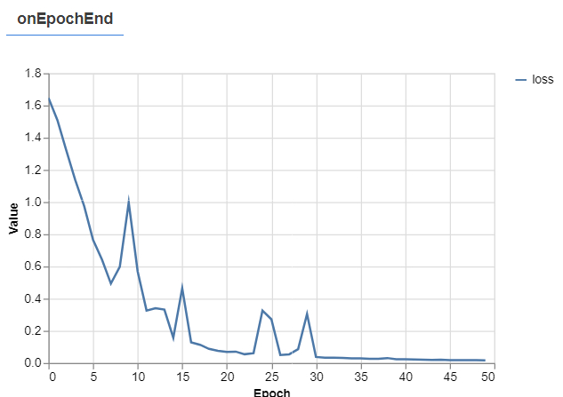



Run 4:

      epochs: 50,

      learningRate: 0.1,

      hiddenUnits: 16,

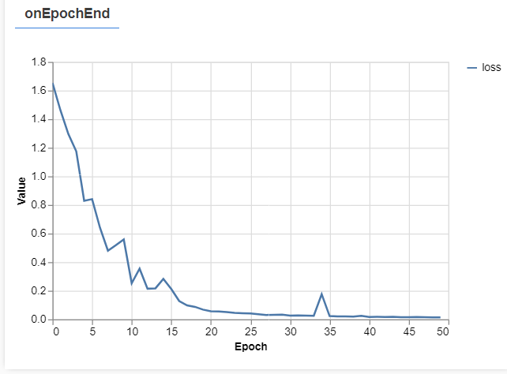



Run 5:

      epochs: 50,

      learningRate: 0.1,

      hiddenUnits: 16,

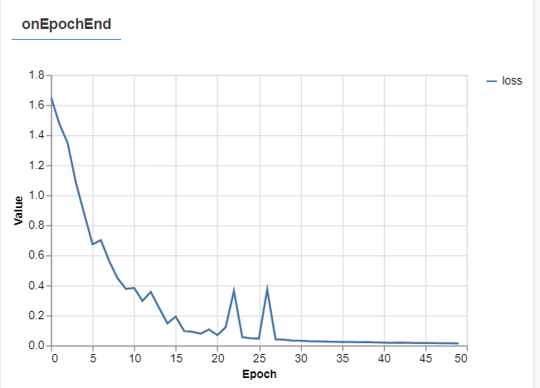



Run 6:

      epochs: 50,

      learningRate: 0.1,

      hiddenUnits: 16,

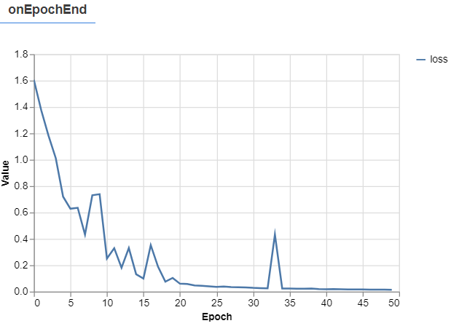



Run 7:

      epochs: 50,

      learningRate: 0.8,

      hiddenUnits: 4,

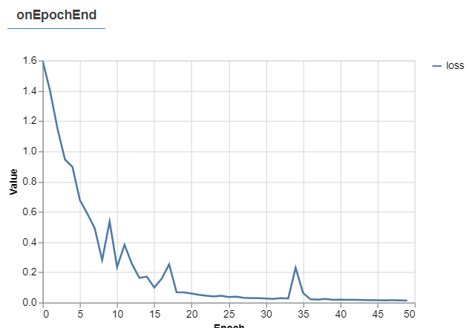 

Run 8:

      epochs: 50,

      learningRate: 0.8,

      hiddenUnits: 4,

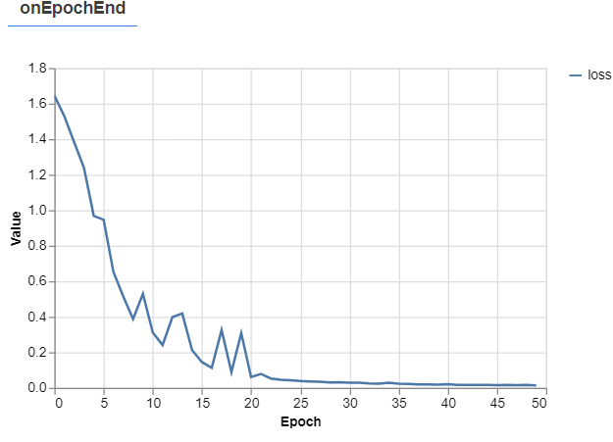 

Run 9:

      epochs: 50,

      learningRate: 0.8,

      hiddenUnits: 4,

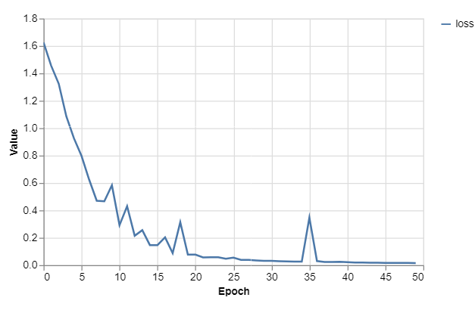



AI settings run 1-3 avg accuracy: 87.78%  
AI settings run 4-6 avg accuracy: 86.82%  
AI setting run 7-9 avg accuracy: 88.33%

Notes:

The 400-600 section seems to consistantly be misinterperated by the AI.

Actions taken:

* Made it label all the poses it got wrong
  + Was mostly run-right



Changes:  
 -Deleted all my learning data for run-right (-222 entries)  
 -Added new data (+403 entries)  
  
Results from changes:

Run 1:

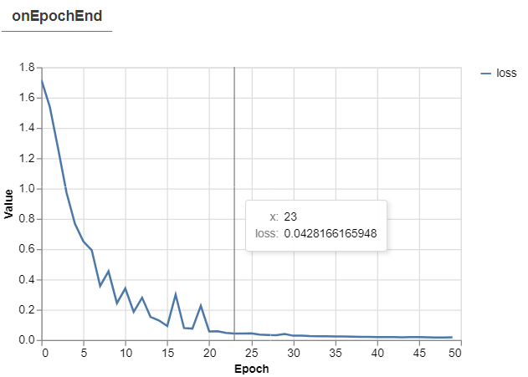

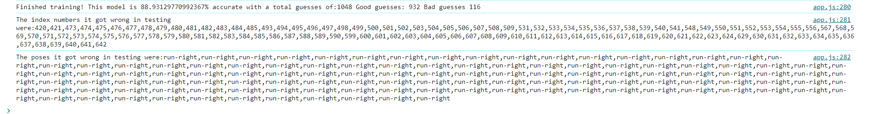

Run 2:

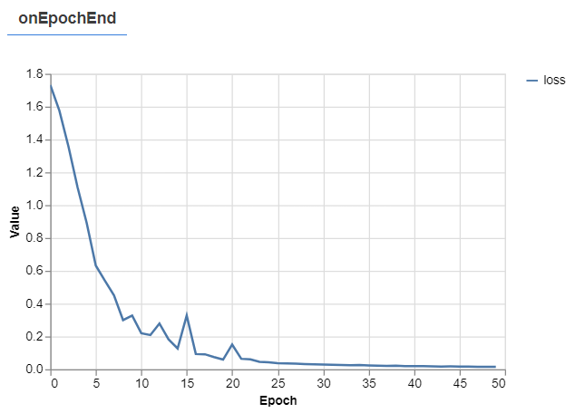 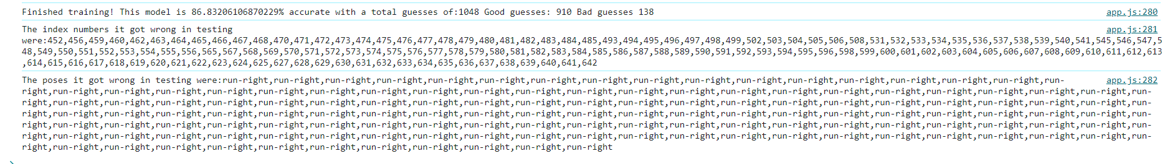

Run 3:  
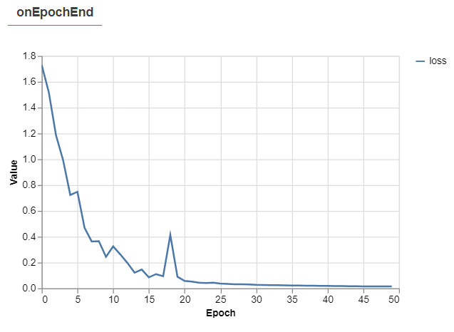 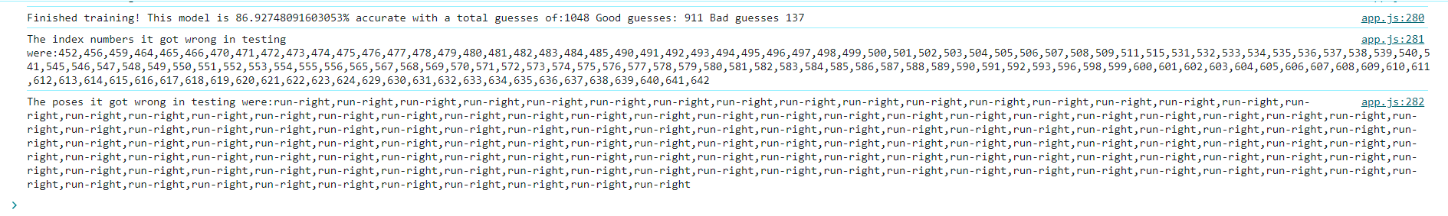

Results changes:

Avg accuracy: 87.56%  
  
Notes:  
Replacing trainingdata had minimal changes in accuracy, testing data is presumably the problem.  
Replacing trainingdata had minimal changes in training, spikes feel as common as usual and in both cases it breaks the 0,2 around 10-15 consistantly.  
  
NEW CHANGES:  
Replaced run-right training data to see if training data is bad. (-223 / +403)

RESULTS NEW CHANGES:

Run 1:

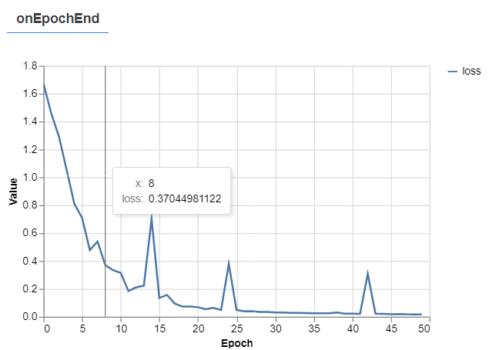



Run 2:

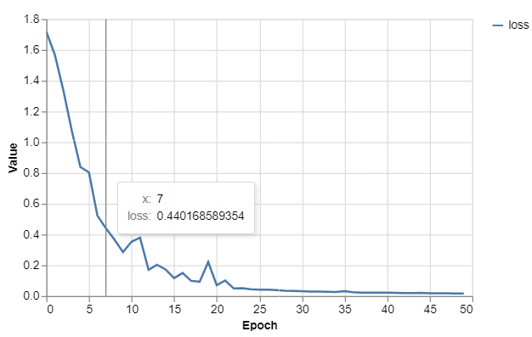



Run 3:

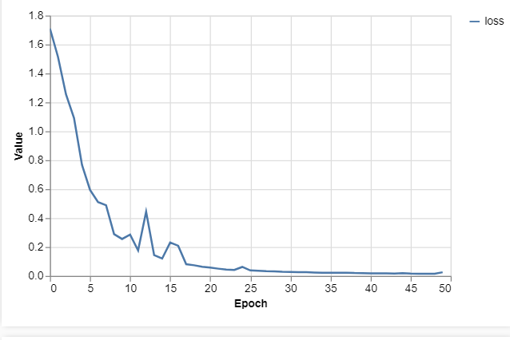  


Cause for suspicious high accuracy: Accidentally copied the new training data for run-right in the test-data instead of the new test data. Fixed this. (-403 / +310)  
  
NEW NEW RESULTS”

Run 1:

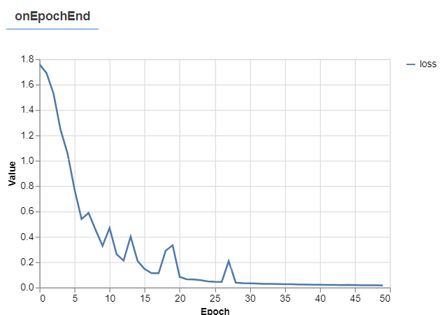

  
  
Run 2:

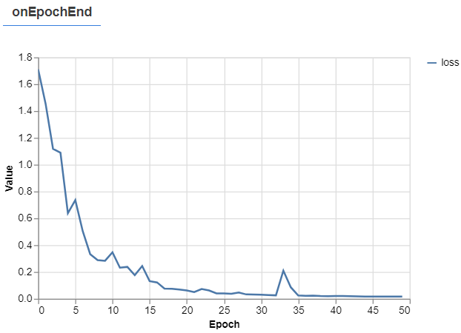



Run 3:

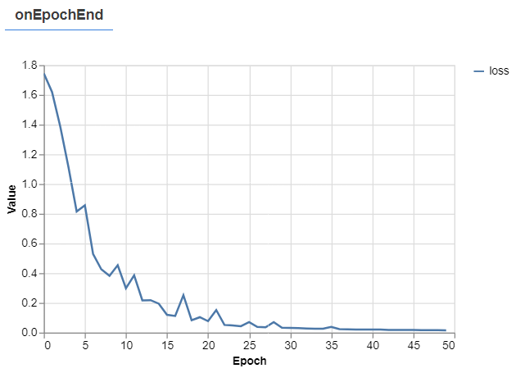 

Avg acc: 100%

Cause: I build the best machine learning thing to ever exist.

Real cause: Unknown.