**Class Diagram:**

This class diagram models a recipe-sharing platform where **Regular Users** and **Administrators** interact with recipes, comments, ratings, challenges, and notifications.

**Key Relationships:**

* **User** can post multiple **Recipes**, leave multiple **Comments** and **Ratings**, save **Favorite Recipes**, and receive multiple **Notifications**.
* **Recipe** can receive multiple **Comments** and **Ratings** and trigger **Notifications**.
* **User** can participate in multiple **Challenges**, and a **Challenge** can have multiple participants.
* **Admin** manages user accounts, moderates content, and oversees **Challenges**.

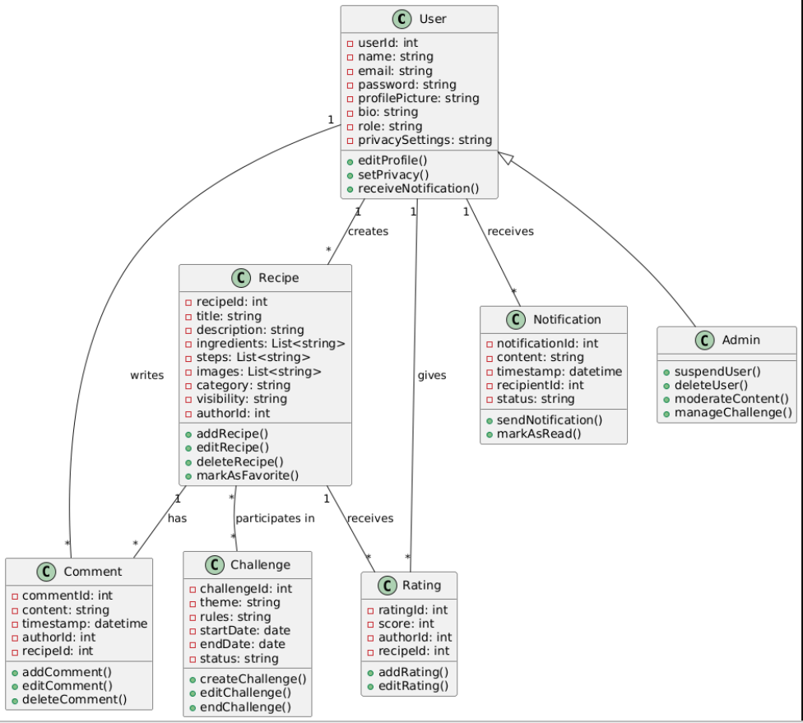

Figure : Class Diagram

**Entity-Relationship Diagram (ERD):**

This ERD models the structure of a recipe-sharing application where users can interact with recipes, comments, ratings, challenges, and notifications.

1. **User**: Represents the individuals using the system, who can post recipes, add comments, rate recipes, participate in challenges, and receive notifications.
2. **Recipe**: Represents a collection of recipes posted by users. Each recipe can have multiple comments and ratings. Recipes also trigger notifications to their authors when a user interacts with them (via comment or rating).
3. **Comment**: Represents comments made by users on recipes. Each comment is associated with both the user who wrote it and the recipe it belongs to.
4. **Rating**: Represents the rating scores given by users to recipes. Each rating is associated with a specific recipe and the user who rated it.
5. **Notification**: Represents the notifications sent to users. Notifications are triggered by various actions, such as comments on a recipe, new ratings, and challenge submissions. Users and recipe authors receive these notifications.
6. **Challenge**: Represents the challenges available in the system that users can participate in. Each challenge can have multiple participants.
7. **ChallengeParticipation**: Represents the user's participation in challenges. It links a user to a specific challenge and can trigger notifications to admins.

**Relationships:**

* A **User** can have multiple **Recipes**, **Comments**, **Ratings**, **Notifications**, and **ChallengeParticipations**.
* A **Recipe** can receive multiple **Comments**, **Ratings**, and trigger **Notifications**.
* A **Comment** and **Rating** are associated with both a **User** and a **Recipe**.
* **ChallengeParticipation** connects **Users** to **Challenges**, with each participation potentially triggering **Notifications** to both the user and the admin.

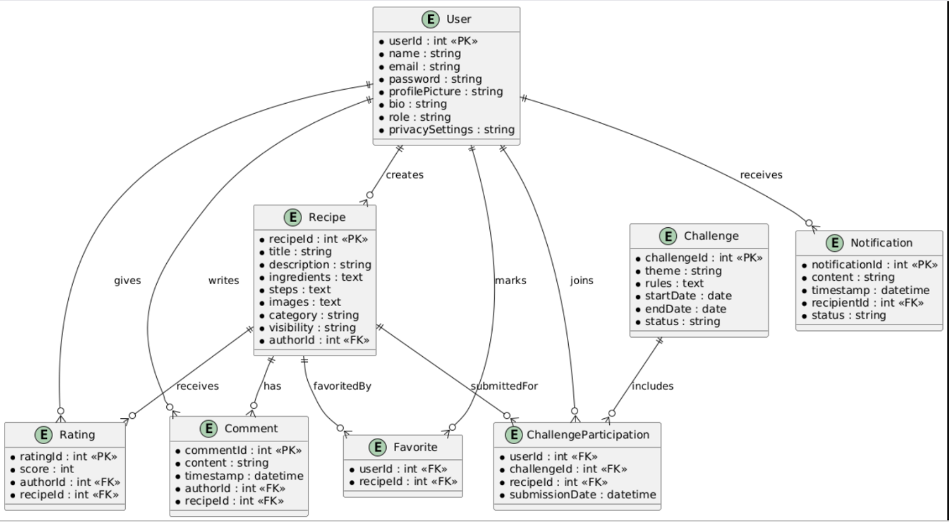

Figure : ERD

**Sequence Diagram:**

The diagram shows a series of interactions between the **User** and other participants like **Recipe**, **Comment**, **Rating**, **Notification**, **Challenge**, and **ChallengeParticipation**. It also includes how the system ensures communication (through notifications) between users, admins, and recipe authors for each action.

Figure : Sequence Diagram

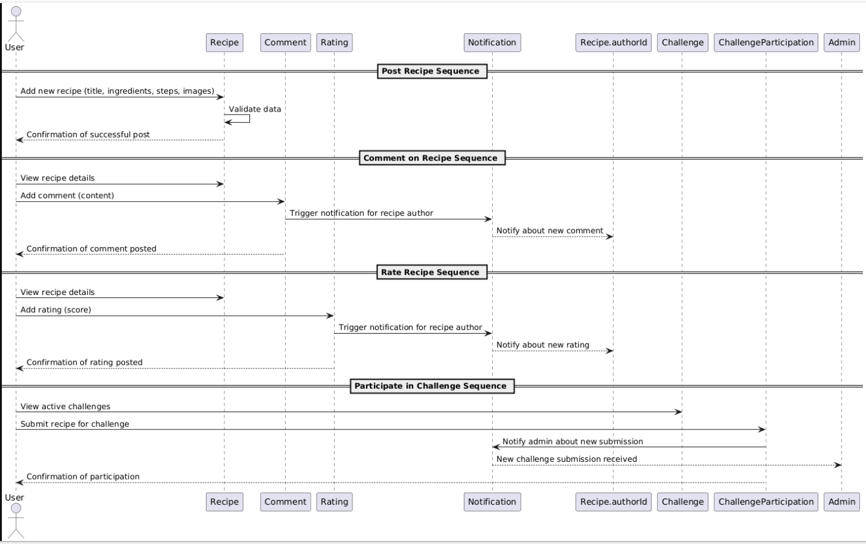

**Activity Description:**

1. **Post Recipe Sequence**:
   * **User** adds a new recipe (with title, ingredients, steps, and images).
   * **Recipe** validates the data and confirms the successful post to the **User**.
2. **Comment on Recipe Sequence**:
   * The **User** views a recipe's details and adds a comment to it.
   * The **Comment** triggers a **Notification** to alert the recipe’s author about the new comment.
   * After sending the notification to the author, a confirmation is sent back to the **User** about the successful posting of the comment.
3. **Rate Recipe Sequence**:
   * The **User** views a recipe and adds a rating (score).
   * The **Rating** triggers a **Notification** to the recipe’s author about the new rating.
   * Once the notification is sent to the author, the **User** receives confirmation of the successful rating.
4. **Participate in Challenge Sequence**:
   * The **User** views active challenges and submits a recipe for a challenge.
   * The **ChallengeParticipation** sends a **Notification** to the **Admin** about the new submission.
   * After notifying the admin, the **User** receives a confirmation of their participation in the challenge.