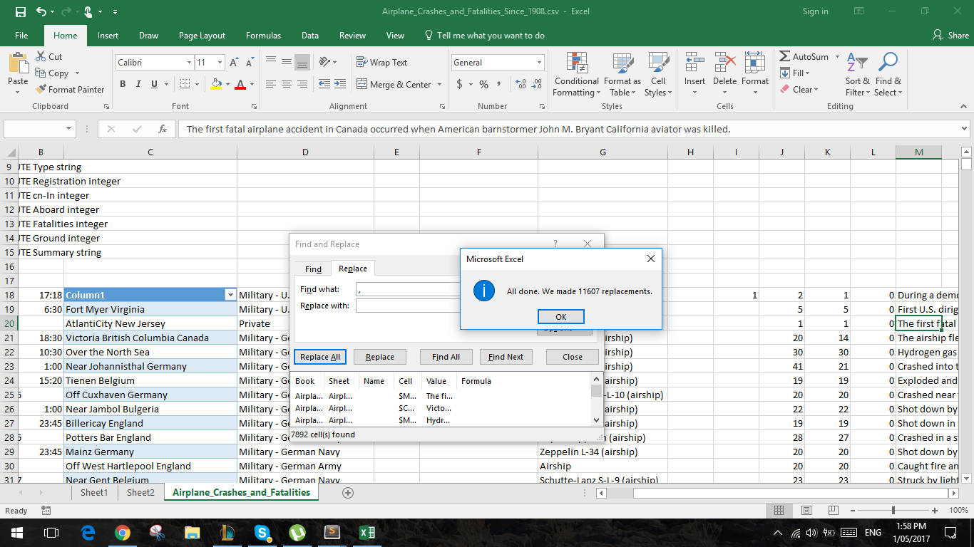

Getting rid of all the commas so that weka won’t read Fort Myer, Virginia as 2 Attributes etc

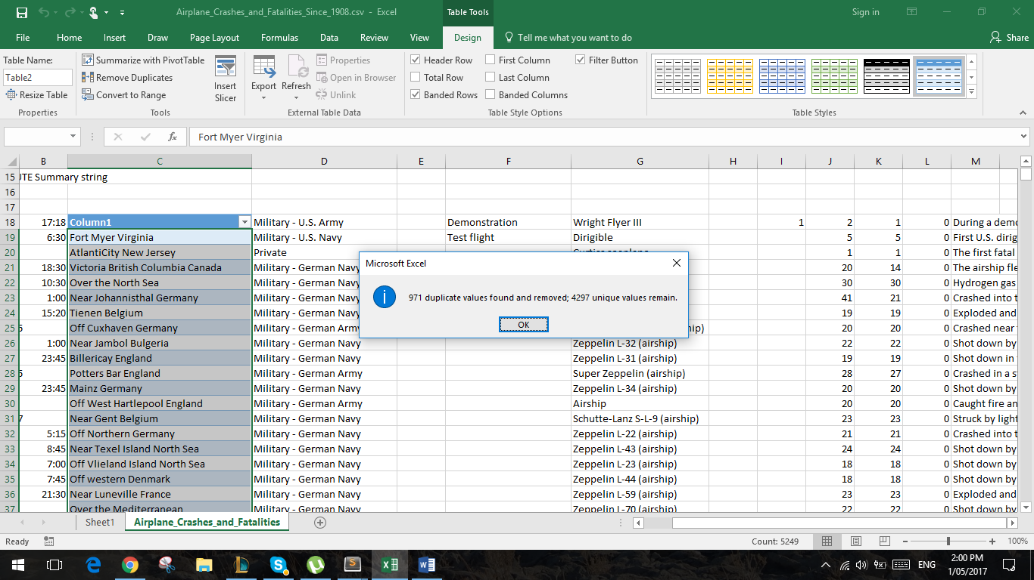

Getting rid of the duplicates so that we can add in all the unique names to filter through with weka

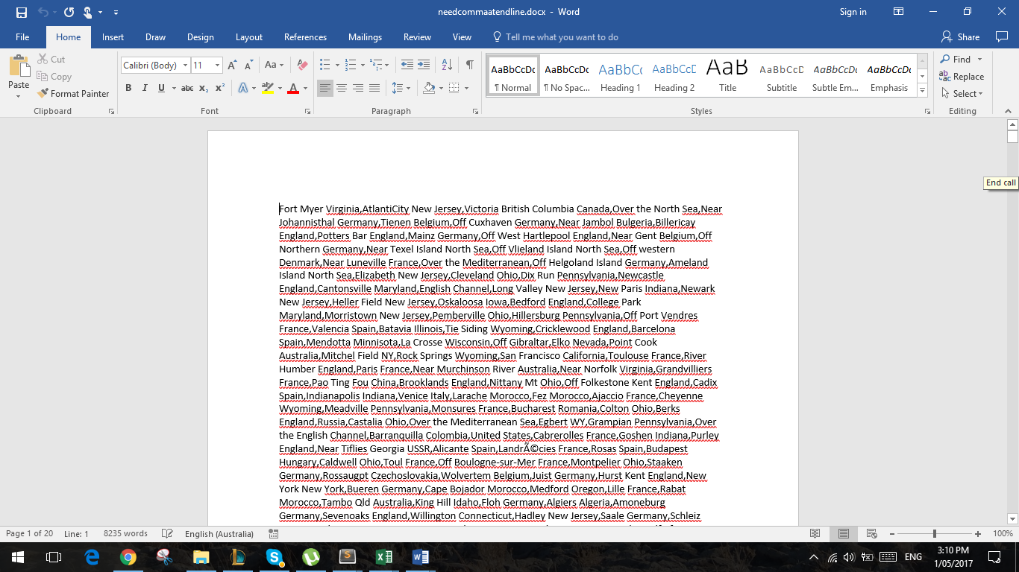

Adding all the non duplicates and adding commas between the locations and removing the new lines