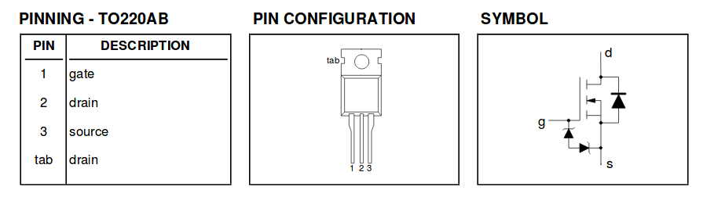Part Number: IRFZ44N

Max Resistance: 22mOhs

Max Current: 49A

Voltage Drop across transistor: .015V

Current through transistor: .37A

Power dissipated: .00555W

1.02V for the two stage system

.002A for the current through the two stage system

.00204W dissipated