|  |  |
| --- | --- |
| **Name of the student** |  |
| **Course/section** |  |
| **Date of Submission** |  |

**Machine Problem 2: Guess the Number Game**

**Description:**

Write a JavaScript game program that uses a loop to allow the user to guess a randomly generated number. The game will prompt the user to enter a number to be guessed, generate a random number between 1 and the user’s input and provide feedback to the user after each guess to indicate whether their guess was too high, or too low or correct.

**Learning Objectives:**

Understand the concept of repetition control structures in JavaScript Learn how to use a while loop to allow the user to guess a number Practice problem-solving and critical thinking skills.

**Requirements:**

1. The program should prompt the user to enter a number to be guessed.
2. Generate a random number between 1 and the user's input.
3. The user will have to guess the number within a certain number of tries.
4. The program should use a loop to allow the user to guess the number. Show how the loop will continue until the user guesses the correct number or runs out of tires, and how the program will provide feedback to the user after each guess.
5. Test their code frequently and experiment with different ways of providing feedback to the user.

**Output:**

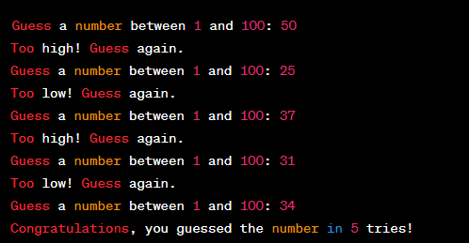

Rubrics:

|  |  |
| --- | --- |
| **Requirements** | **Points** |
| Prompts the user to input a number to be guessed | 10 |
| Use a for loop to check the guessed number against the random number | 20 |
| Use if statement to provide feedback to the user | 20 |
| Display the output | 15 |
| Code readability | 20 |
| Code efficiency and elegance | 15 |
| **Total Machine Problem Grade** | **100** |

Go to Module Lab SB:  
 -copy the url of the home page for your s05/activity repo (URL on browser not the URL from clone button) and link it to our SB lab discussion:

[SOLUTION]

* **Github URL:**

*Paste here your Github URL:*

* **Python Code:**

*Paste here your Python code:*

* **Output:**

*Paste here output of your Python solution:*