Overview

Overview

diagramma UML fatto bene -> buona architettura dati

descrizione classi

flowchart,

screenshot codice importante

Database

Database

The DB can only be accessed using the DB API, which can only use stored procedures to access it. This is implemented to secure sensitive data

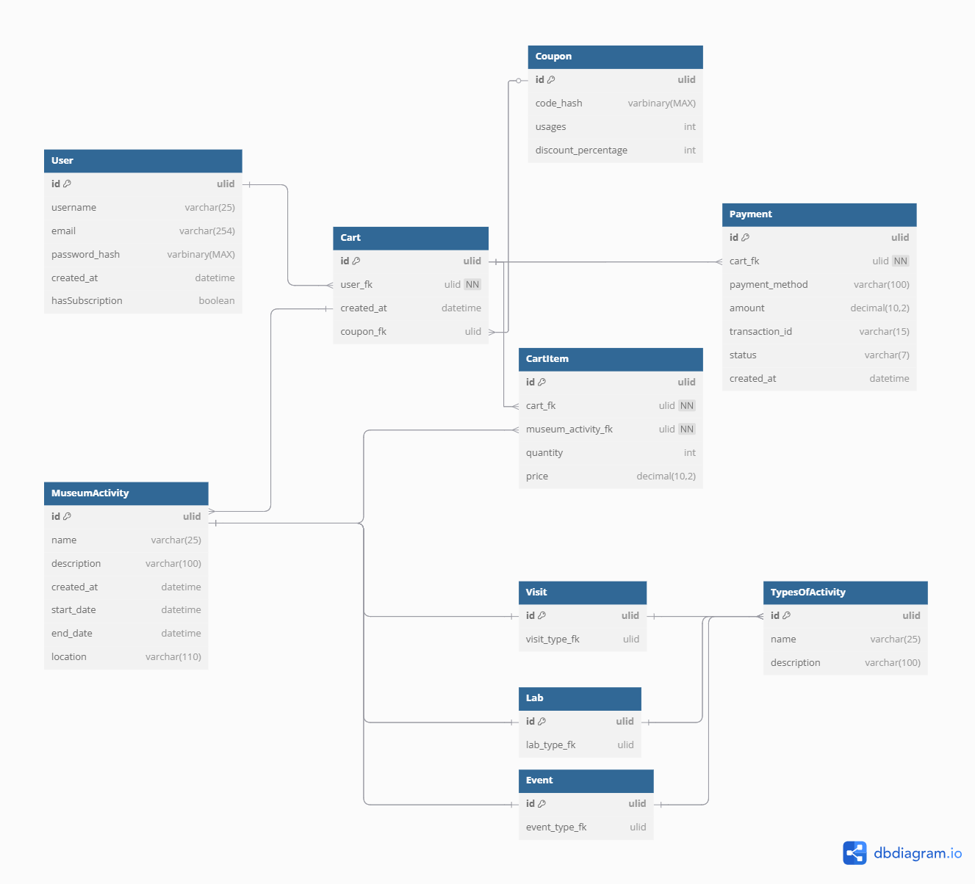

The stored procedures are

CreateNewAccount

GetAccount

ChangePassword

ChangeUsername

ChangeEmail

ClearCart

AddActivityToCart

RemoveActivityFromCart

ChangeActivityQuantityInCart