**University of Nevada Las Vegas. Department of Electrical and Computer Engineering Laboratories.**

|  |  |  |  |  |  |
| --- | --- | --- | --- | --- | --- |
| Class: | **EE221 Circuits II -1001** | | | Semester: | **Summer 2022** |
|  | | | | | |
| Points |  | Document author: | **Angelo Nolasco** | | |
|  | Author's email: | **Nolasco@unlv.nevada.edu** | | |
|  | | | |
| Document topic: | **Final Project: Noise Detector** | | |
| Instructor's comments: | | | | | |

**1. The Description and Goal of The Project**

The noise detector should be able to detect the noise level someone makes. Also, any sound, like clap, TV sound, music, etc. So, A LED should turn on when it hears a sound, when the noise level is normal or loud the led turn on. When the noise level low the led will just blink, and no noise turns off. IF you yell and take 1 second pause the led will blink fast.

**2. Circuit Implementation and Results**

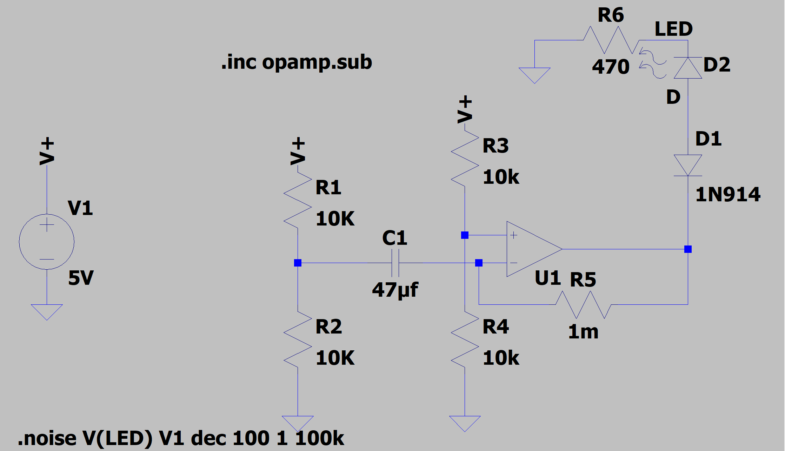

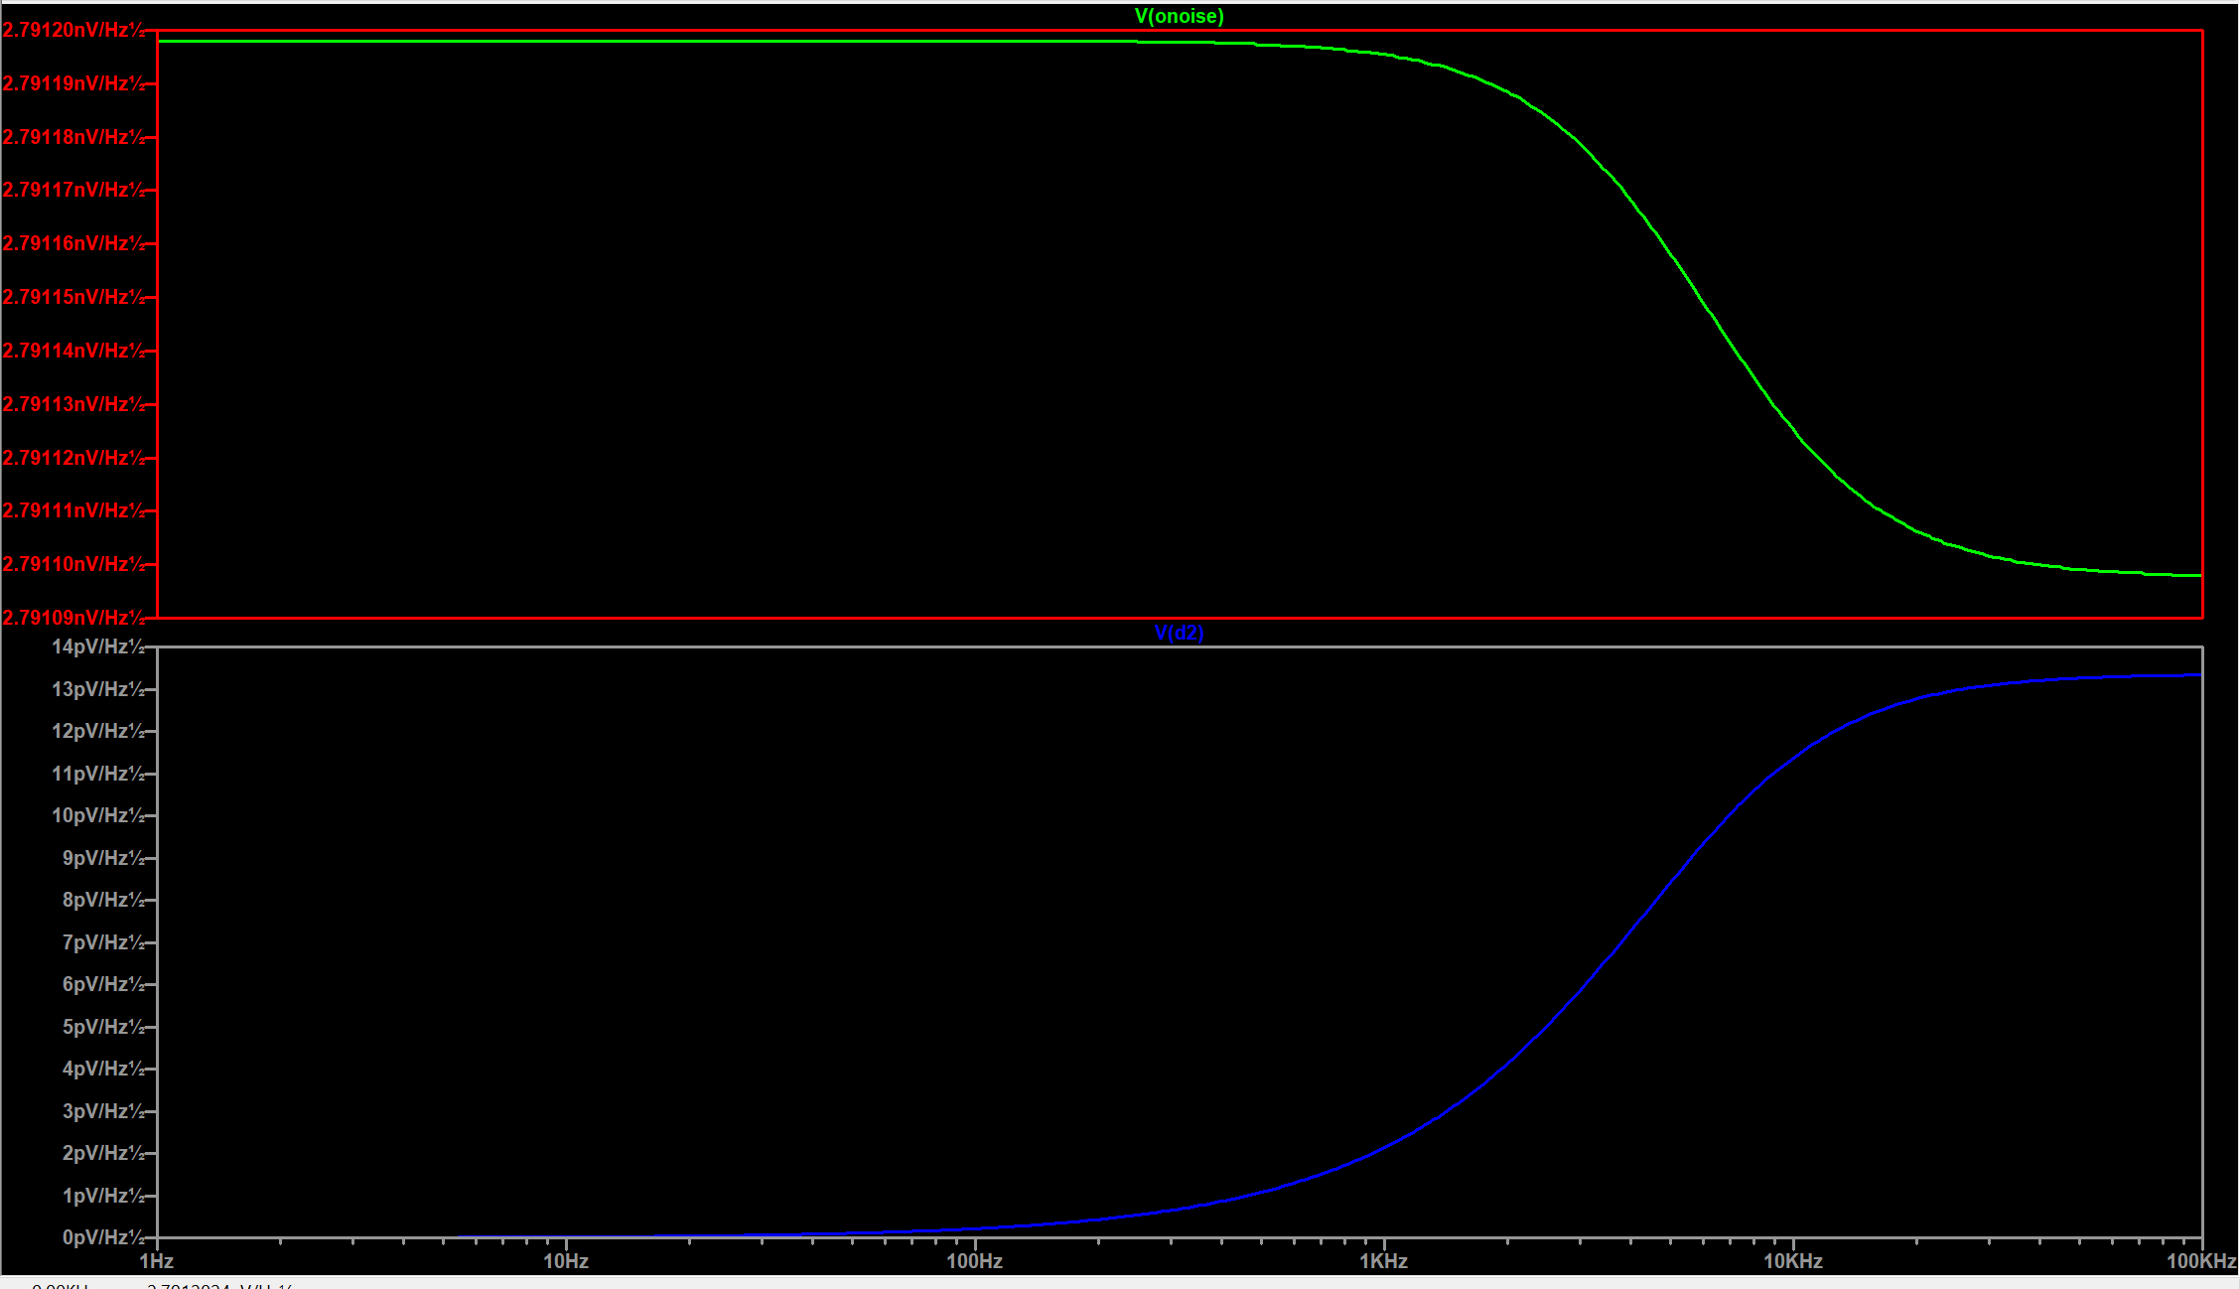

**3. Circuit Explanation**



* I put two voltage dividers to create a smaller resistor for the op amp, the voltage dividers are the 10k.
* Then I put a feedback resistor which is the 1M. It acts like negative feedback for the op amp.
* I add a diode, so when there no noise the LED will turn off.
* The 5v is the power it gives to the led, and the mic.

**4. Problem Encountered**

* First Issue was getting noise to show the led turn on in simulation on LTSPICE.
  + The main issue was getting noise, so it can show to LED turn on in the simulation. What I did was use the simulation command, which allowed me to use the noise simulation. Since LTSPICE has no component for microphone. The use noise simulation it allows you to set the frequency from start to end. They you but the input, the output is the what is graph which is the noise.
* Second Issue was that I did not get the right size on diode.
  + The main issue was that the diode was too big to fit in my breadboard. So, what I did was use two test hook clip and jumper wires to connect to the breadboard.

**5. Conclusions & Summary**

Overall, the project was too hard to build and great project to do. I did have things I had struggle with like in LTspice get the output that showed the LED turning on or off. Which I fixed with using the noise analyzer in spice. Another thing was not purchasing the right diode size for my breadboard, but I just used test hook clip and jumper wires to connect the board. The last thing I struggle with was getting the right voltage to make my project work. What did was do a voltage divider, that allow the voltage drop from 9v to 5v. These are the things I struggled with but found a solution to it. Do these project greater, and greater experience for because I got to learn new things on LTspice, and allowed me to work on my owned. Which allowed to struggled and think of ways to find a solution.