2a
Train size 10000, dev size 1000
LR | Hidden Units | Steps | Last Loss | New LR
0.5 | 25 | 0 | 5.016975861837498 | 0.1786
0.1 | 25 | 0 | 5.218972718033429 | 0.0357
0.05 | 25 | 0 | 5.407677518765296 | 0.0179
0.5 | 25 | 2 | 5.0351412747655795 | 0.1786
0.1 | 25 | 2 | 5.214505668687516 | 0.0357
0.05 | 25 | 2 | 5.403824569896471 | 0.0179
0.5 | 25 | 5 | 5.01800895542185 | 0.1786
0.1 | 25 | 5 | 5.214640703207686 | 0.0357
0.05 | 25 | 5 | 5.403781106364606 | 0.0179
0.5 | 50 | 0 | 4.973139445434447 | 0.1786
0.1 | 50 | 0 | 5.132931888175016 | 0.0357
0.05 | 50 | 0 | 5.312957608309723 | 0.0179
0.5 | 50 | 2 | 5.029222280349144 | 0.1786
0.1 | 50 | 2 | 5.1365600271929965 | 0.0357
0.05 | 50 | 2 | 5.314183768404833 | 0.0179
0.5 | 50 | 5 | 5.021098622112132 | 0.1786
0.1 | 50 | 5 | 5.13682405830371 | 0.0357
0.05 | 50 | 5 | 5.314223521752088 | 0.0179

The model achieves minimal lost with a learning rate of 0.5, 50 hidden units and no steps for truncated propagation. Results represent that reducing the learning rate worsens the loss. Additionally, when increasing the number of hidden unit, the loss decreases except when the learning rate is 0.5 and the number of steps to look back in truncated propagation is 5. In this case only a slight increase in the loss could be observed. Moreover, in four out of the six scenarios, fewer truncated propagation steps slightly improves the loss. However, differences are minor and may not confidently illustrate the impact of the number of truncated propagation steps on the loss.

2b

Mean loss → 4.4264
Adjusted perplexity → 112.902
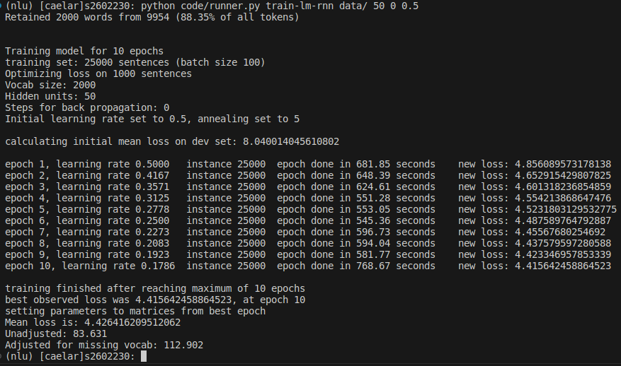
Unadjusted perplexity → 83.631

