Akalugwu Angelrita
AIB-24
Lab 7 – REST API
- Initial items in GET/devices:
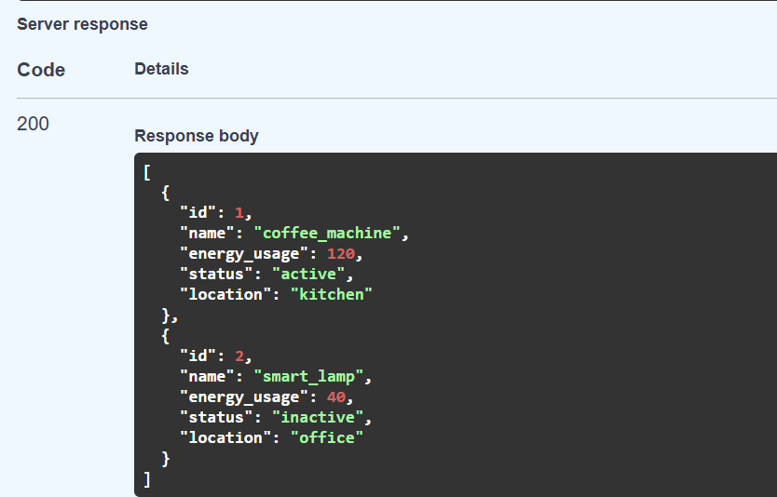

- Request to add device:
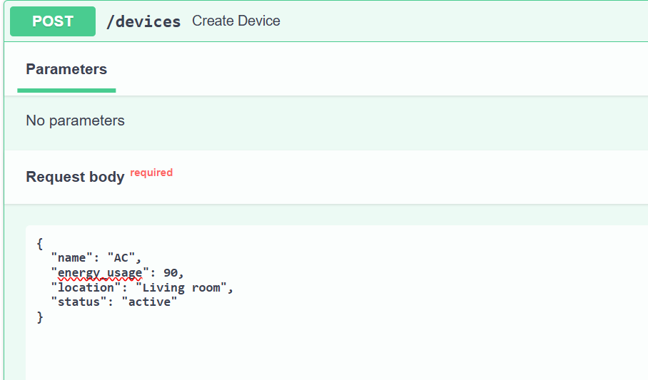

Response to added device
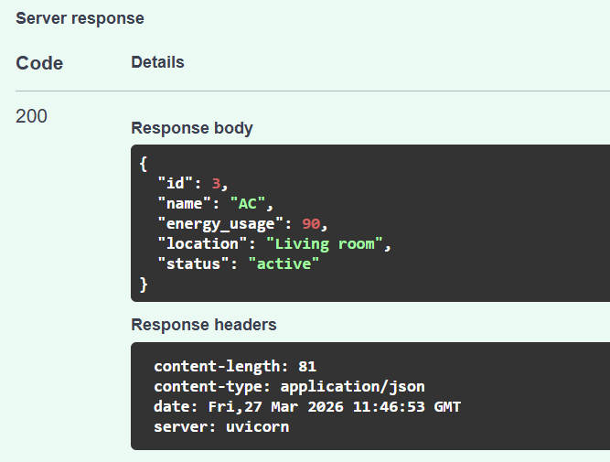

- List of devices after post:
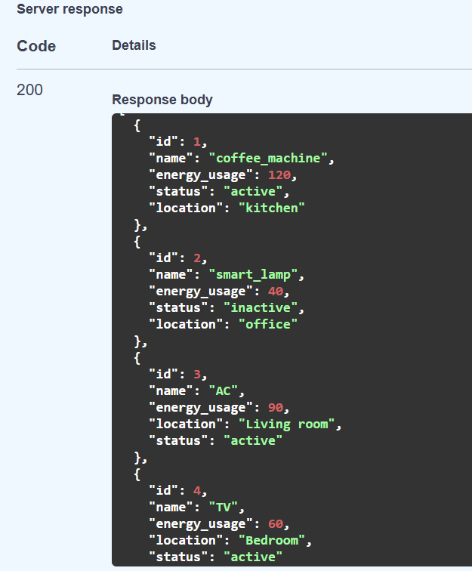

- Request to get device by ID:
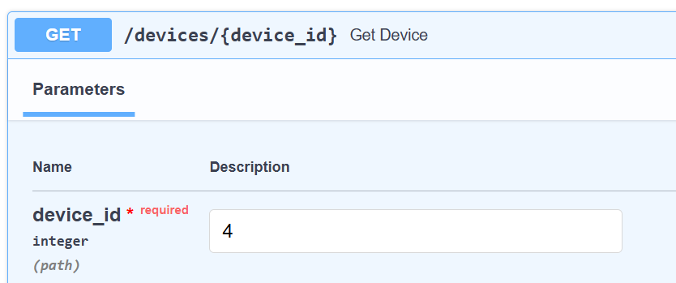
Response after request:
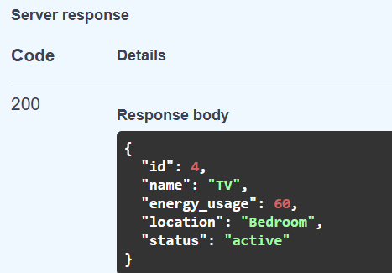

- Deleting an item using ID:
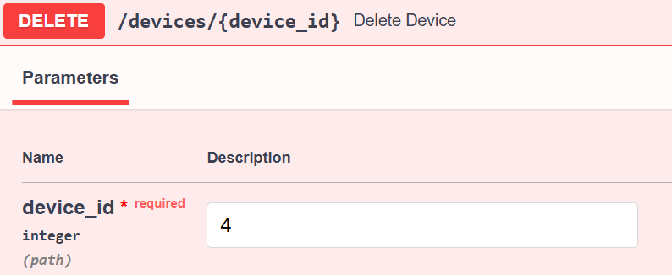

- List of all devices after modification (deleting):
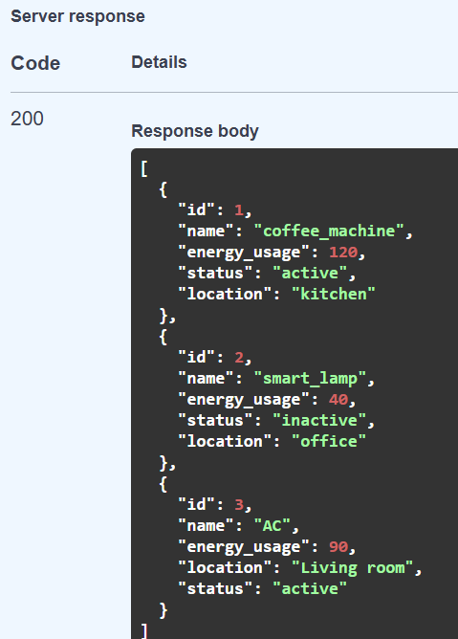

- List of active devices:
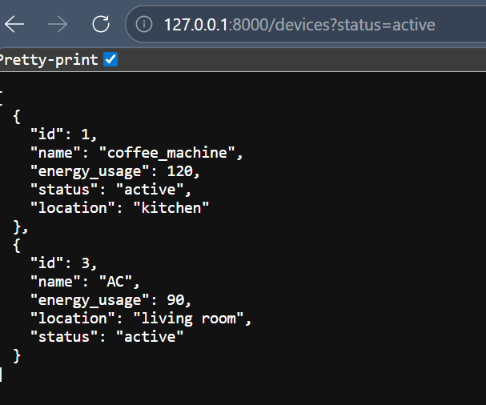

- Total energy usage:
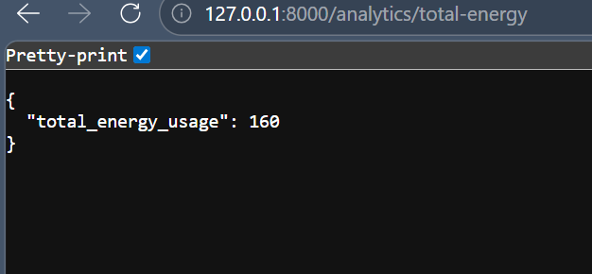

- Bonus: Updating device information using PUT

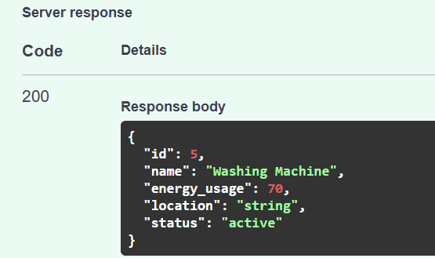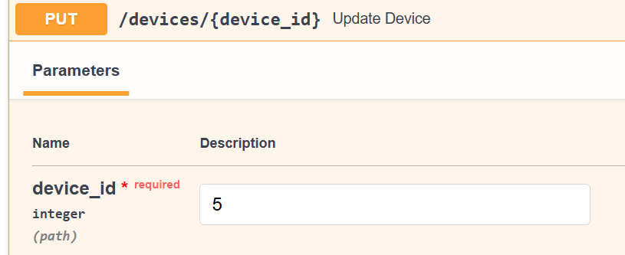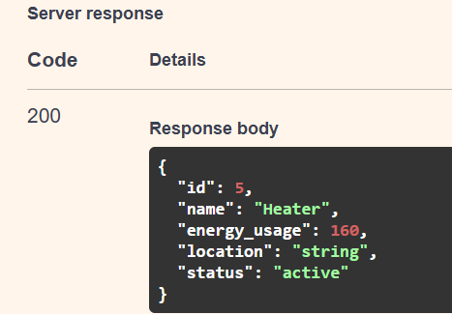
Previous device – Implementation – Updated device

SmartBuilding Device Management API
Project Description

1. Overview
The SmartBuilding Device Management API is a RESTful web service designed to manage and monitor IoT devices in smart buildings. It provides endpoints for creating, reading, updating, and deleting device records, as well as analytics to track energy usage and device statuses.
This API is ideal for building automation systems, energy management platforms, or smart home applications.

2. Features; Core Functionality
- Device Management: Add, retrieve, update, and delete IoT devices.
- Filtering: Filter devices by status (e.g., active, inactive).
- Analytics: Calculate total energy usage and other key metrics.

Endpoints
Endpoint | Method | Description
/ | GET | Welcome message
/devices | GET | List all devices (with optional status filtering)
/devices | POST | Add a new device
/devices/{device_id} | GET | Retrieve a specific device by ID
/devices/{device_id} | PUT | Update a device’s information
/devices/{device_id} | DELETE | Remove a device
/analytics/total-energy | GET | Calculate total energy usage of all devices

3. Technical Stack
- Framework: FastAPI (Python)
- Data Model: Pydantic for request/response validation
- Data Storage: In-memory list (for simplicity; can be replaced with a database)
- Testing: Manual testing with curl, Postman, or HTTPie
In summary, this project is:
- Scalable: Can be extended for large-scale smart building deployments.
- Efficient: FastAPI ensures high performance and easy maintenance.
- Flexible: Supports integration with other IoT platforms and databases.

