Comments for CIPL SMS proposal on September 30, 2016

1. Framework: yii2, application template: kartik-v/yii2-app-practical-a
2. UI Design: Reference lastpass.com and onelogin.com, with responsive and modern look.
3. User Registration/Login
   1. Email verification for account activation.
   2. Password strength indicator and requirement (minimal strength must met)
   3. Capthca image verification (registration required, login optional)
   4. Password Recovery.
4. Manage profile
   1. Email, Password, Picture
   2. First Name, Last Name, Middle Name, Title
   3. Address: Company, Line 1, Line 2, City / Town, State / Province, Zip/Postal Code
   4. Home Phone, Mobile Phone, Fax
   5. Once user profile is modified, the modification will be synchronized across all enrolled services.
5. APP/Service list - HTML Static
   1. Services are listed in the form of icon, click the icon will show service description, a link to demo, and a enroll button. A service may have a Frontend and a Backend. Services can be grouped, searched, and sorted (JS client-side).   
      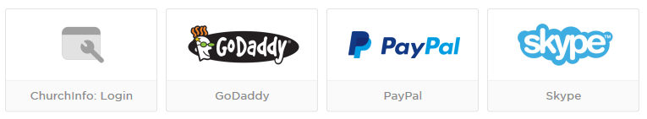
   2. Once enrolled, service will show on user’s dashboard/home page. Enrollment could be on an existing domain, or a new domain; could be an existing user (providing user name, password), or a new user.
   3. If an existing domain with a new user is selected, a new account in the service domain will be created, and the user profile will be copied from the SMS to the service domain.
   4. If a new domain is selected, a new database (and source code) of the service will be created and started, and the user profile will be copied from the SMS to the new service domain. Church Management service is a good example for this case.
   5. Scenario Example:
      1. Support Ticket System: Existing domain, existing user
      2. Survey Management: Existing domain, new user
      3. Church Management: New domain
6. Admin
   1. Manage admin profile
   2. Add/Edit/Delete User
   3. Add/Edit/ Delete Service