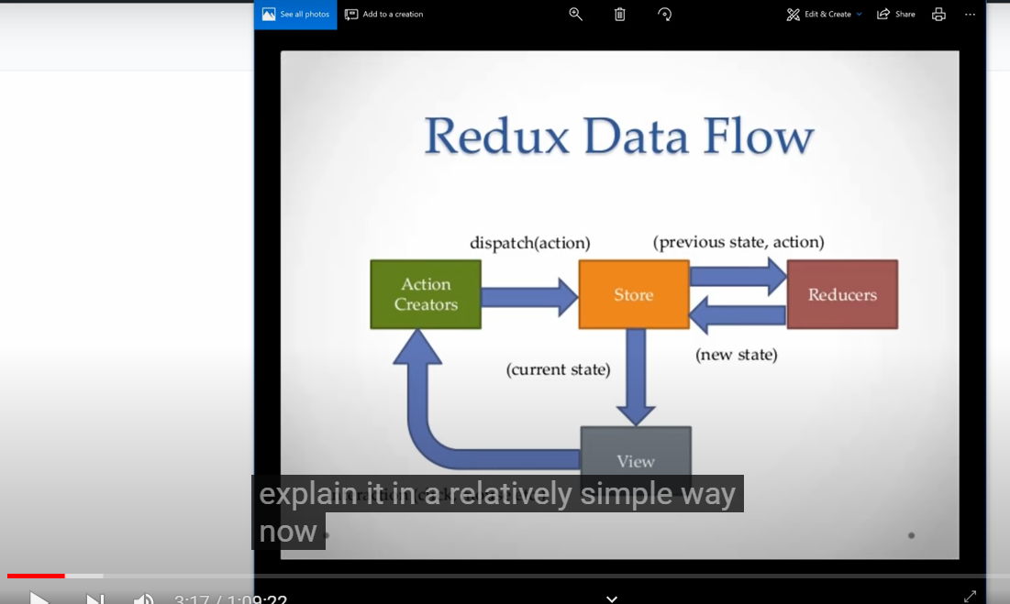

Now down here you have your view which is basically your react components and then you have your store which includes your state and it sends the state down to your component, alright now inside your component you may have a button that you click , or a form that is to be submitted and that fire of the action an action creators which will dispatch h an action to the store.
You have these reducers which are pure function that specify how the application State should change in response to that action alright, and then the reduces respond with that new state, and like I said State is immutable so it can’t really be modified, it’ s basically recreated as new state in turns that gets send down to your component

After creating react app boilerplate by npx create-react-app redux and install react es7 extension
From that react extension for vs code I can do rcc tab and that will give me a class based component,
And if I want the function based component I could do rfc

Install Redux
npm install redux react-redux redux-thunk

Store
A store holds the whole state tree of your application. The only way to change the state inside it is to dispatch an action on it

