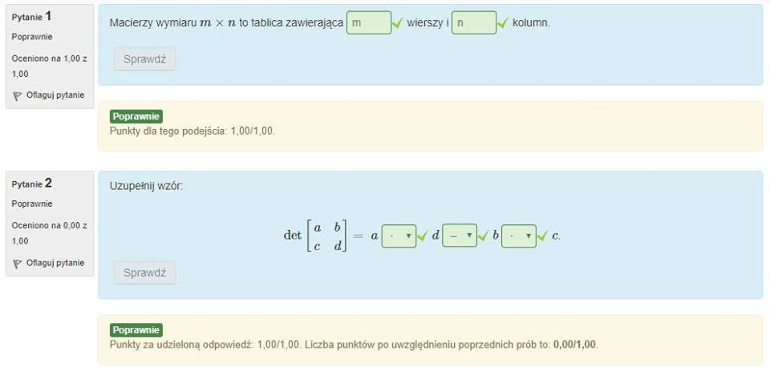

Proste rzeczy :D

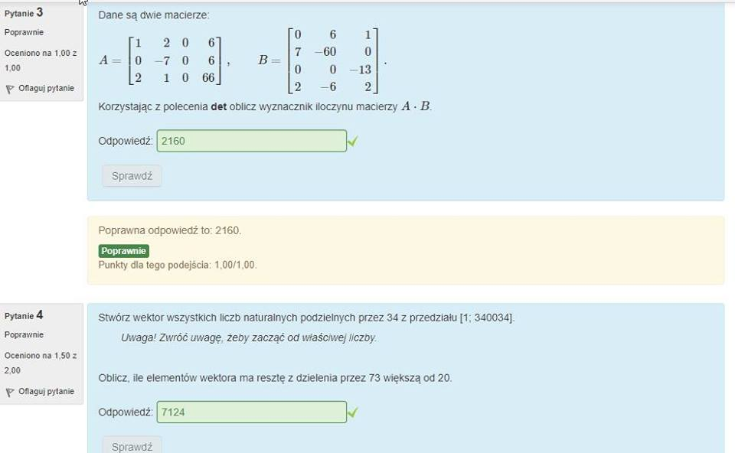

>> a=[1,2,0,6;0,-7,0,6;2,1,0,66]

a =

1 2 0 6

0 -7 0 6

2 1 0 66

>> b=[0,6,1;7,-60,0;0,0,-13;2,-6,2]

b =

0 6 1

7 -60 0

0 0 -13

2 -6 2

>> c=a\*b

c =

26 -150 13

-37 384 12

139 -444 134

>> det(c)

ans = 2160.0

>>

>> d=[34:34:340034]

d(mod(d,73)<=20)=[]

length(d)

ans = 7124

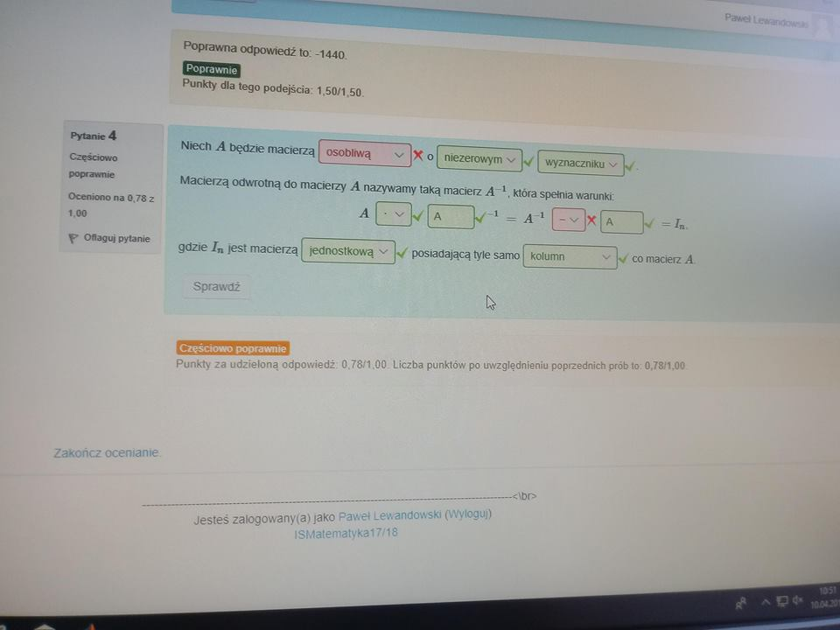

Ni wiem ☹ teoria to jest

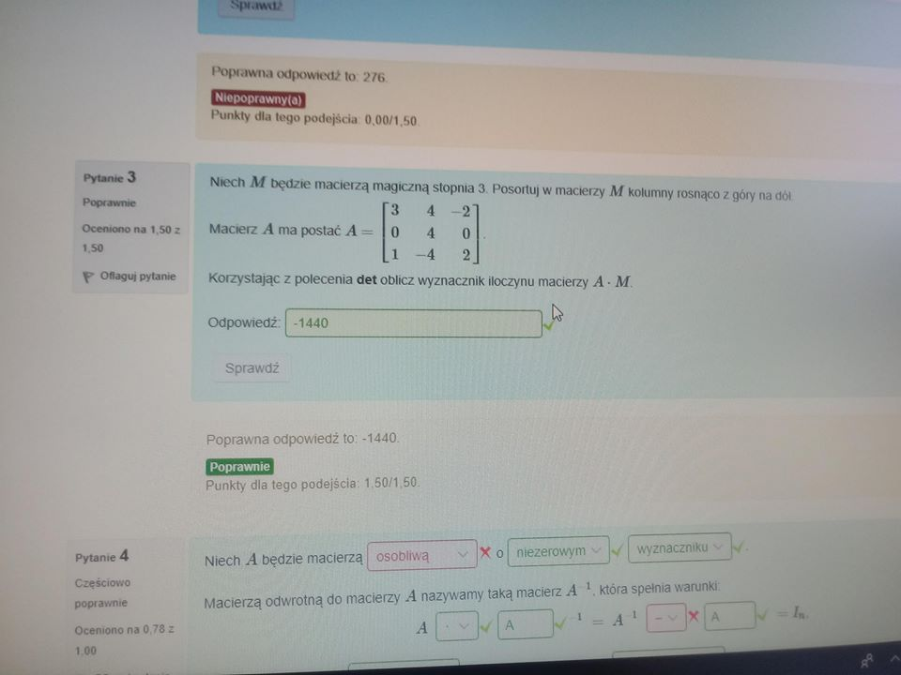

e=magic(3)

e =

8 1 6

3 5 7

4 9 2

e=sort(e)

e =

3 1 2

4 5 6

8 9 7

>> f=[3,4,-2;0,4,0;1,-4,2]

f =

3 4 -2

0 4 0

1 -4 2

>> g=f\*e

g =

9 5 16

16 20 24

3 -1 -8

>> det(g)

ans = -1440

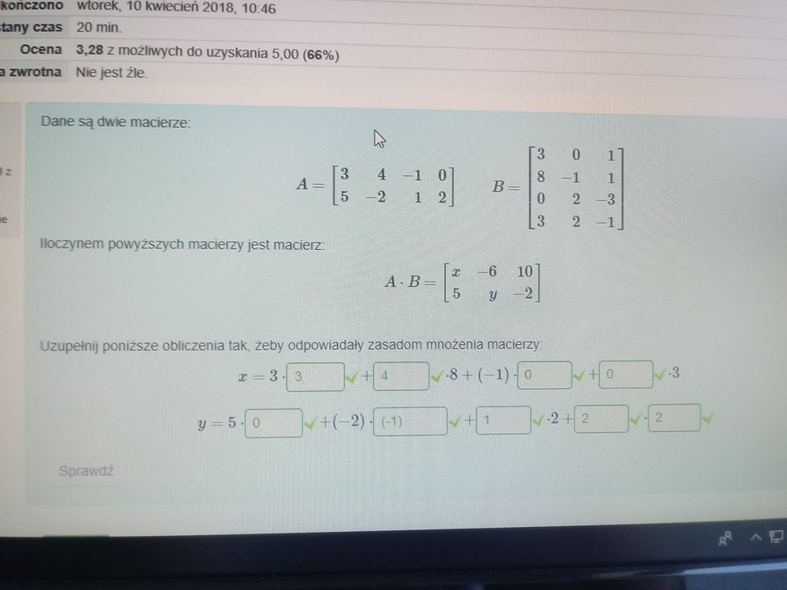

Zasada mnożenia macierzy :D