R markdown lab

Jeff Leek

July 3, 2015

1. Try compiling this document using the "Knit HTML" button. What files are produced?
2. Edit the output to be "pdf_document" and recompile. What files are produced?
3. Edit the output to be "word_document" and recompile. What files are produced?
4. What does the label "chunk1" do in the following code chunk?

x = rnorm(100)  
plot(x)

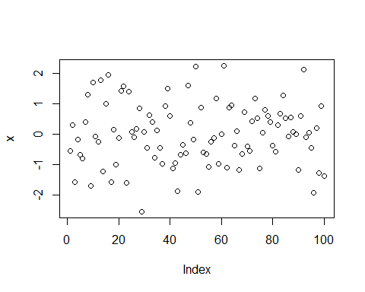

### This is a primary header. Add a secondary header with ## on the line below and recompile.

1. Change fig.height to something larger/smaller and see what happens

x = rnorm(100)  
plot(x)

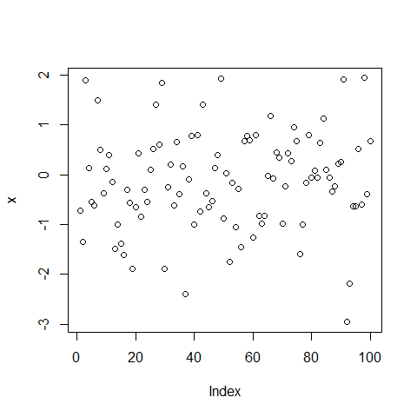

1. Add a chunk option of fig.align="center" to center this plot

x = rnorm(100)  
plot(x)

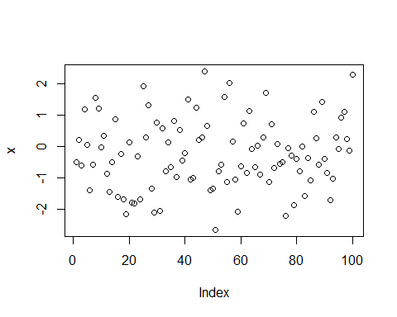

1. Add a chunk option of echo=FALSE and see what happens

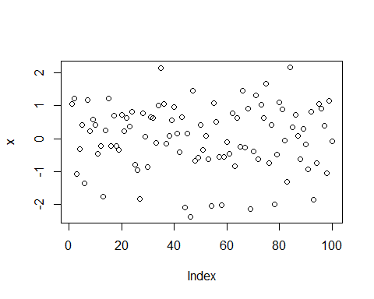

1. Uncomment this code and recompile the document. Then add a chunk command cache=TRUE and recompile. What files are created? Try compiling one more time.

Sys.sleep(10)

1. Check out the docs at: <http://rmarkdown.rstudio.com/> and look under formats. See if you can create and compile an R markdown presentation.
2. Add the command devtools::session_info() to this chunk and look at the output

devtools::session_info()

## Session info --------------------------------------------------------------

## setting value   
## version R version 3.3.1 (2016-06-21)  
## system x86_64, mingw32   
## ui RTerm   
## language (EN)   
## collate English_United States.1252   
## tz America/Los_Angeles   
## date 2016-07-11

## Packages ------------------------------------------------------------------

## package * version date source   
## codetools 0.2-14 2015-07-15 CRAN (R 3.3.1)  
## devtools 1.12.0 2016-06-24 CRAN (R 3.3.1)  
## digest 0.6.9 2016-01-08 CRAN (R 3.3.1)  
## evaluate 0.9 2016-04-29 CRAN (R 3.3.1)  
## formatR 1.4 2016-05-09 CRAN (R 3.3.1)  
## htmltools 0.3.5 2016-03-21 CRAN (R 3.3.1)  
## knitr 1.13 2016-05-09 CRAN (R 3.3.1)  
## magrittr 1.5 2014-11-22 CRAN (R 3.3.1)  
## memoise 1.0.0 2016-01-29 CRAN (R 3.3.1)  
## Rcpp 0.12.5 2016-05-14 CRAN (R 3.3.1)  
## rmarkdown 1.0 2016-07-08 CRAN (R 3.3.1)  
## stringi 1.1.1 2016-05-27 CRAN (R 3.3.0)  
## stringr 1.0.0 2015-04-30 CRAN (R 3.3.1)  
## withr 1.0.2 2016-06-20 CRAN (R 3.3.1)  
## yaml 2.1.13 2014-06-12 CRAN (R 3.3.1)