**API BUGS**

Get Employee

1. **Server authorization**

When there is no authorization, it sends a 500 (server error), but it should return a 401 (Unauthorized).

*Steps to reproduce*

1. *Do not configure the API Key authorization.*
2. *Send a valid GET request to the server:*

*curl --location -g 'https://wmxrwq14uc.execute-api.us-east-1.amazonaws.com/Prod/api/employees/{{id}}' *

*--header 'Authorization: Basic {{token}}' 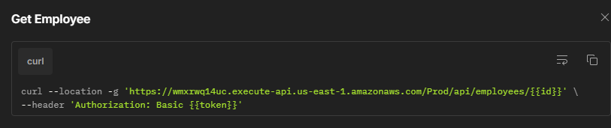*

1. *The response will show 500 internal server Error*

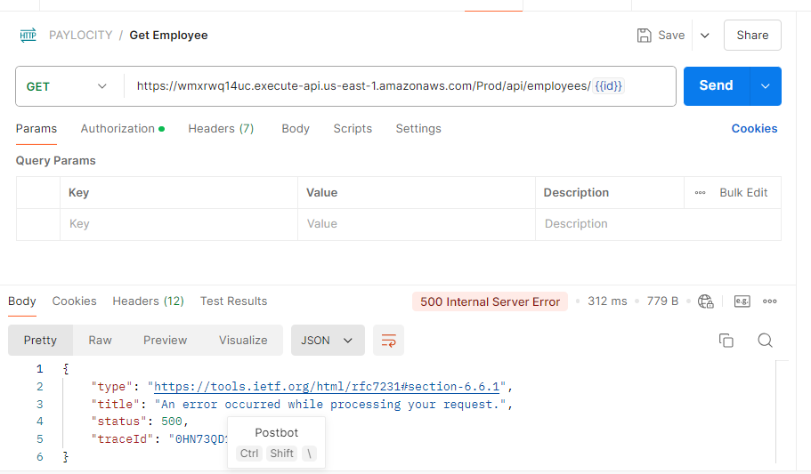

1. Retrieving a deleted or non-existent employee. When we try to retrieve an employee who has already been deleted or that doesn’t exist, it returns a 200 (OK) status, but it should return a 404 (Not Found).

*Steps to reproduce*

1. *Send a GET request to the server with the ID of an employee who does not exist or has been deleted:*

*curl --location -g 'https://wmxrwq14uc.execute-api.us-east-1.amazonaws.com/Prod/api/employees/{{id}}' *

*--header 'Authorization: Basic {{token}}'*

*2. It will return a 200 OK error, but it should return a 404 Not Found.*

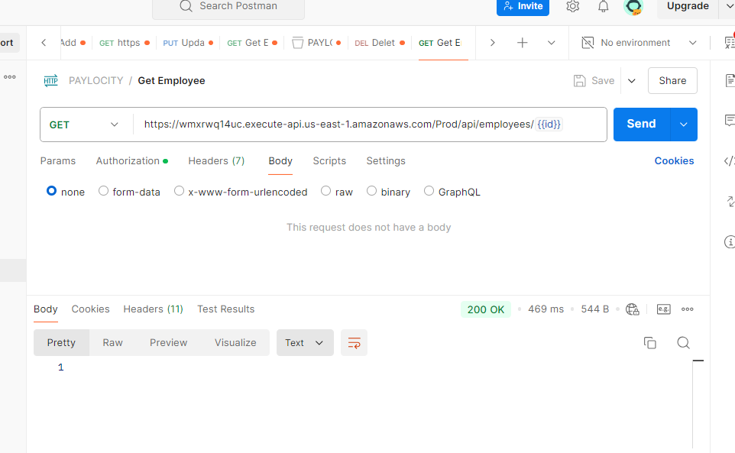

Get Employee List

1. **Server authorization**

When there is no authorization, it sends a 500 (server error), but it should return a 401 (Unauthorized).

*Steps*

1. *Do not configure the API Key authorization.*
2. *Send a valid GET request to the server:*

curl --location 'https://wmxrwq14uc.execute-api.us-east-1.amazonaws.com/Prod/api/employees' \--header 'Authorization: Basic {{token}}'

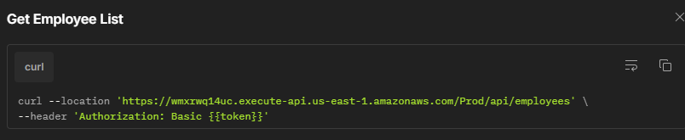

1. *The response will show 500 internal server Error*

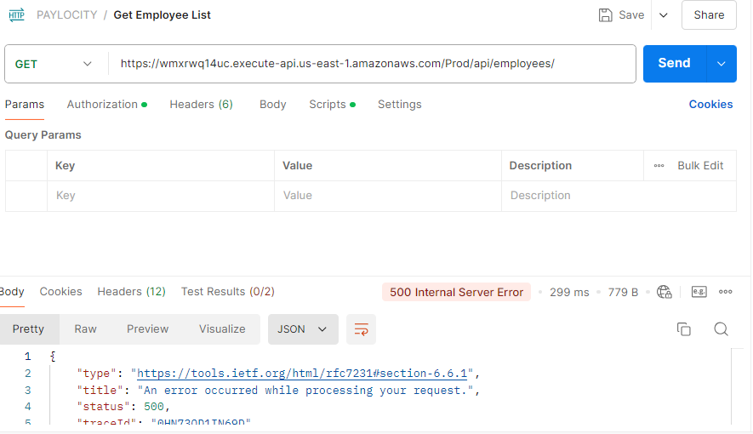

2. List without employees. When there are no employees, the server returns a 200 OK status; it should return a 404 Not Found status.

Steps to reproduce

1. *Send a valid GET request to the server:*

curl --location 'https://wmxrwq14uc.execute-api.us-east-1.amazonaws.com/Prod/api/employees' \--header 'Authorization: Basic {{token}}'

1. *The response will return a 200 OK status.*

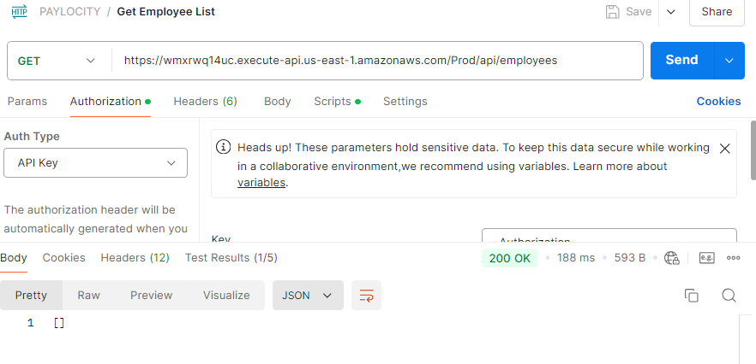

Add Employee

1. **Server authorization**

When there is no authorization, it sends a 500 (server error), but it should return a 401 (Unauthorized).

Steps to reproduce

*1. Do not configure the API Key authorization.*

*2. Send a valid POST request to the server:*

*curl --location 'https://wmxrwq14uc.execute-api.us-east-1.amazonaws.com/Prod/api/employees' *

*--header 'Authorization: Basic {{token}}' *

*--header 'Content-Type: application/json' *

*--data '{*

*"firstName": "Natasha",*

*"lastName": "Romanoff",*

*"dependants": 3*

*}'*

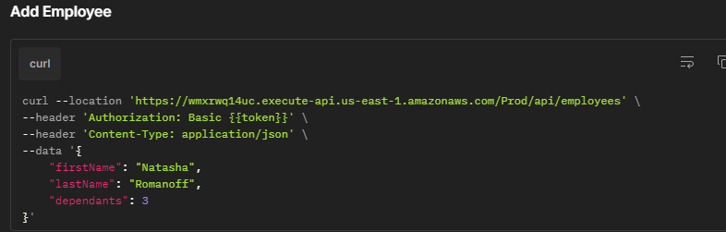

*3. The response will show 500 internal server Error*

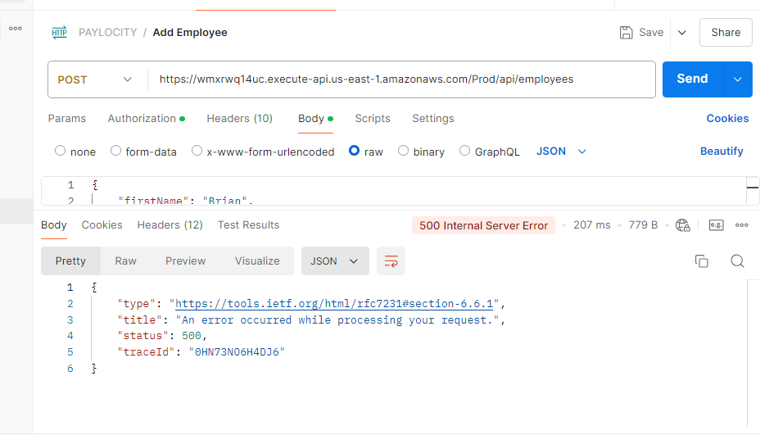

1. **Adding an employee**. When adding an employee, the server responds with a 200 status, but it should respond with a 201 status to indicate that the employee was created.

Steps to reproduce

1. *Send a valid POST request to the server to add an employee:*

*curl --location 'https://wmxrwq14uc.execute-api.us-east-1.amazonaws.com/Prod/api/employees' *

*--header 'Authorization: Basic {{token}}' *

*--header 'Content-Type: application/json' *

*--data '{*

*"firstName": "Natasha",*

*"lastName": "Romanoff",*

*"dependants": 3*

*}'*

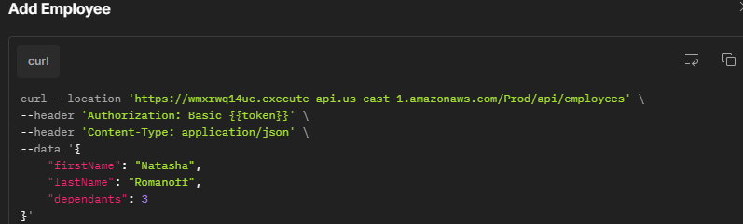

1. *The server will respond with 200 OK status*

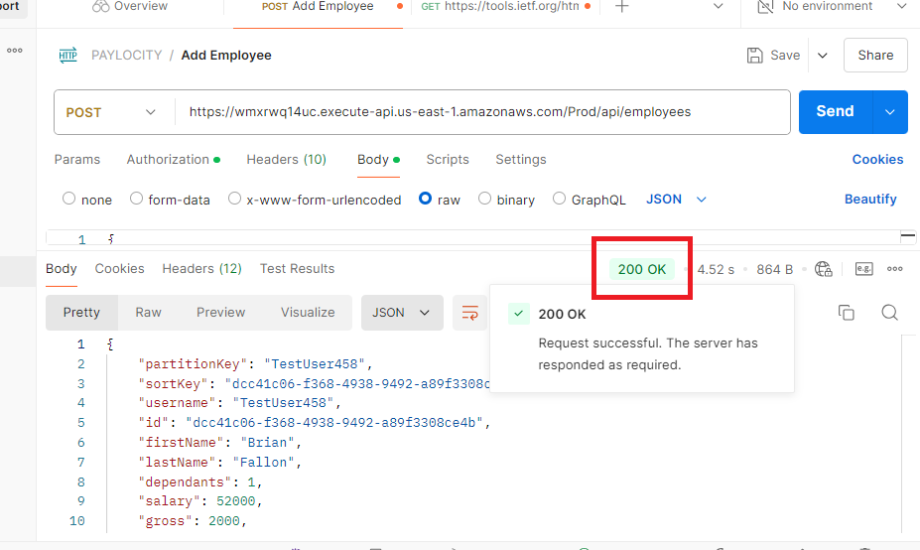

**3. Employee duplication**. The API allows creating the same employee multiple times with the same first and last name, although it assigns a different ID.

*Steps to reproduce*

1. *Send a valid POST request to the server to add an employee:*

*curl --location 'https://wmxrwq14uc.execute-api.us-east-1.amazonaws.com/Prod/api/employees' *

*--header 'Authorization: Basic {{token}}' *

*--header 'Content-Type: application/json' *

*--data '{*

*"firstName": "Natasha",*

*"lastName": "Romanoff",*

*"dependants": 3*

*}'*

**

1. *Once the employee is added, repeat the steps with the same first and last name. The API will add the employee.*

**4**. **Signs and numbers in employee’s Name**. It allows adding signs and numbers in the employee's first name and last name.

*Steps to reproduce*

*1. Send a valid POST request to the server to add an employee, Add signs and/or numbers in the first name and last name.*

*curl --location 'https://wmxrwq14uc.execute-api.us-east-1.amazonaws.com/Prod/api/employees' *

*--header 'Authorization: Basic {{token}}' *

*--header 'Content-Type: application/json' *

*--data '{*

*"firstName": "Natasha$#",*

*"lastName": "123Romanoff(&",*

*"dependants": 3*

*}'*

1. *It will add the employee*

Update Employee

1. **Server authorization**

When there is no authorization, it sends a 500 (server error), but it should return a 401 (Unauthorized).

*Steps*

*1. Do not configure the API Key authorization.*

*2. Send a valid PUT request to the server:*

*curl --location --request PUT 'https://wmxrwq14uc.execute-api.us-east-1.amazonaws.com/Prod/api/employees' *

*--header 'Content-Type: application/json' *

*--header 'Authorization: Basic {{token}}' *

*--data '{*

*"id": "1945d706-39f3-49eb-bea8-98abcf766e5e",*

*"firstName": "Wanda",*

*"lastName": "Maximoff",*

*"dependants": 2*

*}'*

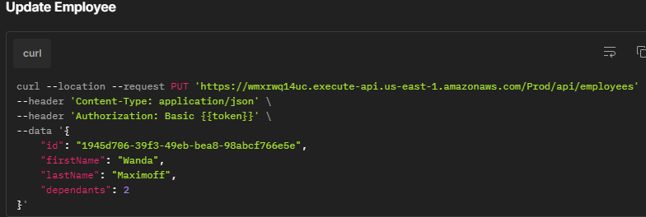

*3. The response will show 500 internal server Error*

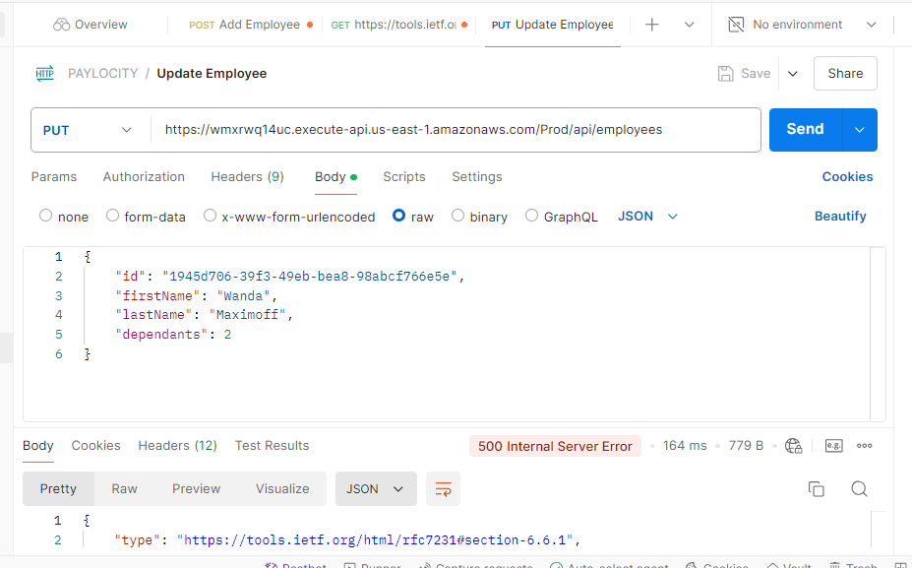

1. **Employee Duplication.**

When you update an existing employee but change a number or letter within the ID, the API duplicates it with a new ID and sets the salary and gross pay to zero.

Steps to reproduce

1. Before you sent the PUT request to the server, Use an existing employee, use their first and last name, and modify a letter or number in the employee ID

curl --location --request PUT 'https://wmxrwq14uc.execute-api.us-east-1.amazonaws.com/Prod/api/employees' \

--header 'Content-Type: application/json' \

--header 'Authorization: Basic {{token}}' \

--data '{

"id": "1945d706-39f3-49eb-bea8-98abcf766e5e",

"firstName": "Nicholas",

"lastName": "Schneider",

"dependants": 1

}'

1. Send the PUT request to the server
2. The employee will be duplicated with the same first name and last name but with a different ID, and it will show the salary and gross as zero.

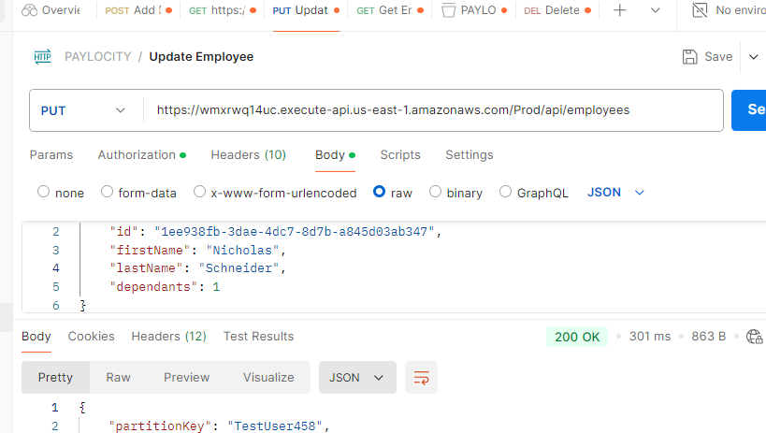

In the UI, we will be able to see that the employee was created.



Delete Employee

1. **Server authorization**

When there is no authorization, it sends a 500 (server error), but it should return a 401 (Unauthorized).

*Steps*

*1. Do not configure the API Key authorization.*

*2. Send a valid DELETE request to the server:*

*curl --location -g --request DELETE 'https://wmxrwq14uc.execute-api.us-east-1.amazonaws.com/Prod/api/employees/{{id}}' \--header 'Authorization: Basic {{token}}'* 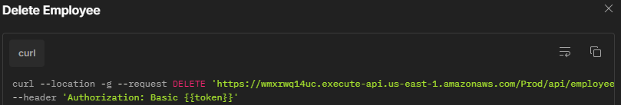

*3. The response will show 500 internal server Error*

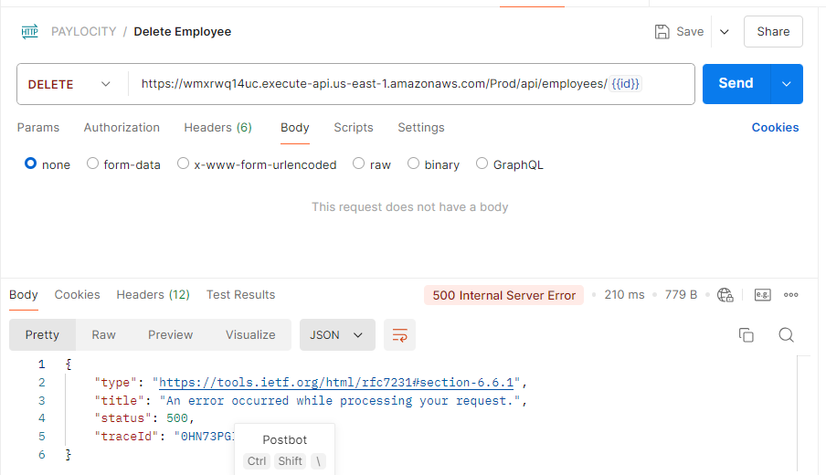

1. Delete a non-existent employee.

When attempting to delete a non-existent employee, a 200 OK status is received; it should return a 404 Not Found status.

*Steps to reproduce*

1. *Send a valid DELETE request with an id from a non existent employee*
2. *It will show a 200 ok status, instead of 404.*

