**UI Bugs**

**Session**

Session Expires without warning. After a certain period, the application's session expires, but it does not display any message about this or return to the initial login page. It simply no longer allows adding, editing, or deleting employees. If the page is refreshed, the dashboard is displayed without any information.

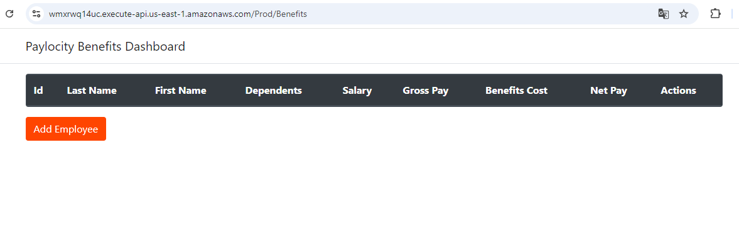

*Steps to reproduce*

*1. Log in to the application*

*2. Leave the application open without using it for more than 1 minute, then try to add an employee. The process will not be completed.*

*3. Refresh the page, and it will display the dashboard without any information*

**Application webpage**

Application webpage redirection to log in.If the dashboard page link is entered in the browser, the dashboard is displayed without any information, but the correct behavior would be to show a 404 Not Found message or redirect to the login page



*Steps to reproduce*

1. *Enter the link https://wmxrwq14uc.execute-api.us-east-1.amazonaws.com/Prod/Benefits in the browser*

**Dashboard**

1. Salary Column. The salary column, we can see a total amount equal to the 26 payments the employee receives per year before taxes, which is the amount of 52,000. Since I don't have information about what this column should display, it should be verified if the amount to be shown is the annual salary (which is 52,000). In that case, I suggest that the column name be more specific, as it may be confusing for the end user, since the column name does not indicate that it is the annual salary
2. First Name Column shows wrong information.

The column displays the employee's Last Name.

1. Last Name Column shows wrong information.

The column displays the employee's First Name.

**Add Employee**

1. Letter in the dependents field. If a letter is entered in the dependents field, the process of adding the user does not continue, but no message is displayed indicating that an integer must be entered.

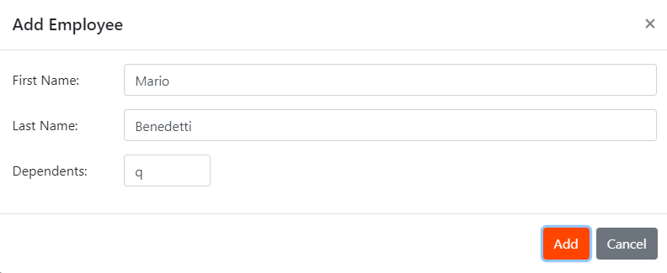

*Steps to reproduce*

*1. Click on "Add Employee"*

*2. Enter First Name*

*3. Enter Last Name*

*4. Enter a letter in the dependents field.*

*5. Click Add button, it will do nothing.*

1. Decimals in the dependents field. The Dependents field allows decimal numbers to be entered, although when adding the employee, only the integer is taken. However, from the UI, it should not allow anything other than an integer to be entered.

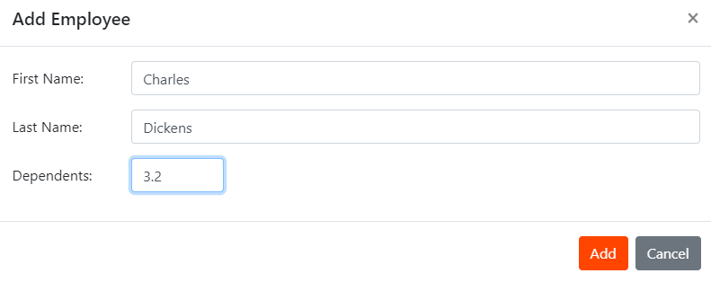

*Steps to reproduce*

*1. Click on "Add Employee"*

*2. Enter First Name*

*3. Enter Last Name*

*4. Enter decimals in Dependents*

*Click Add button. The employee will be added using only the integer entered in the dependants.*

1. String Fields allows numbers and symbols. The First Name and Last Name fields allow the entry of numbers and symbols.



1. **Employee Duplication**. Employees with the same names can be added multiple times, even though a unique ID is created for each employee.

*Steps to reproduce*

*1. Click on "Add Employee"*

*2. Enter First Name*

*3. Enter Last Name*

*4. Enter Dependents*

*Once the employee is added, repeat the steps with the same, first and last name, than the employee you just added before.*

*Then you will see that the employee is added to the dashboard*

