15210: Parallel and Sequential Data Structures and Algorithms

ParenLab

Zikang Wang (zikangw)

5.1

For a sequence, function subDist S would go along S to find the longest distance starting from its first element.

Function max S is a recursive function, it would compare the value of subDist S and the subsequence of S that has the largest parenthesis distance, then return the larger one of the two. The base case of this case is the last two elements of S, which would return 0 or 2.

Therefore, the work of this algorithm can be represented as

$$n+(n-1)+(n-2)+…+2=\frac{(n+2)(n-1)}{2}$$

That is,

$$W(n)=O(n^{2})$$

Since we used recursion and computed the distance in each turn of the recursion,

$$S=O(n^{2})$$

One improvement is saving the largest distances starting from each element in a sequence first, then compare, so it can be parallel and S would reduce to n.

But I’m busy and lazy…

5.2

1.

Guess:

$$W(n)=An+Blogn+C$$

So we need to find A, B and C

Base Case: $n=1$

$$W(1)=A+C=log1=0$$

Inductive Case: $n≥2$

$$W(n)=2T(\frac{n}{2})+logn=2A(\frac{n}{2})+2Blog\frac{n}{2}+2C+logn=An+(2B+1)logn+2C-2Blog2$$

To finish the inductive,

$$B=2B+1$$

$$C=2C-2Blog2$$

$$A+C=0$$

Therefore,

$$B=-1$$

$$C=-2log2$$

$$A=1$$

So,

$$W\left(n\right)=n-logn-2log2$$

$$W\left(n\right)=Θ(n-logn-2log2)$$

2.

If $W_{showt}∈Θ(n)$, then we can assume $W_{showt}=k_{1}n+k_{2}$, then

$$W\left(n\right)=2W\left(\frac{n}{2}\right)+k_{1}n+k_{2}$$

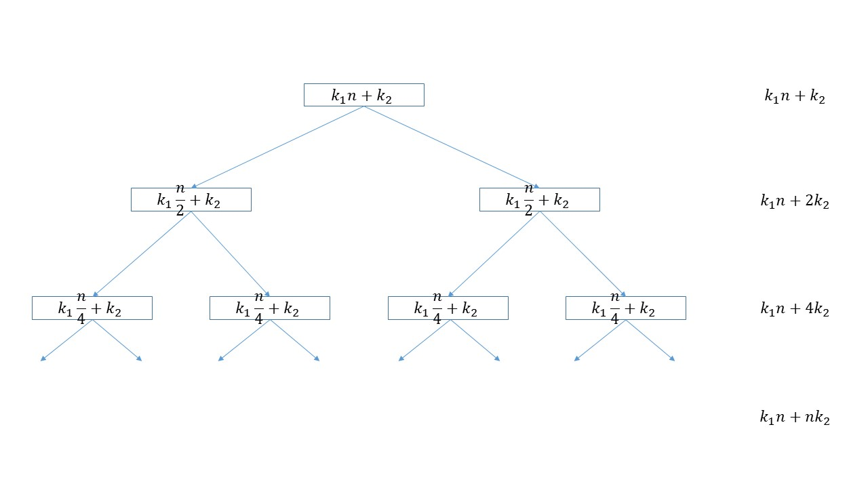

Sum all the layers up,

$$sum= k_{1}n\log{n}+(2n-1)k_{2}$$

Therefore,

$$W\left(n\right)=Θ\left(n\log{n}\right)+Θ\left(n\right)=Θ\left(n\log{n}\right)$$

5.3

Use brick method,

|  |  |  |
| --- | --- | --- |
| Number of Nodes | Work per Node | Total Work |
| $$1$$ | $$n^{2}$$ | $$n^{2}$$ |
| $$9$$ | $${(\frac{n}{3})}^{2}$$ | $${9∙(\frac{n}{3})}^{2}=n^{2}$$ |
| …… | | |

Work on two layers are the same $W_{i}=W_{i+1}$, this is a balanced tree

Define d = depth then on the leaf node, the work is,

$${(\frac{n}{3^{d-1}})}^{2}=1$$

Therefore,

$$d=\log_{3}{n}+1$$

$$W\left(n\right)=n^{2}×d=Θ(n^{2}\log{n})$$

5.4

Similar to 5.3,

|  |  |  |
| --- | --- | --- |
| Number of Nodes | Work per Node | Total Work |
| $$1$$ | $$\log{n}$$ | $$\log{n}$$ |
| $$1$$ | $$\log{\sqrt{n}}$$ | $$\frac{1}{2}\log{n}$$ |
| …… | | |
| $$1$$ | $$1$$ |  |

Total work is decreasing, ${cW}_{i}<W_{i-1}$, this is a root dominant tree, therefore

$$W\left(n\right)=W_{root}\left(n\right)=Θ(\log{n})$$

5.5

Use the brick method:

|  |  |  |
| --- | --- | --- |
| Number of Nodes | Work per Node | Total Work |
| $$1$$ | $$\log^{2}{n}$$ | $$\log^{2}{n}$$ |
| $$1$$ | $$\log^{2}{\frac{n}{4}}$$ | $$\log^{2}{\frac{n}{4}}$$ |
| …… | | |
| $$1$$ | $$1$$ |  |

Total work is decreasing, ${cW}_{i}<W_{i-1}$, this is a root dominant tree, therefore

$$W\left(n\right)=Θ(\log^{2}{n})$$

5.6

|  |  |  |
| --- | --- | --- |
| Number of Nodes | Work per Node | Total Work |
| $$1$$ | $$1$$ | $$1$$ |
| $$2$$ | $$1$$ | $$2$$ |
| $$4$$ | $$1$$ | $$4$$ |
| …… | | |
| $$n$$ | $$1$$ | n |

Define d = depth, we have

$$2^{d-1}=n$$

$$d=logn+1$$

Therefore,

$$W\left(n\right)= \frac{1∙(2^{d}-1)}{2-1}=2n-1=O(n)$$

5.7

$$T\left(n\right)=T\left(\frac{n}{5}\right)+T\left(\frac{7n}{10}\right)+O(logn)$$

Guess:

$$T\left(n\right)≤k_{1}n^{x}+k_{2}logn$$

Base Case: $n=1$

$$T(1)=k_{1}=O(1)≤O(logn)$$

Inductive Case: $n>1$

$$T(n)=T\left(\frac{n}{5}\right)+T\left(\frac{7n}{10}\right)+O\log\left(n\right)≤[k_{1}{(\frac{n}{5})}^{x}+k_{2}log\frac{1}{5}n]+[k_{1}{(\frac{7n}{10})}^{x}+k_{2}log\frac{7}{10}n]+logn=[{(\frac{1}{5})}^{x}+{(\frac{7}{10})}^{x}]k_{1}n^{x}+k_{2}logn+(k_{2}log\frac{7n}{50}+logn)=k_{1}n^{x}+k_{2}logn$$

To make the above equation valid, let:

$${(\frac{1}{5})}^{x}+{(\frac{7}{10})}^{x}=1$$

$$k_{2}log\frac{7n}{50}+logn=const$$

Therefore, the parameters should be:

$$k_{1}=c,$$

$$k_{2}=-1$$