Toolbox for the Modeling and Analysis of Thermodynamic Systems (T‑MATS)

User’s Guide

Jeffryes W. Chapman

Vantage Partners, LLC,

Cleveland, OH 44135

Thomas M. Lavelle

NASA Glenn Research Center,

Cleveland, OH 44135

Ryan D. May

Vantage Partners, LLC,

Cleveland, OH 44135

and

Jonathan S. Litt, Ten-Huei Guo

NASA Glenn Research Center,

Cleveland, OH 44135

Revisions list

|  |  |  |  |
| --- | --- | --- | --- |
| Version | Date | User | Description |
| v1.0 | 2013-11-15 | JWC | Initial Release |
| v1.1 | 2014-10-01 | JWC | Added T-MATS Cantera updates |

**Table of Contents**

[1 Introduction 4](#_Toc407703078)

[1.1 Identification 5](#_Toc407703079)

[1.2 Notation 6](#_Toc407703080)

[1.3 System Overview 6](#_Toc407703081)

[1.4 T-MATS quick start guide 6](#_Toc407703082)

[1.4.1 Installing T‑MATS 6](#_Toc407703083)

[1.4.2 Un-installing T‑MATS 7](#_Toc407703084)

[1.4.3 T‑MATS examples 8](#_Toc407703085)

[1.4.4 Block Help 8](#_Toc407703086)

[2 T‑MATS Library Structure 9](#_Toc407703087)

[3 T‑MATS Tools 10](#_Toc407703088)

[3.1 GF\_Convert 10](#_Toc407703089)

[3.2 Block Link Setup 10](#_Toc407703090)

[4 T‑MATS Simulation creation 11](#_Toc407703091)

[4.1 Simulation Setup 11](#_Toc407703092)

[4.2 T‑MATS formatting 13](#_Toc407703093)

[4.2.1 Color Coding 13](#_Toc407703094)

[4.2.2 Simulink Wiring 13](#_Toc407703095)

[4.2.3 Mask format 14](#_Toc407703096)

[4.2.4 S‑Functions 16](#_Toc407703097)

[4.3 Solver Setup 16](#_Toc407703098)

[4.4 Turbomachinery Plant Setup 16](#_Toc407703099)

[4.4.1 Independent and Dependent variables 17](#_Toc407703100)

[4.4.2 Maps 17](#_Toc407703101)

[4.4.3 Compressor Variable Geometries (IGVs and VSVs) 21](#_Toc407703102)

[4.4.4 Bleeds and Air Bypass 21](#_Toc407703103)

[4.4.5 Turbofan modeling options 23](#_Toc407703104)

[4.4.6 iDesign 24](#_Toc407703105)

[4.5 Cantera Integrated Blocks 24](#_Toc407703106)

[4.5.1 Cantera Installation 24](#_Toc407703107)

[4.5.2 Using T-MATS\_Cantera Blocks and scripts 24](#_Toc407703108)

[4.5.3 Interfacing with Cantera 27](#_Toc407703109)

[5 Customization 30](#_Toc407703110)

[5.1 Library Blocks 30](#_Toc407703111)

[5.1.1 Creating new Simulink Library Browser folders 31](#_Toc407703112)

[5.2 S‑functions 31](#_Toc407703113)

[5.3 Tool Creation 32](#_Toc407703114)

[6 Troubleshooting T‑MATS 33](#_Toc407703115)

[6.1 Convergence “Errors” 33](#_Toc407703116)

[6.2 Crashing 34](#_Toc407703117)

[7 T‑MATS Tutorials 35](#_Toc407703118)

[7.1 T‑MATS example 1: Newton-Raphson Equation Solver 35](#_Toc407703119)

[7.2 T‑MATS example 2: Example\_GasTurbine\_SS 38](#_Toc407703120)

[7.2.1 Creating the Gas Turbine Plant 38](#_Toc407703121)

[7.2.2 Plant Solver integration and plant inputs 41](#_Toc407703122)

[7.3 T‑MATS example 3: Example\_GasTurbine\_Dyn 44](#_Toc407703123)

[7.3.1 General Architecture 44](#_Toc407703124)

[7.3.2 Adding control to the simulation 48](#_Toc407703125)

[7.3.3 Plant interface with outer loop systems 50](#_Toc407703126)

[7.3.4 Advanced Simulation Structure and Formatting 50](#_Toc407703127)

[8 Acknowledgments 52](#_Toc407703128)

[9 Appendix A 53](#_Toc407703129)

**Index of Figures**

Figure 1. Sample simulation architecture for a dynamic system. 12

Figure 2. Sample T-MATS function block parameters mask. 14

Figure 3. Sample T-MATS function block parameters mask with vectored inputs and checkboxes. 15

Figure 4. Sample turbojet block diagram. 17

Figure 5. Sample compressor map (pressure ratio vs. corrected flow). 18

Figure 6. Sample compressor map (efficiency vs. corrected flow). 19

Figure 7. Sample turbine map (corrected flow vs. pressure ratio). 20

Figure 8. Sample turbine map (efficiency vs. pressure ratio). 20

Figure 9. Sample fan model creation schemes for a gas turbine with bypass. 23

Figure 10. T-MATS/Cantera block hierarchy. 27

Figure 11: Sample MATLAB internal problem message 34

Figure 11. Model configuration parameters setup. 36

Figure 13. Run equation solver. 37

Figure 14. Gas turbine plant. 40

Figure 15. Steady-state solver setup. 42

Figure 16. Iterative NR Solver w JacobianCalc wiring. 45

Figure 17. Dynamic gas turbine simple “outer” loop. 47

Figure 18. Dynamic gas turbine with controller. 49

**Index of Tables**

Table 1. T-MATS user’s manual notation. 6

Table 2. T-MATS color coding. 13

Table 3. Dynamic turbofan model independent and dependent variables. 17

Table 4. Compressor map equations. 19

Table 5. Compressor map equations. 21

Table 6. T-MATS\_Cantera flow vector structure for Simulink. 26

Table 7. Package TMATSC functions and classes. 28

Table 8. Class TMATSC.FlowDef methods, Cantera interface functions. 29

Table 9. T-MATS library file structure. 30

Table 10. Steady-state turbofan engine example, unused outputs. 38

Table 11. Example 2 convergence outputs. 43

# Introduction

The Toolbox for the Modeling and Analysis of Thermodynamic Systems (T‑MATS) is a Simulink toolbox intended for use in the modeling and simulation of thermodynamic systems and their controls. The package contains generic thermodynamic and controls components that may be combined with a variable input iterative solver and optimization algorithm to create complex systems to meet the needs of a developer.

The goal of the T‑MATS software is to provide a toolbox for the development of thermodynamic system models, which contains a simulation framework, multi-loop solver techniques, and modular thermodynamic simulation blocks. While much of the capability in T‑MATS is in transient thermodynamic simulation, the developer’s main interests are in aero-thermal applications; as such, one highlight of the T‑MATS software package is the turbomachinery block set. This set of Simulink blocks gives a developer the tools required to create virtually any steady‑state or dynamic turbomachinery simulation, e.g., a gas turbine simulation. In systems where the control or other related systems are modeled in MATLAB/Simulink, the T‑MATS developer has the ability to create the complete system in a single tool.

T‑MATS turbomachinery blocks were created using a philosophy that combines the understandability and logic of physics-based models with the accuracy and tunability of empirically-developed models. This user’s guide is written with the assumption that the user is familiar with modeling thermodynamic systems, and a user is encouraged to see the referenced documentation[[1]](#footnote-1),[[2]](#footnote-2) for a review of general thermodynamic and modeling principles before building a simulation.

T‑MATS is written in MATLAB®/Simulink® v2012b (The Mathworks, Inc.), is open source, and is intended for use by industry, government, and academia. All T‑MATS equations were developed from public sources and all default maps and constants provided in the T‑MATS software package are nonproprietary and available to the public.[[3]](#footnote-3) The software is released under the Apache V2.0 license agreement. License terms and conditions can be found at <http://www.apache.org/licenses/LICENSE-2.0>.

## Identification

The T‑MATS user’s guide applies to version 1.0 of the T‑MATS software package, as developed by NASA Glenn Research Center. The package consists of a T-MATS Simulink library containing the following sub-libraries: Effectors and Controls, Numerical Methods, Solver, and Turbomachinery. In addition, the T-MATS package contains development tools, “T-MATS tools,” as well as examples to demonstrate how systems may be created using the Simulink libraries.

## Notation

The notation summarized in Table 1 will be used throughout the T-MATS User’s Guide.

Table 1. T-MATS user’s manual notation.

|  |  |
| --- | --- |
| Type | Definition |
| Courier Font | MATLAB function, Simulink blocks, or code (i.e., Simulink: From block) |
| *Times New Roman Font Italics* | Variables (i.e., *f*(*x*)) or file names, block input/output |
| Arial Font | File Paths (i.e., TMATS\_Library\MEX) |
| Platform: Name block | Signify what library a block is taken from (i.e., Simulink: From block) |

## System Overview

The Toolbox for the Modeling and Analysis of Thermodynamic Systems (T‑MATS) is a generic thermodynamic simulation system built in MATLAB/Simulink. Developed to use graphical-based simulation techniques to meet the requirements of industry professionals as well as academics, T-MATS combines generic thermodynamic and controls modeling capability with a numerical iterative solver to create a framework for the creation of complex thermodynamic system simulations. Numerical methods utilized by T-MATS include Newton-Raphson iterative solving techniques and Jacobian calculation techniques.

## T-MATS quick start guide

### Installing T‑MATS

To install T‑MATS execute the following steps:

1. Download T‑MATS from the GIT server <https://github.com/nasa/T-MATS>/releases, click the green download button for the latest version, and extract the files to a folder that can be accessed by MATLAB, ensuring there are no spaces in the path name. Note that T‑MATS was developed in the Microsoft Windows 7 operating system using MATLAB (v2012b and v2013b) and Microsoft Software Development Kit (SDK) 7.1; it is not guaranteed to work on other operating systems, with other MATLAB versions, or with other compilers.
2. Navigate to the directory of the desired released version of T‑MATS in the downloaded zip file, TMATS\_vXX, in MATLAB.
3. Run *Install\_TMATS.m*; this will set up the paths for T‑MATS as well as create the mex files.

If the user does not have elevated privileges, paths may not have been saved properly. If the paths have not been saved, new paths must manually be added to the *pathdef.m* file. Open the “Set Path” window by clicking on the “Set Path” button in the MATLAB toolbar on the HOME tab and add the paths (\TMATS\_Library, \TMATS\_Library\MEX, \TMATS\_Library\TMATS\_Support, and \TMATS\_Tools) to the list. Click “Save” to save the path definitions; a message will pop up warning that administrator privileges are required and providing the option to instead save the paths to a new *pathdef.m* file. Save this file to a location on the MATLAB path. Note: this process will save the current path list; before saving, it should be verified that no unintended paths are on the list.

1. To add the T-MATS tools to the Simulink toolbar, create the MATLAB file, *startup.m*, with the following lines of code:

load\_simulink

Menu\_customization\_TMATS

The *startup.m* file may be saved anywhere on the MATLAB path, and these lines function to load T‑MATS editing tools to the Simulink window each time MATLAB is opened. If a *startup.m* file already exists, just add the above lines of code.

If, during MATLAB startup, a warning is displayed notifying the user that *Menu\_customization\_TMATS.m* cannot be found, it is probable that the T-MATS paths have not been added properly in MATLAB. The most common reasons for missing path definitions are that either the T‑MATS paths were not loaded into the *pathdef* file (see step 3 to solve this issue) or the modified *startup.m* file is being used by a version of MATLAB that T-MATS was not installed on. The warning messages can be removed by either installing T‑MATS on the other version or by placing the *startup.m* file in a path used only by the desired MATLAB version. It should be noted that, while these warnings may be annoying, they will have no effect on the performance or functionality of MATLAB if T-MATS is not used.

1. Optionally, if a user wishes to use the Cantera integrated T-MATS blocks, the MATLAB Cantera toolbox will need to be installed. Instructions detailing the installation process are detailed in Section 4.5.1.

At this point the T‑MATS library installation is complete. T‑MATS modules may be found in the Simulink Library Browser under the heading “TMATS.” T‑MATS tools may be found under “Diagram” in the Simulink model window menu bar.

### Un-installing T‑MATS

To remove T‑MATS, execute the following steps:

1. Execute *Uninstall\_TMATS.m* from the same location that *Install\_TMATS* was run. (By default, these files are both located in the TMATS folder).
   1. If paths were added manually to the *pathdef.m* file during installation, they must be removed manually by re-saving the *pathdef.m* file after the *Uninstall\_TMATS.m* file has been run.
2. Remove the following lines from the *startup.m* file:

load\_simulink

Menu\_customization\_TMATS

### T‑MATS examples

T‑MATS includes a number of sample systems set up to help a user gain insight into how to use the T‑MATS library to simulate thermodynamic systems. To gain access to these examples, navigate to the Examples folder under TMATS\_Examples and run *TMATS\_Run\_Example.m*. A selection of different examples will be listed in the MATLAB window (as shown below); the user can then indicate the number corresponding to the example to open. An alternate way to open an example is to navigate directly to the folder containing the example and run the *\*\_setup\_everything.m* file (or by opening the *\*.slx* file, in cases where a setup file does not exist).

>> run (‘C:\Builds\TMATS\_C\TMATS\_Examples\TMATS\_Run\_Example.m’) Select the enumeration of the T‑MATS Example to be set up: 1) NewtonRaphson\_Equation\_Solver 2) Steady State GasTurbine 3) Dynamic GasTurbine 4) Steady State Dual Spool High Bypass Engine JT9D

5) Dynamic Dual Spool High Bypass Engine JT9D

6) Steady State JT9D, Cantera

7) Cancel Setup

The *\*\_setup\_everything.m* script will execute every command necessary to set up that particular example, which may include any of the following: loading variables to the workspace, creating paths, loading busses, and opening the Simulink model. The paths can be removed by running the corresponding *\*\_Example\_cleanup.m* file.

### Block Help

Each T‑MATS module contains a help file that explains the particulars of how to set up that block, therefore the low level functionality of each block will not be discussed in this document.

# T‑MATS Library Structure

The T‑MATS Library, as displayed in the Simulink Library Browser, contains four sub-libraries: Effectors and Controls, Numerical Methods, Solver, Thermo, Turbomachinery, and Turbomachinery\_Cantera.

1. Effectors and Controls: This sub-library contains the building blocks of the outermost loop of a simulation. The library blocks are simple representations of effector and control system components. Depending on the fidelity requirements of the simulation, it may be necessary to develop more complex models.
2. Numerical Methods: This sub-library contains the most basic building blocks of the numerical solvers required to simulate a T‑MATS system. These blocks are very generic and can be used to create iterative solvers for a wide range of systems, even outside of T‑MATS.
3. Solver: This sub-library contains blocks that simplify simulation creation, including hybrid blocks, comprised of blocks from the “Numerical Methods” sub-library, and blocks that are useful for general simulation development.
4. Thermo: This sub-library contains blocks for general Thermodynamic systems. Many of the blocks located within this sub-library may be used in other TMATS libraries.
5. Turbomachinery: This sub-library contains the building blocks necessary to create a gas turbine model for simulation. The blocks are based on basic thermodynamic equations and principles, and use a series of maps that define the characteristics of the system being modeled. The default maps and constants in T‑MATS are intended only for demonstration.
6. Turbomachinery\_Cantera: This sub-library contains turbomachinery blocks that require the Cantera software package to run.

T‑MATS is intended to be an environment for building thermodynamic simulations in Simulink with the goal of dynamic analysis and controls design. The sub-libraries discussed above provide the basic building block of a simulation, however a user may be required to create new blocks, and/or tweak existing blocks, to meet his/her specific needs.

# T‑MATS Tools

T‑MATS comes with a set of tools designed to make model creation easier and faster. These tools are located on the Simulink menu bar under Diagram ‑> T‑MATS Tools. Each tool will be described in the following sections.

## GF\_Convert

The GF\_Convert tool changes the selected Simulink: GoTo block into a Simulink: From block, or vice versa. It will also convert a Simulink: Outport into a Simulink: Inport and vice versa.

## Block Link Setup

Block Link Setup will create Simulink: GoTo blocks and/or Simulink: From blocks that correspond to a particular subsystem’s inputs and outputs, and then connect them with wires. T‑MATS blocks will be dealt with on a case-by-case basis, with blocks and connections created as appropriate for that particular block. In many cases, additional Simulink: GoTo or Simulink: From blocks will be created that are intended to be used in other parts of the simulation. The Block Link Setup tool may also be used to create a Simulink: Inport or Simulink: Output block for a selected Simulink: GoTo or Simulink: From block, or vice versa.

# T‑MATS Simulation creation

## Simulation Setup

In many thermodynamic systems, the inputs to each component alone are not enough to determine how the system will respond. For example, the mass flow rate and pressure ratio across a compressor are not unique for a given shaft speed. In order to resolve this, a compressor map is used to solve for incoming flow to the compressor block. This calculated compressor flow and the actual incoming flow are then compared to calculate a flow error. During simulation, the flow error is driven to zero by adjusting the R-line value to change the position on the map at which the compressor is operating (see section 4.4 for more details).

The T‑MATS software package contains blocks that allow for easy creation of a thermodynamic model that requires “outer loop” iteration (over time) and “inner loop” iteration. The iterative solver blocks in the “Solver” sub-library apply a Newton‑Raphson method to iteratively solve for plant independent variables by monitoring plant dependent variables. For the example in the previous paragraph, the dependent variable is flow error and the independent variable is R‑line. As with all Newton‑Raphson techniques, a Jacobian for the plant is calculated by the solver; this Jacobian is essentially a linear map from the plant independent variables to the dependent variables, which may change based on the system operating point and the degree of system nonlinearity. In cases where the Newton‑Raphson solver fails to converge in a timely manner due to a non-linearity, the T‑MATS solver blocks will add robustness by recalculating the Jacobian matrix.

An easy way to learn how to use the T‑MATS “Solver” sub-library is to look at the examples. There are three examples included in the T-MATS software package that demonstrate progressively more complicated solver implementations; for more information on the examples and setup, see the tutorial (Section 7). In the first and simplest example, *NewtonRaphson\_Equation\_Solver*, the TMATS: SS NR Solver w JacobianCalc block is used to solve a system of three equations for three unknowns. It should be noted that the independent variables (*x*) and the dependent variables (*f*(*x*)) are both expressed in the form of a 3x1 vector. The input to the iterative solver block can be of any length, as long as the inputs, outputs, and appropriate mask input variables are all the same length.

The second example (*GasTurbine\_SS\_Template*) sets up a gas turbine with a steady-state solver using the T‑MATS block set. In this example, the TMATS: SS NR Solver w JacobianCalc block is used as the system solver. The four inputs, or dependent variables (on the right hand side of the solver block), are the normalized flow errors from the nozzle, turbine, and compressor, as well as shaft acceleration. The independent variables are flow into the engine, R‑line (compressor), PR‑map (turbine), and mechanical shaft speed. Components in the “Turbomachinery” sub-library have been color-coded for convenience (more details on the color scheme are in Section 4.2.1).

The third example (*GasTurbine\_Dyn\_Template*) simulates a dynamic gas turbine system. This system requires setting up a hierarchy with the TMATS: Iterative NR Solver w JacobianCalc block, as shown in Figure 1. The solver block and the plant (shown here as the IterativeSolver and InnerLoopPlant blocks) must be placed in a Simulink: While Iterator subsystem block. During operation, this setup will iteratively solve for convergence at each time step, “pausing” time to converge the system (if convergence has been lost), then begin evolving through time. To allow for dynamics, the Newton-Raphon solver does not solve for mechanical shaft speed as in the steady-state solver example; instead *Ndot* is integrated outside of the solver loop to calculate the shaft speed. In addition to the while-loop hierarchy, the dynamic gas turbine example also outlines how busses and model calls may be incorporated in the simulation structure. Most of this added structural complexity is not required and has been included for demonstrative purposes only. What is required is that the plant and the TMATS: Iterative NR Solver w JacobianCalc block are in one subsystem, with a Simulink: While Iteration block, and that all outside effectors are outside of that subsystem, as shown in Figure 1.

For more information on the example and setup, see the tutorial (Section7).

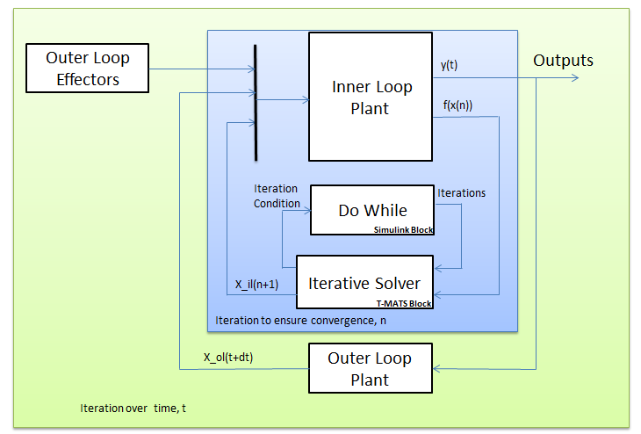

Figure 1. Sample simulation architecture for a dynamic system.

## T‑MATS formatting

### Color Coding

The inputs and outputs of T‑MATS blocks are color coded to aid in simulation setup:

Table 2. T-MATS color coding.

|  |  |
| --- | --- |
| Color | Description |
| Blue | Gas path information containing flow, enthalpy, total temperature, total pressure, and flow composition (typically fuel to air ratio (*FAR*)) |
| Dark Green | Independent variable |
| Green | Dependent variable |
| Red | Independent variable that is obtained through integration in a dynamic simulation, but may be solved for by the solver in a steady‑state simulation (e.g. shaft speed) |
| Magenta | Dependent variable that is integrated in a dynamic simulation, but may be used as a dependent variable in the iterative solver in the steady‑state simulation (e.g. *Ndot*) |
| Pink | Contributor to calculation of a dependent variable (e.g. torque) |
| Yellow | Effector command (example fuel flow), not typically used by the solver |

Typically, items of one color connect to items of the same color (red and magenta items may be exceptions, as noted in Table 2).

### Simulink Wiring

T‑MATS uses a vectored input/output scheme to limit inputs and outputs to those that are absolutely necessary. This means that many of the wires represent arrays of numbers that must be delivered correctly for the simulation to work properly. The order of elements in these wires is given in the “help” page for each block; alternatively, the wire definitions may be viewed by looking under the mask or by running the wire into a bus selector. As a special case, the bleed outputs from the compressor and the cooling flow inputs to the turbine are both dynamically-sized vectors that reflect the number of designed bleeds (specified in the compressor or turbine mask). In general, if an output is not expected to be wired directly to another block, it will be placed in the *\*\_Data* bus (e.g., stall margin is located in the *C\_Data* output of the compressor block).

### Mask format

T‑MATS makes extensive use of the subsystem mask tools in Simulink. Each T‑MATS block comes with a mask that has been created to allow the user to provide to the block any required parameter or setting without having to enter the block itself. The mask parameters for each T-MATS block may be viewed by double-clicking on that block; an example of a T-MATS block mask can be seen in Figure 2.

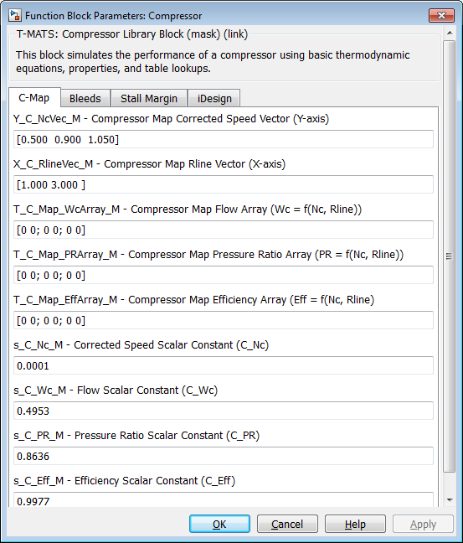

Figure 2. Sample T-MATS function block parameters mask.

At the top of the popup will be the name of the library block followed by a block description. The variables that may be changed in the mask will be listed in the parameters section, which may have multiple tabs. Each mask parameter input description is formatted as: “Name\_M – Definition [units, if applicable] (matrix size, if applicable) (equation format),” where the suffix “\_M” denotes a variable defined in the mask. “Equation format” is typically used for table formatting, described later in this section. Check boxes are used in cases where features can be enabled or disabled; variable names for these items have the form “(VariableName)En\_M”. At the bottom of the parameter dialog is a “Help” button that will provide more information about the block when clicked.

Many T‑MATS blocks accept vector inputs, the length of which may determine the number of block inputs, dependent variables, independent variables, or block outputs. If an input description contains the symbol (“(size)x1”), then that input needs to be a vector of length “size” as dictated by the design. In a specific module, the value of “size” needs to be the same for each item. For example, in the compressor block the dimensions of the input for customer bleed are *cbx1* and for fractional bleed are *bx1*, so the length of the customer bleed vectors should all be the same (*cb*) and the length of fractional bleed vectors should be the same (*b*); it is not required that *cb* = *b*, as demonstrated in Figure 3 where *cb* = 3 and *b* = 2.

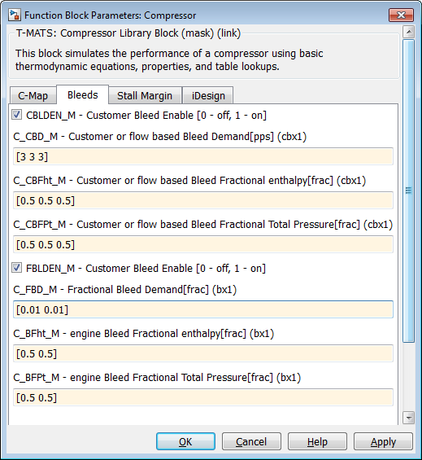

Figure 3. Sample T-MATS function block parameters mask with vectored inputs and checkboxes.

Maps and tables in T‑MATS are entered as mask variables, with two inputs required for 1‑D tables (axis and value breakpoints) and three inputs required for 2‑D tables (breakpoints for two axes and for values). The axis breakpoint arrays will be indicated by the prefix “X\_” or “Y\_” while prefix “T\_” indicates the array of table values. Scalars, which change the scale of maps and tables, are prefixed with “s\_.” The input descriptions of all tables include a simple equation, surrounded by “(),” that denotes which axis variables are used for that particular table (e.g., in the compressor, “Wc = f (Nc,R‑line)” denotes that an element of table *Wc* can be expressed as a function of axis variables *Nc* and *R‑line*, which are defined right above it). Errors will be encountered if single element array (1x1) is entered for tables; instead a line or plane of the same number, for 1-D or 2-D tables respectively, should be entered to create a table with the same value. For example, a 2‑D table with *x*‑axis = [0 1], *y*‑axis = [0 1], and table values = [5 5; 5 5], creates a plane of value 5.

### S‑Functions

Many T‑MATS function blocks make use of S‑functions, which allow code to be developed in the C programming language and then be used by Simulink. (See Section 5.2 for more details about S‑functions operation and Appendix A for a simple code example.) It is important to have a basic understanding of S‑functions so the code may be tuned for each user’s need. The C code is compiled for use in Simulink via the MATLAB *mex* command.

## Solver Setup

The T-MATS solver block sets are based around two major components: an iterative solver and a Jacobian calculator. The iterative solver makes use of the Newton-Raphson method to step a plant toward solution and is described mathematically in Eq. (1):

|  |  |  |
| --- | --- | --- |
|  |  | (1) |

The Jacobian is a linear map between plant inputs and outputs. It is defined by perturbing each plant input from an initial condition (*x*) to find the effect on the plant outputs (*f*). A more precise mathematical description of the Jacobian can be seen in Eq. (2).

|  |  |  |
| --- | --- | --- |
|  |  | (2) |

T-MATS solver blocks work in two major steps. In the first step, the Jacobian calculator calculates a linear map of the plant. Starting at the initial condition, the Jacobian calculator takes turns perturbing each input slightly, recording the results, and calculating the slope of each output as a function of each input. Once this is completed for each input, the Jacobian is built, inverted, and sent to the Newton-Raphson block. In the second step, the Newton-Raphson solver steps toward a solution using the Jacobian developed in the first step. This solver method makes the assumption that the plant is locally linear, so it is possible that the solver will not converge on a solution when the system is (highly) nonlinear. The help files for the blocks inside the solver (TMATS: Newton Raphson Solver and TMATS: Jacobian Calculator) include more information about the solver and how it works.

## Turbomachinery Plant Setup

The “Turbomachinery” sub-library of the T‑MATS Simulink library contains the generic blocks that may be combined to create gas turbines. The most basic definition of a gas turbine is a compressor in series with a burner, a turbine, and a shaft to connect them; more complex gas turbines may have multiple sets of compressors and turbines, as well as different air bypass setups. A simple example of a working gas turbine, used throughout this document, is the turbojet, which consists of a compressor, a burner, a turbine, and a nozzle in series (as shown in Figure 4). Descriptions of the plant setup in this section assumes the reader has some understanding of turbomachinery; if this is not the case, the reader should refer to the sources listed in Section 1.

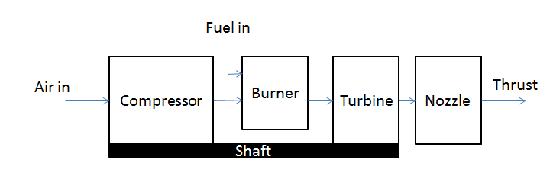

Figure 4. Sample turbojet block diagram.

### Independent and Dependent variables

In a turbomachinery system, flow from station to station is typically unknown and must be solved for. T‑MATS solver blocks can be used to drive the flow errors (the difference between input flow and internally calculated flow) to zero by changing the location of the operating point on compressor and turbine maps. When setting up the simulation, the number of independent variables must match the number of dependent variables. Variable definitions for the dynamic gas turbine example (a simple turbojet) can be seen in Table 3.

Table 3. Dynamic turbofan model independent and dependent variables.

|  |  |
| --- | --- |
| Dependent variables | Independent variables |
| Nozzle Flow Error | Flow into Engine |
| Turbine Flow Error | Turbine PR‑map |
| Compressor Flow Error | Compressor R‑line |

(Note: See the color coding section, 4.2.1, for an easy way to find typical independent and dependent variables)

It should be noted that, although certain inputs may be known in some simulations, setting the known independent variables to constants, and removing dependent variables from the solver, should not be done because minor changes in the vector of independent variables may drive convergence to a map point that does not exist, which will result in the simulation crashing. It is more prudent to simply use the known value(s) in the initial conditions of the independent variables and allow the solver to use the dependent variables to solve for it. If the initial conditions are indeed the steady-state solutions, the final value of the independent variables will remain close to, or the same as, the initial values. If precise input/output interdependencies are required, they can be generated using the TMATS: Jacobian Calculator block in the “Numerical Methods” sub-library.

### Maps

The TMATS: Compressor block uses maps to compute efficiency, pressure ratio, and corrected flow for the compressor, each as a function of corrected compressor speed (*Nc*) and R‑line (typically solved for by the iterative solver) as shown in Figure 5 and Figure 6. Because of the complication of creating a large multidimensional table in MATLAB, the compressor maps in Figure 5 and Figure 6 have been broken down into three different tables for T-MATS, which solve for corrected flow (*Wc*), pressure ratio (*PR*), and efficiency (*Eff*) separately. In addition, scalars have been provided to modify the inputs and outputs of this interpolation to modify performance map characteristics. The scaling of the compressor module’s maps is summarized below in Table 4. It should be noted that, for each turbomachinery component in T‑MATS, speed and flow are corrected as in Eq.(3), where *Nmech* is mechanical shaft speed, *Tin* is total temperature at the block input, *Tstd* is standard day temperature (518.67degR), *Pin* is total pressure at the block input, *Pstd* is standard day pressure (14.7psia), and *Win* is flow at the block input.

|  |  |
| --- | --- |
|  | (3) |

C:\Builds\autotest_20120828\CMap.eps

Figure 5. Sample compressor map (pressure ratio vs. corrected flow).

C:\Builds\autotest_20120828\CMapE.eps

Figure 6. Sample compressor map (efficiency vs. corrected flow).

Table 4. Compressor map equations.

|  |  |
| --- | --- |
| Compressor map variable | Map equations |
| Scaled compressor speed | *Nc‑map* = *Nc* \* *C\_Nc* |
| Pressure Ratio | *PR* = tablelookup(*R‑line*, *Nc‑map*) \* *C\_PR* |
| Corrected Flow | *Wc* = tablelookup (*R‑line*, *Nc‑map*) \* *C\_Wc* |
| Efficiency | *Eff* = tablelookup (*R‑line*,*Nc‑map*) \* *C\_Eff* |

(Note: Table definition variables are not listed, however it should be noted that each 2‑D map requires *x*‑axis, *y*‑axis and table values definition.)

The TMATS: Turbine block uses maps to compute the efficiency and corrected flow for the turbine. These two variables are taken as functions of corrected turbine speed (*Nc*) and PR‑map value (typically solved for by the iterative solver), as shown in Figure 7, and T‑MATS uses two tables to represent the turbine map: one solves for efficiency (*Eff*) and the other for corrected flow (*Wc*). As with the compressor map definition, scalars are provided to allow for modification of performance map characteristics. Scaling of the turbine block’s maps has been summarized in Table 5.

C:\Builds\autotest_20120828\TMap.eps

Figure 7. Sample turbine map (corrected flow vs. pressure ratio).

C:\Builds\autotest_20120828\TMapE.eps

Figure 8. Sample turbine map (efficiency vs. pressure ratio).

Table 5. Compressor map equations.

|  |  |
| --- | --- |
| Turbine map look up | Map equations |
| Scaled turbine speed | *Nc‑map* = *Nc* \* *C\_Nc* |
| Scaled Pressure Ratio | *PR-map* = *PRinput* \* *C\_PR* |
| Corrected Flow | *Wc* = tablelookup (*PR‑map*, *Nc‑map*) \* *C\_Wc* |
| Efficiency | *Eff* = tablelookup (*PR‑map*, *Nc‑map*) \* *C\_Eff* |

(Note: Table definition variables are not listed, however it should be noted that each 2‑D map requires *x*‑axis, *y*‑axis and table values definition. Also, turbine-defined parameters are independent of compressor-defined parameters.)

T‑MATS has been designed to be as flexible as possible; however compressor and turbine maps can be defined in various ways. In cases where the maps are not compatible and cannot be adjusted for use with the T-MATS block sets, new modules must be created to be compatible with the map version that is desired.

One case where a map can be converted for use in a T-MATS module is when a compressor EM-line is used. An EM‑line is an R‑line that has been forced to take the form of a linear equation. The compressor module for T‑MATS is designed to use tables for the map, not equations, but a translation from one map style to the other is possible by creating an R‑line from the EM‑line through calculation of various R‑line points using the EM‑line equation. Take, for example, the case where corrected flow (*Wc*) is a table lookup based on compressor speed (*Nc*) and EM-line, and the compressor pressure ratio and efficiency are defined as in Eq. (4).

|  |  |  |
| --- | --- | --- |
|  |  | (4) |

To convert this map to an R‑line based map, pairs of *Nc* and EM-line values may be chosen for calculation of *PR* and *Eff* tables based solely on *Nc* and EM‑line (EM‑line values can essentially be used in place of R‑line values). The table for *Wc* is already in an acceptable form, so translation is not required. In this example, all T‑MATS scalars would be equal to 1 as they do not appear in the compressor map definition.

### Compressor Variable Geometries (IGVs and VSVs)

Variable geometries (VGs) within the compressor perform essential functions in many modern large engines. Inlet guide vanes (IGVs) and variable stator vanes (VSVs) are two such geometries that may need to be taken into account when developing a gas turbine engine model in T-MATS. In the TMATS: Compressor block VG positions must be taken into account in the compressor maps. At this time, T‑MATS does not have the ability to produce off-nominal transients of the VGs; however this feature is planned for future releases.

### Bleeds and Air Bypass

High pressure air generated by turbomachinery is a versatile commodity with a wide range of uses. In T‑MATS, the removal of air via “bleeds” or air bypasses can be modeled in a few ways: inter‑stage bleeds, such as customer bleeds and fractional bleeds, may be enabled for the TMATS: Compressor module and the T‑MATS: Splitter block allows for the creation of bypass flow. The customer bleed is a constant demand for flow while fractional bleed is a fraction of the total flow through the compressor. Typically, customer bleed is air demanded for use by a system outside of the engine (e.g., to cool the cabin, run power generators, etc.) and fractional bleed is used as cooling flow in turbine components. Bleed flow outputs are vectors of flow path variables (color-coded blue as described in Table 2) combined in series and contain all information required for general processing. As currently written, twenty bleed flows of each bleed type may be requested in a block. Each bleed flow may be “pulled off” the bleed vector output and routed into the intended/appropriate input, such as cooling flow for a turbine.

Main air bypasses in the model may be created using the TMATS: Splitter block, which typically work in conjunction with a nozzle block. See Section 4.4.5 for more details about how to use a splitter to create a high bypass engine model.

### Turbofan modeling options

Modeling a turbofan engine may require the creation of a fan module and the adoption of a system architecture that partitions flow into a main flow path and a bypass flow path. This architecture can be set up in several ways, each of which makes use of compressor, splitter, and nozzle T‑MATS modules. In T‑MATS, a fan may be modeled as a one-stage compressor, or the two flow paths in a high bypass engine (commonly called the tip and hub flows) may instead be modeled using one of the three flow-splitting modeling architectures in Figure 9:

1. Split the main flow path before the fan, modeling the tip and hub flows separately with two compressor blocks.
2. Dedicate separate input flows to the tip and hub, modeling each with separate compressor blocks.
3. Split the main flow path after the fan, modeling the entire fan with one compressor block (tip and hub flows are combined).

The architecture chosen for a model will mainly be determined by the available maps, and the options in Figure 9 are by no means the only options for modeling tip and hub flow. It should be mentioned that the inclusion of a bypass flow creates additional independent and dependent variables that must be added to the solver. The additional independent variables are the input flows, R‑lines, and/or splitter bypass ratios for the added components, while the additional dependent variables are the flow errors associated with these same components.

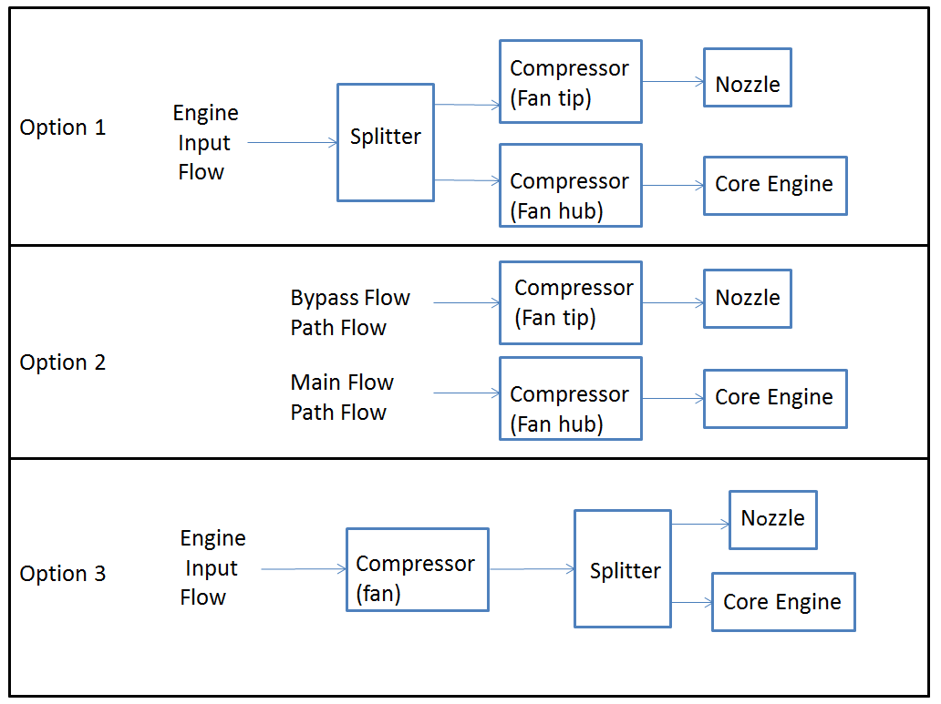

Figure 9. Sample fan model creation schemes for a gas turbine with bypass.

### iDesign

Certain T‑MATS turbomachinery blocks have the capability of calculating engine map scale factors and internal variables, based on design or steady-state input parameters, through the process called iDesign. This process may be turned on through the mask variable iDes\_M located under the iDesign tab of appropriate blocks. The iDes\_M value may be set to 0, 1, or 2.

A value of 0 turns iDesign on and will allow the simulation to save key variables (i.e., scale factors and other key internal variables, such as nozzle throat area, etc.).

A value of 1 turns iDesign off and specifies that the simulation shall use the key variables created when the system was run with iDesign turned on.

A value of 2 turns iDesign off, but sets the key variables to values specified in the block mask.

Blocks that utilize iDesign (compressor, turbine modules, etc.) require certain design or steady-state variables to be known and entered into their masks in order for iDesign to work; the help menu for each of these blocks should be consulted to determine what is required. Once this information has been defined, the simulation can be run. Typically, an iDesign run involves simulation of a steady-state model to allow the solver to converge to its design point (or a suitable steady-state value). Once complete, the scale factor for iDesign enabled blocks may be found in the *\*\_Data* output bus, in a specified .mat file, or in the workspace. Be aware that running T‑MATS dynamically with iDesign enabled (0) will produce unpredictable results that should not be used. Also note that, in cases where the maps have not been scaled, the values calculated by iDesign should be within 1% of 1. Otherwise, in cases where the maps have been scaled (as in *Example\_Gas\_Turbine\_SS*) the values calculated by iDesign may vary widely from 1 with a final value dictated by the requirements of the final map.

## Cantera Integrated Blocks

Some T-MATS blocks have been integrated with the open source Cantera software package. As stated by the software documentation (<https://code.google.com/p/cantera/>), “Cantera is a suite of object-oriented software tools for problems involving chemical kinetics, thermodynamics, and/or transport processes.” Integration of Cantera brings many new capabilities to T-MATS, including the use of off nominal fuels, alternate flow path gasses, etc. This is accomplished with the addition of a new MATLAB package that includes a new Simulink sub-library, Turbomachinery\_Cantera, and new package scripts and classes.

### Cantera Installation

T-MATS\_Cantera makes use of MATLAB scripts with Cantera functions built in, which are located within the \TMATS\TMATS\_Library\MATLAB\_Scripts\Cantera\_Enabled folder. To use these scripts the Cantera Toolbox must be installed into MATLAB/Simulink. Instructions on how to install the Cantera package are located at the software homepage (<https://code.google.com/p/cantera/> and <http://cantera.github.io/docs/sphinx/html/index.html> ). It should be noted that T-MATS\_Cantera was developed using the Cantera Toolbox version 1.0. Toolbox version numbers can be checked using the ver command in MATLAB.

### Using T-MATS\_Cantera Blocks and scripts

T-MATS blocks that utilize Cantera functions are located in the Simulink library browser under \*\_Cantera and Cantera enabled scripts are located in the TMATSC MATLAB package. Before a simulation containing T‑MATS\_Cantera blocks or scripts can be run, a global variable, fs, must be defined and the script *canteraload.m* located in the folder, TMATS\TMATS\_Library\MATLAB\_Scripts\Cantera\_Enabled\+TMATSC, must be filled out.

The *canteraload.m* script defines the Name and Species of the flow streams. Currently there may be up to six flow types that each contain up to six molecule components. This information is organized into a 6×6 matrices with rows containing molecule types and columns containing their proportions by weight. Flow compositions are determined from a 6×1 vector where each value relates to one row of the 6×6 matrix. For example, a flow composition vector of [1 0 0 0 0 0] would relate to Air comprised of: N2; 0.7547, O2; 0.232, and AR; 0.0128 as seen below (Note, all compositions are proportional by weight). In general the flow composition vector is generated automatically then used along with the Name and Species matrices to complete and execute Cantera functions. Because of this, Name and Species form must be consistent with Cantera function notation. Default definitions for *Name* and *Species* is located below and details generic air (row 1), water (row 2), and fuel (row 3). The remaining 3 rows have not been defined.

Name = { 'N2' 'O2' 'AR' '' '' '';... %Air

'H2O' '' '' '' '' '';... %Water

'CH2' 'CH' '' '' '' '';... %Fuel

'' '' '' '' '' '';...

'' '' '' '' '' '';...

'' '' '' '' '' '' };

Species = { 0.7547 0.232 0.0128 0 0 0;... %Air

1 0 0 0 0 0;... %Water

0.922189 0.077811 0 0 0 0;... %Fuel

0 0 0 0 0 0;...

0 0 0 0 0 0;...

0 0 0 0 0 0};

In addition to specifying the composition values for the flows, it is also important to create the Cantera phase object to allow Cantera to communicate with MATLAB appropriately. The phase object is defined by creating global variable fs in the MATLAB workspace. The variable fs must contain all necessary molecule types that are used in the load script presented above. Below is an example of the commands that may be used to declare fs.

global fs

fs = importPhase('gri30.cti')

The Cantera function importPhase will import one phase from an input file, in this case gri30.cti.

For T‑MATS\_Cantera Simulink blocks, flow information is transferred via a 25×1 vector that is defined as shown in Table 6. This vector contains detailed flow information that may be used for calculations or informational purposes inside and/or outside of T‑MATS blocks. The class containing methods TMATSC.FlowDef and TMATSC.FlwVec defines names for the flow vector, and may be updated per user requirements. It should be noted that all communication between Cantera and MATLAB is handled with a MATLAB class, as described in the next section, and a flow vector is only required because Simulink is incompatible with classes.

Table 6. T-MATS\_Cantera flow vector structure for Simulink.

|  |  |  |
| --- | --- | --- |
| # | Variable | Description |
| 1 | W | gas path flow [pps] |
| 2 | s | entropy [BTU/(lbm\*degR)] |
| 3 | Tt | total temperature [degR] |
| 4 | Pt | total pressure [psia] |
| 5 | ht | enthalpy [BTM/lbm] |
| 6 | rhot | total density (rho) [lbm/ft^3] |
| 7 | gamt | total specific heat ratio (gamma) |
| 8 | Ts | static temperature [degR] |
| 9 | Ps | static pressure [psia] |
| 10 | hs | static enthalpy [BTU/lbm] |
| 11 | rhos | static density (rho) [lbm/ft^3] |
| 12 | gams | static specific heat ratio (gamma) |
| 13 | Vflow | flow velocity [ft/sec] |
| 14 | MN | Mach number |
| 15 | A | flow area [in^2] |
| 16-21 | CompVal\_TMATS | Flow composition vector, see *canteraload.m* for definition of the 6 matter types |
| 22-25 | none | future use |

### Interfacing with Cantera

T-MATS blocks that utilize Cantera functions have been built in a hierarchical fashion to allow a user to update the blocks to a level with which they are familiar. Looking at Figure 10, a simulation may be created in Simulink using the set of T-MATS\_Cantera blocks. These blocks consist of an M-S-function that calls MATLAB scripts written using the TMATSC MATLAB package. This MATLAB package consists of specialty scripts and a class called FlowDef that acts as a simplified interface with Cantera. When working with a design any of these levels may be adjusted to meet task requirements.

Simulation

(Simulink)

T-MATS\_Cantera Block

(M-S-function)

Functional script

(MATLAB script)

TMATSC package, FlowDef class

(MATLAB script)

Cantera Commands

Figure 10. T-MATS/Cantera block hierarchy.

The TMATSC MATLAB package contains a class and functions that are used in the creation of the T­‑­MATS Cantera block set and are summarized in Table 7. Functions located within the package offer file manipulation and reading scripts useful for manipulating data storage.

Table 7. Package TMATSC functions and classes.

|  |  |
| --- | --- |
| Function | description |
| Object = FlowDef() | Flow object constructor (see Table 8) |
| [val] = canteraload(RequestType) | Returns Name or Species matrix to be used in Cantera command generation. |
| [effMap, WcMap] = PRmapFile(MapFileName, NcMap, PRmap) | Table lookup for effMap and WcMap |
| [effMap, PRMap, WcMap, StallMargin] = RlineMap(MapFileName, NcMap, Rline) | Table lookup for effMap, PRMap, WcMap, and StallMargin |
| [val] = getV(var, parent) | Get a variable from the workspace |
| setV(var, parent, value) | Set a variable to the workspace. |
| [string] = stripchar(string) | Remove’ \’, ‘/’, or ‘\o’ from a character string. |

The class TMATSC.FlowDef offers the ability to create flow objects that contain all the flow information required for thermodynamic computations, as well as laying out a simplified interface with Cantera functions, as shown in Table 8. Interaction with the Simulink environment is accomplished with the generation of a flow vector, described in Table 6 above, based a flow object. TMATSC functions and class methods can be imported into a script by implementing the command “import TMATSC.\*” or by placing TMATSC. or TMATSC.FlowDef. , respectively, before the command.

Table 8. Class TMATSC.FlowDef methods, Cantera interface functions.

|  |  |
| --- | --- |
| Class Method | description |
| Flow object construction: |  |
| flow\_new = FlowDef() | 0 input Creates empty TMATSC flow object |
| flow\_new = FlowDef(FlowVector) | 1 input. Flow constructor based on flow vector. |
| flow\_new = FlowDef(flow, compNN, W, Tt, Pt) | 4 inputs. Create populated flow object with total values only (Total only, based on set\_TP) |
| flow\_new = FlowDef(flow, compNN, W, Ts, Ps, MN) | 5 inputs. Create populated flow object (Total and Static, based on set\_TsPsMN) |
| flow\_new = CanSet(flow) | Set flow object composition values to Cantera format (CompVal\_Can based on CompVal\_TMATS flow object value) |
| flow\_new = CanSet(flow, compNN) | Set flow object composition values to Cantera format (CompVal\_Can based on input compNN, 6×1 vector) |
| Cantera interface functions: |  |
| flow\_new = flowadd(flow1, flow2) | Add flow1 and flow2 together, conserving enthalpy and mass |
| flow\_new = flowcopy(flow) | Copy information from one flow to another flow |
| mass\_frac = getMassFraction(flow, c) | Return mass fraction of compound c in the object flow |
| flow\_new = set\_hP(flow, ht, Pt) | Set total conditions based on flow, total enthalpy and total pressure |
| flow\_new = set\_MN1(flow) | Set the static conditions to sonic flow based on flow conditions |
| flow\_new = set\_MNPs(flow, Ps) | Set the static conditions based on flow and static pressure |
| flow\_new = set\_SP(flow, S, Pt) | Set the total conditions based on flow and input entropy and total pressure |
| flow\_new = set\_TP(flow, Tt, Pt) | Set the total conditions based on flow, total temperature, and total pressure |
| flow\_new = set\_TsPsMN(flow, Ts, Ps, MN) | Set the conditions based on flow, static temperature, static pressure, and Mach number |
| Flow object manual set functions: |  |
| flow\_new = TotalSet(flow, s, Tt, Pt, ht, rhot, gamt) | Manually sets total variables in flow object |
| flow\_new = StaticSet(flow, Ts, Ps,hs, rhos, gams) | Manually sets static variables in flow object |
| flow\_new = SpeedSet(flow, MN, A, Vflow) | Manually sets speed variables in flow object |
| flow\_new = SClr(flow) | Clears all static variables in a flow object |
| flow\_vector = FlwVec(flow) | Creates 25×1 flow vector |

To create an empty flow object, the following code can be executed in the MATLAB command prompt:

NewFlowObject = TMATSC.FlowDef();

Alternatively, a Cantera flow vector, as described in Table 6 , can be used to generate a defined flow object as shown below:

NewFlowObject = TMATSC.FlowDef(Flow\_Vector);

The flow vector may be regenerated from the flow object using the FlwVec command:

FlowVector = FlwVec(FlowObjectName);

A good rule of thumb when choosing to use T‑MATS\_Cantera flow vectors or flow objects, is that a flow object created from the flow class should be used when working with the MATLAB scripting language, and the flow vector should be used only when transferring data out of Simulink blocks. It should be noted that when filling in a flow object manually, the TMATSC.CanSet method must be run after the CompVal\_TMATS vector property has been set to automatically generate the CompVal\_Can property, which is required by Cantera commands.

# Customization

Although T‑MATS blocks are designed to be as general as possible, a user may need to customize an existing function within T-MATS, or create an entirely new function, to meet the needs of a specific application. This section will go over how to add new blocks to the library and how to change existing blocks to meet simulation needs.

The library file structure, in Table 9, reflects how T-MATS blocks are displayed in the Library Browser.

Table 9. T-MATS library file structure.

|  |  |
| --- | --- |
| File | Map equations |
| slblocks.m | MATLAB script. Highest Level file, contains library definition for the Simulink Browser Library |
| TMATS\_Lib.slx | Library file, contains subroutines that act as folder links for libraries |
| TMATS\_FolderName.slx | Library file, contains library links to the various T‑MATS blocks |
| Lib\_FolderName\_BlockName\_TMATS.slx | Library file, contains individual T‑MATS blocks |

## Library Blocks

The T‑MATS library is essentially a grouping of useful Simulink blocks that can be connected together to create complex thermodynamic systems. By adding new library blocks, it is possible to expand and customize the simulation environment to meet the needs of the simulation. A new block can be added to a T‑MATS library by performing the following steps:

1. Navigate to the \TMATS\_Library folder in your T‑MATS installation directory.
2. Open the Simulink Library Browser and create a new library by clicking File ‑> New ‑> Library (or open and rename an existing T-MATS library file with a file name to reflect the contents of the new library).
3. Create a block in the library file, making sure that the highest view in the hierarchy contains only a subsystem. The library file must be saved before it can be linked to a T-MATS library.
4. Open the file of the T-MATS sub-library into which the new block will be linked (e.g. *TMATS\_Solver*) and drag the new block into that window to create the link. Note that Simulink may prompt the user to unlock the library before it can be edited. This can be done by clicking Diagram-> Unlock Library.
5. After refreshing the Simulink Library Browser (F5), the new block will appear in the window.

### Creating new Simulink Library Browser folders

Simulink Library Browser folders are an easy and convenient way to organize blocks contained in a library. The file *slblocks.m* is used to add libraries to the highest level of the Simulink Library Browser’s hierarchy. For T‑MATS, this file links the high-level Library block, *TMATS\_Lib* (which contains all the block “folders” for T‑MATS), to the Simulink Library Browser. When adding new blocks to T‑MATS that do not fit into the current library organization, it is suggested to add another folder to the library by augmenting a new “folder” to the *TMATS\_Lib.slx* library file following these steps:

1. Open *TMATS\_Lib.slx*, located at TMATS\TMATS\_Library.
2. Create a subsystem with no inputs or outputs, giving it an appropriate name. Note that the library will need to be unlocked (following the prompt from Simulink) before it can be edited.
3. Right click the block and select “Properties” from the menu. Under the “Callbacks” tab, select OpenFcn and add the name of the library file containing the “folder” to the contents area (for example, *TMATS\_Turbo*).

## S‑functions

In T‑MATS, many blocks utilize Simulink S‑functions. S‑functions allow for the integration of Simulink with code written in another programing language (in this case, C or C++), imparting a number of advantages over using traditional Simulink blocks. One advantage is speed: while many Simulink blocks and MATLAB functions can run quite fast, compiled C code typically runs much faster. A second advantage is that using S-functions allows for the use of legacy code, which may not be written in Simulink/MATLAB, in simulation development. (Legacy code, however, does require some modification to match the special formatting requirements of S‑functions.) It should be noted that in order to use C code in a simulation, a MATLAB-compatible compiler must be installed and the code must be compiled (using the MATLAB *mex* function) to produce a MEX file.

S‑functions calls are created in Simulink by placing in the model the S‑function block located within the Simulink ‑> “User‑Defined Functions” sub-library in the Simulink Library Browser. By default, S‑function code in T‑MATS has been written in C. Starting with an example S‑function as a template (such as the marked up function in Appendix A), modifications are generally only needed to the definitions at the top of the file, and to the mdlInitialSizes and mdlOutputs functions, to create any functionality. A quick reference for the most common MATLAB/Simulink S-function programming functions is listed below:

1. ssGetSFcnParam: get a parameter from the dialog box.
2. mdlInitializeSizes: initialize the size of the input and output ports
3. mdlInitializeSampleTimes: initialize code sampling characteristics
4. mdlOutputs: includes the main body of code and defines the outputs
5. mdlTerminate: ends the S-function, includes code that executes at the end of the simulation

For more information on S-function block setup, creation of MEX files, or functions prefixed with an *mdl* or *ss*, see the MATLAB help functions. Additional T‑MATS code that may be used as examples can be found in the TMATS\TMATS\_Library\MEX\C\_code folder.

## Tool Creation

T‑MATS makes use of internal MATLAB menu functions, which act to call .m scripts each time the menu item is selected. The setup of these menu functions is handled by the file *Menu\_customization\_TMATS.m*, located within the TMATS\Tools folder. Once T‑MATS is installed, this script is called each time MATLAB is opened to create the items in the T-MATS tools menu using the sl\_customization\_manager command.

# Troubleshooting T‑MATS

## Convergence “Errors”

When running T‑MATS modules in a loop with solver blocks, the simulation will first act to converge the plant. In a simulation with new compressor and turbine maps, it is common for discrepancies in parameters to be present. These discrepancies are the equivalent of placing the wrong hardware on the gas turbine (e.g. a gas turbine with a compressor that is too small) and will cause problems with plant convergence. Failures in convergence often result in Simulink notification of errors in blocks that seemingly have nothing to do with the solver, such as integrators or state-space blocks, which makes troubleshooting the error more difficult. This is why, if an error occurs when running a model, the value of dependent variables (*f(x)*) routed to the solver should be checked first. If any of the values are inf, NaN, or outside the specified iteration condition limits for the solver, the simulation is not converging. It should be noted that in some cases T‑MATS blocks will issue errors. The reason for these errors will be justified in the error message and they will not be reviewed in this document.

Troubleshooting a convergence issue can be very difficult. Outlined here are a few ways to troubleshoot a suspect simulation:

1. **Double‑check block inputs:** Check for errors in the maps and constants used in the simulation.
2. **Check solver inputs:** Improper independent variable initial conditions, perturbation size, etc. may cause the solver to get stuck in a local minimum that does not result in system convergence.
3. **Check independent/dependent variable matching:** Verify that all system independent variables and dependent variables are accounted for in the simulation/solver.
4. **Component testing:** If data is available (from another example of the system) at the input and output of each component (station), the simulation can be broken down to the component-level, feeding the inputs observed from the other model to the inputs of each block. This can help isolate a specific block that is not modeled correctly.
5. **Steady-state testing:** If the system is intended to be run dynamically, try running it in steady-state first to identify if a problem with the solver parameters is contributing to the convergence problem.
6. **Run without solver:** Take out all the solvers and run the simulation with constant input to each independent variable; if there is another example of the system that the model can be compared against, doing so can help find errors.
7. **Analyze the Jacobian:** It may be useful to look at the Jacobian (*J*), which shows the relationship between independent variables and dependent variables in the system, as the solver tries to converge to a solution. This value is located within *S\_Data* bus output from the solver blocks and can be displayed using the Simlunk: Display sink block. Given an understanding of which independent variables should affect which dependent variables, the values of the Jacobian may be used to determine a possible source of error in the model.
8. **iDesign:** The iDesign feature, which can be turned on for each block, forces the simulation to converge; this feature may be used to help determine how “close” to convergence the simulation is, with the caveat that unrealistic scalars may be produced (e.g. efficiency of a component might be greater than 1). See Section 4.4.6 for more information on iDesign.

## Crashing

There may be times when a T‑MATS simulation will crash and issue a system error, causing MATLAB to close ungracefully (Figure 11). These internal errors typically arise due to errors in the execution of the compiled C code (generally when the C code attempts to access memory locations that it doesn’t have access to). This can occur when:

* Attempting to access elements of arrays outside of the memory range (e.g., element 21 of a 15 element array).
* Using pointers incorrectly.
* Passing arrays to other functions by reference.

One such error has been observed when a length-1 vector or array is provided for a mask parameter used for table lookup. If the simulation crashes, one of the first steps should be to check that the mask parameters for each T‑MATS module have proper length. It should be noted this is just one possible reason for the crash.

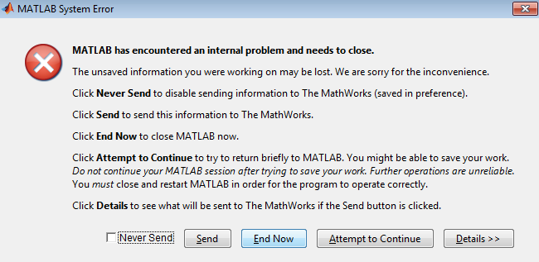

Figure 11: Sample MATLAB internal problem message

# T‑MATS Tutorials

The T‑MATS software package is a Simulink library that can be used to model any thermodynamic system. In order to help the user better understand how the various blocks in the library can be assembled, the software package contains three examples. This tutorial will describe their development and highlight important points that the user should keep in mind when developing simulations. As a user works through the tutorial, it may be useful to have the corresponding example from the T-MATS library loaded for comparison.

## T‑MATS example 1: Newton-Raphson Equation Solver

This section will describe how to combine T‑MATS blocks to create a simple equation solver. This solver is included in the examples section of T‑MATS (*NewtonRaphon\_Equation\_Solver.slx*).

1. **Create plant**

In this example, the plant is fully defined, is dependent only on a set of inputs, has 3 independent variables and 3 dependent variables, and is in the form of polynomials (created with Simulink: Fcn blocks). For quick reference, the three functions used in the T‑MATS example have been reproduced in Eq. (5).

|  |  |  |
| --- | --- | --- |
|  |  | (5) |

1. **Place the solver**

In this case, the system is not time-dependent so the steady-state solver block (TMATS: SS NR Solver w JacobianCalc) will be used.

1. **Connect the blocks**

The outputs of the function blocks are dependent only on the inputs to the function blocks. The T‑MATS solver block has been designed to accept a vector input and produce a vector output, requiring that the outputs of the function blocks be multiplexed together, and then wired to the input of the solver block, *f*(*x*). The output of the solver, *X*, can be routed directly to the input of each function block, as those blocks accept a vector input (see the diagram later in this section, where displays were added to enable the user to observe results).

1. **Set up the solver**

Double click the solver. The mask parameters need to be tuned per the application. The length of the vectors *SJac\_Per\_M* and *SNR\_IC\_M* must both be equal to the number of independent variables and dependent variables in the system (in this case, 3). See the example model *NewtonRaphson\_Equation\_Solver.slx* to view the mask parameters for this particular case.

1. **Configure the simulation**

To avoid encountering errors when running the simulation, the solver options should be set up prior to doing so through the “Configuration Parameters” window, accessed from the “Simulation” option on the Simulink menu bar. Navigate to the “Solver” pane and select the fixed-step, discrete solver as shown in Figure 11.

1. **Run the simulation**

At this point the system can be run. Click the green play button at the top of the Simulink model. If the simulation solver options have been properly set up, the simulation will run successfully

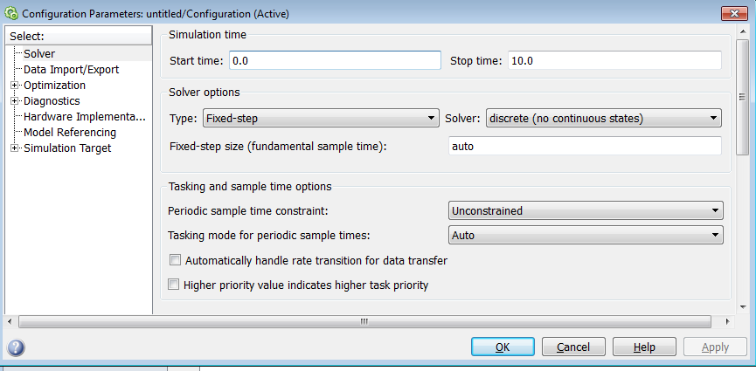

Figure 11. Model configuration parameters setup.

1. **Execution is complete, interpret results**

The displays will be populated with the solution to the equations (see Figure 13 ). The element *Converged* in the S*\_Data* output vector shows whether the model has converged. This element will be 1 if the convergence criteria have been met, but will be 0 if the solver inputs, *f(x)*, do not approach zero.

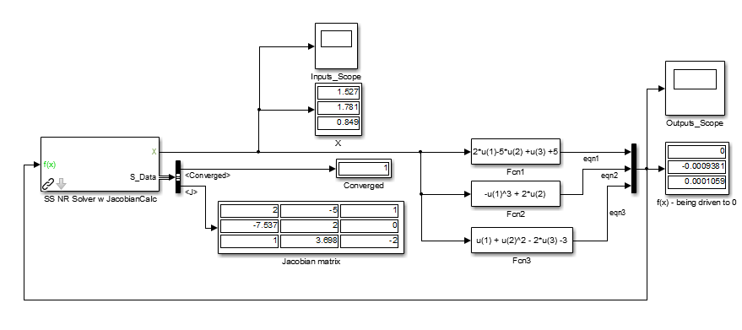

Figure 13. Run equation solver.

## T‑MATS example 2: Example\_GasTurbine\_SS

This section will describe how to combine T‑MATS blocks to create the simple steady-state gas turbine example included with T‑MATS (*GasTurbine\_SS\_Template.slx*). Note that the example model makes use of the Block Link Setup tool to produce a clean-looking model by replacing lines with Simulink: GoTo and Simulink: From blocks.

### Creating the Gas Turbine Plant

1. **Gather the blocks**

Place TMATS: Shaft, Compressor, Burner, Turbine, Duct, and Nozzle blocks into a model. These are located in the “Turbomachinery” sub-library of T‑MATS.

1. **Connect the core gas path**

Line up the blocks in the same order as they are listed in step 1 and connect each *GasPthChar* output to the *GasPathChar* input of the next block. (The shaft is not part of this step.)

1. **Connect the bleed gas path**

Although this example does not use customer bleed or cooling flow, connecting the *FBldsCharOut* output from the compressor with the *CoolingFlwCharIn* input to the turbine will allow for these features to be added later, if necessary.

1. **Route un-used outputs to terminator blocks**

The outputs listed in Table 10 are not used in this tutorial and should be wired to a Simulink: Terminator block.

Table 10. Steady-state turbofan engine example, unused outputs.

|  |  |
| --- | --- |
| Block | Unused Output |
| Compressor | *CustBldsCharOut* |
| *C\_Data* |
| Burner | B\_Data |
| Turbine | *T\_Data* |
| Nozzle | *WOut* |
| *Fg* |
| *N\_Data* |

Note that using the Block Link Setup tool on each block will automatically place the Simulink: Terminator blocks at these outputs.

1. **Set up the shaft component**

Connect *NmechOut* (from the shaft) to the *Nmech* input on both the compressor and turbine. Multiplex the *TrqOut* outputs from the compressor and turbine and connect this signal to the *Torque* input on the shaft.

1. **Set up the input flow**

The TMATS: Ambient block converts environmental characteristics to gas turbine thermodynamic characteristics; place this block in the model and connect the *GasPthChar* output to the *GasPthChar* input of the TMATS: Compressor block. The ambient pressure (*Pamb*) output of the TMATS: Ambient block needs to be routed to the *Pamb* input of the TMATS: Nozzle while the *A\_Data* output is unused and can be routed to a Simulink: Terminator block.

Set inputs for the environmental conditions (TMATS: Ambient block) and fuel flow (TMATS: Burner block) to constants, since the simulation will solve for steady-state.

1. **Define the mask parameters**

Constants and maps for each component should be updated per the user’s particular application. See the example model for values usable for this particular case. (Note that the actual values for each parameter are in the setup file, which creates the variables specified for the mask parameters in the Simulink model file.) The completed gas turbine plant model should resemble Figure 14, where Simulink: Display blocks have been added at the output of each component.

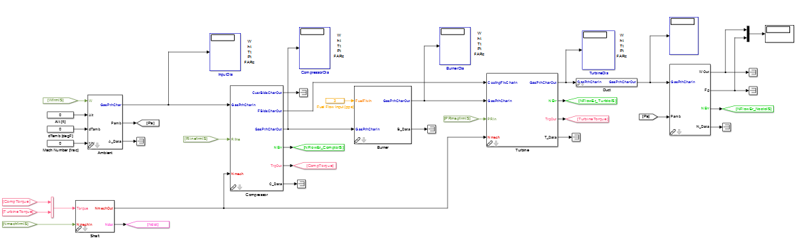

Shaft

Nozzle

Burner

Turbine

Compressor

Duct

Ambient

Figure 14. Gas turbine plant.

### Plant Solver integration and plant inputs

1. **Create the solver**

Place the TMATS: SS NR Solver w Jacobian Calc block in the model. Multiplex all dependent variables (component outputs color coded in green) and *Ndot* (from the shaft) and route the signal to the *f(x)* input of the solver block. De-multiplex the output of the solver block, *X*, and route each independent variable to one of the dark green inputs of the component blocks; one of the independent variables should be routed to the *NMech* input of the shaft block. In this example there are four independent variables and four dependent variables, as shown in Figure 15, where display blocks have been added to the solver input and output to aid in determining if the solver has converged to a solution.

1. **Set up the solver parameters**

Once the signals have been connected, the solver mask parameters should be defined; these parameters include the initial conditions, the termination conditions, and other values that affect the accuracy of the solver. See the example for the values used for this model.

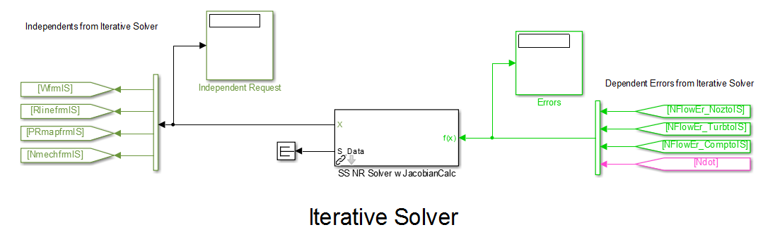

Figure 15. Steady-state solver setup.

1. **Configure the solver**

Open the simulation configuration window (Simulation -> Model Configuration Parameters on the Simulink menu bar) and select a fixed-step discrete solver, specifying the start and stop times as well as the fixed step size. (See the tutorial in Section 7.1 for more information on setting up the solver for simulation.)

1. **Running the simulation**

Once the engine model has been created and connected to the solver, the simulation can be run by pressing the run button located in the menu bar. After completing the run, the display blocks should be checked for convergence. It can be seen in Table 11 that the independent and dependent variables in example 2 are being driven to convergence (that is, the flow errors approach zero).

Table 11. Example 2 convergence outputs.

|  |  |  |  |
| --- | --- | --- | --- |
| Independent variable | Independent Request (value) | Dependent Variable | Errors  (dependent value) |
| W (system input) | 101.2 pps | Normalized flow error Nozzle | 6.413e-06 N/A |
| R-line (compressor) | 1.955 N/A | Normalized flow error compressor | 6.379e-06 N/A |
| PRmap (turbine) | 3.054 psia/psia | Normalized flow error Turbine | 4.884e-06 N/A |
| Nmech (shaft) | 9980 rpm | Ndot (shaft) | 0.007742 rpm/sec |

Because the steady-state gas turbine example requires definition of a large number of block parameters, the example was developed to utilize a setup script (the filename has the suffix “*\_setup\_everything*”). When run, this script creates a path to the SimSetup folder and runs all the files in that folder, which create the variable *MWS* in the workspace. This variable is a MATLAB data structure that contains many of the variables used in the example, which can be accessed with the syntax: *MWS.Component.Variable* (for example, *MWS.HPC.s\_Wc* can be used to access the scalar for the *Wc* map in the HPC). When the simulation is run, Simulink will look for *MWS* in the MATLAB workspace and load the required variables. The example has been configured to automatically remove the temporary paths (created by the setup script) by running a cleanup script when the model file is closed.

## T‑MATS example 3: Example\_GasTurbine\_Dyn

Although it has the capability to solve for a steady-state condition, T‑MATS is designed to ultimately be used in a dynamic simulation environment. This section will describe how to create a dynamic gas turbine simulation using T-MATS blocks and will also provide demonstration of various MATLAB practices the user may wish to utilize when developing a new simulation. This example is included in the examples section of T‑MATS (*GasTurbine\_Dyn\_Template.slx*).

Before attempting to recreate the dynamic gas turbine simulation example, the user should read through the previous two examples, as certain topics covered in them will be skipped here. In particular, the description of how to structure the model assumes that the engine plant model has already been constructed, following the instructions presented in Section 7.2 for the steady-state gas turbine simulation.

### General Architecture

Implementing a dynamic solver in T‑MATS requires that at least two separate loops be set up. This example uses an “inner” loop, which solves for convergence, and an “outer” loop, which steps through time. The “inner” loop includes the plant and the solver, and is where the independent variables are solved for from the dependent variables. The “outer” loop sets up the dynamic portion of the simulation and represents evolution of the system, which is converged at each time-step, over time. A hierarchical approach is required when creating such nested loops in Simulink (see Section 4.1 for more details).

#### Creating a Dynamic Simulation framework

1. **Set up the inner loop**

Starting with the steady-state model described in the previous section, place a Simulink: While Iterator Subsystem in the model. Enter the subsystem and double-click the Simulink: While Iterator block to open the parameter window. Make the following changes: set the maximum number of iterations to -1, change the loop type to “do-while”, and check the box next to the “Show iteration number port” option.

1. **Prepare the steady-state model for dynamic simulation**

Delete the default input and output ports in the Simulink: While Iterator Subsystem. Copy and paste the entire steady-state model (plant and solver blocks) into the subsystem. It may be helpful at this step to place the plant in its own subsystem within the while-iterator subsystem, as shown in Figure 16, where the low-level gas turbine components have been placed in the InnerLoopPlant subsystem.

1. **Add the dynamic solver**

Replace the TMATS: SS NR Solver w JacobianCalc block with the TMATS: Iterative NR Solver w JacobianCalc block and connect the *do\_while\_Condition* output of the T-MATS solver to the *cond* input of the Simulink: While Iterator block, and the output of the Simulink: While Iterator block to the Iterations input of the T-MATS solver block, as shown in Figure 16.

1. **Set up the solver**

In the dynamic simulation, shaft speed is not one of the solver independent variables; reduce the order of the system by removing *Ndot* from the input to the solver block, and *NMech* from the output of the block, at the same time routing *Ndot* to the outer loop of the model and creating an input (for *NMech*) from the outer loop to the plant model. (A bus selector may be used for routing signals; see Section 7.3.4.1 for more information on this modification.)

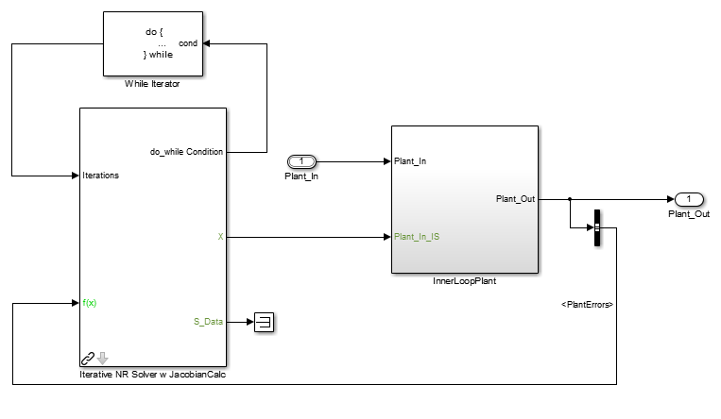

Figure 16. Iterative NR Solver w JacobianCalc wiring.

1. **Setup the outer loop**

Outside of the while iterator subsystem, route *Ndot* to the input of the TMATS: OuterLoop integrator block from the “Solver” sub-library (a bus selector may be used) and route the output of the integrator block to the NMech input of the plant (in the inner loop).

To speed up the ability to modify the model when running multiple simulations, the environmental inputs (to the TMATS: Ambient block) and the fuel flow input (to the TMATS: Burner block), may similarly be routed from the outer loop to the inner loop. Bus creators may be used to combine these signals with *NMech*, as shown in Figure 17, to produce a cleaner-looking model.

1. **Define the plant inputs**

Environmental inputs and fuel flow may be defined by connecting TMATS: Model Source blocks (from the “Solver” sub-library) to the respective inputs. The mask parameters for these blocks include a time vector and a vector that defines the values the signal takes at each time; the simulation profile can be defined through these inputs.

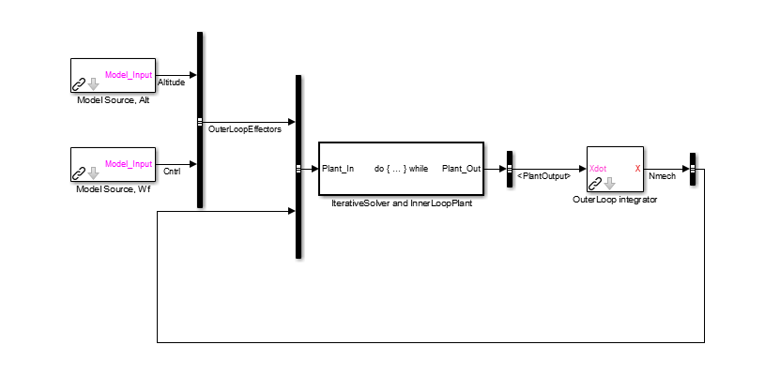

Figure 17. Dynamic gas turbine simple “outer” loop.

### Adding control to the simulation

This section will describe how to add a simple feedback controller to the T‑MATS simulation that uses shaft speed as the feedback signal.

1. **Prepare the open-loop model for a controller**

Replace the fuel flow TMATS: Model Source block with a TMATS: Model Source block for the shaft speed and place a TMATS: Simple PI controller block (from the “Effectors and Controls” sub-library) in the outer loop of the model

1. **Connect the controller**

Wire *Nmech*, the output of the outer loop integrator block, to the *Input\_sensed* input of the PI controller (this may require adding a Simulink: Zero‑Order Hold block to sample *Nmech*). Also wire the output of the TMATS: Model Source block for shaft speed to the *Input\_dmd* input of the PI controller, as shown in Figure 18. The output of the PI controller block should be wired to the fuel flow input of the burner block in the inner loop (i.e., inside the subsystem with the Simulink: While Iterator block).

1. **Tune the controller**

The gains of the controller (defined in the mask parameters) may be tuned until the desired response is obtained. Note that although the PI controller may function adequately in a simple gas turbine, it does not represent a realistic gas turbine controller and will not have the ability to account for multi-variable constraints without significant modification.

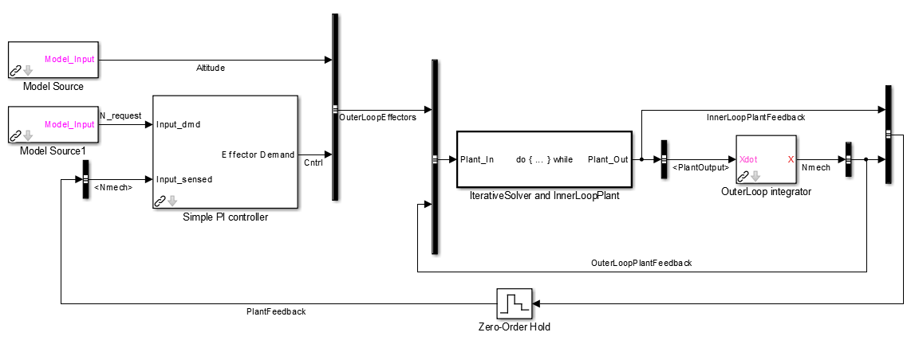

Figure 18. Dynamic gas turbine with controller.

### Plant interface with outer loop systems

In a real system, engine effectors and internal states need to be accessed with control system hardware. The T‑MATS package comes with generic controller interface blocks, such as the first-order sensor and actuator blocks in the “Effectors and Controls” sub-library, which may be used to simulate the dynamics introduced with added hardware. These blocks may be added to the “outer” loop of the model to increase simulation fidelity.

### Advanced Simulation Structure and Formatting

The dynamic gas turbine example employs a few optional structural and formatting techniques that help to organize and partition the simulation. These options are useful when developing a complicated model or when several developers are collaborating to create the model. The techniques described in this section are based on MATLAB/Simulink blocks and are independent of the T-MATS package.

#### Busses

Busses are a useful way to route signals through a Simulink model while keeping the diagram clean.

##### Creating Busses:

1. Place a Simulink: Bus Creator block in the model. Any signal fed into that bus creator will be on the bus and associated with the name of the wire fed into the bus creator. (Note that this is the only step required if a bus stays within a single model.)
2. The Bus Editor (found in the Edit menu) may be used to create bus elements. A bus that has been created in the Simulink diagram should also be created in the Bus Editor, being careful to organize the elements in the same order as they appear in the Simulink diagram.
3. After creating the bus, in the Bus Editor, select “Export to File” in the File menu of the editor. This saves the bus to a file that must be loaded before opening the Simulink model. (For example, the *setup\_everything.m* script for the GasTurbine\_Dyn\_Template example loads all the necessary bus elements from the folder Bus)
4. To add any element to the bus later, these steps must be repeated (i.e., open the bus editor, add the new item, then save the item to a file.)

##### Using Busses:

1. Bus elements may be routed off the bus through the use of the Simulink: Bus Selector block. Simply wire the bus into the selector, and then use the dialog box to select which bus element(s) to output.

#### Model Calls

Model calls may be used to incorporate external files into a Simulink model. This type of partitioning has three main advantages: it allows multiple users to work on the simulation at the same time (provided they don’t need the same file at the same time), it enables cleaner software version control, and it enables model reuse.

Setting up a model call requires placing a Simulink: Model block, from the “Ports and Subsystems” sub-library, in the model. Once the block has been placed, the file name of the model to be called should be specified in the dialog box opened by double-clicking the block. In the gas turbine example with the dynamics solver, calls were made to external plant and control models. The simulation may use Simulink: Model blocks with busses, which requires that the bus object creation method be followed.

Model Calls can also be used to simulate the plant in multiple simulation environments. For example, a steady–state simulation environment and a dynamic simulation environment could be created that both reference the same plant. This way, instead of having to modify two models to update the plant, a single file (containing the plant model) may be modified and these changes would be reflected in both simulation environments.

# Acknowledgments

The authors would like to thank Alicia Zinnecker and Yuan Liu of N & R Engineering, and Jeffrey Csank of NASA Glenn Research Center for their work on T‑MATS testing and for general technical advice. We would also like to thank Sanjay Garg at NASA Glenn Research Center for his support in the development of T‑MATS, and the NASA Aviation Safety Program’s Vehicle Systems Safety Technologies (VSST) project for funding this work.

# Appendix A

/\* T-MATS -- Ambient\_TMATS.c

\* % \*\*\*\*\*\*\*\*\*\*\*\*\*\*\*\*\*\*\*\*\*\*\*\*\*\*\*\*\*\*\*\*\*\*\*\*\*\*\*\*\*\*\*\*\*\*\*\*\*\*\*\*\*\*\*\*\*\*\*\*\*\*\*\*\*\*\*\*\*\*\*\*\*

\* % written by Jeffryes Chapman

\* % NASA Glenn Research Center, Cleveland, OH

\* % March 19, 2013

\* %

\* % This file converts Altitude and MN to common engine input variables.

\* % \*\*\*\*\*\*\*\*\*\*\*\*\*\*\*\*\*\*\*\*\*\*\*\*\*\*\*\*\*\*\*\*\*\*\*\*\*\*\*\*\*\*\*\*\*\*\*\*\*\*\*\*\*\*\*\*\*\*\*\*\*\*\*\*\*\*\*\*\*\*\*\*\*/

#define S\_FUNCTION\_NAME Ambient\_TMATS

#define S\_FUNCTION\_LEVEL 2

#include "simstruc.h"

Function parameter inputs.

#include "constants\_TMATS.h"

#include <math.h>

#define X\_A\_AltVec\_p(S) ssGetSFcnParam(S,0)

#define T\_A\_TsVec\_p(S) ssGetSFcnParam(S,1)

#define T\_A\_PsVec\_p(S) ssGetSFcnParam(S,2)

Number of parameter inputs

#define NPARAMS 3

extern double interp1Ac(double aa[], double bb[], double cc, int ii,int \*error);

C code function call definition

static void mdlInitializeSizes(SimStruct \*S)

{

int i;

ssSetNumSFcnParams(S, NPARAMS); /\* Number of expected parameters \*/

if (ssGetNumSFcnParams(S) != ssGetSFcnParamsCount(S)) {

/\* Return if number of expected != number of actual parameters \*/

return;

}

for (i = 0; i < NPARAMS; i++)

ssSetSFcnParamTunable(S, i, 0);

ssSetNumContStates(S, 0);

ssSetNumDiscStates(S, 0);

Number of inputs within the first inport

if (!ssSetNumInputPorts(S, 1)) return;

ssSetInputPortWidth(S, 0, 3);

ssSetInputPortRequiredContiguous(S, 0, true);

ssSetInputPortDirectFeedThrough(S, 0, 1);

if (!ssSetNumOutputPorts(S, 1)) return;

ssSetOutputPortWidth(S, 0, 5);

Number of outputs within the first outport

ssSetNumSampleTimes(S, 1);

ssSetNumRWork(S, 0);

ssSetNumIWork(S, 0);

ssSetNumPWork(S, 0);

ssSetNumModes(S, 0);

ssSetNumNonsampledZCs(S, 0);

ssSetOptions(S,

SS\_OPTION\_WORKS\_WITH\_CODE\_REUSE |

SS\_OPTION\_EXCEPTION\_FREE\_CODE |

SS\_OPTION\_USE\_TLC\_WITH\_ACCELERATOR);

}

static void mdlInitializeSampleTimes(SimStruct \*S)

{

ssSetSampleTime(S, 0, INHERITED\_SAMPLE\_TIME);

ssSetOffsetTime(S, 0, 0.0);

ssSetModelReferenceSampleTimeDefaultInheritance(S);

}

static void mdlOutputs(SimStruct \*S, int\_T tid)

Begin C code for S-function here

{

/\*-------- vector & array data -------\*/

const real\_T \*X\_A\_AltVec = mxGetPr(X\_A\_AltVec\_p(S));

const real\_T \*T\_A\_TsVec = mxGetPr(T\_A\_TsVec\_p(S));

const real\_T \*T\_A\_PsVec = mxGetPr(T\_A\_PsVec\_p(S));

/\*------get dimensions of parameter arrays-------\*/

const int\_T A = mxGetNumberOfElements(X\_A\_AltVec\_p(S));

/\*---------Define Inputs--------\*/

Assign “u,” inputs from Simulink

const real\_T \*u = (const real\_T\*) ssGetInputPortSignal(S,0);

double AltIn = u[0]; /\* Altitude(ft) \*/

double dTempIn = u[1]; /\* delta Temperature [degF] \*/

Set variables from “u”

double MNIn = u[2]; /\* Mach Number (frac) \*/

real\_T \*y = (real\_T \*)ssGetOutputPortRealSignal(S,0); /\* Output Array \*/

Assign, “y” outputs to Simulink

/\*--------Define Constants-------\*/

double PsOut, TsOut, TtOut, PtOut, VengOut, TsStDayOut, Vsound;

int interpErr = 0;

/\* Static Temperature \*/

TsStDayOut = interp1Ac(X\_A\_AltVec,T\_A\_TsVec,AltIn,A,&interpErr);

TsOut = TsStDayOut + dTempIn;

/\* Static Pressure\*/

PsOut = interp1Ac(X\_A\_AltVec,T\_A\_PsVec,AltIn,A,&interpErr);

/\*------ Total Temperature ---------\*/

TtOut = TsOut \* (1+MNIn\*MNIn\*(C\_GAMMA-1)/2);

/\*------ Total Pressure ---------\*/

PtOut = PsOut/(pow((TsOut/TtOut),(C\_GAMMA/(C\_GAMMA-1))));

/\*---- Engine Velocity ---------\*/

Vsound = C\_MACH1 \* sqrt(TsOut);

VengOut = Vsound \* MNIn;

Set “y,” outputs to Simulink. Continued on next page

/\*------Assign output values------------\*/

y[0] = TtOut; /\* Total Temperature [degR] \*/

y[1] = PtOut; /\* Total Pressure [psia] \*/

y[2] = PsOut; /\* Static Pressure [psia] \*/

y[3] = TsOut; /\* Static Temperature [degR] \*/

y[4] = VengOut; /\* Engine Velocity [ft/sec] \*/

}

static void mdlTerminate(SimStruct \*S)

{

}

#ifdef MATLAB\_MEX\_FILE /\* Is this file being compiled as a MEX-file? \*/

#include "simulink.c" /\* MEX-file interface mechanism \*/

#else

#include "cg\_sfun.h" /\* Code generation registration function \*/

#endif

/\*==================\*/

1. <http://www2.chem.umd.edu/thermobook/> :Referenced as of 9/2013 [↑](#footnote-ref-1)
2. Jones, S. M.,”Steady‑State Modeling of Gas Turbine Engines using the Numerical Propulsion System Simulation Code,” GT2010‑22350, ASME Turbo Expo, Glasgow, UK, June 14-18, 2010. [↑](#footnote-ref-2)
3. Jones, S.M.,”An Introduction to Thermodynamic Performance Analysis of Aircraft Gas Turbine Engine Cycles Using the Numerical Propulsion System Simulation,” NASA/TM-2007-214690, March 2007. [↑](#footnote-ref-3)