**ABSTRACT**

The world is still working hard to recover from the harm that was caused by the widespread spread of COVID-19, but there is a new threat that the monkeypox virus might become a worldwide pandemic. Even though the monkeypox virus is not as harmful or infectious as COVID-19, new cases of the sickness are nevertheless being documented each and every day from a broad variety of countries all over the globe. As a direct result of this, the possibility of another worldwide pandemic breaking out as a direct consequence of insufficient preventative measures would not be a complete surprise to anybody. This is due to the fact that there are not yet sufficient preventive measures in place. Recently, machine learning (ML) has shown tremendous promise in image-based diagnosis, particularly in areas such as the detection of cancer, the identification of tumor cells, and the detection of COVID-19 patients. ML has also been used in the process of identifying individuals with COVID-19. As a consequence of this, a technique that is similar to the aforementioned one may be used in order to identify the sickness that was connected with monkeypox as it appeared on human skin. After then, it is possible to gather this picture and use it in further phases of the process of detecting the ailment. On the other hand, there is no dataset containing Monkeypox information that is accessible to the general public and that can be used for the purpose of training and testing machine learning models while they are in the process of being developed. Because of this, there is an urgent need to build a dataset that contains photographic examples of people who have been diagnosed with monkeypox. This should be done as soon as possible. In light of this possibility, the current research offers a newly developed dataset that has been given the name "Monkeypox2022. " This dataset is publicly available to the general public for the purpose of utilization, and it may be obtained via our united GitHub repository. This dataset got its name from the hypothetical consequences that may arise as a result of using it. The dataset was produced by gathering photographs from a variety of open-source and internet sites, all of which did not place any limitations on how the images may be used, not even for commercial endeavors. These portals are available to anybody who wants to use them. This allows a more secure way to be utilized and disseminated for making use of such data, which may be advantageous throughout the process of designing and implementing any kind of machine learning models. In addition, we present and assess an improved version of the VGG16 model. This model is made up of a total of two separate trials, and we refer to these experiments as Study One and Study Two. According to the findings of our preliminary investigation using computational methods, the model that we proposed has an accuracy of 97.18 percent (area under the curve = 97.2) for identifying monkeypox patients in Study One, and 88.8 percent (area under the curve = 0.867) for identifying monkeypox patients in Study Two. These figures were derived from our analysis of the area under the curve. In addition, we explain the prediction and feature extraction of our model by utilizing Local Interpretable Model-Agnostic Explanations (LIME), which helps to give deeper insights on particular elements that identify the onset of an infection with the monkeypox virus..

*± ±*

***K*eywords** Deep learning *·* Disease diagnosis *·* Image processing *·* Monkeypox virus *·* Machine learning *·* monkeypox dataset *·* Transfer learning

# Introduction

As a result of the outbreak of COVID-19 in 2020, the whole globe was put in jeopardy; however, the emergence of monkeypox in 2022, which was reported by a number of countries, reveals the existence of yet another global danger. The Zoonotic Orthopoxvirus is responsible for the infectious illness known as monkeypox. This virus, which is closely linked to both cowpox and smallpox and is a member of the Poxviridae family and the genus Orthopoxvirus, is the causative agent of monkeypox. However, human-to-human transmission is also an incredibly common mode of transmission [2]. Monkeys and rodents are the primary vectors for disease transmission. In 1958, the virus was discovered for the first time in the body of a monkey by researchers working in a laboratory in Copenhagen, Denmark [3]. In 1970, amid an enhanced drive to eliminate smallpox, the Democratic Republic of the Congo documented the first human case of monkeypox [4]. This occurred throughout the course of the campaign. Many people who live in close proximity to tropical rainforests are susceptible to contracting monkeypox, which is often spread across the central and western regions of Africa. When a person comes into intimate touch with another sick person, animal, or object, they may get contaminated with the virus itself. Direct body-to-body contact, animal bites, respiratory droplets, or mucus from the eye, nose, or mouth may all be responsible for its transmission [5]. Fever, body pains, and exhaustion are some of the early-stage symptoms that people who have been infected with monkeypox may experience. The long-term impact of monkeypox is a red bump that appears on the skin [6].

Even though monkeypox is not quite as infectious as COVID 19 based on the information that has been gathered so far, the number of reported cases is climbing. In West and Central Africa combined, there were barely fifty cases of monkeypox in the year 1990 [7]. On the other hand, the number of cases increased to 5000 in 2020. In the past, it was believed that monkeypox was exclusively present in Africa; but, in 2022, the identification of the persons who were affected by the virus was reported by various additional non-African nations in Europe and the United States [8]. [Citation needed] As a consequence of this, a widespread sense of overwhelming dread and fear is gradually developing among the general population; this is often reflected in the opinions expressed by individuals on social media.

According to the recommendations made by the Centers for Disease Control and Prevention (CDC), there is currently no medication that is suitable for the Monkeypox virus [9]. However, in order to meet the pressing demand, the Centers for Disease Control and Prevention (CDC) gave its approval to the use of two oral medications, Brincidofovir and Tecovirimat, to treat monkeypox virus [10]. These treatments had previously been used only to treat the smallpox virus. Nevertheless, the immunization against the monkeypox virus is the most effective treatment available. Although vaccinations against the monkeypox virus that have been licensed by the Food and Drug Administration (FDA) are already available, these vaccines have not yet been administered to humans in the United States. In several other nations, vaccinations developed to combat the smallpox virus are administered to patients suffering with monkeypox [11].

Initial observations of the peculiar features of any skin lesions that are present and a thorough investigation into the patient's exposure history are required for the diagnostic process of monkeypox. However, the use of electron microscopy to examine lesions on the skin is the gold standard for conclusively diagnosing the virus. In addition, the monkeypox virus may be validated by the use of polymerase chain reaction (PCR) [12], which is a technique that is now being used widely in the diagnosis of COVID-19 patients [13–16].

Machine learning (ML) is a relatively new subfield of artificial intelligence (AI) that is shown significant promise in a variety of applications. These applications range from decision-making tools and industrial sectors to medical imaging and disease diagnosis. Clinicians are able to get imaging solutions that are safe, accurate, and quick because to the special properties that ML has. These imaging solutions have gained universal recognition as a valuable decision-making tool [17]. For the purpose of diagnosing breast cancer, for instance, Miranda and Felipe (2015) created computer-aided diagnostic (CAD) systems that make use of fuzzy logic. Fuzzy logic has an advantage over traditional machine learning in that it may eliminate time-consuming computational problems while simultaneously imitating the line of thinking and approach used by experienced radiologists. The algorithm will produce a cancer detection result based on the approach that is desired if the user assigns parameters such as contour, density, and shape. [18] Ardakani et al. (2020) assessed ten distinct deep learning models using a small dataset consisting of 108 patients with COVID-19 and 86 patients who did not have COVID-19, and they attained an accuracy of 99 percent [19]. Using 453 CT scan images, Wang et al. (2020) created a modified inception-based model and achieved an accuracy of 73.1 percent [20]. [20] A low-complexity convolutional neural network (CNN) was developed by Sanddep et al. (2022) as a method for identifying skin illnesses such as psoriasis, melanoma, lupus, and chickenpox. They demonstrate that it is feasible to diagnose skin diseases using image analysis with a 71 percent degree of accuracy by utilizing an existing version of VGGNet. In contrast, their suggested approach achieves the highest outcomes, demonstrating superior performance by obtaining an accuracy of around 78%. Using MobileNet, Velasco et al. (2019) suggested a smartphone-based skin disease diagnosis system and found an accuracy of around 94.4 percent in recognizing individuals with chickenpox symptoms [21]. Acne, candidiasis, cellulitis, chickenpox, and other skin illnesses were among those that Roy et al. (2019) were able to identify using a variety of segmentation techniques [22].

At the time that this article is being written, there has not been a single research paper that has been uncovered that demonstrates the potential of ML methods in the detection of Monkeypox illness via image processing techniques. We discovered two fundamental reasons for the lack of a basis for the creation of an image-based diagnosis of the illness known as monkeypox:

1. There is no dataset that is available to the general public that can be used to train and evaluate a machine learning (ML) model for diagnosing monkeypox.

2. Because the virus has just recently been substantially exposed in many countries, it is normal practice for an appropriate ML method to be included with the dataset, and a model often needs longer time to be presented.

Taking all of these possibilities into consideration, we came to the conclusion that it is necessary to compile a dataset that contains images of patients who are suffering from the monkeypox disease. This will make it possible for a large number of researchers and practitioners to get right to work on designing and putting forward a novel AI-assisted strategy. Dr. Joseph Cohen's creation of the Monekypox data set at the beginning of the COVID-19 outbreak served as an inspiration for us when we decided to create the Monekypox data set. Dr. Cohen assembled the dataset from a variety of different sources, including websites and journals [23]. Their beginning dataset consisted of COVID-19 and Non-COVID-19 chest X-ray pictures of 98 samples, but our starting dataset is made of 164 samples, and the total sample size after data augmentation is 1915. This difference is due to the fact that our dataset was created more recently. Different studies carried out in the beginning of COVID-19 make use of restricted datasets and emphasize the importance of transfer learning approaches by providing a wide variety of deep learning-based screening models [14, 19, 20]. These studies were undertaken by numerous researchers. As a result, we anticipate that our dataset will serve the same function and assist researchers and practitioners who are eagerly waiting to get access to the dataset in order to construct a model for diagnosing Monkeypox disease. This is because our dataset will contain the same amount of information as other datasets. The following is an overview of our technological contribution:

1. Create the first publicly available collection of monkeypox photos by compiling photographs gathered from a variety of sources (such as websites and news outlets), which may be found in the following github repository; 2.

2. Present a low-modified version of the VGG16 model in order to identify patients with monkeypox based on picture data; and

3. In order to confirm our results, please provide a post-image analysis explanation using locally interpretable model-agnostic explanations (LIME).

The following sections of the paper are organized as follows: In Section 2, a condensed description of the experiment's methodology is provided, which is then followed by the findings in Section 3. Our work is discussed briefly in Section 4, and a summary of our general results, along with some potential avenues for further investigation, is presented in Section 5.

# Methodology

This part provides an overview of the data gathering and augmentation approach, the construction of the proposed modified VGG16 deep learning model, the experimental setup, and the performance evaluation matrices that were used to carry out the experiment.

## Data collection

* + 1. Because the monkeypox virus is quickly spreading over a significant number of countries, it is very important in this day and age to identify individuals who are exhibiting signs that they may be infected with it. The strain that has been placed on clinical diagnostics as a direct consequence of the epidemics has led many experts working in the field of medicine to the conclusion that artificial intelligence (AI) technologies would be able to alleviate some of this strain by evaluating visual data [13]. This conclusion was reached as a direct consequence of the burden that has been placed on clinical diagnostics as a direct consequence of the epidemics. We found that hospitals in China and Italy have used interpreters that were based on AI and image processing in order to improve the efficiency with which the hospitals handled COVID-19 patients [14, 16, 24]. This was done with the purpose of boosting the degree of medical care that COVID-19 patients are able to get from the hospitals via the implementation of these changes. On the other hand, as of the time that this article is being written, there is no nodataset relating to monkeypox that is readily accessible to the general public. As a consequence of this, it is difficult to realize the potential advantages of using an AI-based strategy in order to immediately detect and prevent the monkeypox illness. As a direct consequence of this, a substantial number of researchers and practitioners are unable to contribute to the diagnosis of the monkeypox sickness making use of the most cutting-edge AI approaches. Acquiring patient photos that indicate monkeypox was a necessary part of the study that is being described here. Because of the constraints discussed before, this was an essential step. Even while our initial dataset only has a small number of samples, we do not think that this will be a problem when we carry out the first round of testing. This is supported by the fact that various pieces of referenced research have in the past employed constrained datasets in order to create AI-based models during the early phases of COVID-19 diseases. This was done in the past. This action was taken while the illness was still in its early stages (see [19, 24] for examples). On the other hand, the database's material will be continually updated with fresh information that has been donated by a large number of organizations that are situated in a variety of different countries around the world. When it came time to collect the data samples, we followed the processes that are detailed here since they were the process that we followed.

1. Since there is no preexisting shared dataset that is made available by an authorized and designated hospital, clinic, or other viable source, the image data for monkeypox is collected from a variety of sources including websites, newspapers, online portals, and publicly shared samples. This is because there is no preexisting shared dataset that is made available by an authorized and designated hospital, clinic, or other viable source. In order to construct a preliminary dataset, this step has to be taken. 2. The usage of the Google search engine will continue throughout the first phase of the inquiry process in order to facilitate the accomplishment of this goal. Figure 1 shows an overview of the many phases that are involved in searching through the data. These procedures are described in further detail below.

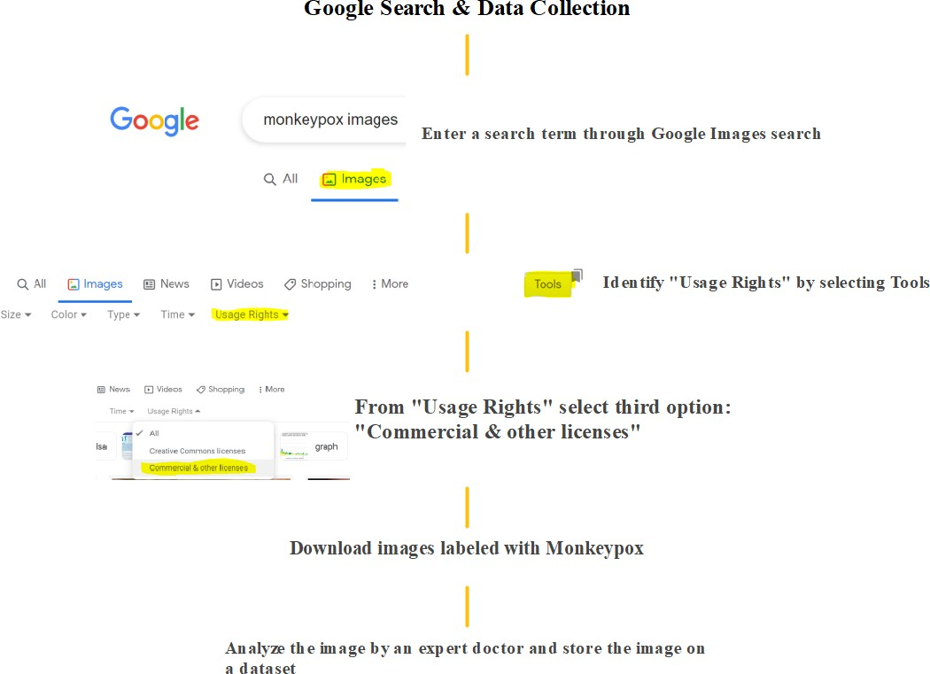

Figure 1: Data collection procedure used in this study.

2. A similar process is used in the collection of the data sample in order to develop the non-monkeypox samples. This sample contains search terms such as "Chickenpox" and "Measles," as well as normal images (i.e., photographs of both hands, legs, and faces) that do not exhibit any symptoms of the disease that has been designated. 3. 4. 5. 6. 7. 8. 9. 10.

3. In order to improve the size of the data sample, more normal photos are being manually gathered from a variety of people who do not have any skin disease symptoms. These participants have given their permission. A permission form is used to get agreement from each participant in order to proceed.

The properties of the many different datasets that were produced during the course of this investigation are outlined in Table 1. Deep architecture such as deep learning networks, CNN, RNN, and generative adversarial networks require a significant amount of data samples in order to construct a model. Transfer learning and conventional machine learning, on the other hand, can perform well with a small number of images. Transfer learning and conventional machine learning can also perform well with a small number of images. In light of this, we have increased the size of the data set by using strategies that are known as data augmentation.

Even though there are only 1915 samples in the dataset, it is still possible to develop a disease diagnosis model by employing the traditional machine learning and transfer learning approach. This was previously demonstrated by a large number of studies during the early stages of COVID-19 when there were very few data samples available. For instance, several studies diagnose COVID-19 patients by using just 40-100 data and using deep learning models [13, 24]. Due to the fact that our dataset in the very beginning stage of the monkeypox has around 1915 samples, we are able to assume that our dataset is more credible. On the other hand, we anticipate that the dataset will grow over time as a result of our continued collection of more data from a variety of open-source sources (i.e., data available to use without privacy concerns, data from the journals and online).

## Data augmentation

The dataset is augmented with the use of the Keras image processing framework, namely the ImageDataGenerator. The ImageDataGenerator function gives you a number of different choices to choose from, such as rotating the image, altering its width and height, and flipping it. [25] contains information on a details facility that is made available by ImageDataGenerator. As can be seen in Table 2, the following parameter is used in this research in order to enhance the picture data. The kinds of generators and facilities are chosen at random in accordance with the recommendations in [26].

Table 1: The sample size of each dataset that has been collected in this study.

|  |  |
| --- | --- |
| Dataset | Total sample |
| Monkeypox | 43 |
| Chickenpox | 47 |
| Measles | 17 |
| Normal | 54 |
| Monkeypox augmented | 587 |
| Chickenpox augmented | 329 |
| Measles augmented | 286 |
| Normal augmented | 552 |
| Total samples | 1915 |

Table 2: Data augmentation techniques used in this study.

Generator Type Facility

Width shift Up to 2% Rotation Range Randomly 0°-45° Zoom range 2%

Height shift Up to 2%

Shear range 2%

Fill mode Reflective Horizontal flip True

Algorithm 1 shows the pseudocode for data augmentation techniques used in this study.

**Algorithm 1:** Pseudo-Code of Data Augmentation

Input: read original image samples x using OpenCV. Resize image into 128 128.

*×*

Store resize image as an array inside a list.

Call Image data generator function

**for** *n* 1 to 20 **do** Batch size = 16 Save to directory

*←*

Save format as “png”

## end for

End of Pseudo-Code.

Figure 2 displays sample images of various datasets developed throughout this study.

## Transfer learning approaches

At first, a transfer learning strategy is used for the pilot test in order to assess the effectiveness of machine learning models applied to a created dataset. A customized version of the VGG16 model is used for the exploratory testing that has been done [27]. A pre-trained architecture, an updated layer, and a prediction class are the three fundamental components that make up the core model (partially adapted from [13]). Following the identification of high-dimensional characteristics with the help of the pre-trained architecture, the updated modified layer is then given the new information. Figure 3 depicts the modified VGG16 models that have been suggested. The model is made up of sixteen CNN layers, each of which has its own unique set of filter widths and stride values [28]. After the initial input layer, as shown in Figure, two convolutional layers, each of which contains a 3x3 filter, are added, followed by a Max Pooling layer, and then another two convolutional layers and one Max Pooling layer are added until it reaches the modified layer sections. This process is repeated until it reaches the end of the modified layer sections. The architecture was made flatter by the application of the modified layer, which was then followed by the three dense and one dropout layer.

During the first phase of parameter tuning, consideration is given to the batch size, the number of epochs, and the learning rate in order to get the best possible results from the proposed model. The first choices made for Study are those pertaining to the following experimental parameters: One

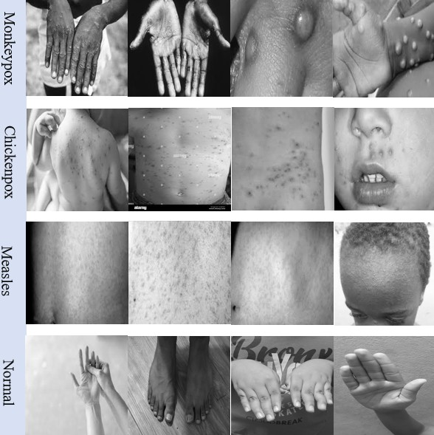

Figure 2: Sample set of images from the developed dataset including Monkeypox, Chickenpox, Measles, and normal images.

(inspired by [15,](#_bookmark31) [29]):

Batch size = [5, 10, 15, 20]

Learning rate = [0.1, 0.01, 0.001]

Number of Epochs = [30, 35, 40, 45]

Using the grid search method following parameters are identified as the most optimal ones:

Batch size = 10 Learning rate = 0.001 Number of Epochs = 35

For Study Two following parameters are used to develop the optimal model:

Batch size = [30, 50, 70, 100]

Learning rate = [0.1, 0.01, 0.001]

Number of Epochs = [50, 70, 100, 150]

And the best result was achieved with:

Batch size = 30 Learning rate = 0.001

Number of Epochs = 100

Because of its superior performance to that of other already existing optimize algorithms, an adaptive momentum estimation, or Adam, is used in the process of optimizing the model loss. Adam often exhibits remarkable performance in binary picture categorization, which is one of the possible benefits of using this system. [30].

## LIME as explainable AI

Local interpretable model-agonistic explanations (LIME) is one of the powerful tools that can help to analyze the model’s true prediction and offer the opportunity to understand the Blackbox behind any CNN model’s final predictions [31]. LIME’s impressive performance in describing the complexities of image classification has led to its extensive application

Figure 3: VGG16 models implemented using transfer learning approaches during this experiment. 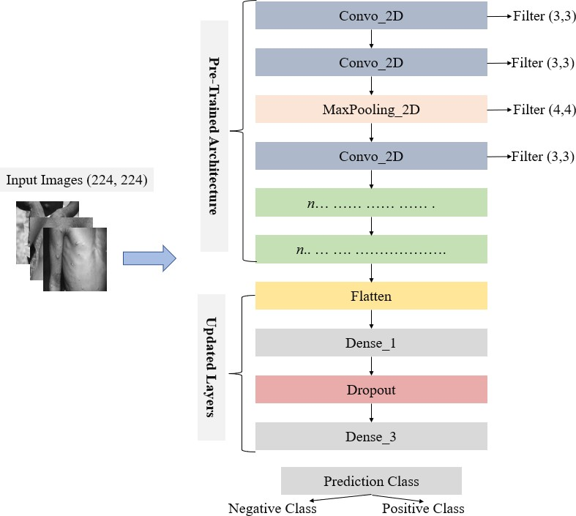

during the last several years [32]. When it comes to the categorization of images, LIME makes use of superpixel. Superpixels are the result of a picture having too many segments removed from it. Superpixels are able to hold a large amount of data and provide assistance in determining crucial aspects of a picture during the initial prediction [13]. The LIME parameters that were used throughout the course of this research in order to compute the superpixel values are shown in Table 3. It is important to note that the parameters have been shown to be beneficial in a variety of picture prediction studies, as is referenced in a variety of previously published literatures [13,](#_bookmark29) [33].

Table 3: Parameter used to identify superpixels.

|  |  |
| --- | --- |
| Function | Value |
| Maximum distance | 150 |
| Kernel size | 4 |
| Ratio | 0.2 |

## Experiment setup

## The experiment was carried out using a conventional laptop with the following specifications: Windows 10, 16 GB of RAM, and an Intel Core I7 processor. The total experiment was carried out five times, and the result that is reported here is the result that is obtained by averaging the results of all five computing runs.

The dataset that was used for this investigation is outlined in Table 4, which can be found here. According to the chart, the dataset for Study One includes 43 samples of monkeypox and 47 samples of chickenpox. The table also reveals that the dataset for Study Two includes 587 samples of monkeypox that have been supplemented and 1167 additional samples. Please take note that the data samples for the Chickenpox, Measles, and Normal pictures have been combined to form the "Other" class. The model was trained using eighty percent of the sample data, and its accuracy was validated using the remaining twenty percent. This is a standard procedure in machine learning fields [34–36].

Table 4: Assignment of data employed to train and test the proposed modified VGG16 deep learning models.

|  |  |  |  |  |
| --- | --- | --- | --- | --- |
| Study | Label | Train set | Test set | Total |
|  | Monkeypox | 34 | 9 | 43 |
|  | Chickenpox | 38 | 9 | 47 |
|  | Total | 72 | 18 | 90 |
|  | Monkeypox augmented | 470 | 117 | 587 |
|  | Others | 933 | 234 | 1167 |
|  | Total | 1403 | 351 | 1754 |

Study One

Study Two

## Performance evaluation

The entire results of the experiment are examined and analyzed with the use of the statistical methods that are the most popular among researchers today, such as accuracy, precision, recall, F1-score, sensitivity, and specificity. The short number of samples in Study One necessitated the adoption of a confidence interval of 95 percent to reflect the overall statistical findings, which were then compared to findings from previously published research that likewise relied on a restricted dataset [20, 24]. For the sake of our dataset, monkeypox may be categorized as either true positive (Tp) or true negative (Tn) depending on the accuracy with which people are diagnosed; alternatively, it may be categorized as either false positive (Fp) or false negative (Fn) if the diagnosis is inaccurate. Following is a detailed explanation of the statistical measures that have been assigned.

Accuracy: The accuracy refers to the total number of occurrences that have been correctly detected across all of the cases. The degree of precision may be calculated using the following equations::

*Tp* + *Tn*

*Accuracy* =

*Tp* + *Tn* + *Fp* + *Fn*

(1)

***Precision:***Precision is assessed as the ratio of accurately predicted positive outcomes out of all expected positive outcomes.

*Tp*

*Precision* =

*Tp* + *Fp*

***Recall:*** Recall refers to the ratio of relevant outcomes that the algorithm accurately identifies.

*Tp*

*Recall* =

*Tn* + *Fp*

(2)

(3)

***Sensitivity:*** Sensitivity refers to the only accurate positive metric relative to the total number of occurrences and can be measured as follows:

*Tp*

*Sensitivity* =

*Tp* + *FN*

(4)

***Specificity:*** It identifies the number of accurately identified and calculated true negatives and can be found using the following formula:

*TN*

*Specificity* =

*TN* + *FP*

(5)

***F1- score:*** The F1 score is the harmonic mean of precision and recall. The maximum possible F score is 1, which indicates perfect recall and precision.

*F* 1 *score* = 2 Precision *×* Recall

*— ×*

Precision + Recall

(6)

***Area under curve:*** The area under the curve (AUC) represents the behavior of the models under various conditions. AUC can be calculated suing following formulas:

Σ

*AUC* = *ri*(*xp*) *− xp*((*xp* + 1)*/*2

*xp* + *xn*

(7)

Where *xp* and *xn* represent positive and negative samples of data, respectively, and *ri* represents the rating of the *i*th positive sample.

# Results

Table 5 presents the overall accuracy, precision, recall, F1 score, sensitivity, and specificity scores that were derived from the preliminary computations that were performed on the train and test set for both Study One and Study Two. These scores were determined by comparing the train set to the test set. In Table 5, the measurement that received the highest score for a given criterion considered in this inquiry is denoted by bold type. In order to offer an accurate overview of the statistical measures, the results are reported with confidence intervals (CI) of 95 percent. This is because the dataset only had a limited number of samples. The results of Study One come out noticeably better when compared to those of Study Two, as is evident from the table. For example, in comparison to the accuracy of the train set result obtained in Study Two, the accuracy of the train set obtained in Study One is up to 9 percent more accurate. The fact that the models performed poorly on the test set for both Study suggests not only that they have a high sensitivity score but also a low specificity score. Despite this, it is possible to conclude that the overall performance of the model is excellent despite the short dataset.

Table 5 displays the results of applying the proposed model to the dataset that was utilized for this research, along with the confidence interval (*α* = 0*.*05).

Study Dataset Accuracy Precision Recall F1-score Sensitivity Specificity

Study One Train set **0.97** *±* **0.018 0.97** *±* **.018 0.97** *±* **0.018 0.97** *±* **0.018** 0.973 *±* 0.017 **0.97** *±* **0.018**

Test set 0.83*±* 0.085 0.88 *±* 0.072 0.83 *±* 0.085 0.83 *±* 0.85 **1** 0.66 *±* 0.12

Study Two Train set 0.88 *±* 0.008 0.86 *±* 0.009 0.87*±* 0.008 0.86*±* 0.009 0.83*±* 0.010 0.89*±* 0.008

Test set 0.78 *±* 0.022 0.75*±* 0.023 0.75*±* 0.023 0.75*±* 0.023 0.650*±* 028 0.83*±* 0.019

Figure 4 illustrates the performance of the models on both the training set and the testing set for each and every epoch of each study. As can be seen in Figure 4, the level of accuracy reached its maximum before the model began to exhibit signs of overfitting after a period of 35 epochs for Study One (a). Figure 4 demonstrates that the training and validation loss both go down to a lower value as the number of epochs increases (a). The results of the model's performance in the Study are shown in Figure 4(b). Two reached its peak point at 100 epochs for both the training and validation dataset.

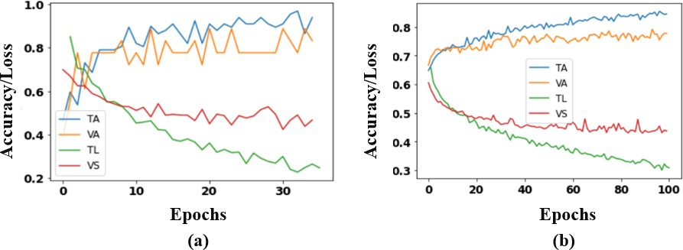

Figure 4 depicts the degree of accuracy and loss that the modified VGG16 model had throughout each epoch when it was applied to (a) Study One and (b) Study Two. TA stands for train accuracy, VA for validation accuracy, TL for train loss, and VS for validation loss are the abbreviations often used in train and validation terminology.

Figure 5, which depicts Study One and Study Two respectively, displays the results of the recommended model's performance in terms of the confusion matrix. The model was evaluated based on the confusion matrix. The graphic illustrates that Study One's train set had the fewest number of incorrectly classified categories, as compared to the other studies (an error rate of 2.7 percent ). On the other hand, the train set from Study Two had the highest proportion of misclassifications (an error rate of 12.33 percent ). It is possible that one of the primary reasons why Study Two produced the highest number of incorrect classifications was due to the unbalanced ratio of the dataset. In this dataset, the ratio of monkeypox cases to other cases was 1:1.98. This could have been one of the primary reasons why Study Two produced the highest number of incorrect classifications.

Figure 6 is a representation of the area under the curve of the receiver operator characteristic (ROC), together with the true positive rate (TPR), and the false positive rate for the upgraded VGG16 models (FPR). As can be seen in Figure 6, the train set that was used in Study One had the greatest overall performance, as shown by the fact that it achieved an area under the curve (AUC) score of 0.972. (a). On the other hand, the test set that was used for Study Two had the lowest performance overall, as shown by the score of 0.748 that it received for the area under the curve (AUC) (refer to Figure 6(b)). It is important to keep in mind that the performance of the model is considered to be poor if the AUC value is less than 0.5, while a figure that is closer to 1 indicates that the model is running at the best potential level. While seen from this angle, the area under the curve (AUC) score of 0.748 obtained on the test set offers further evidence confirming the model's stability when it is being utilized for prediction.

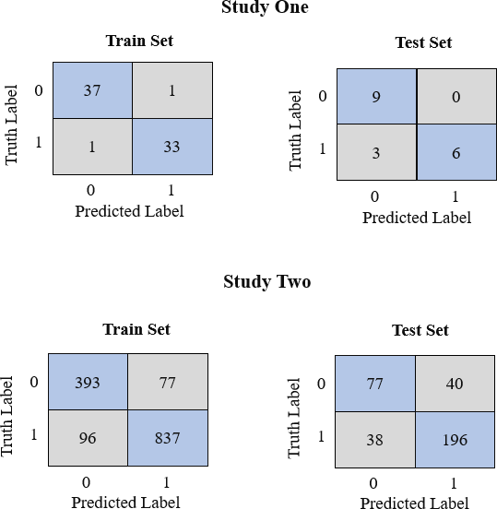

Figure 5: Confusion matrices for the proposed model applied to Study One and Two.

Figure 7 presents a visual representation of the top four characteristics uncovered by the suggested models using LIME. It is clear from looking at the picture that the image displaying signs of monkeypox was incorrectly identified as one showing chickenpox in Study One, namely in Figure 7(d). We are also able to examine why the suggested model incorrectly identified the photos by using LIME, as shown in Figure 7(d). For instance, the model focused most of its attention on the region in Figure 7(d) that did not exhibit any signs or symptoms of monkeypox. In Study Two, our suggested model correctly labeled all four photos from the test set, as can be shown in Figuren7(e)-(h).

# Discussions

During the course of this research endeavor, we produce an original dataset that has the potential to be put to use in the construction and training of machine learning models for the categorization of the Monkeypox infection via the use of image analysis techniques. Additionally, a modified version of the VGG16 model is constructed, and its ability to differentiate between patients who have the Monkeypox sickness and those who do not have the disease is tested in two separate studies. Our proposed model achieved an accuracy of roughly 0.83 to 0.085 on a dataset that was not very large, which is in line with the results of many other pieces of research that demonstrate the superiority of the transfer learning technique on datasets that are not very large. In addition, we examined the model by applying it to an uneven dataset, and the findings indicated that it had an accuracy of 0.78 0.022 on the test set. This was based on the fact that the dataset was not evenly distributed. Any machine learning model must first be able to provide reliable interpretation in order for it to be used in clinical trials, as stated in a report that was presented not too long ago by the World Health Organization (WHO) [37]. Because of the significance of this subject, the work that we have presented here explains and shows our post prediction analysis by using LIME, which is one of the most well-known explainable AI approaches currently available. We were able to demonstrate, with the assistance of LIME, that our models are capable of acquiring information from afflicted sites and finding those locations on their own. Our method of data collection, as well as the efficacy of our model, is subjected to the scrutiny of trained medical experts, who make certain that our model's efficacy is satisfactory by examining both methods. We were unable to find a single study that can be used to assess how well our model works in contrast to others since there is no image dataset for monkeypox that is currently accessible. On the other hand, it is fair to presume that our new dataset will give academics and practitioners with a fantastic opportunity to construct image-based analytical tools for the diagnosis of monkeypox disease and put their expertise to use in the real world.

*±*

*±*

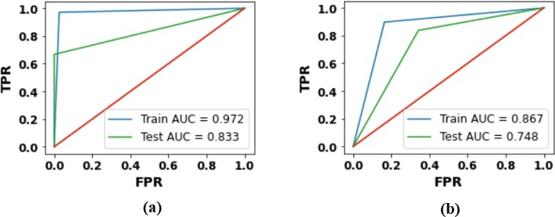

Figure 6: AUC-ROC curves for (a) Study One, and (b) Study Two wherein, TPR—true positive rate, FPR—false positive rate.

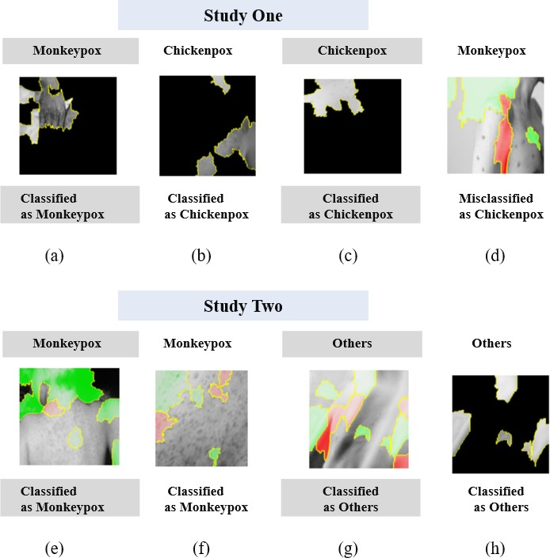

Figure 7: Top four features that enabled the classification between Monkeypox, Chickenpox and Others from the image data.

Finally, healthcare professionals can easily adapt our model as it is cost and time effective and does not require extensive PCR or microscopy testing. As an effect, our proposed model provides an opportunity to test in real-time screening of the patients with Monekypox symptoms. Apart from many advantages, the following limitations of our study provide urgent opportunity for additional research:

* 1. Due to the time constraints, the developed dataset contains limited samples.
  2. The data are primarily collected through various open sources instead of any specific hospital or clinical facility.

# Conclusion

The purpose of the research is to alleviate the persistent lack of data pertaining to patient photos that have been infected with the monkeypox virus. Individuals are finally given the opportunity to share and utilize that data for experimentation and even for commercial reasons as a result of the fact that the dataset is generated by gathering the photos from open sources and is publicly accessible to use without any privacy limitations. A modified version of the VGG16 model was used in each of the investigations that we carried out, which took into consideration both moderate and small datasets. Our findings suggest that using transfer learning approaches, the proposed modified VGG16 can distinguish patients with monkeypox symptoms from others in Study One and Study Two with an accuracy ranging from 78 percent to 97 percent. This is based on the fact that our findings indicate that the modified VGG16 is able to differentiate between patients with monkeypox symptoms and others. Finally, we have made use of LIME in order to offer the appropriate explanation of the rationale behind our model's prediction. This is one of the current requirements for deploying machine learning models for clinical trials, and it was necessary for us to meet this need. In order to demonstrate that the findings may be trusted, the predictions made by our algorithm were double reviewed by medical professionals. We plan to place a strong emphasis on the potential of artificial intelligence-based technologies, which have the potential to play an important part in identifying and preventing the contamination of the beginning stages of the monkeypox virus. We have high hopes that the dataset we have made accessible to the public will play an essential part and provide a chance to machine learning researchers who are unable to construct an AI-based model and carry out the experiment owing to a lack of data. As a result of the fact that our proposed model is supported by a large body of previously published literature that makes use of the transfer learning approach in the development of an AI-based diagnosis model, it will also encourage future research and practitioners to make use of the transfer learning approach and apply it in clinical diagnosis. Updating the dataset by continuously collecting new images of monkeypox-infected patients, evaluating the performance of the proposed VGG16 model on highly imbalanced data, comparing the performance of our model with the findings of other researchers (once those findings are available), and deploying our proposed model in the development of a mobile-based diagnosis tool are some of the ways that some of the limitations associated with our work can be alleviated.

# References

1. Andrea M McCollum and Inger K Damon. Human monkeypox. *Clinical infectious diseases*, 58(2):260–267, 2014.

1. Emmanuel Alakunle, Ugo Moens, Godwin Nchinda, and Malachy Ifeanyi Okeke. Monkeypox virus in nigeria: infection biology, epidemiology, and evolution. *Viruses*, 12(11):1257, 2020.

1. Marlyn Moore and Farah Zahra. Monkeypox ( *accessed* on may 22, 2022). [https://www.ncbi.nlm.nih.gov/](https://www.ncbi.nlm.nih.gov/books/NBK574519/) [books/NBK574519/](https://www.ncbi.nlm.nih.gov/books/NBK574519/), May 2022.

1. Leisha Diane Nolen, Lynda Osadebe, Jacques Katomba, Jacques Likofata, Daniel Mukadi, Benjamin Monroe, Jeffrey Doty, Christine Marie Hughes, Joelle Kabamba, Jean Malekani, et al. Extended human-to-human transmission during a monkeypox outbreak in the democratic republic of the congo. *Emerging infectious diseases*, 22(6):1014, 2016.

1. Phi-Yen Nguyen, Whenayon Simeon Ajisegiri, Valentina Costantino, Abrar A Chughtai, and C Raina MacIntyre. Reemergence of human monkeypox and declining population immunity in the context of urbanization, nigeria, 2017–2020. *Emerging Infectious Diseases*, 27(4):1007, 2021.

1. Monkeypox signs and symptoms. (***accessed on may 30, 2022***). [https://www.cdc.gov/poxvirus/](https://www.cdc.gov/poxvirus/monkeypox/symptoms.html) [monkeypox/symptoms.html](https://www.cdc.gov/poxvirus/monkeypox/symptoms.html), 2022.

1. Michaeleen Doucleff. Scientists warned us about monkeypox in 1988. here’s why they were right. (***accessed on may 27, 2022***). [https://www.npr.org/sections/goatsandsoda/2022/05/27/1101751627/](https://www.npr.org/sections/goatsandsoda/2022/05/27/1101751627/scientists-warned-us-about-monkeypox-in-1988-heres-why-they-were-right) [scientists-warned-us-about-monkeypox-in-1988-heres-why-they-were-right](https://www.npr.org/sections/goatsandsoda/2022/05/27/1101751627/scientists-warned-us-about-monkeypox-in-1988-heres-why-they-were-right), May 2022.

1. Multi-country monkeypox outbreak in non-endemic countries.(*accessed on may 29, 2022*). [https://www.who.](https://www.who.int/emergencies/disease-outbreak-news/item/2022-DON385) [int/emergencies/disease-outbreak-news/item/2022-DON385](https://www.who.int/emergencies/disease-outbreak-news/item/2022-DON385), 2022.

1. Monkeypox and smallpox vaccine. (***accessed on may 30, 2022***). [https://www.cdc.gov/poxvirus/](https://www.cdc.gov/poxvirus/monkeypox/clinicians/treatment.html) [monkeypox/clinicians/treatment.html](https://www.cdc.gov/poxvirus/monkeypox/clinicians/treatment.html), 2022.

1. Hugh Adler, Susan Gould, Paul Hine, Luke B Snell, Waison Wong, Catherine F Houlihan, Jane C Osborne, Tommy Rampling, Mike BJ Beadsworth, Christopher JA Duncan, et al. Clinical features and management of human monkeypox: a retrospective observational study in the uk. *The Lancet Infectious Diseases*, 2022.

1. Alice Park. There’s already a monkeypox vaccine. but not everyone may need it. (***accessed on may 27, 2022***).

<https://time.com/6179429/monkeypox-vaccine/>, 2022.

1. Diagnostic tests. (**accessed on may 30, 2022**). [https://www.nj.gov/agriculture/divisions/ah/](https://www.nj.gov/agriculture/divisions/ah/diseases/monkeypox.html) [diseases/monkeypox.html](https://www.nj.gov/agriculture/divisions/ah/diseases/monkeypox.html), 2022.

1. Md Manjurul Ahsan, Kishor Datta Gupta, Mohammad Maminur Islam, Sajib Sen, Md Rahman, Mohammad Shakhawat Hossain, et al. Covid-19 symptoms detection based on nasnetmobile with explainable ai using various imaging modalities. *Machine Learning and Knowledge Extraction*, 2(4):490–504, 2020.

1. Md Manjurul Ahsan, Tasfiq E Alam, Theodore Trafalis, and Pedro Huebner. Deep mlp-cnn model using mixed-data to distinguish between covid-19 and non-covid-19 patients. *Symmetry*, 12(9):1526, 2020.

1. Md Manjurul Ahsan, Md Tanvir Ahad, Farzana Akter Soma, Shuva Paul, Ananna Chowdhury, Shahana Akter Luna, Munshi Md Shafwat Yazdan, Akhlaqur Rahman, Zahed Siddique, and Pedro Huebner. Detecting sars-cov-2 from chest x-ray using artificial intelligence. *Ieee Access*, 9:35501–35513, 2021.

1. Md Manjurul Ahsan, Redwan Nazim, Zahed Siddique, and Pedro Huebner. Detection of covid-19 patients from ct scan and chest x-ray data using modified mobilenetv2 and lime. In *Healthcare*, volume 9, page 1099. Multidisciplinary Digital Publishing Institute, 2021.

1. Md Manjurul Ahsan and Zahed Siddique. Machine learning-based heart disease diagnosis: A systematic literature review. *Artificial Intelligence in Medicine*, page 102289, 2022.

1. Gisele Helena Barboni Miranda and Joaquim Cezar Felipe. Computer-aided diagnosis system based on fuzzy logic for breast cancer categorization. *Computers in biology and medicine*, 64:334–346, 2015.

1. Ali Abbasian Ardakani, Alireza Rajabzadeh Kanafi, U Rajendra Acharya, Nazanin Khadem, and Afshin Moham- madi. Application of deep learning technique to manage covid-19 in routine clinical practice using ct images: Results of 10 convolutional neural networks. *Computers in biology and medicine*, 121:103795, 2020.

1. Linda Wang, Zhong Qiu Lin, and Alexander Wong. Covid-net: A tailored deep convolutional neural network design for detection of covid-19 cases from chest x-ray images. *Scientific Reports*, 10(1):1–12, 2020.

1. R Sandeep, KP Vishal, MS Shamanth, and K Chethan. Diagnosis of visible diseases using cnns. In *Proceedings of International Conference on Communication and Artificial Intelligence*, pages 459–468. Springer, 2022.

1. Kyamelia Roy, Sheli Sinha Chaudhuri, Sanjana Ghosh, Swarna Kamal Dutta, Proggya Chakraborty, and Rudradeep Sarkar. Skin disease detection based on different segmentation techniques. In *2019 International Conference on Opto-Electronics and Applied Optics (Optronix)*, pages 1–5. IEEE, 2019.

1. Joseph Paul Cohen, Paul Morrison, and Lan Dao. Covid-19 image data collection. *arXiv preprint arXiv:2003.11597*, 2020.

1. Ali Narin, Ceren Kaya, and Ziynet Pamuk. Automatic detection of coronavirus disease (covid-19) using x-ray images and deep convolutional neural networks. *Pattern Analysis and Applications*, 24(3):1207–1220, 2021.

1. Imagedatagenerator. (**accessed on may 10, 2022**). [https://www.tensorflow.org/api_docs/python/tf/](https://www.tensorflow.org/api_docs/python/tf/keras/preprocessing/image/ImageDataGenerator) [keras/preprocessing/image/ImageDataGenerator](https://www.tensorflow.org/api_docs/python/tf/keras/preprocessing/image/ImageDataGenerator), 2022.

1. Sreenivas Bhattiprolu. Data augmentation. (**accessed on may 10, 2022**). <https://github.com/bnsreenu>, 2020.

1. Hussam Qassim, Abhishek Verma, and David Feinzimer. Compressed residual-vgg16 cnn model for big data places image recognition. In *2018 IEEE 8th Annual Computing and Communication Workshop and Conference (CCWC)*, pages 169–175. IEEE, 2018.

1. Wafaa Shihab Ahmed et al. The impact of filter size and number of filters on classification accuracy in cnn. In

*2020 International conference on computer science and software engineering (CSASE)*, pages 88–93. IEEE, 2020.

1. James Bergstra and Yoshua Bengio. Random search for hyper-parameter optimization. *Journal of machine learning research*, 13(2), 2012.

1. Luis Perez and Jason Wang. The effectiveness of data augmentation in image classification using deep learning.

*arXiv preprint arXiv:1712.04621*, 2017.

1. Marco Tulio Ribeiro, Sameer Singh, and Carlos Guestrin. " why should i trust you?" explaining the predictions of any classifier. In *Proceedings of the 22nd ACM SIGKDD international conference on knowledge discovery and data mining*, pages 1135–1144, 2016.

1. David Cian, Jan van Gemert, and Attila Lengyel. Evaluating the performance of the lime and grad-cam explanation methods on a lego multi-label image classification task. *arXiv preprint arXiv:2008.01584*, 2020.

1. Pan Pan, Yichao Li, Yongjiu Xiao, Bingchao Han, Longxiang Su, Mingliang Su, Yansheng Li, Siqi Zhang, Dapeng Jiang, Xia Chen, et al. Prognostic assessment of covid-19 in the intensive care unit by machine learning methods: model development and validation. *Journal of medical Internet research*, 22(11):e23128, 2020.

1. Sharada P Mohanty, David P Hughes, and Marcel Salathé. Using deep learning for image-based plant disease detection. *Frontiers in plant science*, 7:1419, 2016.
2. Tim Menzies, Jeremy Greenwald, and Art Frank. Data mining static code attributes to learn defect predictors.

*IEEE transactions on software engineering*, 33(1):2–13, 2006.

1. Salvatore J Stolfo, Wei Fan, Wenke Lee, Andreas Prodromidis, and Philip K Chan. Cost-based modeling for fraud and intrusion detection: Results from the jam project. In *Proceedings DARPA Information Survivability Conference and Exposition. DISCEX’00*, volume 2, pages 130–144. IEEE, 2000.

1. World Health Organization et al. Ethics and governance of artificial intelligence for health: Who guidance. *Who*, 2021.