COMPS203F Lab 02a

Instructions
- Download the lab materials from OLE and unzip it to your desktop.
- The source folder contains all the source files for each question.
- For those students who are using the PC in school labs, boot up the partition Ewin64.
- Refer to the last page for submission details. Only lab 5 and 7 will be marked finally, other labs submitted will NOT be marked.

[Part A] Example
Study the examples provided from the sample folder with the order specified in the folder names.

[Part B] Exercises

Q1 Basic tasks on GUI

The GUI of this program:
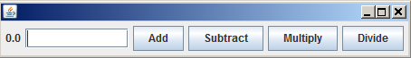

Download the java file named SimpleCalculator.java from source folder, and then complete all the following into this java file:

- Import the necessary class libraries.
- Create a class SimpleCalculator with details below (refer to DemoText.java):
  - Add Jbuttons named addButton, subButton, mulButton, divButton for add, substract, multiply and divide operations respectively.
  - Add a Jlabel named label with initial value “0.0” (String type).
  - Add a JTextField named numField with size 10.
  - Add an attribute named result (double type) with initial value 0;

public class SimpleCalculator _____________________________________ {
private JButton addButton = ____________________;
…
}
- Create a constructor with details below:
  - Set the flowLayout.
  - Add all the GUI components to frame.
  - Add the action listeners to each button.
  - Set the frame “EXIT_ON_CLOSE” to default close operation.
  - Size the frame by calling method pack().

- Create a method actionPerformed(ActionEvent e) with no return value which perform the +-*/ operations once the related button is pressed, i.e.
  - For example, to perform 1*5 = 5 , follow the steps below:
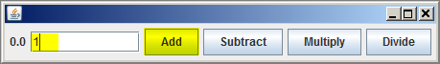
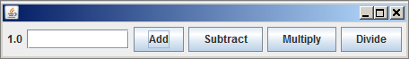

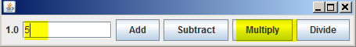
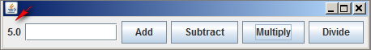

  - Complete the coding for method actionPerformed(ActionEvent e) so that all +-*/ operations are functional.

Q2 Layout Managers
- Create a class BorderLayoutFrame using BorderLayout() with details below (no action will be performed):
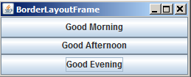

- Create a class Keypad using GridLayout() with details below (no action will be performed):
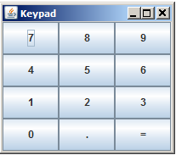

Q3 Radio Buttons (Homework)
- Create a class MultipleChoice using JRadioButton with details below:
  - The GUI is shown below:
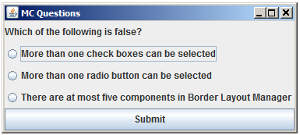

  - Only the second option is Correct, i.e.
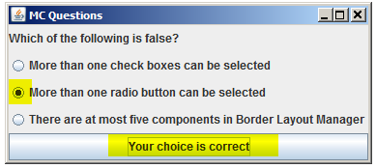

  - Other options are Incorrect, i.e.
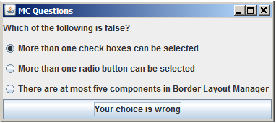
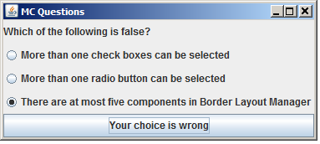

Submit the file(s) of the homework question to OLE on or before the due date.

Prepared by Terri Wong

