COMPS203F Lab 02b

Instructions
- Download the lab materials from OLE and unzip it to your desktop.
- The source folder contains all the source files for each question.
- For those students who are using the PC in school labs, boot up the partition Ewin64.
- Refer to the last page for submission details. Only lab 5 and 7 will be marked finally, other labs submitted will NOT be marked.

[Part A] Example
Study the examples provided from the sample folder with the order specified in the folder names.

[Part B] Exercises

Q1 Checkboxes
- Create a class ComputerPrice using JCheckBox with details below:
  - The GUI is shown below:
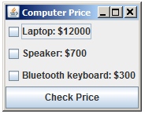

  - More than one items can be selected and then press the button (action performed) i.e.
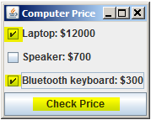

  - Then, the total price of the items checked will be calculated and shown in the button. A message dialog will also be shown i.e.:
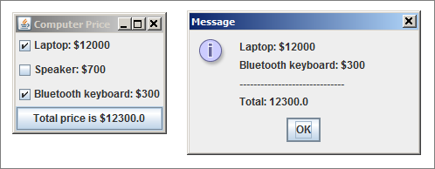

[Hint]

public void actionPerformed(ActionEvent event) {
double total = 0;
String msg = "";

//check the event’s source from the button
if (______________________________ ) {

//check if the laptop’s checkbox is selected
if (_________.isSelected()){

//get the index of the "$"
int index = ______.getText().indexOf(_____) ________ ;

//get the actual price and convert to double type
//using .subString and ______.parseDouble
double price = ______.parseDouble(_____.substring(______));

//add total price
total ______________________;

//add message content using .getText()
msg = ______________; }
…
}

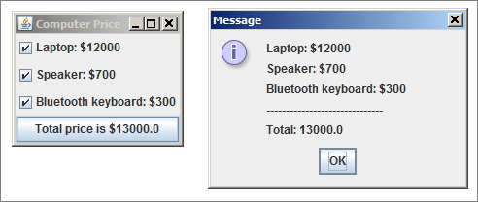

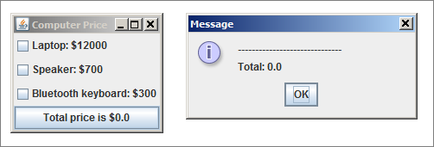

Q2 TextArea (Homework)
- Create a class TextAreaWordCount using JTextArea and JScrollPane with details below:
  - The GUI is shown below:
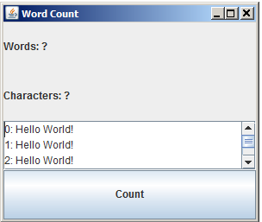

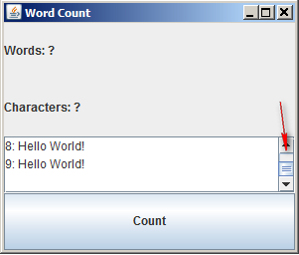

  - The program details are listed below:
    - Create two labels with initial text as shown above
    - Create a textarea with row = 3 and column = 25
    - Create a button
    - Create a scrollpane
    - Set the layout to GridLayout
    - Add the string “Hello World” for 10 times (with index no.) using a for loop into the textarea.
    - Add an action perform method when the button is pressed, which will start counting the no. of words and no. of characters stored in the textarea. i.e.
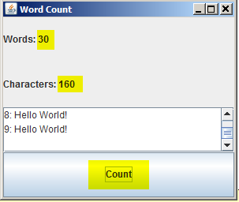

[Hint]
- Self-study the sample TextSplitDemo.java from the sample folder
- Look up the whitespace character “\s” at https://docs.oracle.com/javase/8/docs/api/java/util/regex/Pattern.html
- Look up escape sequence “\” at https://www.tutorialspoint.com/java/java_characters.htm

Compress the .java files from the homework questions into a zip file using 8-digit of your student ID i.e. 12345678.zip, and then submit to OLE on or before the due date.

