COMPS203F Lab 03a

Instructions
- Download the lab materials from OLE and unzip it to your desktop.
- The source folder contains all the source files for each question.
- For those students who are using the PC in school labs, boot up the partition Ewin64.
- Refer to the last page for submission details. Only lab 5 and 7 will be marked finally, other labs submitted will NOT be marked.

[Part A] Example
Study the examples provided from the sample folder with the order specified in the folder names.

[Part B] Exercises
Q1 JPanel
- Create a class SalespersonInfoFrame using three JPanel objects with details below (no action will be performed):
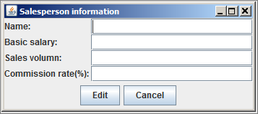

Q2 Menu
- Create a class PullDownMenu using JMenu, JMenuBar, JMenuItem with details below:
  - The GUI is shown below:


  - When “Exit” is chosen, the application will be close:
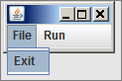

[Hint]
// event handling
public void actionPerformed(ActionEvent event) {
Object …;
if (…) {
System.exit(0);
}
…

  - When “Computer Price” is chosen, load the ComputerPrice.java from lab02:
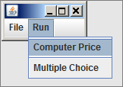

[Hint]
To add a separator between menuItems, call method .addSeparator() , refer to https://docs.oracle.com/javase/tutorial/uiswing/components/separator.html

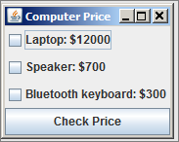

[Hint]
// remember to comment out this line if invoked by PullDownMenu
// in the constructor method ComputerPrice()

// setDefaultCloseOperation(EXIT_ON_CLOSE);

  - When “Multiple Choice” is chosen, load the MultipleChoice.java from lab02:
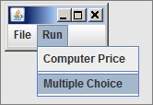
Q3 An ArrayList of Checkboxes (Homework)
- Rewrite the class ComputerPrice (from lab02) this time using ArrayList of JCheckBox with other details unchanged:
  - The GUI and other details unchanged, refer to lab02:
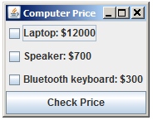

[Hint]

//Resolve ArrayList<>
import java.util.*;

public class ComputerPrice extends JFrame implements ActionListener {
private ArrayList<JCheckBox> checkList = new ArrayList<>(); }
…
}

Submit the .java file(s) of the homework question to OLE on or before the due date.

Prepared by Terri Wong

