COMPS203F Lab 03b NetBeans IDE Installation and Demonstration

[Part I] Install JDK 15
- For Win64, download it from http://learn.ouhk.edu.hk/~t810870/203f/install/ directly.

[Note]:
If you have installed previous JDK version (i.e., version 8), you can still install this version (version 15) without uninstalling any previous versions. Different versions can be installed concurrently in Windows/Mac OS.

- For other OS NOT on Win64, go to https://www.oracle.com/java/technologies/javase-downloads.html
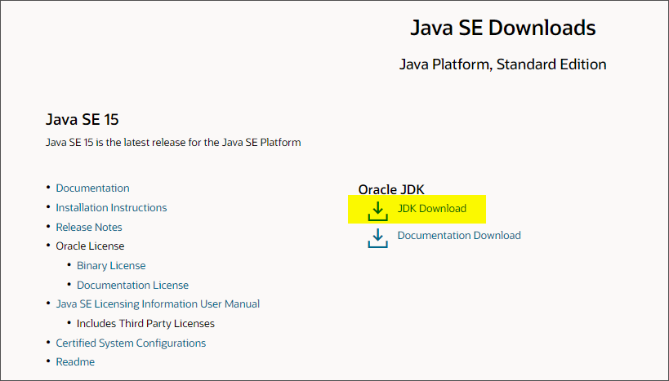

- Locate the jdk-15_windows-x64_bin.exe (ignore the version no.) and then install it in your computer.
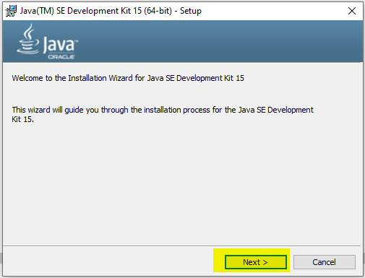

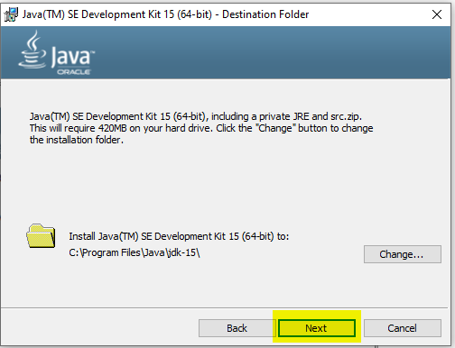

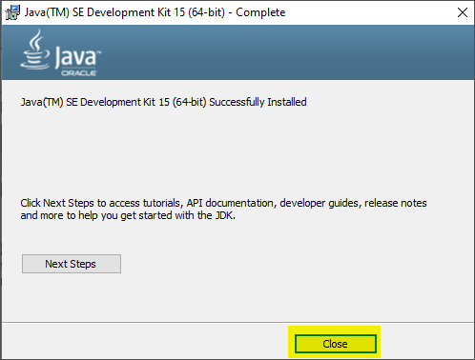

[Part II] Install NetBeans

- For Win64, installer is already provided in the zip file.
- For other OS NOT on Win64, go to https://netbeans.apache.org/download/index.html
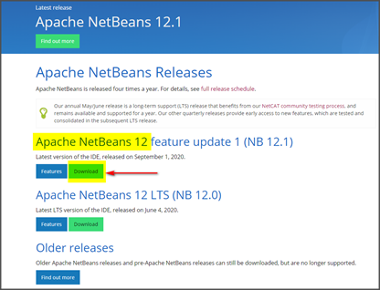

- Locate the Apache-NetBeans-12.1-bin-windows-x64.exe (ignore the version no.) and then install it in your computer.
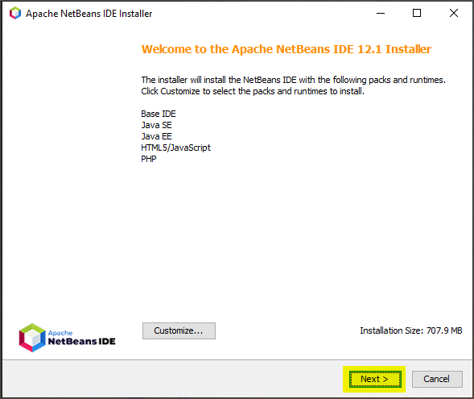

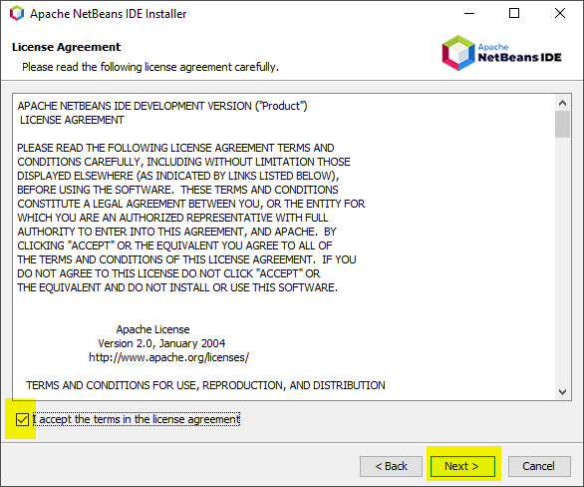

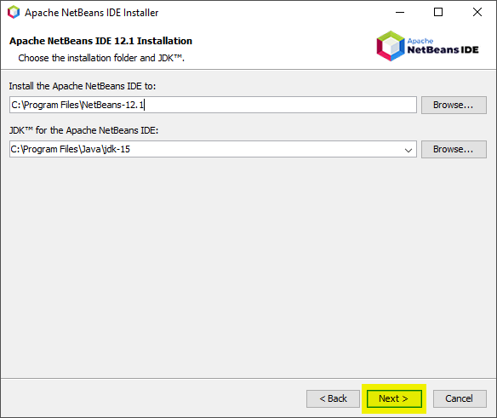

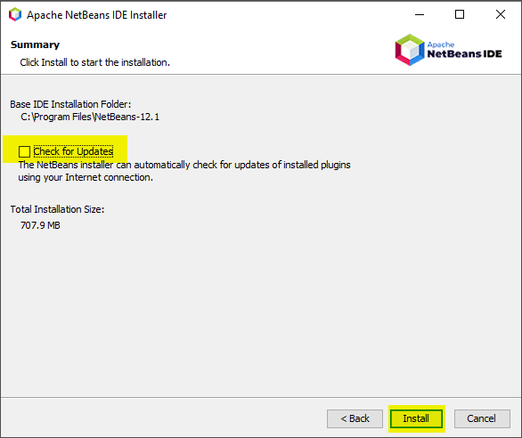

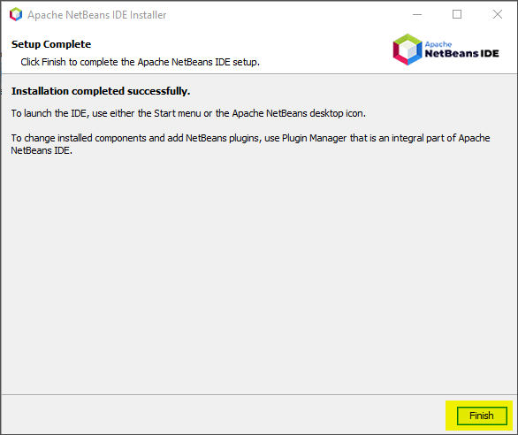

[Part III] Start a New NetBeans Project
- Follow the steps below to installl the NetBeans Plug-in for the first time opening a new project.
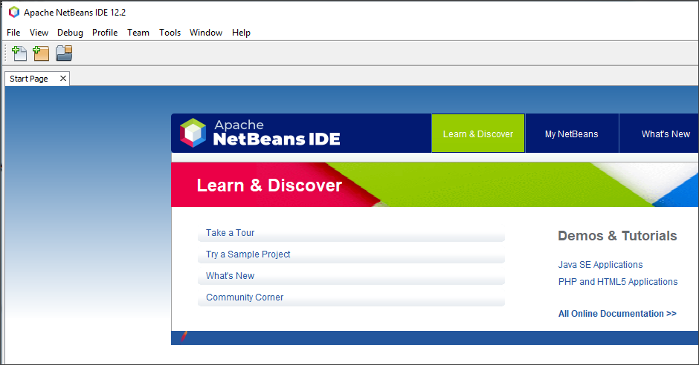

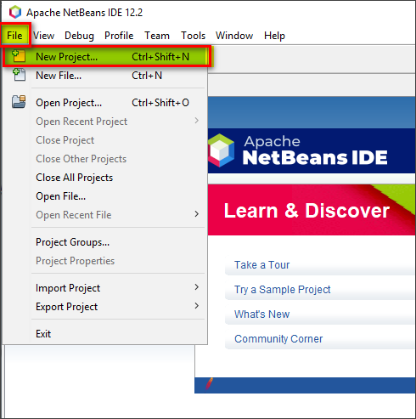

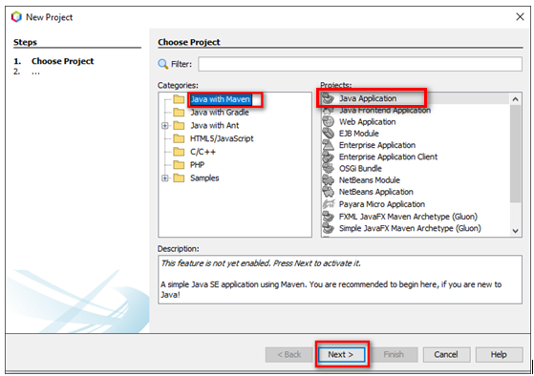

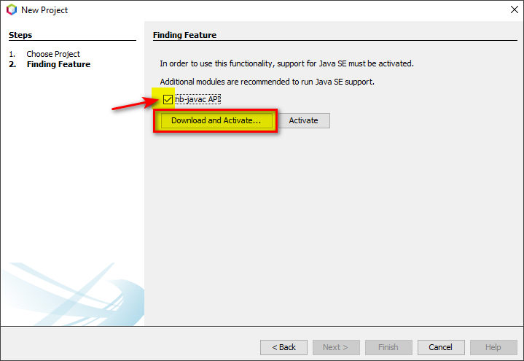

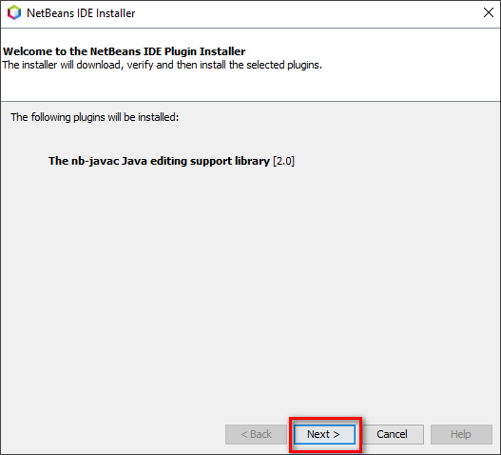

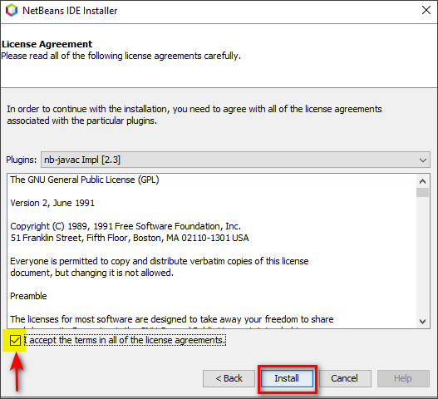

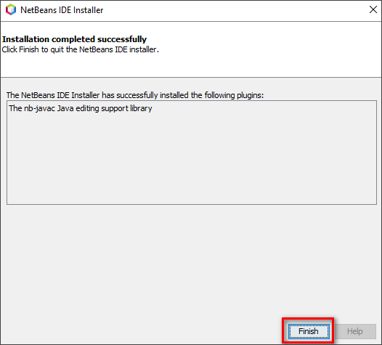

- Now, go to File -> New Project, choose Java with Maven -> Java Application
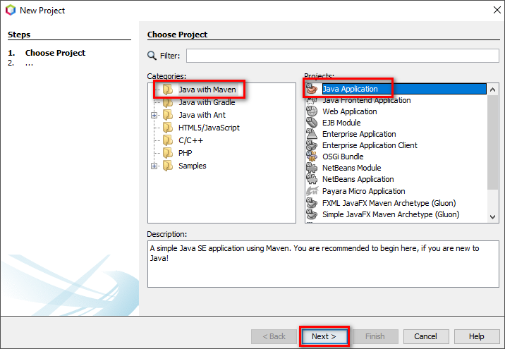

- Choose project Name and Location, leave the Package field as blank
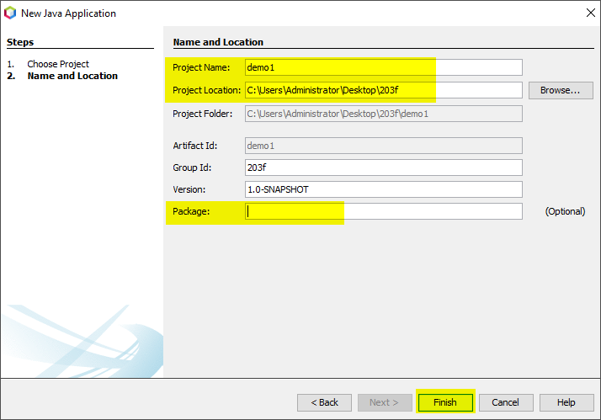

- Right click Source Package -> New -> JFrame Form
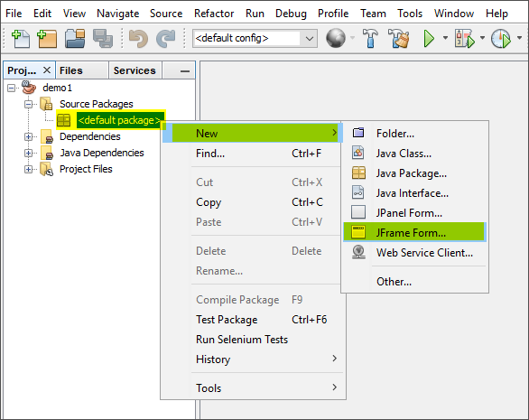

- Name the class name as JFrameDemo
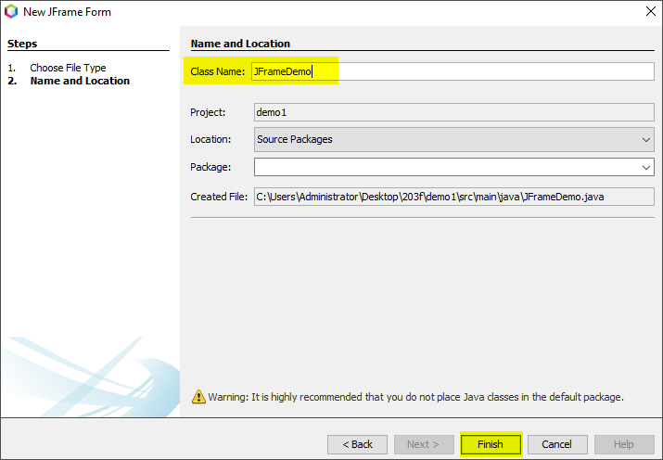

- Open in Design view
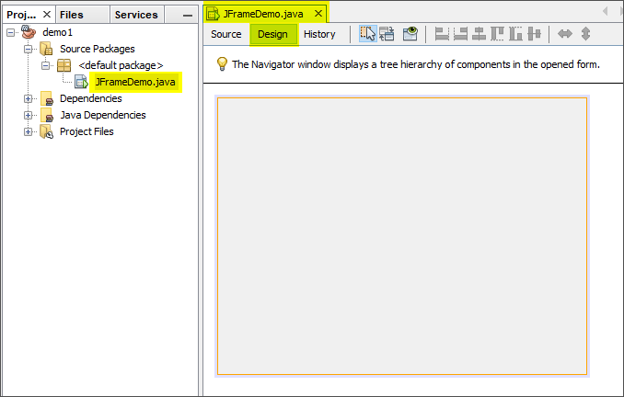

- Drag and drop a button object into the design panel
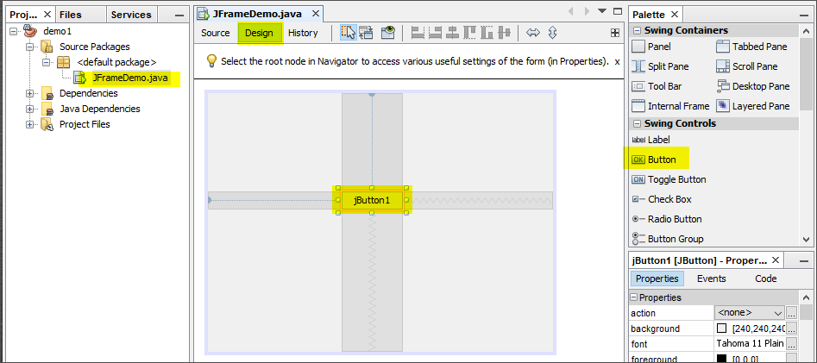

- Change the button’s text
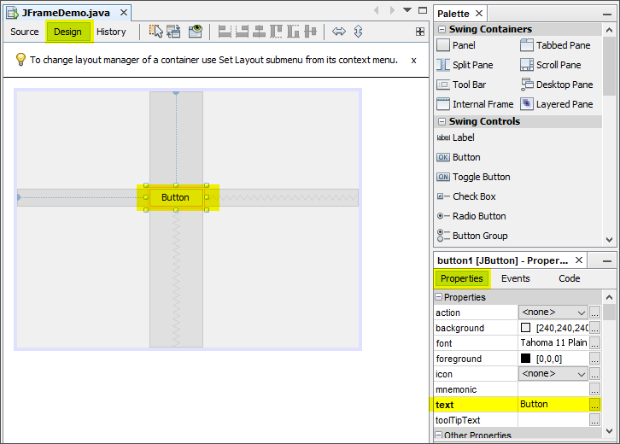

- Change the button variable name
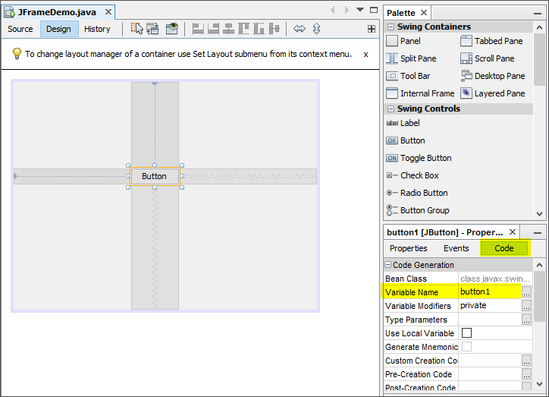

- Right click the file name JFrameDemo.java and choose Run File
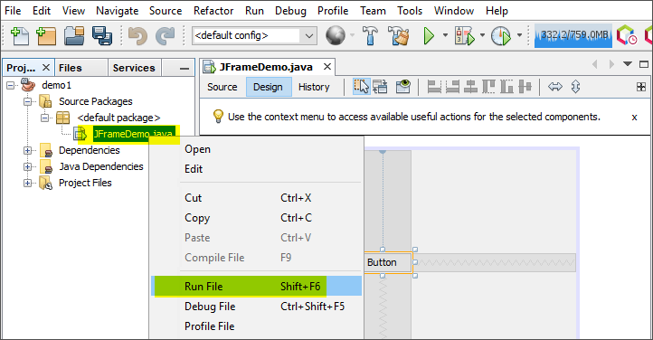

- The Output is shown below:
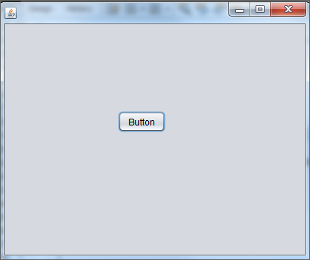

[Optional]
If the Palette or Properties windows are accidentally closed, refer to the steps below of how to re-open them:
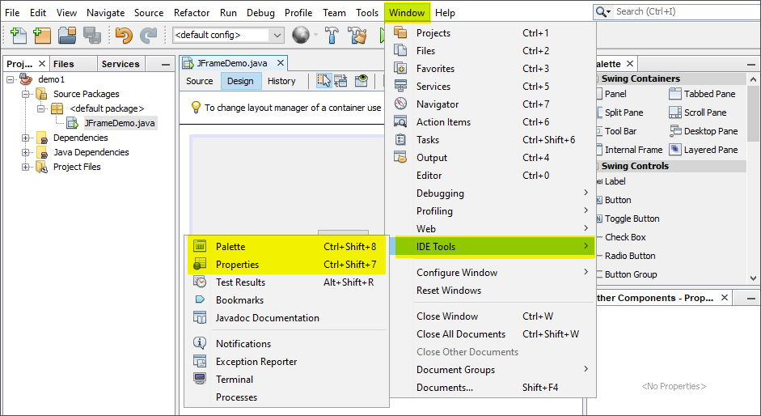

Prepared by Terri Wong

