COMPS203F Lab 07 File Encryption

Instructions
- Download the lab materials from OLE and unzip it to your desktop.
- The source folder contains all the source files for each question.c
- For those students who are using the PC in school labs, boot up the partition Ewin64.
- Refer to the last page for submission details. Only lab 5 and 7 will be marked finally, other labs submitted will NOT be marked.

[Part A] Example
Study the examples provided from the sample folder with the order specified below:
- Write Read Byte
- Write Read HTML
- Encrypt

[Part B] Exercises
Q1 (Homework)

- Write a class FileManager2 as a subclass of JFrame. It has a text field of length 20, a radio button labelled "Read file" , another radio button “Encrypt” and a button labelled "Go". Also create a main method so that the class can by run.
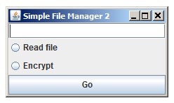

- Create a text file test.txt under the same directory, and add the following content to it:
hello world
hello class

- Add the action handling statement(s) and method to the class. When the button is pressed and the radio button “Read file” is selected, display the file content to the console. You are required to use the method read() without any parameters (i.e., read a char at a time). Remember to close the file when the end of the file is reached. In the catch block, display the message of the exception returned by e.getMessage() (if your exception variable is e).

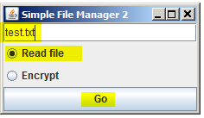

// display the file content to the console
---------- Capture Output ----------
File contents :
hello world
hello class

- Instead of displaying the content to console, create a new JFrame object displayFrame (with title "File content") which contains a text area to display the file content. You can add something to the object using displayFrame.add(). Use other methods in the same way.

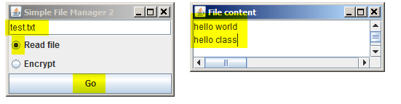

- If "Encrypt" is chosen and "Go" is pressed, encrypt the content of the File content window by adding 13 to the ASCII value of each English alphabet. If the resulting value is greater than the value of 'Z' for capital letters (or 'z' for lower case letters), subtract 26 from it. If you press "Encrypt" again, you should be able to get back the original text. The content of file test.txt remains unchanged.

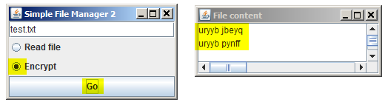

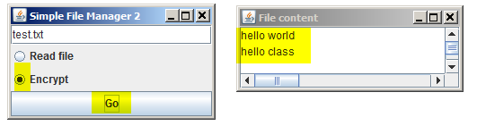

Submit the FileManager2.java file only of the homework question to OLE on or before the due date. (No need to submit the test.txt or a zip file).

Prepared by Terri Wong

