COMPS203F Lab 09 (a) Installation of PostgreSQL Database

[Part A] Installation of PostgreSQL Database
- If the operating system of your computer is window 64-bit, refer below:
- download and unzip all the files to your desktop (ignore the installers’ version no.).

- If the operating system of your computer is NOT window 64-bit, refer to the Appendix section (last part of this tutorial note).

- Double click the .exe file to start the installation process.
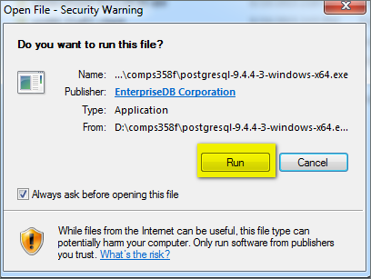

- Follow the steps below:
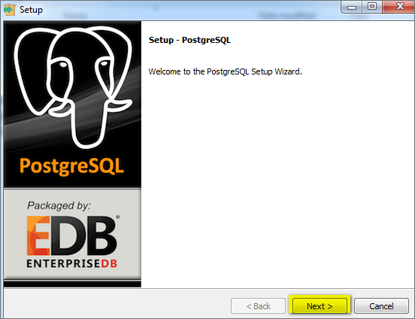
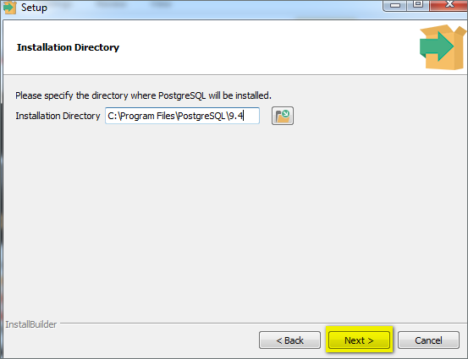
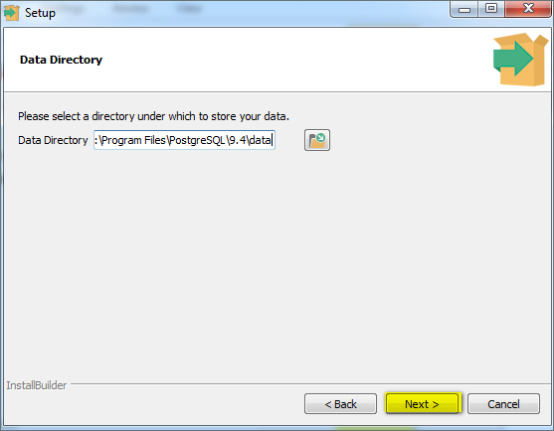

- Enter the administrator password, i.e. use pass123 which is identical to the password used in the sample java program provided.
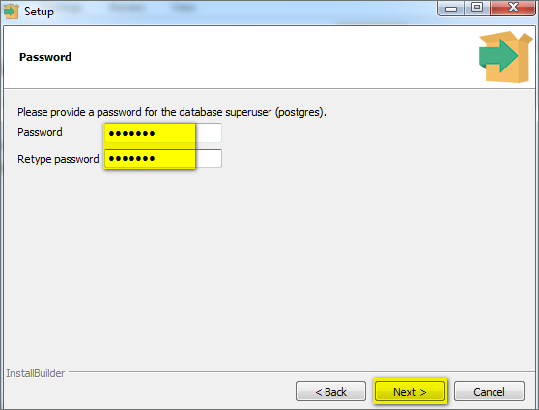

- Follow the steps below:
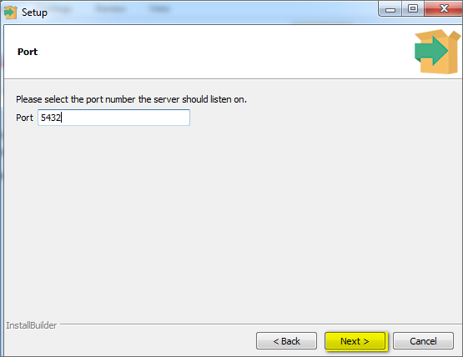
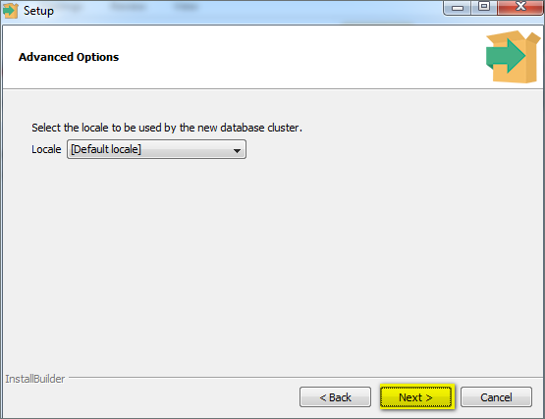
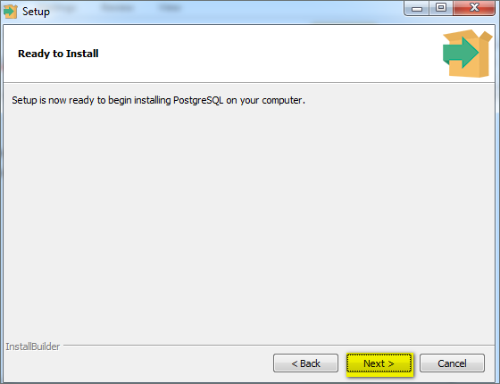

- Uncheck the option for stack builder, and then click Finish
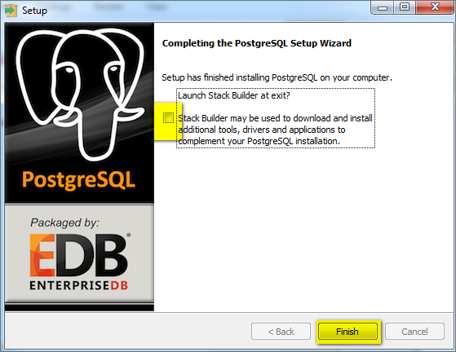

You should now successfully installed the database.

[Part B] Demonstration Using PostgreSQL Database Client
- Go to Program -> PostgreSQL -> pgAdmin III
- Right click the PostgreSQL Database Server and choose “connect”, then enter the password: pass123
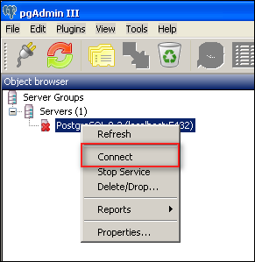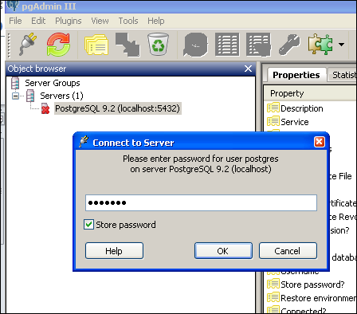
- Go to Databases -> postgres -> schemas -> public -> table, then click the SQL command prompt ():
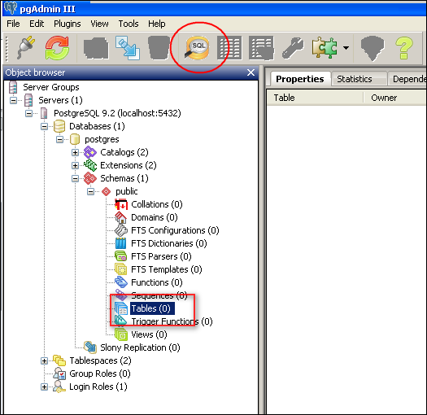

- Create the Student Relation in the SQL command prompt by running SQL codes from the following:
create table student(studentID varchar(8) primary key, name varchar(50), weight numeric(4,1) );

insert into student values ('11223344', 'Ada', 45);
insert into student values ('11223355', 'Ben', 66.5);

select * from student;

--comment
--command to delete all records (delete rows only, not the whole table):
--delete from student;

--command to delete (drop) the whole table (delete both rows and table):
--drop table student;

- Press Run button or Function Key F5 to run the codes as SQL scripts:
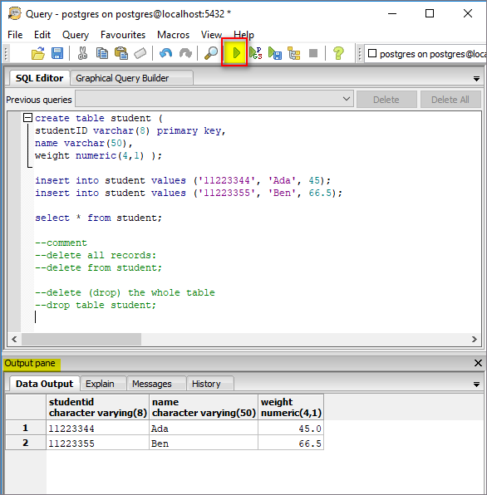
[Note] To run SQL codes individually, select one or many SQL statements and then click

- To view the tables, press the “refresh” button:
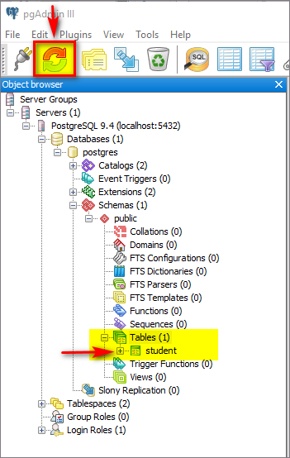

- To view the records, right click any table i.e. table “student” and choose “view data”:
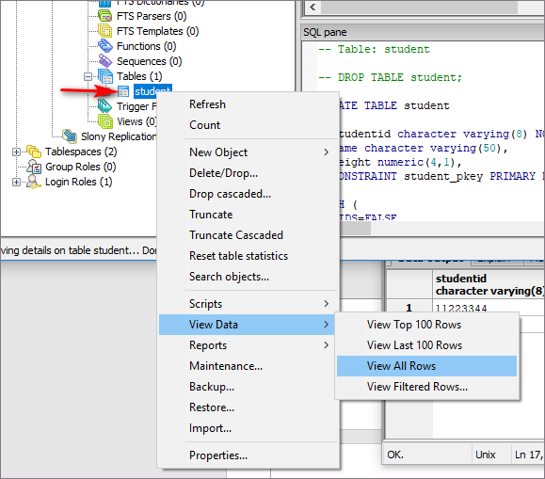

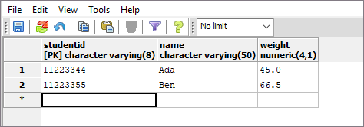

[Part C] Appendix

Note: read this section ONLY if the operating system of your computer is NOT window 64-bit version!
Refer to the following for OS versions other than window 64-bit:
https://www.postgresql.org/download/

Choose the OS, i.e. this time we choose Windows as the OS:
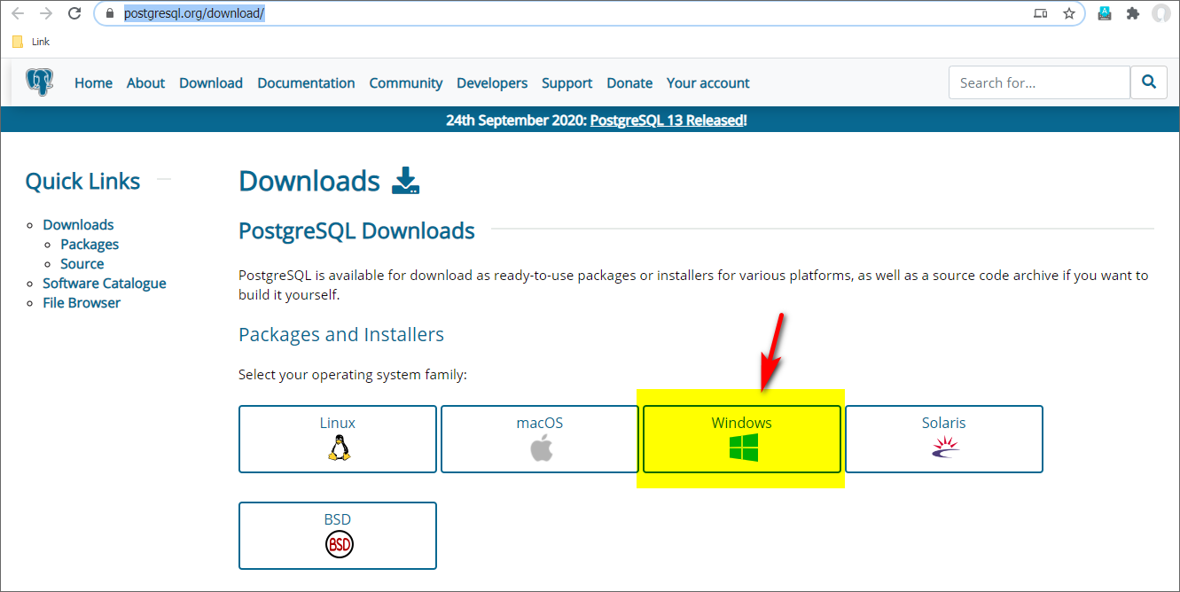

Choose the “Installer” for the selected OS:
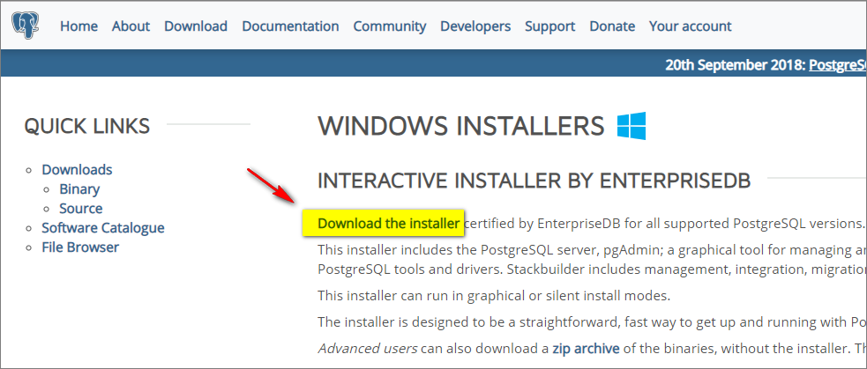

Finally, choose the version to install for different OS, i.e. for Win32 are available currently:
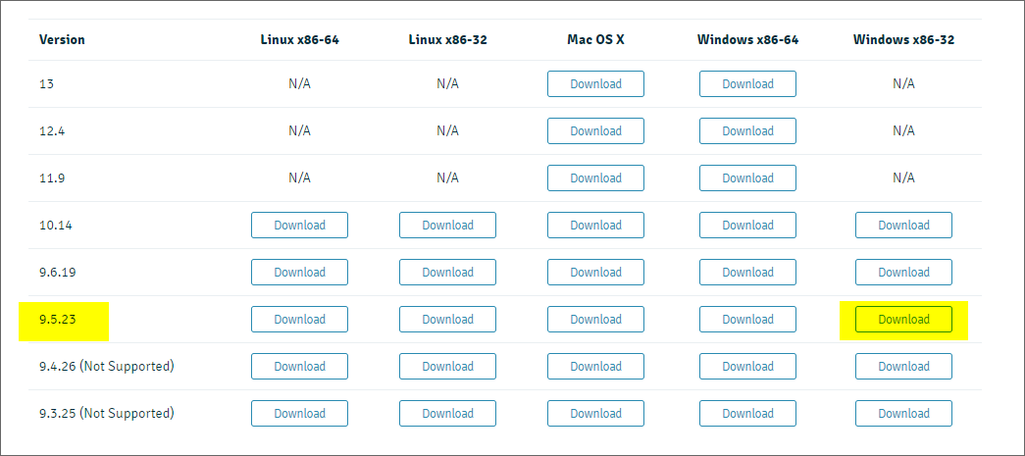
Note: version 9.5.23 is having the same user interface with version 9.4.4 which is installed in the demonstration earlier. You may download this version for Win32.

After successful installation, you may open the database client from:
- Go to Program -> PostgreSQL -> pgAdmin III

[Note you need to login to the pgAdminIII using the administrator password created during the installation]

Prepared by Terri Wong

