COMPS203F Lab 09 (b) SQL, PostgreSQL and JDBC

Instructions
- Download the lab materials from OLE and unzip it to your desktop.
- The source folder contains all the source files for each question.
- For those students who are using the PC in school labs, boot up the partition Ewin64.
- Refer to the last page for submission details. Only lab 5 and 7 will be marked finally, other labs submitted will NOT be marked.

[Part A] Using NetBeans IDE and JDBC
[Note] If you haven’t installed NetBeans yet, refer to lab03 for instructions.

Study the examples using NetBeans provided from the sample folder. Follow the steps below:
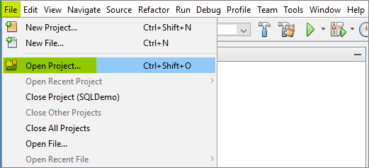

Open the project SQLDemo:
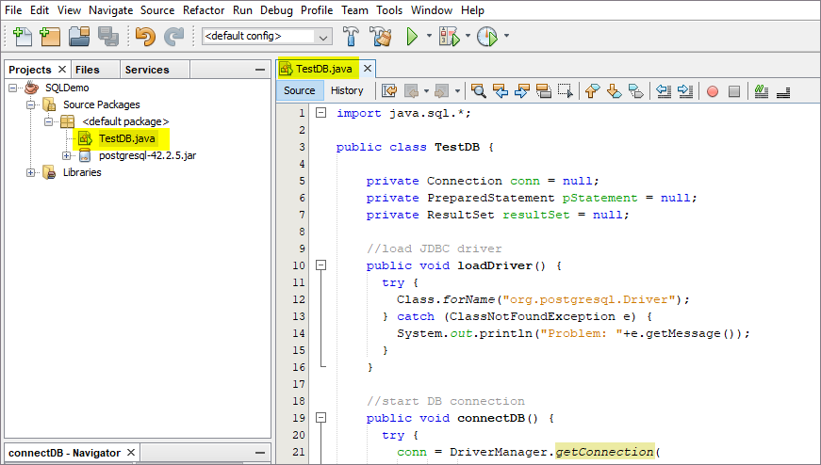

Right click TestDB.java and click Run File:
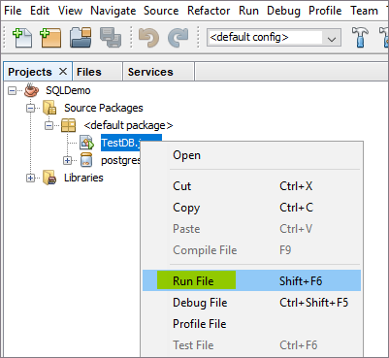

Output:
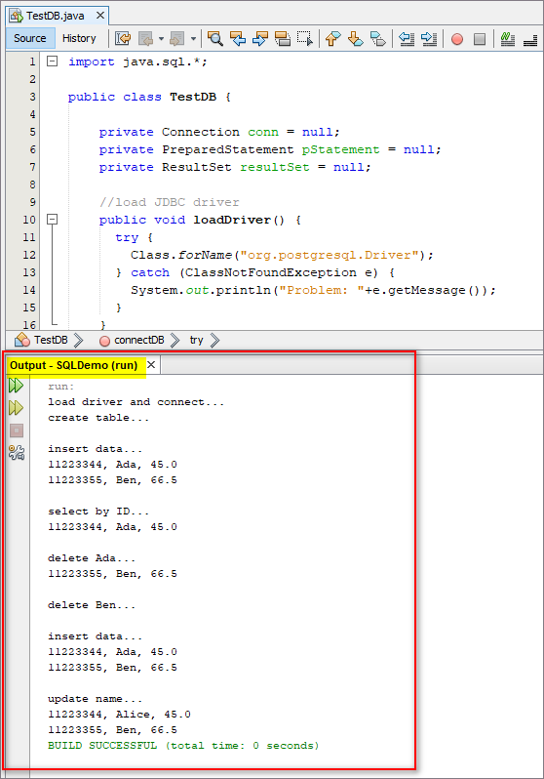
[Note] If you entered different adminstration password during the PostgreSQL DB installation, you may now need to change the password “pass123” to your own password as below:
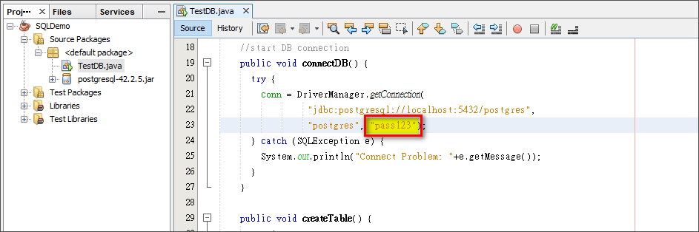

[Part B] Exercises
Q1 (Homework)

- In PgAdminIII, run the following SQL codes:

create table product(id int primary key, name varchar(30), qty int, price numeric(5,1));

insert into product values(1001, 'bread', 10, 5.5);
insert into product values(1002, 'butter', 4, 23);
insert into product values(1003, 'honey', 8, 250.9);

commit;

select * from product;

--to drop table
--drop table product;

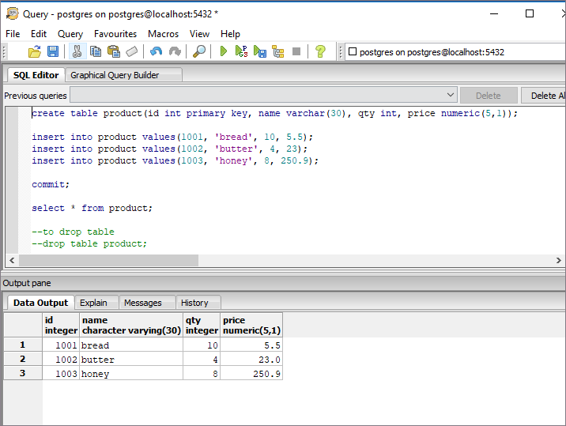

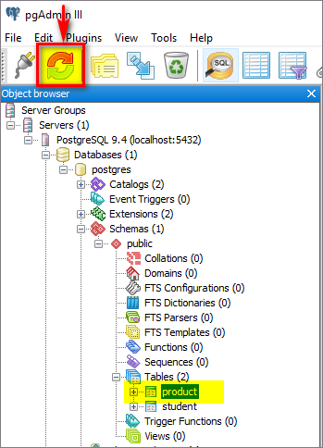

- In NetBeans, add a new java class named “ProductDB.java” by right click the <default package>:
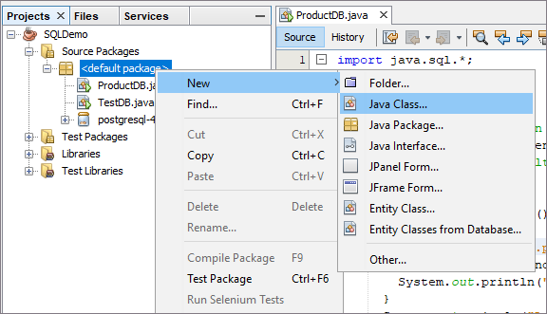

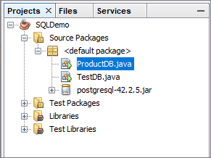

- In class ProductDB, complete the following:
  - Based on sample Class TestDB, create two methods of loadDriver() and connectDB(). Display messages properly in each method if they are ended successfully.

In main method, call the two methods and test the output as (note the last two lines are printed from each of the methods):

load driver and connect...
Load driver successful
DB connection successful

  - Create a method public void selectAllData() which prints all the product records. Test it in the main method. Output as:

select data...
1001, bread, 10, 5.5
1002, butter, 4, 23.0
1003, honey, 8, 250.9

  - Create a method public void selectByPrice(Double aPrice) which prints the product name and price where the price in Product table is greater than aPrice. i.e, selectByPrice(20.0) will give the output as:

select by price...
butter, 23.0
honey, 250.9

  - Create a method public void deleteByID(int aID) which delete the records where the product id equals to aID. i.e, in main method, call deleteByID(1002) and then call selectAllData() will give the output as:

delete by id...
1001, bread, 10, 5.5
1003, honey, 8, 250.9

  - Create a method public void deleteAllData() which delete all the records. Output as (also call selectAllData()):

delete all data...

  - Create a method public void insertData() and setData(…) which add the original records back to the table. Output as (also call selectAllData()):

insert data...
1001, bread, 10, 5.5
1002, butter, 4, 23.0
1003, honey, 8, 250.9

  - Create a method public void updateQty(String aName, int newQty) which update the records with new qty values where name equals to aName. i.e., update the qty to 20 for bread. Output as (also call selectAllData()):

update qty...
1001, bread, 20, 5.5
1002, butter, 4, 23.0
1003, honey, 8, 250.9

  - Create a method public void updateAllPrice(double rate) which increases all the prices by the rate. i.e., update all the prices by rate 1.1. Output as (also call selectAllData()):

update all price...
1001, bread, 20, 6.1
1002, butter, 4, 25.3
1003, honey, 8, 276.0

Compress the NetBeans project from the homework question into a zip file using 8-digit of your student ID i.e., 12345678.zip, and then submit to OLE on or before the due date.

Prepared by Terri Wong

