COMPS203F Lab 12 JSON

[Part A] Examples
Open the sample project using Netbeans and run the java files individually. Study the examples provided from the sample folder with the order specified below:
- CreateJSON.java
which converts the following student records in XML structure to JSON structure:
Student records in XML format:
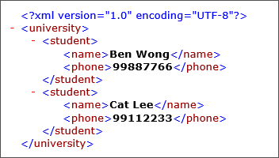

Student records in JSON format (under the sample folder json/university.json):
{"university":{"student":[{"phone":"99887766","name":"Ben Wong"},{"phone":"99112233","name":"Cat Lee"}]}}

- ProcessJSON.java
which shows some add/change/delete functions working with student records in JSON format, output file as university_output.json

[Note] - The json files generated are located in the json folder under the project directory, i.e.
sample->JsonDemo->json
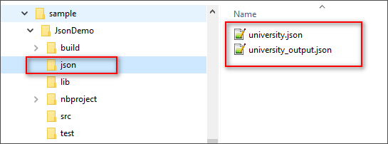

You may open the .json files using Notepad++ or Chrome browser.
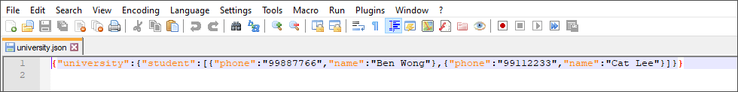

[Part B] Exercises
Q1
- Using Netbeans, create a new class OrderCreate, complete the following:
  - Based on the sample class JSONCreate, this class will display and create a json file “order.json” under json folder: The json content is based on the following xml structure:

<?json version="1.0" encoding="UTF-8"?>
<order>
<product>
<id>1001</id>
<name>coke</name>
<qty>10</qty>
<price>5.5</price>
</product>
<product>
<id>1002</id>
<name>tea</name>
<qty>4</qty>
<price>16.3</price>
</product>
<product>
<id>1003</id>
<name>butter</name>
<qty>2</qty>
<price>23</price>
</product>
</order>

The file order.json contains:
{"order":{"product":[{"price":"5.5","qty":"10","name":"coke","id":"1001"},{"price":"16.3","qty":"4","name":"tea","id":"1002"},{"price":"23","qty":"2","name":"butter","id":"1003"}]}}

Q2
- Create a new class OrderProcess, complete the following:
  - Based on sample Class JSONProcess, create a method public JSONObject importJSON(String filename). Assume all the json files are located in json folder under the project directory. In main method, call the methods and test the output as:

import json file: json/order.json

  - Create a method public void printArray() which prints all the elements. Test it in the main method. Output as:

print all element list:
ID: 1001
Name: coke
Qty: 10
Price: 5.5
ID: 1002
Name: tea
Qty: 4
Price: 16.3
ID: 1003
Name: butter
Qty: 2
Price: 23

  - Create a method public void printArray(String aID) which prints the element with id equal to aID . Test it in the main method. Output as:

print element list for ID 1003:
ID: 1003
Name: butter
Qty: 2
Price: 23

  - Create a method public void printFilter(double aPrice) which prints the element(s) with price greater then aPrice . Test it in the main method. Output as:

print element list for price > 10:
ID: 1002
Name: tea
Qty: 4
Price: 16.3
ID: 1003
Name: butter
Qty: 2
Price: 23

  - Create a method public void printTotal() which prints the total of the order. Test it in the main method. Output as:

print order total:
Order Total: $166.2

  - Create a method public String findName(String aID) which returns the name of the element with aID. Test it in the main method. Output as:

find name of ID 1002:
tea

  - Create a method boolean changeQty(String aID, String newQty) which returns true if update is successful and returns false otherwise. Test it in the main method. Output as (also call printList(aID)):

change qty of 1002:
ID: 1002
Name: tea
Qty: 18
Price: 16.3

  - Create a method public JSONObject exportJSON(String filename). Assume all the json files are located in json folder under the project directory. In main method, call the methods and test the output as:

exporting to json/order_output.json

  - Check the order_output.json content:
{"order":{"product":[{"price":"5.5","qty":"10","name":"coke","id":"1001"},{"price":"16.3","qty":"18","name":"tea","id":"1002"},{"price":"23","qty":"2","name":"butter","id":"1003"}]}}

There is no need to submit the homework queston to OLE this week.

Prepared by Terri Wong

