GEN B 168F
You have a choice:
Career decision-making

Assignment 1

Student Name: Angold, Jiawei Wang
Student ID: s12395870

Tutorial Group: T04
Submitted to: MS Amy Chan
Date of Submission: 13 Nov 2020

Overview

My name is Jiawei Wang. A year-2 student in the school of science and technology.
And this is my very first time to think about my future career seriously.
I divide this report into 4 parts, with introducing myself in 4 different aspects:
Personality. Skills. Values. Career.

1. Personality

Personality, which refers to individual differences in characteristic patterns of thinking, feeling and behaving (Wikipedia, 2017). In my opinion: The personality is the nature of a
person, which means the most unchangeable things of human being.

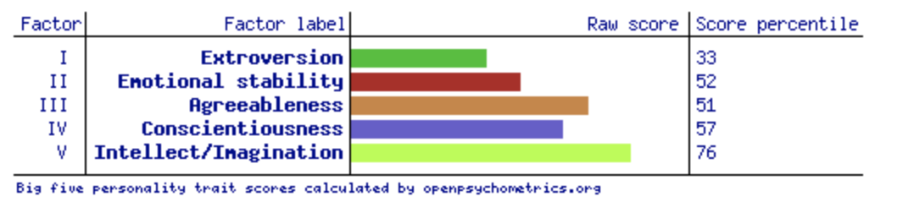
This figure above is My Big five personality trait scores. This model is trying to use 5 different factors to determine someone’s personality. [1]

In Big five personality model. A person can find its personality easily by answering some questions, so it may just can describe their personality roughly and help them find the most prominent feature.

My two most prominent factors are: Introversion (67%) and Imagination (76%).

- Introversion is the quality of being shy and quiet. Which means preferring to spend time alone rather than often being with other people.
- In my opinion. The biggest cause of my introversion is lack of self-confidence, that makes me very humble and sometimes it leads to missed opportunities.
- The advantage of being introversion very time is that I don’t need spend too much time on interpersonal communication, and I’m very enjoy the time being along so that I can spend more time to do things I want.

- Imagination is the ability to form pictures in the mind.
- In my opinion. I like to imagine is because I am very concerned about what others think of me. That makes when I do or want to do somethings, I will first generate a picture in my mind, which described what other people’s behavior after knowing that.
- The advantage of being imagination is that if one thing is done, great achievements will be maked or big improvement will get. Then I’ll try my best to achieve it and never give up or retreat.
1

2. Skills

When we talked about skills, it is usually accompanied by career choice.
I am an IT student, which means I’ll face the computer most of the time. And as many other industries, it is also important to keep many skills on my heart.

Hard Skills:
Which means specific, teachable abilities that can be defined and measured. [2]
In my opinion. Which types of Hard skills are very important.
For example:
In Computer Science. Learn how to use other’s achievement or project is going to get hard skills. Like programming or debugging in a high-level machine. But if you are not excellent enough, it is very easy for you to be replaced by others. In some point of view. “high-level” means easy to understand and also easy to control, especially in computer science which is very abstract than others. Therefore, if you don’t understand the principle of what you are doing. Then anybody could replace your seat.

It is very important to understand the basic principles of this huge system. For computer science, it is operating system, compiler, etc. It may be very difficult to learn, and very hard to get it very well. But if you make it your foundation, you’ll have the most basic ability to face problems. “Hard to control”, I think is the another meaning of “Hard Skill”.

Soft Skills
Skills which characterise relationships with other people, or skills for communications, and self-management. [2]

As I mentioned above, as an IT student. If you don’t understand the basic principle of what you are doing. It is very easy for you to be replaced by others. Another reason of this is that computer science is growing faster and faster than any other subject all over the world. Many people in this industry don’t have the time and energy to keep learning new technologies as they get older and have their families. Therefore, they are very easy to be eliminated by younger people who has more energy and more modern hard skills than you.

To avoid this. Apart from having these hard skills. Self-management like keep learning is also very important. Which means can have a better adapt to this era.

3. Values

In real situations. A person’s attitude to his/her life, we call it the value. This may be hard to really affects what happening now. But this can really affect what will happens in the future. Which can be defined “the road of life”.

I am a person who like fantasy. Perhaps in the road of growing up, I did not suffer too much. That makes I always have a good impression of many things and big dreams to be achieved.
I think all my life must to be greatful. At least in my opinion (Terminal value).
2
Because of this instrumental value.[3] On my mind. My life is sprit in one direction. And hard to give up when fail or meet difficulties.

4. Career

After getting enough self-knowledge. I decided to think about my career seriously:

- Career options: I want to be a researcher in Computer Science.
- Position: Work in tech-companies on Silicon Valley then be a professor in university.
- Career path: After graduation from university. I want to work in a tech-company in Hong Kong, while working, keep learning. Then go to a big company like Microsoft or Apple. After working for years. I will come back and trying to be a professor in a University, while teaching, keep researching.

Justification:
As I mentioned below. I am a person who is like to being alone and imagination. Although there are many bad effects of this. It can also help me have more time doing things that my long-life want.

Reference:

[1] Goldberg LR (January 1993). "The structure of phenotypic personality traits". American Psychologist. 48 (1): 26–34. doi:10.1037/0003-066x.48.1.26. PMID 8427480.

[2] https://zety.com/blog/hard-skills-soft-skills#:~:text=Hard%20skills%20are%20teachable%20and,getting%20along%20with%20other%20people

[3] "What is Computer Science? - Computer Science, The University of York". www.cs.york.ac.uk. Retrieved June 11, 2020.

2

3

[1] Goldberg LR (January 1993). "The structure of phenotypic personality traits". American Psychologist. 48 (1): 26–34. doi:10.1037/0003-066x.48.1.26. PMID 8427480.

