CPE 464 - Selective-Reject Program Design
Due Monday, May 17, 2021 at 11:59 pm

Design assignment: You may work on this in groups (up to 3 people). You only need to turn in one assignment for the group but you must put each group members name and a picture of the group (a picture of a zoom screen works) on the first page. All group members must be present for all work (except the final write-up). If you work in a group, you must provide a picture of your group on the first page with some flow diagrams or state diagrams in the picture!

Once the design work (e.g packet flows, state diagrams and program tree/common code) is done you MUST stop working as a group. Your program code needs to be your own.

NOTE – handwritten/hand-drawn is fine. This assignment is a tool to help you successfully write your rcopy and server programs.

PART I – Design questions

- STOP – Read the entire program #3 spec before continuing. I recommend you underline the important parts as your read it.

- Give a packet flow diagram of the following scenarios (use a diagram similar to the ones done in class – labeled arrows between rcopy and server.) and discuss what implications this has on your rcopy and server programs (during the transmission of the file data):
  - Normal flow – nothing lost (no errors in data or flow control packets)
  - One data packet lost in a window of size 3 (include how its recovered)
  - Multiple packets lost in a window (look at both sequential packets being lost and non-sequential e.g packets 6 and 9 being lost with window size of 10)
  - RR lost for packet 2
  - Multiple RR’s lost (e.g. RR 2 and RR 3 lost)
  - SREJ lost
  - Entire window of data being lost
  - Entire window of RR’s being lost

- Looking back at question 1, which of those scenarios may cause your window to close? (Explain each case also explain what will need to be retransmitted… I know the window will close if the window size is to small… so don’t just say that. Which of the above situations will cause the window to close because of the loss packet(s)?

- Regarding the following possible scenarios for receiving data. Explain how this scenario can happen and list what action you will take with the data and how you will reply to the sender (it is possible that one or more of these scenarios cannot happen):

  - Data frame number is a duplicate of one you have already received
  - Data frame number is greater than the one you expected but is still in your window size.
  - Data frame number is the one you are expecting but you have already received frames with higher numbers.

- Managing the Server’s window: Walk through the following examples using the technique I showed in class using the Lower, Upper and Current indexes for the server’s window. I am ok with hand drawn and you don’t need to repeat everything, just cross out the numbers as your window moves. I just want you to understand how the window indexes work.

Example (note - I show 2 tables so I can demonstrate the movement of the pointers, you can just use the same table and cross out the pointers as they change. This example below assumes a window size of 3.

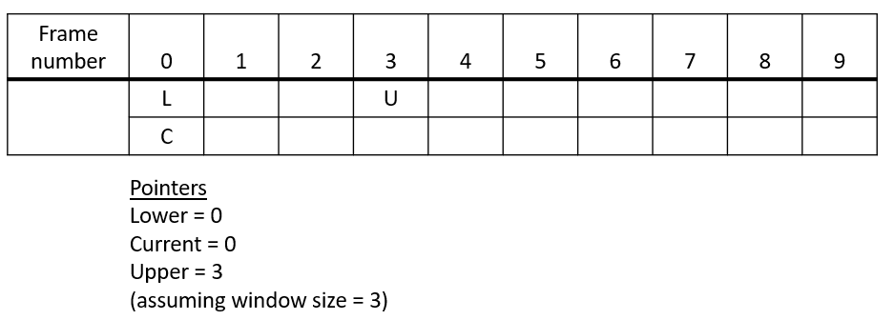

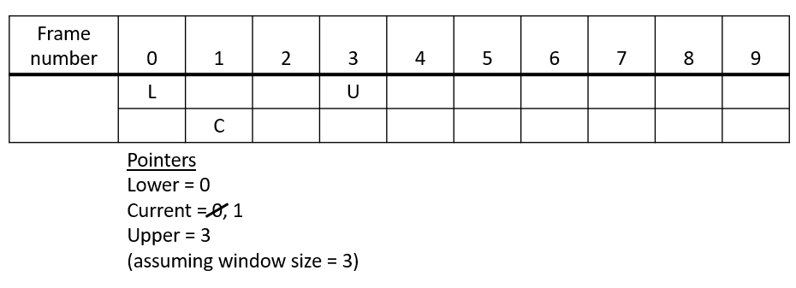

Send packet 0

- Walk through the scenario: send frame 0, 1, 2 and then receive RR 1, receive RR 3, send frame 3 and 4. (window size = 3)
- Walk through the scenario: send frame 0, 1, receive RR 1, send frames 2, 3, receive SREJ 2, resend 2, receive RR 4. (window size = 3)

- Assume your program receives data frames 1,2,3,4,5 and then receives frame 7 and 8 and then frames 10, 11 and 12 (some recovered packet(s) is/are needed to make this work). Draw a packet flow diagram of your solution using a window size of 3. Discuss how your implementation will handle this situation. How are RR’s and SREJ’s sent? What packets are sent/resent?

- Draw a packet flow diagram for the following scenario but include for sender of the data only the value for the bottom of the window, lower edge of the window and upper edge of the window for each send and receive. You can use a notation like (Bottom of window, current frame, upper edge)… so (3,3,6) would mean the bottom of the window is 3 the current to send is 3 and the upper edge of the window is 6. (sender is the one sending the file data)
  - With a window size of 5: sender sends data packets 1-3, sender receives RR 2, sender sends packets 4,5,6, sender receives RR 6, sender sends packets 7 and 8, sender receives SREJ 7, sender sends 7, 9 and 10
  - With a window size of 5: sender sends data packets 1-5, sender receives nothing and timeouts, sender resends packet 1, sender receives RR 6, sender sends 6, 7, 8, 9
  - With a window size of 5: sender sends data packets 1-5, sender receives RR 3, sender receives SREJ 3, sender resends packet 3, sender receives RR 6, sender sends 6, 7, 8, sender receives SREJ 6

- Draw a packet flow diagram for the following scenarios for the connection establishment and then filename exchange (end the diagram with the first data packet being successfully received).

  - No packets lost
  - First packet (flag=1) is lost from rcopy
  - Second packet sent by rcopy is lost (filename packet).
  - First packet sent by the server is lost. (flag = 2)
  - First two packets sent by the server are lost. (flag = 2 packets)
  - After filename exchange and you start to send data, what happens if the entire first window of data is lost.
  - After filename exchange and you start to send data what happens if an entire window of RRs are lost.

- Give a packet flow diagram on how you will handle the last packet of the file.
  - Last data packet is lost
  - RR for last data packet is lost.
  - The 2nd and 5th data packet from the end is lost (so the final data packet gets there but the one before that does not… and the one 4 before that does not). Your window size is 7.

Part II – State diagrams

Turn in a state diagram for Rcopy and another for server (so two diagrams). These diagrams should start with the filename exchange and cover the sending/acking of the last packet. Only worry about the file transfer between one rcopy program and one server process/thread.

Part III – Windowing Library

As part of program #3, you are going to implement a library (so a .c and .h file) that implements the windowing functionality (including the window data structure and accessor code) needed by both rcopy and server. Note the needs for managing the window data structure in the rcopy and server programs are slightly different but do overlap. You window must be managed as a circular queue.

- Reread the program requirements regarding the window library.
- Starting with the server, look at your answers to part I and II above and walk through using a window data structure on your server (e.g look at the upper, lower, and current variables, what happens when a packet is sent, an RR arrives…) and answer the following three questions:
- What actions do you need to take to manage the data structure (e.g. add a packet to you window data structure)
- What questions do you need to ask about your window (e.g. is the window closed?)
- What data do you need to maintain to manage your window?
- Now look at rcopy, look at your answers to part I and II above and walk through using a window data structure in rcopy, answer the following three questions:
- What actions do you need to take to manage the data structure (e.g. add a packet to you window data structure)
- What questions do you need to ask about your window
- What data do you need to maintain to manage your window?

Part IV – Function hierarchy drawing and listing common code
This section has two parts:

- Function hierarchy drawing: Turn in a hierarchical (e.g. a tree of functions) drawing of each of your programs (one for rcopy one for server). This is a course grain overview of your implementation. Many of the branches in this tree should be at least 4 nodes in depth. The goal is to identify the worker function (lower functions used to support your higher level logic) that are common between the rcopy and server and also within rcopy and server.

- Common Code: List the functionality that is common between the programs

Looking at your design including your hierarchical drawings, what functionality is common between the two programs (rcopy and server)? This is functionality that will be written in a separate code file (.c and related .h) and linked into rcopy and server as part of creating your executables (i.e. in your Makefile).

Make a copy of your packet flows, state diagrams and code breakdown before you turn them in… you will not get them back in time to help you write the program.

The window is closed if you have sent window size number of packets and have not received any acknowledgment for those packets.
While this problem only lists a few RRs, I would recommend you send an RR every time a good packet (in order, error free) arrives. It is more complex to accumulate RRs and only send them every few packets. But, this is a design decision and is up to you.
Remember, you are designing and implementing a library to manage your windowing. This means you need to figure out what data you need for your window and what accessor functions you need to utilize your window in your rcopy and server code.

