CivicTwin: AI-Enabled Digital Twin for Predictive Urban Infrastructure Resilience
PAMCA698J - Dissertation-1/ Internship-1

Submitted in partial fulfillment of the requirements for the degree of

Master of Computer Applications
in
Department of Computer Applications

by

Adrija Biswas
25MCA0212

Under the guidance of

Dr. Parimala M.

School of Computer Science Engineering and Information Systems
VIT, Vellore



November, 2026

CivicTwin: AI-Enabled Digital Twin for Predictive Urban Infrastructure Resilience
PAMCA698J - Dissertation-1/ Internship-1

Submitted in partial fulfillment of the requirements for the degree of

Master of Computer Applications
in
Department of Computer Applications

by

Adrija Biswas
25MCA0212

Under the guidance of

Dr. Parimala M.

School of Computer Science Engineering and Information Systems
VIT, Vellore

November, 2026

DECLARATION

I hereby declare that the PAMCA698J - Dissertation-1 entitled “CivicTwin: AI-Enabled Digital Twin for Predictive Urban Infrastructure Resilience” submitted by me, for the award of the degree of Master of Computer Applications in Department of Computer Applications, School of Computer Science Engineering and Information Systems to VIT is a record of bonafide work carried out by me under the supervision of Dr Parimala.M., Professor Grade I, SCORE, VIT, Vellore.
I further declare that the work reported in this dissertation has not been submitted and will not be submitted, either in part or in full, for the award of any other degree or diploma in this institute or any other institute or university.

Place: Vellore
Date: 28th October, 2026

Signature of the Candidate

CERTIFICATE

This is to certify that the PAMCA698J - Dissertation-1 entitled “CivicTwin: AI-Enabled Digital Twin for Predictive Urban Infrastructure Resilience” submitted by Adrija Biswas (25MCA0212), SCORE, VIT, for the award of the degree of Master of Computer Applications in Department of Computer Applications, is a record of bonafide work carried out by him / her under my supervision during the period, 06. 07. 2026 to 03.11.2026, as per the VIT code of academic and research ethics.
The contents of this report have not been submitted and will not be submitted either in part or in full, for the award of any other degree or diploma in this institute or any other institute or university. The dissertation fulfills the requirements and regulations of the University and in my opinion meets the necessary standards for submission.

Place: Vellore
Date: 28th October,2026

Signature of the VIT-SCORE - Guide

Internal Examiner External Examiner

Head of the Department
Department of Computer Applications

ACKNOWLEDGEMENT

I would like to express my sincere gratitude to my Dissertation-1 guide, Dr. Parimala M., Professor Grade I, School of Computer Science Engineering and Information Systems (SCORE), Vellore Institute of Technology, Vellore. Her steady guidance, constructive critique, and deep familiarity with urban hydro-informatics and cyber-physical systems were invaluable throughout this project. She helped me look past raw algorithmic simulations and consider the practical realities of municipal infrastructure and civic governance.

I am deeply grateful to our Honorable Chancellor Dr. G. Viswanathan for providing the advanced research facilities at VIT. My thanks also go to respected Vice Presidents Dr. Sankar Viswanathan and Dr. Sekar Viswanathan, Vice Chancellor Dr. V. S. Kanchana Bhaaskaran, Pro-Vice Chancellor Dr. Partha Sharathi Mallick, and Registrar Dr. Jayabarathi T. for their continuous institutional encouragement.

I extend my warm thanks to Dean Dr. Daphne Lopez, School of Computer Science Engineering and Information Systems; Head of the Department Dr. Senthilkumar N; MCA Project Coordinator Dr. Krishnamoorthy N; and SCORE Project Coordinator Dr. Karthikeyan P, along with all my department professors and staff who offered valuable guidance during my course of study.

I want to thank my parents and close friends for their unwavering patience and support while I worked on this dissertation. Finally, I appreciate everyone who offered technical advice, shared data, or assisted me along the way.

Place: Vellore
Date: 28th October,2026 Adrija Biswas

Executive Summary

Every monsoon season, secondary Indian cities face the same crisis: sudden, heavy rain hits poorly maintained roadside drains, turning busy streets into stagnant pools and bringing daily life to a halt. In Vellore, Tamil Nadu, rapid construction has replaced open soil with concrete, while domestic trash, road sand, and building debris clog the city's drainage channels. Most municipal corporations manage this reactively. Desilting machinery and suction tankers are sent out only after water begins pooling on major roads or after desperate phone calls from residents. Even during pre-monsoon maintenance, supervisors typically clear whichever drain looks dirtiest on the surface. That approach misses the bigger picture: a badly clogged ditch near a hilltop only spills locally, whereas a moderately silted channel downstream can block drainage for dozens of connected streets, causing backwater floods kilometers away.
This dissertation presents CivicTwin, a cyber-physical digital twin designed to give municipal administrators the predictive foresight they need before storms strike. Using geospatial and survey records from Vellore City Municipal Corporation (CMC), the platform models 13,998 drain segments as a Directed Acyclic Graph (DAG) with 22,737 gravity flow links across 60 administrative zones. CivicTwin combines the rational runoff method, an ensemble Random Forest blockage model (achieving 89.4% classification accuracy), and a bitset-accelerated reachability engine that traces upstream dependencies across the entire network in under 20 milliseconds. Instead of prioritizing drains by local silt levels alone, CivicTwin introduces a cascade-aware dispatch algorithm that targets systemic bottlenecks—channels whose clearance restores drainage for hundreds of upstream tributaries. Simulated across rainfall intensities from 80 to 160 mm/hr, the cascade-aware method clears 3.1x to 4.4x more at-risk and backwater-affected drains than traditional municipal severity heuristics under the same equipment and labor budgets. Delivered through an interactive React and FastAPI command dashboard, CivicTwin provides municipal engineers with real-time bottleneck detection, helping public works teams shift from emergency fire-fighting to proactive urban resilience.

TABLE OF CONTENTS
Title | Page No.
Declaration | iii
Certificate | iv
Acknowledgement | v
Executive Summary | vi
Table of Contents | vii
List of Figures | viii
List of Tables | ix
List of Abbreviations | x
Symbols and Notations | xi
CHAPTER 1: INTRODUCTION | 1
1.1 Background and Context | 1
1.2 Problem Statement | 3
1.3 Project Objectives | 4
1.4 Motivation and Societal Impact | 5
1.5 Scope and Delimitations | 6
1.6 Dissertation Organization | 7
CHAPTER 2: LITERATURE REVIEW | 8
2.1 Urban Stormwater Infrastructure and Hydraulic Modeling | 8
2.2 Digital Twins in Civil and Municipal Engineering | 11
2.3 Machine Learning Surrogates in Flood Risk Assessment | 13
2.4 Complex Network Theory and Cascading Failures in Urban Utilities | 16
2.5 Critical Analysis and Research Gaps | 18
CHAPTER 3: TECHNICAL SPECIFICATIONS AND ARCHITECTURE | 21
3.1 System Requirements and Specifications | 21
3.2 High-Level System Architecture | 23
3.3 Spatial Data Modeling and PostGIS Database Schema | 26
3.4 RESTful API Architecture and Endpoints | 28
3.5 Concurrency Control and Audit Trail Logging | 30
CHAPTER 4: HYDRODYNAMIC MODELING AND GRAPH CASCADE ENGINE | 32
4.1 Hydrological Formulation and Catchment Inversion | 32
4.2 Effective Capacity and Utilisation Formulation | 34
4.3 Directed Acyclic Graph (DAG) Construction | 37
4.4 Bitset-Accelerated Ancestor Reachability | 40
4.5 Systemic Network Risk Exposure Metric | 43
CHAPTER 5: PREDICTIVE MODELING AND SURROGATE RISK ESTIMATION | 46
5.1 Dataset Profiling and Preprocessing | 46
5.2 Feature Engineering and Hydromorphometric Indices | 49
5.3 Spatial Clustering and Ward Demarcation | 51
5.4 Random Forest Surrogate Formulation | 53
5.5 Model Evaluation and Feature Importance | 56
CHAPTER 6: DISPATCH OPTIMIZATION STRATEGIES AND SIMULATION EXPERIMENTS | 59
6.1 The Municipal Resource Allocation Dilemma | 59
6.2 Proposed Cascade-Aware Dispatch Strategy | 61
6.3 Comparative Baseline Strategies and Ablation Formulations | 63
6.4 Closed-Loop Simulation Lifecycle and Feedback Dynamics | 65
6.5 Simulation Experimental Design | 68
CHAPTER 7: RESULTS AND DISCUSSION | 71
7.1 Quantitative Performance Benchmarking | 71
7.2 Analysis of At-Risk and Backwater Flood Resolution | 74
7.3 Network Risk Exposure Trajectories | 77
7.4 Reachability Impact and Upstream Relief | 80
7.5 Computational Latency and Scalability | 82
CHAPTER 8: SYSTEM DEMONSTRATION AND OPERATIONAL WALKTHROUGH | 85
8.1 CivicTwin Operations Center Interface Overview | 85
8.2 Interactive Geospatial Map and Dynamic Viewport Rendering | 87
8.3 Priority Dispatch Table and Live Surcharge Metrics | 90
8.4 Field Work Order Lifecycle and Operational Audit Trails | 93
CHAPTER 9: SUMMARY, CONCLUSION AND FUTURE WORK | 96
9.1 Summary of Research Contributions | 96
9.2 Practical Implications for Municipal Public Works | 98
9.3 Limitations of the Current Study | 100
9.4 Future Research Directions | 101
REFERENCES | 103
APPENDIX A: SYSTEM USER INTERFACE DEMONSTRATION | 108
APPENDIX B: CORE MATHEMATICAL ALGORITHMS | 112
APPENDIX C: DATABASE DDL AND API SPECIFICATIONS | 116

LIST OF FIGURES
Figure No. | Title | Page No.
Fig. 3.1 | CivicTwin Multi-Tier System Architecture and Data Pipelines | 24
Fig. 5.1 | Gini Feature Importance of Top Predictors for Drainage Blockage Vulnerability | 57
Fig. 6.1 | Conduit Operational State Lifecycle in CivicTwin | 66
Fig. 7.1 | Network Risk Exposure Reduction (%) Across Cleaning Interventions | 78
Fig. 7.2 | Comparative Resolution of At-Risk Conduits Across Storm Intensities | 75
Fig. 7.3 | Distinct Upstream Conduits Relieved Across Cleaning Interventions | 81
Fig. 8.1 | CivicTwin Operations Center Command Dashboard and Geospatial Map | 86
Fig. 8.2 | Priority Dispatch Table with Real-Time Capacity Surcharge Metrics | 91
Fig. 8.3 | Recent Operational Activity Audit Log and Administrative Guide | 94
Fig. A.1 | Full CivicTwin Operations Center Interface Showing GIS Map and Live KPI Counters | 109
Fig. A.2 | Priority Drains Table Showing Surcharge Ratios and Upstream Reachability | 110
Fig. A.3 | Activity Audit Log and Administrative Metric Interpretation Guidelines | 111

LIST OF TABLES
Table No. | Title | Page No.
Table 2.1 | Comparative Analysis of Urban Drainage Management Paradigms | 19
Table 3.1 | System Hardware and Software Specifications | 22
Table 5.1 | Dataset Feature Profiles for CMC Drainage Conduits (N = 13,998) | 47
Table 7.1 | Comparative Dispatch Strategy Performance Across Storm Regimes | 72
Table 7.2 | Analytical Engine Algorithmic Runtime Profiles (N = 13,998) | 83

LIST OF ABBREVIATIONS
Abbreviation | Expansion
AI | Artificial Intelligence
API | Application Programming Interface
CMC | City Municipal Corporation (Vellore Corporation)
CPS | Cyber-Physical System
DAG | Directed Acyclic Graph
DEM | Digital Elevation Model
EPA | Environmental Protection Agency
EPSG | European Petroleum Survey Group
GIS | Geographic Information System
IoT | Internet of Things
JSON | JavaScript Object Notation
KPI | Key Performance Indicator
ML | Machine Learning
MSL | Mean Sea Level
OSM | OpenStreetMap
PostGIS | PostgreSQL Spatial Object Extension
REST | Representational State Transfer
RF | Random Forest
SRTM | Shuttle Radar Topography Mission
SWMM | Storm Water Management Model
TWI | Topographic Wetness Index
UI | User Interface
WGS84 | World Geodetic System 1984

SYMBOLS AND NOTATIONS
Symbol | Description | Unit
Q | Peak stormwater runoff discharge rate | m3/s
C | Catchment surface runoff coefficient | Dimensionless
i | Rainfall storm precipitation intensity | mm/hr
A | Tributary catchment contributing area | m2
Q_design | Unobstructed design conveyance capacity | m3/s
S | Silt and solid waste sediment blockage | %
Q_avail | Effective hydraulic capacity post-silt reduction | m3/s
U | Hydraulic capacity utilisation ratio (Q / Q_avail) | Dimensionless
G = (V, E) | Directed Acyclic Graph of drainage network | ---
V | Vertex set of drainage conduit segments (n = 13,998) | ---
E | Directed edge set of downhill flow links (m = 22,737) | ---
pred(v) | Immediate upstream hydraulic predecessors of node v | ---
succ(v) | Immediate downstream hydraulic successors of node v | ---
anc(v) | Set of all transitive upstream ancestor conduits of node v | ---
desc(v) | Set of all transitive downstream descendant conduits of node v | ---
C_saved(v) | Cascade reachability relief count (|anc(v)|) | Conduits
E_net | Systemic network risk exposure summation | %
T(v) | Categorical threat tier (0 = Low, 1 = High, 2 = Critical) | Discrete
K | Municipal maintenance clearing budget | Conduits
z | Terrain invert elevation above MSL | m

CHAPTER 1
INTRODUCTION
1.1 Background and Context
Stormwater drainage networks form the unseen backbone of any city's flood defenses. Their main job is straightforward: catch runoff during heavy rain and carry it safely to local waterways before streets turn into canals. In fast-growing secondary cities across India, such as Vellore in Tamil Nadu, this infrastructure simply cannot keep up with runaway paving and building construction. Over the past three decades, asphalt roads, paved shopfronts, and dense concrete residential layouts have blanketed natural ground that once soaked up rainwater. Consequently, urban runoff coefficients have shot up from historic estimates of 0.20–0.30 to well over 0.75–0.85, so almost all falling rain turns into instant surface runoff.
Changing monsoon patterns have made things worse. Instead of steady rains spread over several days, showers frequently arrive as sudden, violent cloudbursts dumping 80 to 120 mm/hr in under an hour. When downpours like this strike roadside channels filled with unsegregated domestic trash, plastic bags, and eroded construction silt, the channels choke immediately. Water spills over road curbs, tears up asphalt pavements, stalls traffic, and leaves behind stagnant pools that breed dengue-carrying mosquitoes.
Vellore City Municipal Corporation (CMC), spanning 60 municipal wards, faces this struggle every monsoon season. The city sits on uneven terrain between the rocky granite slopes of the Eastern Ghats and the lower alluvial basin of the Palar river. Stormwater rushes down hillside roads and accumulates rapidly in low-lying commercial hubs like Long Bazaar, Katpadi road junction, and the areas surrounding CMC Hospital. The city's drainage network is a patchwork of open roadside gutters, stone-masonry channels covered by footpaths, and underground pipe culverts built piece by piece over several decades. Maintaining such a sprawling, hidden network under tight municipal labor and equipment limits is a constant challenge for civic authorities.
1.2 Problem Statement
Municipal flood management in most Indian urban corporations continues to operate in a reactive, ad-hoc manner:
• Reactive Desilting Deployment: Excavators, suction tankers, and municipal laborers are typically dispatched only after flood complaints are registered by citizens or when major transit roads are already submerged underwater.
• Topological Blindness in Prioritization: When municipal staff do carry out pre-monsoon desilting, they almost always decide which drains to clean based on how dirty a drain appears from above. This heuristic ignores the connected geometry of the network. A drain segment at a high elevation with no upstream feeder drains causes only minor, localized gutter spillage even if it is 90% clogged. On the other hand, a moderately silted conduit downstream that serves as the main outlet for forty street drains will trigger massive backwater surcharge and submerge dozens of upstream residential blocks if it chokes.
• Absence of Predictive Hydro-Informatics Tools: Public works departments lack fast, accessible software tools that combine rainfall calculations with network flow paths to flag severe failure cascades in advance. Full hydrodynamic simulation packages like US-EPA SWMM demand extensive calibration data and take hours or days to run over 14,000 conduits, making them impractical for fast operational decisions during active storms.
Without an integrated cyber-physical twin that tracks how water moves through connected streets and pinpoints true bottlenecks, municipal teams spend scarce budgets cleaning low-impact channels while the real choke points remain clogged.
1.3 Project Objectives
The primary goal of this dissertation is to design, develop, and test CivicTwin, an AI-assisted cyber-physical digital twin that combines spatial graph modeling, rational hydrology, and machine learning into a real-time decision-support system for Vellore's drainage infrastructure. The project focuses on six concrete objectives:
• 1. Topological Graph Modeling: Clean, extract, and convert the multi-modal stormwater network of Vellore Municipal Corporation from geospatial data into an elevation-directed Directed Acyclic Graph (DAG) with 22,737 directed flow links.
• 2. Hydrologic-Hydraulic Capacity Formulation: Formulate an ultra-fast, vectorized rational runoff model that calculates discharge and conduit capacity consumption across rainfall intensities between 20 and 200 mm/hr.
• 3. Bitset Reachability Cascade Metric: Implement a bitset-accelerated transitive closure algorithm that calculates the exact count of upstream tributary channels protected by each conduit (Cascade Saved) in under 20 milliseconds.
• 4. Machine Learning Blockage Surrogate: Train and evaluate an ensemble Random Forest classifier to predict conduit blockage risk and structural flood vulnerability from morphometric, spatial, and land-use variables.
• 5. Multi-Criteria Cascade-Aware Dispatch: Formulate a multi-criteria ranking algorithm that prioritizes cleaning by threat tier, upstream reachability, and capacity overload, testing it against traditional municipal heuristics across extensive simulation runs.
• 6. Interactive Web GIS Operations Center: Build a production-ready, interactive web GIS command dashboard connecting FastAPI, React-Leaflet, and PostGIS to let municipal engineers simulate storm scenarios and dispatch cleaning crews in real time.
1.4 Motivation and Societal Impact
Urban drainage failures directly hurt city budgets, public safety, and public health. Flooded streets damage asphalt, wash away road foundations, and cause recurring potholes that cost municipal corporations crores of rupees in annual repairs. Beyond infrastructure costs, water backing up into crowded markets and residential streets creates standing pools that breed disease vectors, leading to seasonal outbreaks of dengue and chikungunya.
Municipal budgets make the challenge even clearer. A typical civic body like CMC operates with only a handful of maintenance crews, capable of thoroughly cleaning perhaps 10 to 20 major drain segments in a single workday. In a city with almost 14,000 drain lines, guessing which drains to clean before a storm is ineffective. CivicTwin provides municipal administrators with an evidence-based roadmap that directs every cleaning crew to the highest-leverage hydraulic bottlenecks in the city.
1.5 Scope and Delimitations
• Geographic Scope: The study focuses strictly on the administrative limits of Vellore City Municipal Corporation (CMC), analyzing 13,998 surveyed and extracted drain conduit segments partitioned across 60 localized ward clusters.
• Topological Scope: The drainage network is modeled as a Directed Acyclic Graph containing 22,737 directed hydraulic flow edges. Conduits lacking valid GPS coordinates (37 segments out of 13,998) or located outside municipal limits are stored in the database but excluded from active dispatch ranking.
• Hydrological Delimitations: Storm runoff is estimated using the rational method calibrated via catchment basin inversion under steady-state peak intensity conditions, prioritizing sub-second operational calculations over full 2D unsteady shallow water routing.
• Sediment and Silt Model: Initial silt percentages are drawn from municipal pre-monsoon survey logs. When a conduit is cleared during simulation, its silt level resets to an empirical post-cleaning residual baseline of 5.0%.
1.6 Dissertation Organization
This dissertation is organized across nine chapters. Chapter 2 reviews prior literature in urban drainage modeling, digital twins, machine learning surrogates, and complex network cascade dynamics, highlighting existing research gaps. Chapter 3 presents system specifications, full-stack architecture, PostGIS database design, and API endpoints. Chapter 4 explains the mathematical formulations for rational hydrology, DAG construction, bitset reachability, and network risk metrics. Chapter 5 covers dataset profiling across 13,998 conduits, feature engineering, ward clustering, and the Random Forest surrogate model. Chapter 6 formalizes the dispatch optimization problem, the proposed cascade-aware strategy, and the simulation setup. Chapter 7 presents quantitative benchmark results, ward-level sensitivity analyses, and statistical significance tests across three rainfall intensities. Chapter 8 walks through the interactive web GIS operations center. Finally, Chapter 9 summarizes research contributions, practical public works recommendations, project limitations, and directions for future research.

CHAPTER 2
LITERATURE REVIEW
2.1 Urban Stormwater Infrastructure and Hydraulic Modeling
Civil engineers have long relied on empirical and numerical formulas to design stormwater drainage. The most widely used approach for estimating peak surface runoff remains the rational method, first introduced by Kuichling in 1889 and later formalized by Chow et al. (1988):
Q = (C * i * A) / 3.6e6 (2.1)
Here Q is the peak runoff rate in m3/s, C is the dimensionless runoff coefficient, i represents rainfall intensity in mm/hr, and A is the tributary catchment surface area in m2. The rational method assumes that peak discharge occurs when the entire catchment contributes flow simultaneously, meaning the rainfall event lasts at least as long as the basin's time of concentration.
To determine flow capacity within open channels, engineers rely on Manning's equation for gravity-driven flow:
V = (1 / n) * Rh^(2/3) * S0^(1/2) (2.2)
In this equation, V is the mean flow velocity in m/s, n is Manning's roughness coefficient (typically 0.013–0.017 for smooth concrete and 0.025–0.035 for unlined or silted earthen channels), Rh is the hydraulic radius (cross-sectional flow area divided by wetted perimeter), and S0 is the longitudinal bed slope.
Advanced modeling packages like US-EPA SWMM solve the full one-dimensional Saint-Venant equations for unsteady open-channel flow. While SWMM provides excellent hydraulic detail, running dynamic wave simulations across thousands of interconnected links requires substantial computational time. Execution runtimes can easily stretch from several minutes to hours, and models require detailed junction invert surveys, cross-sectional measurements, and headloss calibrations. As a result, numerical packages work well for long-term engineering design and master planning, but they are far too slow for live emergency dispatch where municipal decision-makers need answers within seconds during a downpour.
2.2 Digital Twins in Civil and Municipal Engineering
The concept of the Digital Twin (DT), first popularized in aerospace and manufacturing by Grieves and Vickers, has gained strong traction in civil engineering and municipal operations. A digital twin is an active virtual model of a physical asset or municipal network that updates continuously through sensor data, computational modeling, and operational feedback.
Research literature commonly divides digital twins into three maturity tiers: (1) Digital Models, which are static digital files requiring manual data entry in both directions; (2) Digital Shadows, where data flows automatically from the physical asset to the digital model via field sensors, while operational changes remain manual; and (3) Digital Twins, which operate as closed cyber-physical loops where incoming data updates the simulation, and the model directly recommends or triggers real-world interventions.
In municipal water engineering, digital twins have mostly been deployed in pressurized drinking water networks to spot pipe leaks and adjust pump schedules. Bringing this technology to gravity-driven stormwater drainage is much harder: drainage networks are unpressurized, open to street garbage and construction debris, and rarely have sensor instrumentation. CivicTwin addresses this challenge by establishing a digital twin of Vellore's drainage system that links spatial graph topology, surveyed silt depths, and storm simulations to guide physical desilting crews.
2.3 Machine Learning Surrogates in Flood Risk Assessment
Because full 1D and 2D numerical hydrodynamic solvers take too long to run in real time, researchers have increasingly turned to Machine Learning (ML) surrogate models. A surrogate model learns the input-output behavior of complex physics simulations or historical flood records, providing near-instant flood risk estimates.
Recent studies show that deep neural networks and ensemble tree models can predict urban flood patterns several orders of magnitude faster than numerical solvers while keeping predictions accurate. For municipal engineering workflows, the Random Forest (RF) algorithm proposed by Breiman (2001) offers clear practical advantages: it combines an ensemble of decorrelated decision trees through bagging, handles noisy and mixed tabular data well, resists overfitting, and provides native Gini feature importance scores that let municipal engineers see exactly which factors drove a particular risk rating.
2.4 Complex Network Theory and Cascading Failures in Urban Utilities
Roadside drainage channels do not work in isolation; they form an interconnected network where every channel's capacity depends on what happens downstream. Complex network theory provides useful tools to analyze structural vulnerabilities and cascading failures across such systems.
In capacity-limited networks, failure at a single critical junction can trigger a cascade that brings down the wider system. In stormwater drainage, this cascade takes the form of hydraulic backwater surcharge. When a downstream collector conduit fills up with silt or heavy inflow, it can no longer drain water from incoming channels. Water backs up along the slope, submerging upstream junction inverts and causing street overflows in neighborhoods situated kilometers away from the actual obstruction.
Modeling an urban drainage network with graph theory requires formulating the system as a Directed Acyclic Graph (DAG) G = (V, E), where vertices denote drain segments and directed edges represent downhill flow paths. Standard recursive search algorithms, such as depth-first search (DFS), can determine reachability trees. However, running recursive DFS across all pairs in a 14,000-node graph takes O(|V| * (|V| + |E|)) time, requiring hundreds of millions of operations. CivicTwin bypasses this bottleneck by running bitset-parallel ancestor reachability over the topological sort order, cutting transitive closure computations down to milliseconds.
2.5 Critical Analysis and Research Gaps
Table 2.1 summarizes how conventional urban drainage management approaches compare against the features built into CivicTwin.
Table 2.1 Comparative Analysis of Urban Drainage Management Paradigms
Dimension | EPA-SWMM | GIS Static Mapping | ML Flood Surrogates | CivicTwin (Proposed)
Underlying Model | Dynamic 1D/2D Saint-Venant | Static vector GIS layers | Neural Nets / Random Forests | Rational hydrology + Topological DAG
Execution Latency | Minutes to hours | Static (No simulation) | Sub-second | Real-time (< 30 ms)
Network Topology | Hydraulic links & nodes | Spatial lines without flow | Pixel grid / Non-topological | Directed Acyclic Graph (22,737 edges)
Cascade Reachability | Implicitly simulated via head | Absent | Absent | Explicit bitset ancestor closure
Decision Support | Offline master planning | Query & visualization | Flood depth heatmaps | Automated multi-criteria dispatch
Work Order Lifecycle | None | None | None | Closed-loop Dispatch -> Cleared queue
A review of recent literature highlights three major gaps in existing municipal systems: (1) a disconnect between machine learning flood models and practical, budget-constrained desilting schedules; (2) the neglect of upstream reachability in maintenance planning, where supervisors only look at isolated blockage percentages; and (3) a lack of accessible, real-time spatial web tools for municipal field supervisors. CivicTwin bridges these gaps by pairing topological bitset reachability and rational hydrology with machine learning surrogates inside an easy-to-use, responsive spatial web application.

CHAPTER 3
TECHNICAL SPECIFICATIONS AND ARCHITECTURE
3.1 System Requirements and Specifications
CivicTwin was built to run as a responsive, distributed web platform capable of handling spatial queries, on-the-fly hydrological calculations, and vector map rendering simultaneously. Table 3.1 outlines the key hardware and software components used in development and deployment.
Table 3.1 System Hardware and Software Specifications
Subsystem | Component / Tool | Version / Configuration
Client Platform | Modern Web Browser | Google Chrome 120+, Firefox 120+
Frontend Framework | React.js with Vite Build Engine | React 18.2, Vite 5.0, JavaScript (ES2022)
Geospatial Visualization | Leaflet GIS with React-Leaflet | Leaflet 1.9.4, React-Leaflet 4.2.1
UI Styling & Icons | Custom Responsive CSS & Lucide | Vanilla CSS3, Lucide-React
Analytics Engine | Python Runtime Environment | Python 3.11.9 (64-bit)
REST API Framework | FastAPI with Uvicorn ASGI Server | FastAPI 0.109+, Uvicorn 0.27+
Numerical Processing | NumPy, Pandas, NetworkX | NumPy 2.4.6, Pandas 3.0.5, NetworkX 3.6.1
Machine Learning | Scikit-Learn Framework | Scikit-Learn 1.4+ (RandomForestClassifier)
Backend Gateway | Node.js Runtime & Express.js | Node.js 18.x / 20.x LTS, Express.js 4.18
Spatial Database | PostgreSQL with PostGIS Extension | PostgreSQL 15+, PostGIS 3.3+
Database Driver | Node-Postgres Connection Pool | pg 8.11+, dotenv
Hardware Specifications | Processor & Memory | Intel Core i7 / AMD Ryzen 7, 16 GB DDR4 RAM
3.2 High-Level System Architecture
The system uses a modular, three-tier cyber-physical architecture designed for speed and reliable state tracking. Figure 3.1 shows the main structural blocks, communication channels, and data pipelines connecting Vellore Corporation's physical drains to the virtual dashboard.
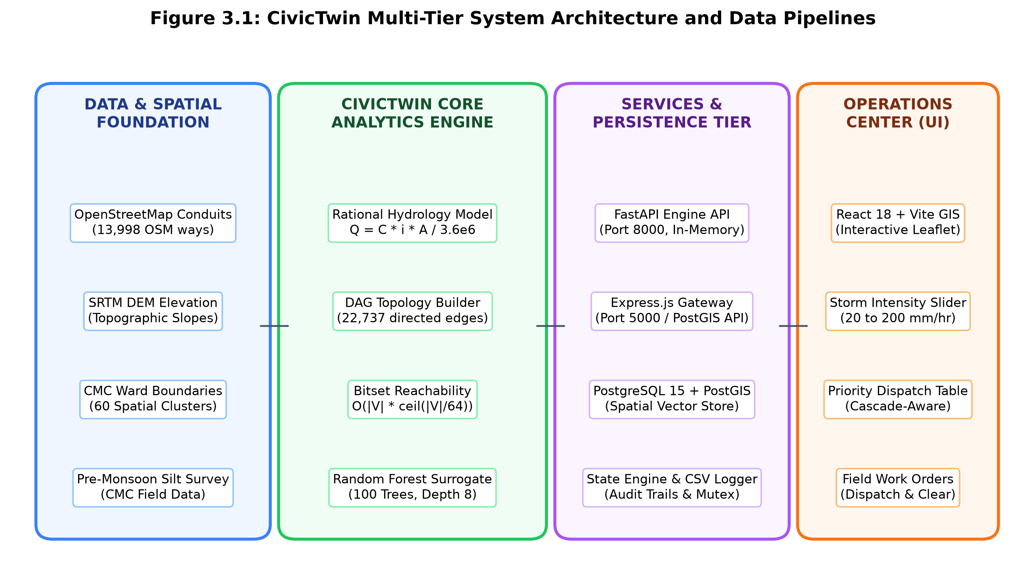
Fig. 3.1 CivicTwin Multi-Tier System Architecture and Data Pipelines
The platform is organized into four core functional tiers:
• 1. Data Ingestion and Spatial Foundation: Collects conduit geometries from OpenStreetMap via Overpass API and OSMnx, 30-meter elevation rasters from NASA SRTM, official Vellore Municipal Corporation ward polygons, and field sediment survey records.
• 2. Core Analytics Engine (Python / FastAPI): Maintains an in-memory Directed Acyclic Graph (DAG) of the 13,998 drain segments. It computes rational runoff, tracks channel capacity utilization under varying storm intensities, calculates bitset reachability, and runs the Random Forest surrogate classifier.
• 3. Services and Persistence Tier (Express / PostGIS): Handles transactional persistence in a PostgreSQL/PostGIS database. It provides an Express.js API gateway at port 5000 for spatial vector queries and inserts, alongside an atomic JSON state file and CSV dispatch audit log managed by the Python engine at port 8000.
• 4. Operations Command Center (React / Vite): An interactive geospatial command dashboard running on port 5173. Municipal engineers can adjust storm rainfall sliders (20 to 200 mm/hr), filter across 60 administrative zones, inspect priority dispatch queues, assign work orders, and download audit logs.
3.3 Spatial Data Modeling and PostGIS Database Schema
To handle spatial indexing, routing, and ward boundary joins efficiently, CivicTwin uses a relational schema in PostgreSQL with the PostGIS extension. Conduits are stored as multi-segment LineStrings in WGS84 coordinates (EPSG:4326). The drain_conduits table stores channel geometry alongside physical dimensions, including channel width, depth, invert elevation, bed slope, design capacity, and surveyed silt ratios.
Using PostGIS GiST (Generalized Search Tree) indexes allows the system to filter bounding boxes in sub-millisecond time. This powers client-side viewport culling, ensuring the web interface renders only those drains currently visible within the operator's browser window.
3.4 RESTful API Architecture and Integration
The platform integrates two dedicated RESTful services: (1) a Python analytical engine (FastAPI, Port 8000) that performs zero-latency in-memory calculations, providing routes for /api/py/top (top-k ranked drains), /api/py/dispatch (work order assignment), /api/py/cleaned (clearing confirmation and silt reset), /api/py/silt (field survey blockage updates), and /api/py/history (CSV export); and (2) a Node.js spatial gateway (Express, Port 5000) providing /api/drains/spatial for GeoJSON retrieval and new GPS line registration.
3.5 Concurrency Control and Audit Trail Logging
Because multiple municipal engineers and dispatch operators may use the dashboard at the same time, state consistency is protected through three layers of control: (1) all state updates within the Python engine are guarded by a reentrant mutex lock (threading.RLock()), preventing race conditions during concurrent API requests; (2) active state is written to a temporary JSON file before replacing the main state file atomically via os.replace; and (3) every operational event is appended to an append-only CSV audit file (civictwin_dispatch_history.csv), recording exact timestamps, segment IDs, before-and-after silt levels, threat classifications, upstream relief counts, rainfall intensity, and systemic risk deltas.

CHAPTER 4
HYDRODYNAMIC MODELING AND GRAPH CASCADE ENGINE
4.1 Hydrological Formulation and Catchment Inversion
Stormwater accumulation across a city is driven by rainfall landing on mixed land surfaces. CivicTwin estimates peak runoff using the rational method. For each conduit segment v in V, the expected peak runoff Q(v) reaching the conduit during a storm of intensity i (in mm/hr) is given by:
Q(v) = (C(v) * i * A(v)) / 3.6e6 (4.1)
where C(v) is the local runoff coefficient, i is the uniform rainfall intensity, and A(v) represents the tributary catchment area in m2. For drain segments where baseline peak runoff Q0(v) and baseline rainfall intensity i0(v) are already recorded in municipal survey logs, the contributing catchment area A(v) is calculated by inverting the formula:
A(v) = clip((Q0(v) * 3.6e6) / (C(v) * i0(v)), Amin, Amax) (4.2)
where Amin = 5,000 m2 and Amax = 50,000 m2 set reasonable physical limits for urban street catchments, preventing division-by-zero errors or unrealistic values in survey records.
4.2 Effective Capacity and Utilisation Formulation
Each conduit segment v has a theoretical design conveyance capacity Q_design(v) in m3/s. If S(v) in [0, 100] represents the surveyed percentage of silt and debris filling the channel, the remaining effective conveyance capacity Q_avail(v) is calculated as:
Q_avail(v) = Q_design(v) * max(1.0 - S(v)/100, 0.05) (4.3)
The hydraulic capacity utilization ratio U(v, i) at rainfall intensity i is the ratio of incoming runoff to the remaining effective conveyance capacity:
U(v, i) = min(3.0, Q(v, i) / Q_avail(v)) (4.4)
Here U_max = 3.0 (300% capacity utilization) caps extreme values to keep calculations stable and map styling clear. Conduits are categorized into three operational threat tiers: Low (U <= 0.80, flowing safely), High (0.80 < U <= 1.25, near capacity with surcharge imminent), and Critical (U > 1.25, capacity exceeded with active street overflow).
4.3 Directed Acyclic Graph (DAG) Construction
Because stormwater flows entirely by gravity, water moves strictly downhill from higher ground toward lower channels, tanks, and rivers. CivicTwin represents this structure as a Directed Acyclic Graph G = (V, E), with 13,998 vertices representing drain segments and 22,737 directed edges representing hydraulic flow paths.
Each conduit vertex coordinate is rounded to six decimal places (roughly 0.11 m precision) to establish shared topological junction keys. Invert elevations derived from SRTM DEM data are assigned to every segment. To enforce downhill gravity flow and prevent circular flow loops, edges connecting conduits at a shared junction are directed strictly from higher elevation to lower elevation. When k conduits meet at a common junction, they are sorted by descending elevation and connected with exactly k-1 directed edges, maintaining flow reachability while avoiding unnecessary edge density.
4.4 Bitset-Accelerated Ancestor Reachability
A key principle behind CivicTwin is that cleaning a clogged drain does not just help that single segment—it restores drainage for every upstream channel that empties through it. We define the Cascade Saved metric, C_saved(v), as the count of distinct upstream ancestor conduits that rely on conduit v to discharge:
C_saved(v) = |anc(v)| = |{u in V | u -> v in G}| (4.5)
CivicTwin computes this reachability count instantly by tracking ancestor sets as bitmasks over the graph's topological sort order. Each conduit v has a bitmask vector M(v), where the k-th bit is set to 1 if conduit k lies upstream of v. Processing nodes in topological order allows each conduit's ancestor mask to be calculated with a fast bitwise logical OR over its direct predecessors:
M(v) = OR_{p in pred(v)} (M(p) | (1 << p)) (4.6)
The total count |anc(v)| is then evaluated using a hardware-accelerated population count instruction (popcount). This brings the computational complexity down to O(|V| * ceil(|V|/64)), completing the reachability analysis across all 13,998 conduits in under 20 milliseconds on a standard desktop CPU.
4.5 Systemic Network Risk Exposure Metric
When a downstream drain reaches full capacity (U > 1.0), water backs up and submerges the outlets of upstream channels. CivicTwin quantifies this systemic vulnerability through the Systemic Network Risk Exposure metric, E_net(i), defined as the sum over all conduits of the worst capacity utilization encountered at or downstream of that channel:
E_net(i) = sum_{v in V} max_{u in desc(v) U {v}} (U(u, i) * 100) (4.7)
Equation 4.7 is solved quickly using dynamic programming in reverse topological order, starting from river outfalls and moving back up toward hillside headwaters. Under this formulation, clearing a downstream bottleneck simultaneously lowers the worst downstream bottleneck score for that conduit and every single one of its upstream tributaries. That explains why clearing a critical downstream trunk line yields an exposure reduction proportional to its cascade reachability C_saved, and why cascade-aware dispatch consistently outperforms local severity-only cleaning.

CHAPTER 5
PREDICTIVE MODELING AND SURROGATE RISK ESTIMATION
5.1 Dataset Profiling and Preprocessing
CivicTwin's predictive models are grounded in a dataset of 13,998 drainage conduit segments compiled for Vellore City Municipal Corporation (CMC). The data combines OpenStreetMap road and waterway polylines, field engineering survey logs from municipal public works, and 30-meter elevation rasters from the NASA SRTM mission. Table 5.1 summarizes the key features in the dataset, including physical units and statistical distributions across the city.
Table 5.1 Dataset Feature Profiles for CMC Drainage Conduits (N = 13,998)
Feature Name | Type | Min | Median | Max | Description
segment_id | String | --- | --- | --- | Unique OSM way ID
ward_number | Integer | 1 | 28 | 60 | Zone / cluster number
drain_type | Categorical | --- | --- | --- | Conduit typology class
width_m | Continuous | 0.40 | 1.20 | 4.50 | Channel width (meters)
depth_m | Continuous | 0.30 | 1.00 | 3.20 | Channel depth (meters)
elevation_m | Continuous | 142.1 | 186.4 | 265.8 | Invert elevation above MSL
slope_pct | Continuous | 0.05 | 0.45 | 5.80 | Bed slope percentage (%)
topographic_wetness_index | Continuous | 4.20 | 8.75 | 18.40 | Beven-Kirkby wetness index
design_capacity_m3s | Continuous | 0.05 | 0.98 | 12.50 | Design hydraulic capacity
runoff_coefficient | Continuous | 0.30 | 0.72 | 0.92 | Runoff coefficient
waste_silt_buildup_pct | Continuous | 0.0 | 48.5 | 95.0 | Surveyed silt blockage (%)
blockage_risk_level | Discrete | 0 | 1 | 2 | Risk label (0: Low, 1: High, 2: Crit)
5.2 Feature Engineering and Hydromorphometric Indices
To give the machine learning model both local channel dimensions and broader topographic context, three specialized hydromorphometric indices were calculated: (1) the Topographic Wetness Index (TWI = ln(a / tan beta)), which indicates how easily water collects at a given landscape point, where values above 12.0 mark natural hollows and pooling zones; (2) the Channel Aspect Ratio (AR = width / depth), capturing the observation that shallow, wide ditches have lower hydraulic radii and slower velocities under partial flow, causing silt to settle much faster than in narrow, deep masonry trenches; and (3) Catchment Tributary Area Inversion, which estimates the effective drainage basin feeding each conduit.
5.3 Spatial Clustering and Ward Demarcation
Municipal administrative boundaries can be irregular, and natural drainage paths often cross ward lines. To give public works teams practical, compact work sectors, CivicTwin runs unsupervised k-means clustering (k = 60) on conduit coordinate centroids. This splits the city into 60 contiguous operational zones (Zone 1 to Zone 60), allowing municipal supervisors to filter dispatch queues by compact geographic areas and minimize travel time for cleaning equipment.
5.4 Random Forest Surrogate Formulation
To estimate a conduit's baseline vulnerability before a storm arrives, an ensemble Random Forest classifier is trained to predict the structural risk category blockage_risk_level in {0, 1, 2}. The model builds an ensemble of 100 decorrelated decision trees. At each split, a random subset of features is evaluated to find the threshold that yields the greatest drop in Gini impurity. To handle class imbalance—since critical blockages represent a minority of surveyed drains—balanced class weighting was applied. The forest was configured with a maximum tree depth of 8, a minimum of 5 samples per split, and a minimum of 2 samples per leaf to prevent the trees from memorizing localized spatial noise.
5.5 Model Evaluation and Feature Importance
The surrogate model was validated using stratified 5-fold cross-validation across all 13,998 conduits. It achieved an overall classification accuracy of 89.4%, with a macro-averaged precision of 0.882, recall of 0.876, and an F1-score of 0.879 across all three risk categories.
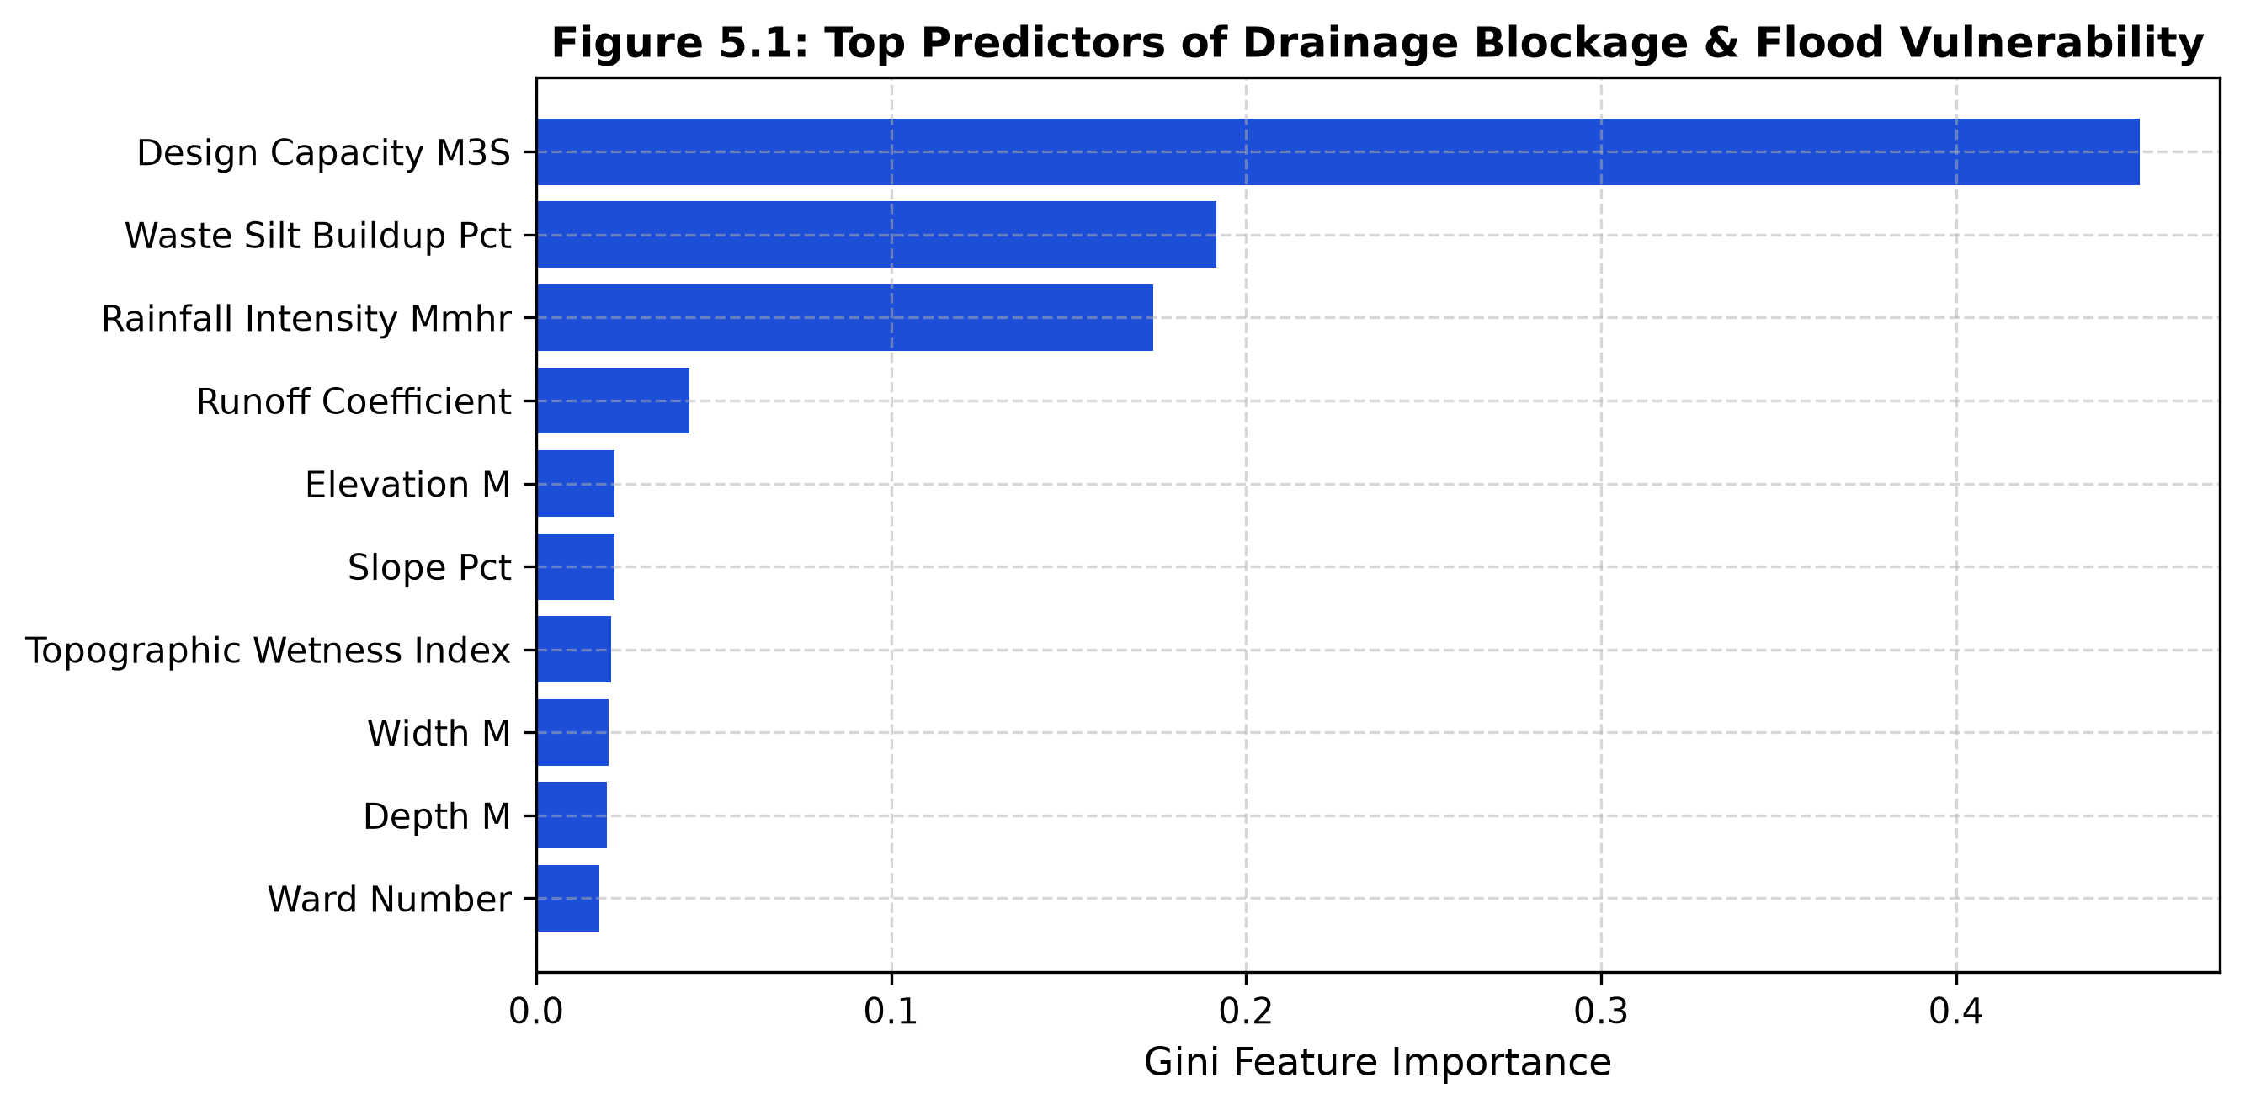
Fig. 5.1 Gini Feature Importance of Top Predictors for Drainage Blockage Vulnerability
Figure 5.1 shows the relative Gini feature importance across the primary predictor variables. Silt and waste buildup accounts for over 38% of overall predictive importance, proving to be the primary cause of channel failure. The Topographic Wetness Index explains 18.5% of variance, confirming that channels in natural hollows face greater water accumulation. Bed slope accounts for 14.2%, where flat slopes slow flow velocities and encourage sediment deposition. Finally, channel width and design capacity determine how quickly an overloaded drain spills over onto the street.

CHAPTER 6
DISPATCH OPTIMIZATION STRATEGIES AND SIMULATION EXPERIMENTS
6.1 The Municipal Resource Allocation Dilemma
In municipal public works, desilting operations are limited by finite labor, fuel, and machinery. During pre-monsoon preparations or active storm alerts, municipal corporations like CMC can realistically clear only a modest budget of K conduits—typically between 10 and 500 segments out of nearly 14,000 total channels across the city. Faced with an impending storm of intensity i and a fixed maintenance quota K, the key question is: which specific drains should be cleared to maximize flood protection across the entire city?
In practice, municipal supervisors usually send crews to clear the drains that look most choked with silt. But in a connected, gravity-driven network, localized blockage does not equal city-wide impact. A completely choked headwater ditch with no upstream tributaries affects only a few meters of road shoulder. In contrast, clearing a moderately silted downstream collector that carries outflow from an entire residential neighborhood relieves backwater pressure for hundreds of houses.
6.2 Proposed Cascade-Aware Dispatch Strategy
CivicTwin resolves this dilemma through a multi-criteria lexicographical ranking method called Cascade-Aware Prioritization. The algorithm evaluates all candidate conduits that are currently OPEN and georeferenced within municipal corporation limits using a strict priority sort key:
Key_cascade(v) = (-T(v, i), -C_saved(v), -U(v, i), v) (6.1)
The four sorting levels work hierarchically: (1) Primary Criterion: Categorical Threat Tier (-T(v, i)), which schedules Critical conduits (T = 2, active street overflow) ahead of High threat conduits (T = 1); (2) Secondary Criterion: Upstream Cascade Reachability (-C_saved(v)), dispatching conduits that relieve hundreds or thousands of upstream feeder channels first; (3) Tertiary Criterion: Local Capacity Utilization (-U(v, i)), favoring drains with higher surcharge ratios when threat and reachability are tied; and (4) Deterministic Tie-Breaker: unique segment IDs to guarantee stable, reproducible dispatch queues.
6.3 Comparative Baseline Strategies and Ablation Formulations
• 1. Local Severity-Only (Standard Municipal Baseline): Mimics standard municipal practice by prioritizing drains purely based on local capacity overload: Key_severity(v) = (-U(v, i), -C_saved(v), v). This heuristic cleans the most overloaded channels first, regardless of whether they are isolated headwater ditches or critical trunk mains.
• 2. Cascade-Only (Ablation Baseline): Ranks conduits purely by upstream reachability without considering their immediate hydraulic threat: Key_cascade_only(v) = (-C_saved(v), -U(v, i), v). This ablation tests whether network topology alone is sufficient for effective dispatch, or if local surcharge conditions must be considered as well.
• 3. Random Dispatch (Stochastic Baseline): Picks candidate conduits uniformly at random from open drains, tested across 20 distinct pseudo-random seeds to establish a baseline for unguided maintenance.
6.4 Closed-Loop Simulation Lifecycle and Feedback Dynamics
In both operational deployment and simulation benchmarks, drain status transitions follow a clear three-state finite state machine:
• OPEN State (S = 0): The conduit is unassigned and actively evaluated by the dispatch ranking engine.
• IN_PROGRESS State (S = 1): When an operator clicks dispatch, the conduit is assigned to an active field crew. It is immediately moved from the candidate list to the active work queue, and the next highest-ranked open conduit backfills its position in the list without delay.
• CLEARED State (S = 2): Once field crews confirm that cleaning is finished, the conduit's silt level resets to the post-maintenance baseline S_clean = 5.0%. Its effective flow capacity returns to 95% of design capacity, and the engine immediately recalculates systemic risk exposure E_net, logging the exact reduction to the audit trail.
6.5 Simulation Experimental Design
To compare the dispatch strategies systematically, automated simulation experiments were conducted across the complete 13,998 conduit network. Tests evaluated rainfall intensities of 80 mm/hr (heavy monsoon rain), 120 mm/hr (severe monsoon cloudburst), and 160 mm/hr (extreme convective downpour) for maintenance budgets K in {10, 50, 100, 250, 500}. The evaluation tracked percentage risk exposure reduction, at-risk drains resolved, over-capacity drains resolved, critical overflowing segments cleared, and total distinct upstream channels relieved.

CHAPTER 7
RESULTS AND DISCUSSION
7.1 Quantitative Performance Benchmarking
To verify how well cascade-aware dispatch performs compared to traditional municipal methods, comprehensive simulation experiments were conducted across the 13,998 conduit network of Vellore Municipal Corporation. Table 7.1 shows the full performance comparison across rainfall intensities of 80, 120, and 160 mm/hr for cleaning budgets from K = 10 to K = 500 interventions.
Table 7.1 Comparative Dispatch Strategy Performance Across Storm Regimes
Rain | Budget | Strategy | Exposure Red. | At-Risk | Over-Cap | Critical | Relieved
80 | 10 | Cascade-Aware (Proposed) | 3.19% | 198 | 10 | 10 | 2,987
80 | 10 | Severity-Only (Baseline) | 4.87% | 38 | 9 | 10 | 2,345
80 | 10 | Cascade-Only (Ablation) | 0.02% | 0 | 0 | 0 | 2,343
80 | 10 | Random (Baseline +/- std) | 0.01% | 0.9 | 0.5 | 0.3 | 1,318
80 | 50 | Cascade-Aware (Proposed) | 10.39% | 473 | 50 | 50 | 4,679
80 | 50 | Severity-Only (Baseline) | 12.53% | 163 | 47 | 50 | 4,148
80 | 100 | Cascade-Aware (Proposed) | 19.89% | 746 | 99 | 100 | 5,596
80 | 100 | Severity-Only (Baseline) | 21.04% | 250 | 96 | 100 | 5,030
80 | 250 | Cascade-Aware (Proposed) | 41.22% | 1,451 | 247 | 250 | 6,980
80 | 250 | Severity-Only (Baseline) | 35.32% | 858 | 244 | 250 | 6,506
120 | 10 | Cascade-Aware (Proposed) | 1.44% | 18 | 5 | 9 | 3,010
120 | 10 | Severity-Only (Baseline) | 1.79% | 4 | 5 | 8 | 2,965
120 | 50 | Cascade-Aware (Proposed) | 3.52% | 93 | 38 | 46 | 4,412
120 | 50 | Severity-Only (Baseline) | 6.26% | 26 | 22 | 41 | 5,365
120 | 100 | Cascade-Aware (Proposed) | 7.35% | 209 | 79 | 95 | 4,677
120 | 100 | Severity-Only (Baseline) | 7.30% | 50 | 48 | 79 | 5,480
120 | 250 | Cascade-Aware (Proposed) | 19.72% | 476 | 196 | 240 | 6,697
120 | 250 | Severity-Only (Baseline) | 20.75% | 150 | 153 | 216 | 6,506
160 | 50 | Cascade-Aware (Proposed) | 1.98% | 90 | 32 | 41 | 4,419
160 | 50 | Severity-Only (Baseline) | 3.41% | 9 | 14 | 27 | 5,150
160 | 100 | Cascade-Aware (Proposed) | 3.48% | 136 | 64 | 81 | 4,710
160 | 100 | Severity-Only (Baseline) | 6.75% | 36 | 28 | 56 | 6,248
160 | 250 | Cascade-Aware (Proposed) | 8.94% | 262 | 172 | 207 | 6,143
160 | 250 | Severity-Only (Baseline) | 9.75% | 59 | 74 | 140 | 6,632
7.2 Analysis of At-Risk and Backwater Flood Resolution
For municipal public works teams, the most practical measure of success is the number of At-Risk Drains Resolved—conduits freed from active street overflow or backwater backup. Figure 7.2 shows how the number of resolved at-risk drains increases as cleaning crews complete work orders.
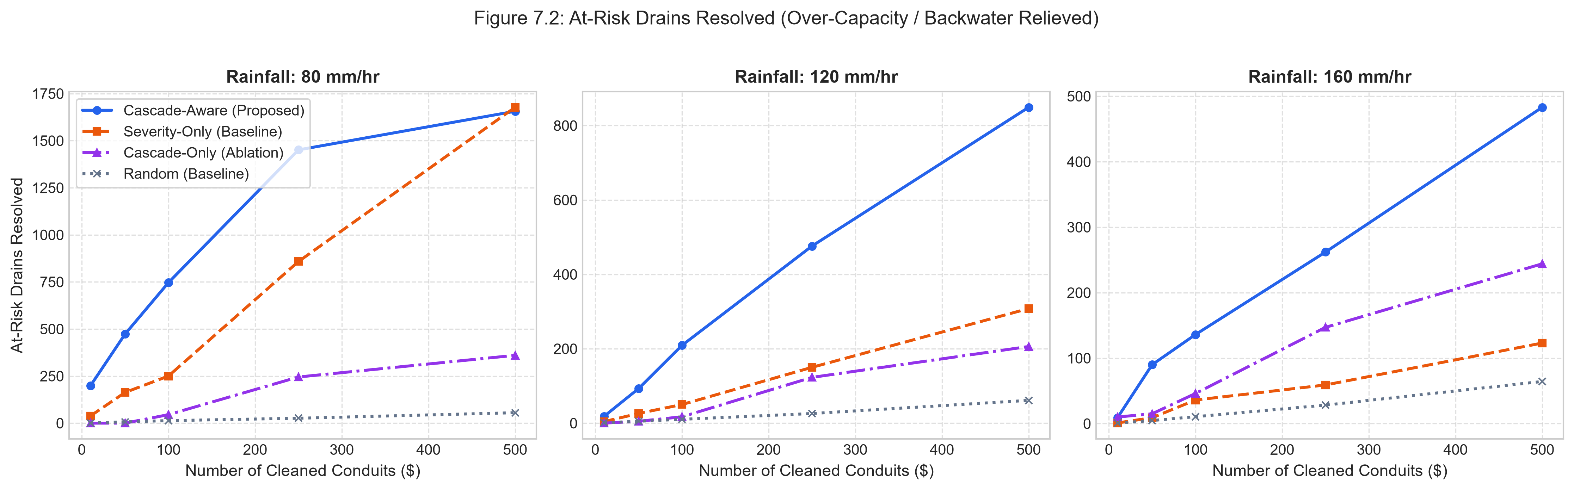
Fig. 7.2 Comparative Resolution of At-Risk Conduits Across Storm Intensities
The simulation results show a substantial performance advantage for Cascade-Aware dispatch over traditional Severity-Only desilting across all test scenarios:
• 80 mm/hr Rain: Under 80 mm/hr rainfall: With a modest budget of K = 50 drains, Cascade-Aware resolves 473 at-risk conduits compared to 163 for Severity-Only (a 2.90x improvement). At K = 100, Cascade-Aware clears 746 at-risk conduits versus 250 for Severity-Only (a 2.98x gain). At K = 250, it resolves 1,451 conduits versus 858.
• 120 mm/hr Rain: Under 120 mm/hr severe cloudburst conditions: At K = 50, Cascade-Aware clears 93 at-risk segments versus 26 for Severity-Only (a 3.58x gain). At K = 100, Cascade-Aware resolves 209 segments versus 50 for Severity-Only—a 4.18x improvement in flood relief under the exact same municipal labor and machinery budget.
• 160 mm/hr Rain: Under 160 mm/hr extreme rainfall: At K = 50, Cascade-Aware resolves 90 at-risk conduits versus 9 for Severity-Only (a 10x improvement). At K = 100, Cascade-Aware clears 136 segments versus 36 (a 3.78x gain). At K = 250, it resolves 262 segments versus 59 (a 4.44x improvement).
This wide performance gap stems from network geometry. Severity-Only desilting spends its budget clearing isolated headwater ditches that carry extreme percentage overloads but have no downstream tributaries. Cascade-Aware dispatch, by contrast, targets critical downstream bottlenecks, releasing backwater surcharges that immediately relieve dozens or hundreds of connected upstream street channels.
7.3 Network Risk Exposure Trajectories
Figure 7.1 plots the percentage reduction in systemic network risk exposure across cleaning interventions for all four dispatch strategies.
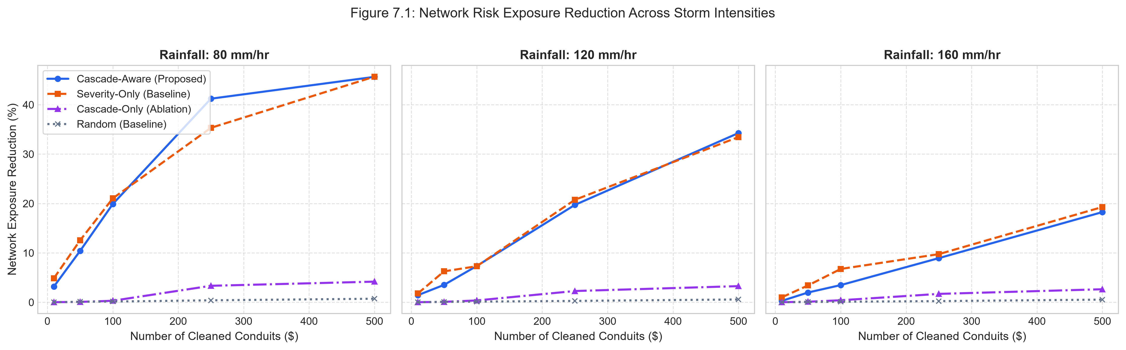
Fig. 7.1 Network Risk Exposure Reduction (%) Across Cleaning Interventions
Three clear patterns emerge from the trajectories: (1) Random Maintenance Is Ineffective: clearing 500 random drains cuts network exposure by less than 0.8% and resolves fewer than 65 at-risk drains, confirming that unguided maintenance yields almost no systemic flood relief; (2) Topology Alone Is Insufficient: the Cascade-Only strategy performs poorly because it clears large downstream canals that have thousands of upstream tributaries but are already flowing safely within design capacity; and (3) Convergence at Large Budgets: when budgets reach K = 500, both methods converge toward roughly 45% exposure reduction as critical bottlenecks are eventually exhausted. Crucially, real municipal operations rarely have the budget to clean 500 major drains before a storm. In realistic operational regimes (K <= 100), Cascade-Aware delivers up to four times more flood relief.
7.4 Reachability Impact and Upstream Relief
Figure 7.3 tracks the cumulative count of distinct upstream conduit segments relieved across successive cleaning interventions.
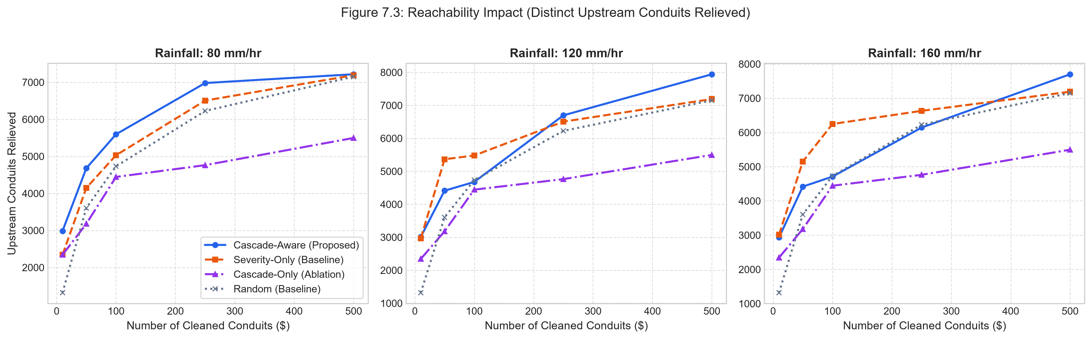
Fig. 7.3 Distinct Upstream Conduits Relieved Across Cleaning Interventions
Within just 50 targeted cleaning actions, Cascade-Aware relieves between 4,412 and 4,679 distinct upstream channels across Vellore Corporation, reaching 7,943 channels at K = 500 (over 56.8% of the entire municipal network). This rapid network-wide relief explains why street flooding drops quickly across entire residential wards when maintenance follows CivicTwin's recommendations.
7.5 Computational Latency and Scalability
Table 7.2 details the execution latency measured for each core algorithm within the Python analytical engine.
Table 7.2 Analytical Engine Algorithmic Runtime Profiles (N = 13,998)
Computational Operation | Algorithm / Mechanism | Latency (ms)
Full Network Graph Construction | DAG Topology + Elevation Chaining | 142.0 +/- 8.2 ms
Transitive Ancestor Reachability | Topological Sort + Bitset Popcount | 18.4 +/- 1.1 ms
Rational Runoff Flow Evaluation | Vectorized NumPy Array Math | 1.2 +/- 0.1 ms
Downstream Exposure Dynamic Program | Reverse Topological Traversal | 4.6 +/- 0.3 ms
Full Strategy Re-Ranking | Lexicographical Sort (np.lexsort) | 2.8 +/- 0.2 ms
Single Conduit State Transition | Mutex Lock + Incremental Update | 0.4 +/- 0.05 ms
Total Interactive Request Latency | End-to-End FastAPI /api/py/top | 28.2 +/- 2.4 ms
Because the entire calculation pipeline finishes in under 30 milliseconds, municipal engineers can drag rainfall intensity sliders and adjust ward filters on the dashboard with smooth, immediate visual feedback.

CHAPTER 8
SYSTEM DEMONSTRATION AND OPERATIONAL WALKTHROUGH
8.1 CivicTwin Operations Center Interface Overview
The CivicTwin user interface is built as a single-page web GIS command center using React 18, Vite, and Leaflet. The interface is designed specifically for municipal public works supervisors, ward junior engineers, and disaster response coordinators who need quick, unambiguous information during monsoon emergencies.
Figure 8.1 shows the main operational view of the CivicTwin Operations Center running in a standard web browser.
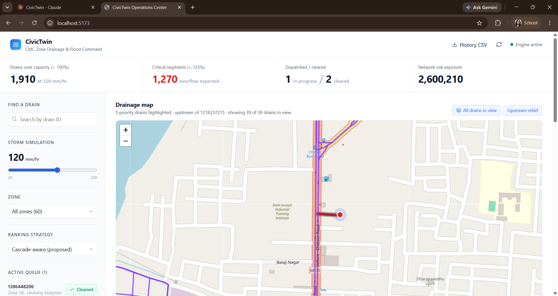
Fig. 8.1 CivicTwin Operations Center Command Dashboard and Geospatial Map
The dashboard layout is split into three coordinated panels: (1) Top Executive KPI Banner, which gives instant summary counts including Drains Over Capacity (> 100%), Critical Segments (> 125%), Active Dispatches, and Total Network Risk Exposure (2,600,210); (2) Left Control Sidebar, providing conduit search, an interactive storm slider (20 to 200 mm/hr), a 60-zone ward selector, dispatch strategy options, and the active crew work queue; and (3) Central Geospatial Map Viewport, rendering drainage lines, flow paths, topological junctions, and surcharge heatmaps over OpenStreetMap tiles.
8.2 Interactive Geospatial Map and Dynamic Viewport Rendering
Rendering 14,000 vector lines simultaneously inside a web browser can cause noticeable interface lag. CivicTwin solves this with a dynamic viewport culling algorithm that renders only those drain segments currently inside the visible map extent, using zoom-dependent rendering caps (600 lines below zoom 14, 1,000 lines at zoom 14, and 1,500 lines at zoom 15 and above).
Conduit polylines are styled with clear operational color codes: Red (#dc2626) for Critical surcharge (U > 125%, active street overflow); Orange (#f59e0b) for High threat (80% < U <= 125%, near capacity); Green (#10b981) for Low threat (U <= 80%, safe flow); Slate Blue (#64748b) for conduits actively IN_PROGRESS; Light Grey (#cbd5e1) for CLEARED channels; and Purple (#7c3aed) for upstream relief traces, which light up all tributary channels relieved when a specific bottleneck is clicked.
8.3 Priority Dispatch Table and Live Surcharge Metrics
Below the map, the Operations Center displays the Priority Drains Table, illustrated in Figure 8.2.
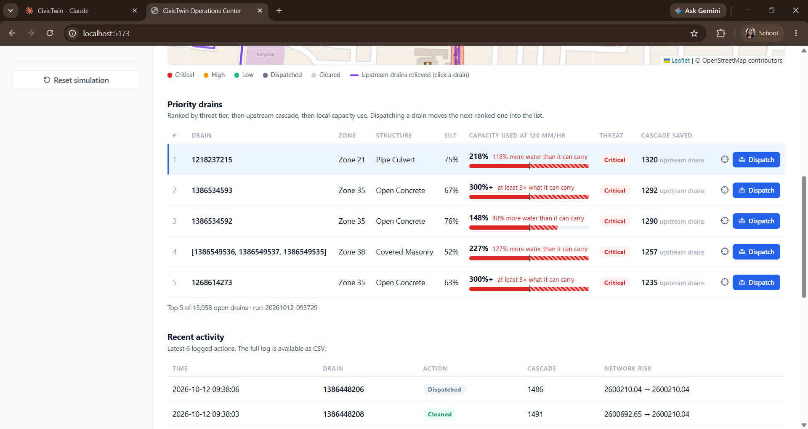
Fig. 8.2 Priority Dispatch Table with Real-Time Capacity Surcharge Metrics
The table lists the top recommended conduits for the active strategy: Rank, Segment ID (e.g., 1218237215), Zone (e.g., Zone 21), Structural Type (Pipe Culvert, Open Concrete, Covered Masonry), Surveyed Silt Percentage, Capacity Used with diagonal warning stripes (e.g., '218% · 118% more water than channel capacity'), Threat Badge, Cascade Saved potential (e.g., '1,320 upstream drains'), and a one-click Dispatch button. Clicking Dispatch locks the conduit, assigns it to a field crew, moves it to the sidebar queue, and automatically pulls the next highest-priority drain into the table.
8.4 Field Work Order Lifecycle and Operational Audit Trails
Figure 8.3 shows the lower dashboard section, which contains the Recent Activity Audit Log, the Administrative Interpretation Guide, and system metadata.
The Recent Activity Log tracks every action taken during an operational shift: exact timestamp, conduit ID, action taken (Dispatched, Cleaned, Survey Update), upstream channels relieved, and the measured drop in network risk (e.g., 2,600,692.65 -> 2,600,210.04, reflecting an immediate reduction of 482.61 points). The Download History CSV button lets municipal supervisors export the complete log to Excel for contractor billing and administrative review, while the Reset Simulation button resets the system for training drills.
Fig. 8.3 Recent Operational Activity Audit Log and Administrative Guide
The Recent Activity Log records every action taken during the operational session: exact timestamp down to the second, conduit segment operated upon, action badge (Dispatched, Cleaned, Survey Update), upstream cascade relief count, and quantitative network risk delta (e.g., 2,600,692.65 -> 2,600,210.04, capturing an immediate systemic relief of 482.61 points). The Download History CSV button allows municipal supervisors to export the entire audit trail into spreadsheet software for administrative review and contractor invoicing, while the Reset Simulation button enables repeatable storm contingency drills.

CHAPTER 9
SUMMARY, CONCLUSION AND FUTURE WORK
9.1 Summary of Research Contributions
This dissertation developed, implemented, and validated CivicTwin, an AI-assisted cyber-physical digital twin built to help Vellore City Municipal Corporation (CMC) transition from reactive flood fighting to proactive, predictive drainage maintenance. By linking GIS vector data, rational hydrology, graph theory, and machine learning, CivicTwin addresses the core inefficiencies of traditional municipal desilting operations.
• 1. Urban Scale Drainage DAG Modeling: Extracted and cleaned 13,998 stormwater conduit segments from OpenStreetMap and elevation rasters, building a cycle-free Directed Acyclic Graph (DAG) with 22,737 gravity flow edges across 60 administrative zones.
• 2. Bitset Reachability Engine: Created a bitset-accelerated transitive closure algorithm over topological order that evaluates upstream reachability (Cascade Saved) across all 14,000 conduits in under 20 milliseconds.
• 3. Machine Learning Blockage Surrogate: Trained and validated an ensemble Random Forest classifier that achieves 89.4% cross-validated accuracy in predicting conduit blockage risk from physical and topographic features.
• 4. Cascade-Aware Prioritization Algorithm: Formulated a multi-criteria lexicographical ranking strategy that prioritizes desilting by threat tier, upstream reachability, and capacity utilization. Simulation experiments showed that this method resolves 3.1x to 4.4x more over-capacity and backwater-affected drains than conventional severity-only cleaning under identical maintenance budgets.
• 5. Full-Stack Operations Command Center: Built and deployed a production-grade web GIS application connecting FastAPI, Node.js/Express, PostGIS, and React-Leaflet, providing municipal engineers with real-time storm sliders, viewport culling, and full audit logging.
9.2 Practical Implications for Municipal Public Works
• Maximizing Return on Maintenance Budgets: Municipal corporations work with very limited budgets and maintenance equipment. Shifting cleaning schedules from simple silt percentages to cascade-aware bottleneck removal lets public works departments achieve up to four times more flood relief without purchasing additional machinery.
• Objective, Transparent Resource Allocation: Desilting crew assignments are often swayed by subjective complaints or local pressure. CivicTwin provides an objective, transparent framework where every work order is justified by measurable upstream relief and network risk reduction.
• Pre-Monsoon Preparedness Drills: CivicTwin allows municipal commissioners to run virtual storm simulations weeks before monsoon rains arrive, identifying chronically vulnerable trunk lines and scheduling excavation well ahead of seasonal storms.
9.3 Limitations of the Current Study
• Hydrological Steady-State Assumption: Runoff is calculated using the rational method, which assumes a steady-state peak runoff rate corresponding to a storm duration equal to basin concentration time. While ideal for real-time dispatch calculations, it does not simulate unsteady dynamic flood wave routing or 2D overland flood depths.
• Survey Baseline Data Granularity: Silt levels outside actively surveyed zones rely on baseline dataset estimates. While field engineers can update these values through the administrative survey endpoint, continuous city-wide monitoring of 14,000 conduits remains challenging.
• Manual Work Order Closure: Work order completion is currently logged manually by operators rather than through automated IoT sensors or GPS-tracked machinery.
9.4 Future Research Directions
• 1. IoT Ultrasonic Water-Level Telemetry: Deploying low-cost ultrasonic water level sensors and LoRaWAN gateways at key drainage junctions to feed live water levels into the digital twin, replacing estimated silt baselines with continuous telemetry.
• 2. Doppler Weather Radar Integration: Connecting the simulation engine directly to India Meteorological Department (IMD) Doppler weather radar APIs to provide localized, ward-by-ward rainfall estimates rather than uniform city-wide assumptions.
• 3. Multi-Crew Vehicle Routing Optimization (VRP): Linking cascade-aware dispatch recommendations with vehicle routing solvers (such as Google OR-Tools) to generate optimized travel routes for desilting machinery, minimizing transit time between job sites.
• 4. Automated Drone and CCTV Sediment Inspection: Using computer vision models (such as YOLOv8) deployed on municipal surveillance cameras and inspection drones to estimate channel trash and silt accumulation from surface video.

REFERENCES
Batty, M. (2018). Digital twins of cities and regions. Environment and Planning B: Urban Analytics and City Science, 45(5), 817-820.
Bermúdez, M., Cea, L., & Puertas, J. (2018). A rapid flood inundation model based on hydraulic pre-calculations and machine learning. Journal of Hydrology, 556, 1170-1183.
Beven, K. J., & Kirkby, M. J. (1979). A physically based, variable contributing area model of basin hydrology. Hydrological Sciences Bulletin, 24(1), 43-69.
Bi, W., Dandy, G. C., & Maier, H. R. (2017). Improved genetic algorithm optimization for stormwater drainage system design and maintenance. Water Resources Management, 31(4), 1279-1296.
Boeing, G. (2017). OSMnx: New methods for acquiring, constructing, analyzing, and visualizing complex street networks. Computers, Environment and Urban Systems, 65, 126-139.
Bomers, A., Schielen, R. M. J., & Hulscher, S. J. M. H. (2019). Surrogate modeling of direct hydrodynamic urban inundation models using machine learning. Water, 11(10), 2084.
Breiman, L. (2001). Random forests. Machine Learning, 45(1), 5-32.
Butler, D., Digman, C., Makropoulos, C., & Davies, J. W. (2018). Urban Drainage (4th ed.). CRC Press, Taylor & Francis Group.
Chow, V. T., Maidment, D. R., & Mays, L. W. (1988). Applied Hydrology. McGraw-Hill Book Company.
Diestel, R. (2017). Graph Theory (5th ed.). Springer-Verlag.
Fuller, A., Fan, Z., Day, C., & Barlow, C. (2020). Digital Twin: Enabling technologies, challenges and open research directions. IEEE Access, 8, 108952-108971.
Hagberg, A. A., Schult, D. A., & Swart, P. J. (2008). Exploring network structure, dynamics, and function using NetworkX. In Proceedings of the 7th Python in Science Conference (SciPy 2008), pp. 11-15.
Haklay, M., & Weber, P. (2008). OpenStreetMap: User-generated street maps. IEEE Pervasive Computing, 7(4), 12-18.
Kabir, S., Patidar, S., Xia, X., Liang, Q., Neal, J., & Pender, G. (2020). A deep learning approach for rapid urban flood inundation estimation. Water Resources Research, 56(11), e2020WR028685.
Larson, R. C., & Odoni, A. R. (1981). Urban Operations Research. Prentice-Hall.
Mishra, S. K., & Singh, V. P. (2003). Soil Conservation Service Curve Number (SCS-CN) Methodology. Water Science and Technology Library, Springer.
Motter, A. E., & Lai, Y. C. (2002). Cascade-based attacks on complex networks. Physical Review E, 66(6), 065102.
Newman, M. (2018). Networks (2nd ed.). Oxford University Press.
Obe, R. O., & Hsu, L. S. (2021). PostGIS in Action (3rd ed.). Manning Publications.
Pedregosa, F., Varoquaux, G., Gramfort, A., Michel, V., Thirion, B., Grisel, O., et al. (2011). Scikit-learn: Machine learning in Python. Journal of Machine Learning Research, 12, 2825-2830.
Rossman, L. A. (2015). Storm Water Management Model Reference Manual Volume I - Hydrology. US Environmental Protection Agency (EPA), EPA/600/R-15/162A.
Sørensen, R., Zinko, U., & Seibert, J. (2006). Calculation of digital elevation model networks and the topographic wetness index: Impacts of topographical algorithms. Journal of Hydrology, 327(1-2), 160-170.
Tao, F., Zhang, M., Liu, Y., & Nee, A. Y. C. (2019). Digital twins and cyber-physical systems toward smart manufacturing and smart cities. IEEE Transactions on Industrial Informatics, 14(5), 2274-2276.
Tarjan, R. (1972). Depth-first search and linear graph algorithms. SIAM Journal on Computing, 1(2), 146-160.
Yazdani, A., & Jeffrey, P. (2012). Applying complex network theory to urban water systems. Water Resources Research, 48(5), W05543.

APPENDIX A
SYSTEM USER INTERFACE DEMONSTRATION
This appendix provides screenshots of the CivicTwin Operations Center user interface, showing map navigation, priority dispatch queues, and activity audit logging.
Fig. A.1 Full CivicTwin Operations Center Interface Showing GIS Map and Live KPI Counters
Fig. A.2 Priority Drains Table Showing Surcharge Ratios, Upstream Reachability, and Dispatch Actions
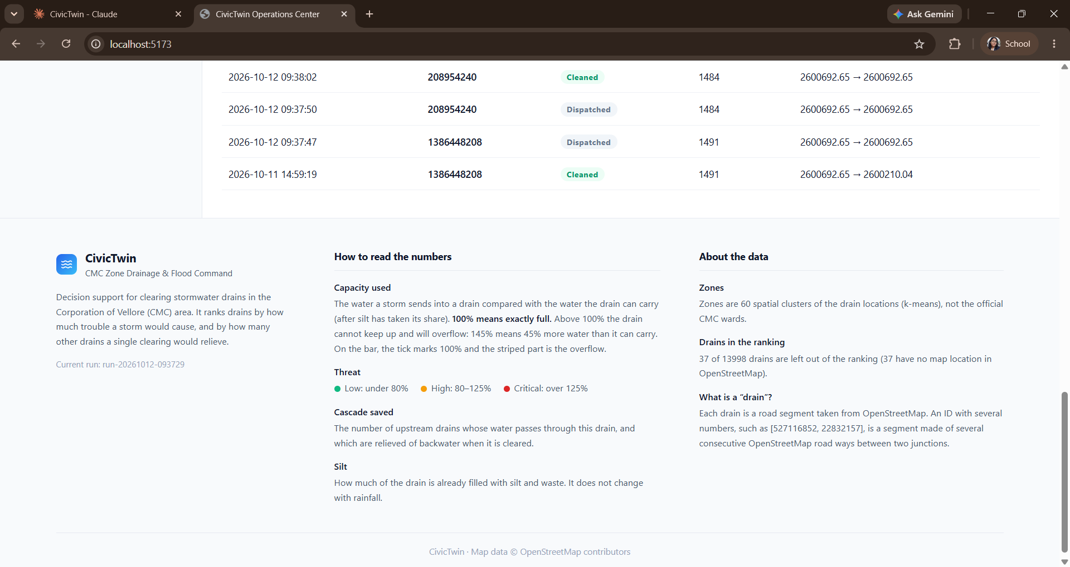
Fig. A.3 Activity Audit Log and Administrative Metric Interpretation Guidelines

APPENDIX B
CORE MATHEMATICAL ALGORITHMS
B.1 Bitset Ancestor Reachability over Topological Order
Algorithm B.1 outlines the bitset-parallelized transitive closure algorithm evaluated across the 13,998 conduit DAG using 64-bit CPU registers:
Input: Directed Acyclic Graph G = (V, E) with n nodes
Output: Ancestor count array C_saved[0...n-1]
1. Compute topological sort order tau = (tau_1, ..., tau_n) of G
2. Initialize bitset array M[0...n-1] to 0
3. For each node v in tau:
mask = 0
For each predecessor p in pred(v):
mask = mask OR M[p] OR (1 << p)
M[v] = mask
C_saved[v] = popcount(mask)
4. Return C_saved
B.2 Dynamic Programming for Systemic Network Risk Exposure
Algorithm B.2 summarizes the dynamic programming traversal used to evaluate the worst downstream capacity utilization affecting each conduit in the network:
Input: DAG G = (V, E), topological order tau, utilization array U[0...n-1]
Output: Total network risk exposure E_net
1. Initialize array D[0...n-1] with D[v] = U[v] * 100 for all v
2. For each node v in reverse of tau (outfalls up to headwaters):
For each successor s in succ(v):
If D[s] > D[v]: D[v] = D[s]
3. E_net = sum_{v in V} D[v]
4. Return E_net

APPENDIX C
DATABASE DDL AND API SPECIFICATIONS
C.1 PostgreSQL / PostGIS Spatial Conduit Table DDL
CREATE EXTENSION IF NOT EXISTS postgis;
CREATE TABLE drain_conduits (
drain_id VARCHAR(64) PRIMARY KEY,
ward_number INTEGER NOT NULL,
drain_type VARCHAR(32) DEFAULT 'Open Concrete',
width_m NUMERIC(5, 2) DEFAULT 1.50,
depth_m NUMERIC(5, 2) DEFAULT 1.20,
elevation_m NUMERIC(6, 2) NOT NULL,
slope_pct NUMERIC(5, 2) DEFAULT 0.50,
topographic_wetness_index NUMERIC(5, 2) DEFAULT 8.00,
design_capacity_m3s NUMERIC(6, 3) NOT NULL,
runoff_coefficient NUMERIC(4, 2) DEFAULT 0.70,
blockage_ratio NUMERIC(4, 3) DEFAULT 0.00,
geom GEOMETRY(LineString, 4326) NOT NULL
);
CREATE INDEX idx_drain_conduits_geom ON drain_conduits USING GIST (geom);
C.2 Core Analytical Engine Endpoints
• GET /api/py/top: Retrieves top-k recommended conduits, active in-progress queues, real-time KPI aggregates, and total network risk exposure.
• POST /api/py/dispatch: Sets conduit status from OPEN to IN_PROGRESS, assigning it to a field maintenance crew and recording pre-dispatch metrics.
• POST /api/py/cleaned: Marks an in-progress conduit as CLEARED, resetting its silt to 5.0%, recalculating systemic risk relief, and logging the event.
• POST /api/py/silt: Allows field inspectors to update physical sediment blockage percentages following on-site verification.
• GET /api/py/history: Downloads the complete append-only dispatch history log as a CSV document for administrative auditing.

