CWSS System

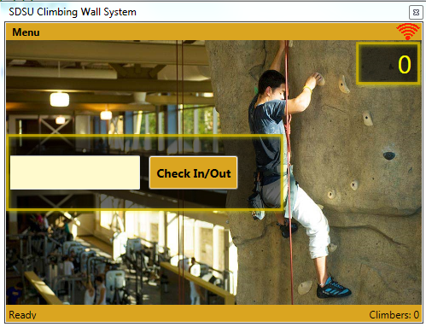

Requirements / Installing

Tested System:
- Microsoft Windows 7 Profesional Notebook Computers -w- Webcam (x2)
- HooToo TripMate Nano Travel Router
- MSR90 Magnetic Strip Reader (x2)

Install:
- Run “CWSS Setup.exe”, run as administrator rights will be requested. (click yes)
- Select install for a remote client machine if installing on a computer intended to only be used as a remote check in machine, otherwise leave unchecked for the host computer.
- Select install magnetic strip reader config if using the MSR90 strip readers.
- Follow the instructions below for setting up the card reader if applicable.

Magnetic Strip Reader Model MSR90 Setup:

(http://www.card-device.com/products_info.asp?Nid=37)

Copy the following settings for best compatibility with the CWSS System:

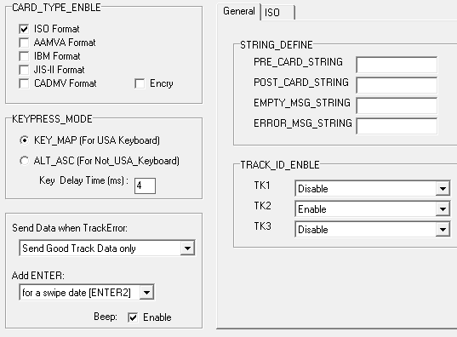
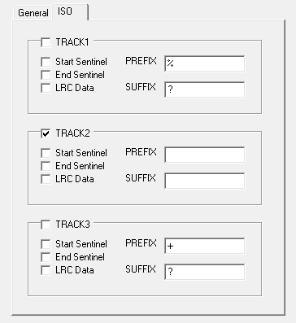
Click on “Download” to configure the device to these settings. Close the config tool. (Done)

Notes:

Other Requirements:
- Adobe Acrobat Extension Required to be installed for Internet Explorer in order to view waiver documents.
- Webcam required to capture real signatures on a real .pdf waiver document. Can only be used on the host (server) computer. Client / Remote machines cannot capture signatures.
- UDP communications must be enabled through the firewall on port 2222 to allow communication between the host and remote machines.

Default Administrator Account:
- user login id: 123456
- password: abc123

Program Keyboard Shortcuts:
- Ctrl + L: Login / Logout
- Ctrl + X: Exit Program
- Ctrl + N: New User
- Ctrl + P: Postit Note
- Ctrl + F1: Enter Client Mode
- Ctrl + W: View Climbers
- Ctrl + C: Calendar
- Ctrl + A: Account Viewer
- Ctrl + R: Reports
- Ctrl + U: Users
- Ctrl + D: Log Viewer
- Ctrl + S: Settings

