Noesis: Selective Memory Injection for
Cross-Tool AI Conversation Consistency
Peizheng Du
October 2026
Abstract
Users converse with multiple AI assistants daily, yet each tool’s memory is isolated: a stance expressed in one tool is unknown to the others, and each conversation starts from scratch. Existing approaches either store flat facts without a notion of confidence, or inject all retrieved context regardless of relevance, causing token costs to explode with memory size. I present Noesis, a local-first memory layer that (1) extracts typed thoughts from conversations across tools into a shared per-user store, (2) gates injection behind a confidence lifecycle in which thoughts mature from tentative to settled based on repetition, assertion strength, cross-tool corroboration, and contradiction signals, and (3) caps injected context with a token budget. Across three models (Gemini Flash-Lite, gemma3:4b, qwen2.5:3b) on 110 paired questions each, memory injection raises answer accuracy from 41.8% to 85.5%, 34.5% to 82.7%, and 37.3% to 62.7% respectively (all $p<0.001$, McNemar’s test). At 500 stored memories, Noesis injects 35 times fewer tokens than a naive RAG baseline while placing 9 of 10 targets at rank 1 (MRR 0.90 vs. 0.002). On strictly cross-tool queries, Noesis retrieves 37% where per-tool isolation is structurally bound to 0%. I release the system, experiment harness, and all raw results.

1 Introduction
Heavy users of AI assistants switch between ChatGPT, Claude, Gemini, and local models throughout the day. Each tool maintains its own isolated memory: a database preference carefully explained to Claude must be re-explained to GPT; a design decision reached with Gemini is invisible to Claude. The reasoning a user performs across tools, such as their positions, preferences, and open questions, evaporates at every tool boundary.
Two families of systems address parts of this problem, each with a critical gap. Fact stores such as Mem0 (Chhikara et al. 2025) persist extracted facts but treat all memories equally: a firmly held professional identity and a passing mention of a tool have the same standing, and there is no mechanism for a memory to earn trust over time. Retrieval-augmented generation (RAG) (Lewis et al. 2020) retrieves relevant context for each query, but naive variants inject everything retrieved; as personal memory grows into the hundreds of items, injected context grows linearly, burying the relevant signal and inflating cost (I measure 7,192 tokens at $n=500$).
Noesis is built on a different premise: what gets injected matters as much as whether anything is injected. Thoughts should earn their way into the context the way beliefs earn their way into a mind: through repetition, consistency, and survival against contradiction.
This paper makes the following contributions:
- A confidence lifecycle for conversational memory (§3). Thoughts are typed (identity, preference, position, question, synthesis, event, contradiction) and mature tentative$→$provisional$→$settled via a four-signal scorer, with type-specific time decay and cluster-aware supersession that reduced stale-stance leakage from 93% to 7% (§3.3).
- Budget-capped selective injection that scales (§5.3). At 500 memories Noesis injects $∼$207 tokens (35 times fewer than naive RAG) while holding MRR at 0.90; naive RAG’s MRR collapses to 0.002 as targets are buried (§5.3).
- Quantified cross-tool memory sharing (§5.4). With a shared per-user store, Noesis retrieves 37% of strictly cross-tool queries versus 0% for per-tool isolation (50% vs. 7.5% over all 40 scenarios)—a gap that is architecturally impossible for isolated systems to close.
- An A/B result across three model tiers (§5.1). On identical $n=110$ question sets, memory injection significantly improves answer accuracy for a cloud model (Gemini Flash-Lite, $+43.6$pp), a mid-tier local model (gemma3:4b, $+48.2$pp), and a small local model (qwen2.5:3b, $+25.5$pp); all $p<0.001$.
The system is local-first: embeddings and retrieval run on-device (sqlite-vec + all-MiniLM-L6-v2), and only optional LLM-based extraction calls a cloud API. All code, the experiment harness, raw results, and a verification script that recomputes every reported number from raw JSON are released.
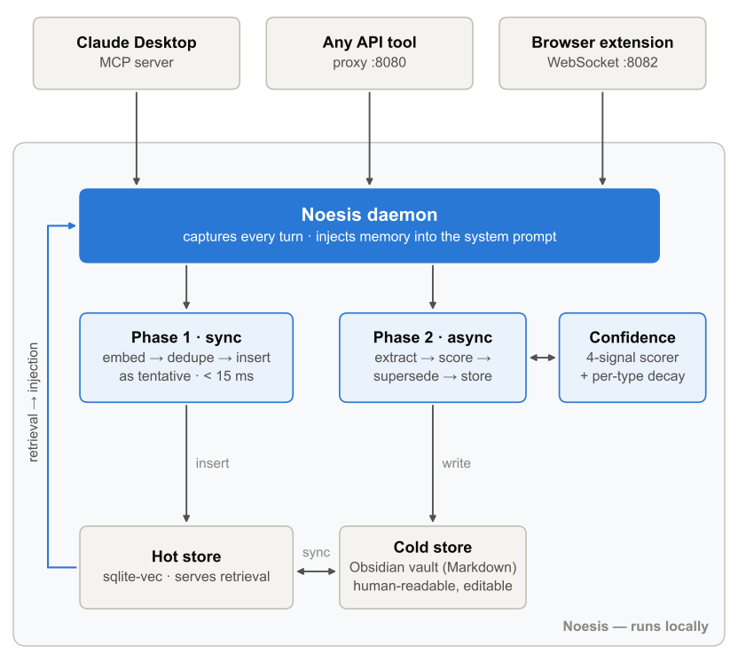
Figure 1. Noesis system architecture. Tools connect through an MCP server, an OpenAI-compatible proxy, or a WebSocket; Phase 1 stores the utterance synchronously ($<$15 ms) and Phase 2 asynchronously extracts, scores, and links the thought. Hot store (sqlite-vec) serves retrieval; cold store (Obsidian vault) keeps memory human-readable and editable.

2 Related Work

Memory for LLM agents.
MemGPT (Packer et al. 2023) treats the LLM as an operating system paging memory between contexts; Letta extends this with archival storage. Mem0 (Chhikara et al. 2025) extracts and updates atomic facts with an LLM pipeline, reporting gains over full-history baselines; A-MEM (Xu et al. 2025) links memories into an evolving Zettelkasten-style network, and Zep (Rasmussen et al. 2025) stores them in a temporal knowledge graph. Generative Agents (Park et al. 2023) rank memories by recency, importance, and relevance, and MemoryBank (Zhong et al. 2024) lets them fade along an Ebbinghaus forgetting curve, the closest precedents for Noesis’s type-specific decay. OpenMemory MCP (Mem0 2025) already shares one local store across MCP clients such as Cursor and Claude Desktop. Noesis differs in (a) its lifecycle, where a memory must earn injection rights before it reaches the prompt, and (b) its entry points beyond MCP: an OpenAI-compatible proxy and a browser extension make clients outside MCP first-class participants. Benchmarks such as LoCoMo (Maharana et al. 2024) and LongMemEval (Wu et al. 2025) offer standard long-term-memory evaluations that this paper does not yet use.

Retrieval-augmented generation.
RAG (Lewis et al. 2020) and successors retrieve per-query context. Self-RAG (Asai et al. 2024) and FLARE (Jiang et al. 2023) improve retrieval quality or adaptivity, but address corpus QA, not a user’s evolving personal memory. My scale experiment (§5.3) shows why naive inject-everything retrieval fails for personal memory: cost grows linearly and ranking collapses. Noesis pairs hybrid retrieval (BM25 + vector + RRF, with time-decay weighting) with a hard token budget and a confidence gate.

Personalization.
PALR (Yang et al. 2023) and related work personalize outputs from user interaction history, typically for recommendation-style tasks. Chat-tool vendor memory features (e.g., ChatGPT memory) are per-product and closed. Noesis’s cross-tool experiment (§5.4) demonstrates a structural advantage of user-scoped rather than tool-scoped memory.

Visualization of embedding spaces.
t-SNE (Maaten and Hinton 2008) and UMAP (McInnes et al. 2018) project high-dimensional embeddings for inspection; force-directed layouts (Fruchterman and Reingold 1991) model attraction/repulsion in 2D. My star map (§6) extends force-directed layout to 3D and adds weak axis springs, so semantic clusters still form freely while time reads left to right and confidence bottom to top.

3 System Design
Noesis sits between AI tools and model providers (Figure 1). API clients point at a local OpenAI-compatible proxy, which injects memory into the system prompt, forwards the request to the configured provider (cloud or local), and captures the conversation for memory formation; Claude Desktop connects through an MCP server and the browser extension through a WebSocket.

3.1 Thought taxonomy and two-phase capture
Conversational memory is typed into seven categories with distinct persistence semantics (Table 1). An identity thought (“I am a backend engineer”) should outlive an event (“I tried Bun yesterday”), and the taxonomy encodes this as type-specific half-lives.
Capture is two-phase. Phase 1 is synchronous and bounded ($<$15 ms): embed, deduplicate by hash, insert as tentative. The conversation never blocks on memory. Phase 2 is asynchronous: an extractor (a small cloud LLM, or a deterministic fallback) classifies the thought; a confidence scorer updates its status; a supersession check retires contradicted predecessors; the cold store (Markdown + YAML frontmatter in an Obsidian vault) is updated for human readability and editability.
Table 1. Thought taxonomy with type-specific half-lives and injection priority.
Type | Definition | Half-life (days) | Priority
identity | Who the user is | $∞$​ | highest (always)
preference | Explicit preference | 90 | high
position | Stance on a topic | 90 | high
question | Open question under exploration | 30 | medium
synthesis | Insight from merged ideas | 180 | medium
event | Happened / decided | 7 | low (recent)
contradiction | Self-contradictory judgment | $∞$​ | flagged

3.2 Confidence lifecycle
Every thought begins tentative: stored, but never injected and invisible to retrieval—the “capture threshold low, injection threshold high” principle. Four signals promote a thought: repetition (the same stance recurs across sessions), assertion strength (“I’ve decided” outranks “maybe”), cross-tool consistency (distinct phrasings of a stance from different tools), and absence of contradiction. The scorer combines them as 0.35 × repetition + 0.25 × assertion + 0.25 × no-contradiction + 0.15 × cross-tool, each scored from 0 to 1; a thought becomes provisional at 0.45 and settled at 0.75. A single firmly stated thought with no conflict (“I prefer X”, assertion 0.8) therefore scores exactly 0.45 and becomes injectable, while settling always requires repetition: at least three similar earlier thoughts with cross-tool corroboration, or six without. Provisional thoughts inject when topic-relevant; settled thoughts always inject. Confidence evolves incrementally: reinforcement $+0.10(1−C)$, conflict $−0.20$, and time decay $C←Ce^{−0.693Δt/t_{1/2}}$ with $t_{1/2}$ set by type (Table 1).

3.3 Cluster-aware supersession
When a user changes their mind (“I moved from MySQL to PostgreSQL”), the old stance should retire. Embedding similarity is the wrong signal here: contradictory stances mention different entities and therefore have low similarity. Noesis detects mind-changes by requiring jointly (1) a replacement verb (“switched to”, “migrated to”, …, EN+ZH), (2) the same domain via a keyword map (both stances are about databases), (3) stance-like type, and (4) injectable status of the new thought. Matched predecessors are marked superseded—excluded by every retrieval path—and linked via superseded_by. In my evaluation (the same 30 scenarios, run once before and once after the fix) this reduced stale-stance leakage from 93% to 7% (Table 2).
Table 2. Supersession fix: stale-stance leakage before/after ($n=30$ scenarios).
Metric | Before | After | $$Δ$$
Old stance leaked into context | 28/30 (93%) | 2/30 (7%) | −87pp
New stance surfaced | 12/30 (40%) | 28/30 (93%) | +53pp
Ideal (new shown, old retired) | 1/30 (3%) | 27/30 (90%) | +87pp

3.4 Selective retrieval and injection
At query time, three channels run in parallel (Figure 2): BM25 for exact terms, dense retrieval for paraphrase, and two lightweight signals (recency, core-facts). Channels fuse via reciprocal-rank fusion with time-decay weighting. A confidence gate drops everything below provisional, and a hard token budget (1,200 tokens) truncates the remainder. The result is injected into the system prompt as compact structured lines.
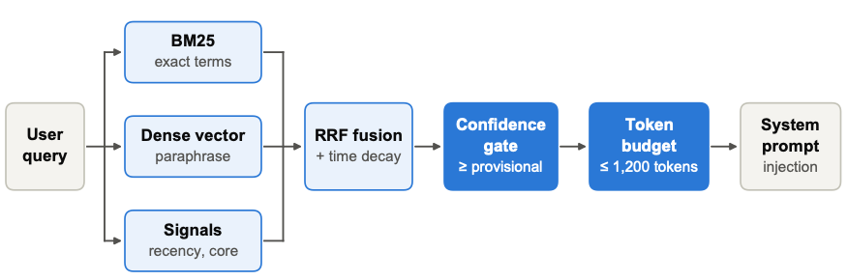
Figure 2. Retrieval and injection pipeline. Three channels fuse via RRF; a confidence gate removes non-injectable thoughts; a token budget caps injected context.

4 Evaluation Setup
I evaluate four research questions:
- RQ1: Does memory injection improve answer accuracy? (A/B, end-to-end, §5.1)
- RQ2: Which components contribute? (ablation, retrieval-layer, §5.2)
- RQ3: How do cost and ranking scale with memory size? (§5.3)
- RQ4: Does cross-tool sharing work? (§5.4)

Models.
Gemini Flash-Lite (cloud; gemini-flash-lite-latest, queried 30 June 2026), gemma3:4b and qwen2.5:3b (local via Ollama), spanning capability tiers.

A/B design.
30 synthetic English user profiles, each with 5 build statements (an identity statement plus preferences, positions, and decisions) followed by 5 test questions whose expected keyword is known from the build statements. Each build statement is stated once and firmly (“I prefer…”, “I decided…”), which is enough to reach provisional (§3.2). For each question the model answers twice: with memory (via the Noesis proxy, which injects context) and without memory (direct to the provider). All models are evaluated on the identical first $110$ questions (22 profiles). Scoring is objective keyword-hit; paired outcomes are tested with McNemar’s $χ^{2}$.

Retrieval-layer experiments.
Ablation, scale, and cross-tool experiments run against the real pipeline without LLM calls, measuring Recall@5, MRR, Precision@5, tentative leakage, and injected tokens.

Reproducibility.
Every number in this paper is recomputed from raw JSON by a released verification script.

5 Results

5.1 RQ1: Memory injection improves accuracy across model tiers
Table 3. A/B results on identical $n=110$ questions. All $p<0.001$ (McNemar, df$=$1).
Model | $n$​ | With | Without | $Δ$pp | $χ^{2}$​
Gemini Flash-Lite | 110 | 85.5% | 41.8% | +43.6 | 42.48
gemma3:4b | 110 | 82.7% | 34.5% | +48.2 | 51.02
qwen2.5:3b | 110 | 62.7% | 37.3% | +25.5 | 16.57

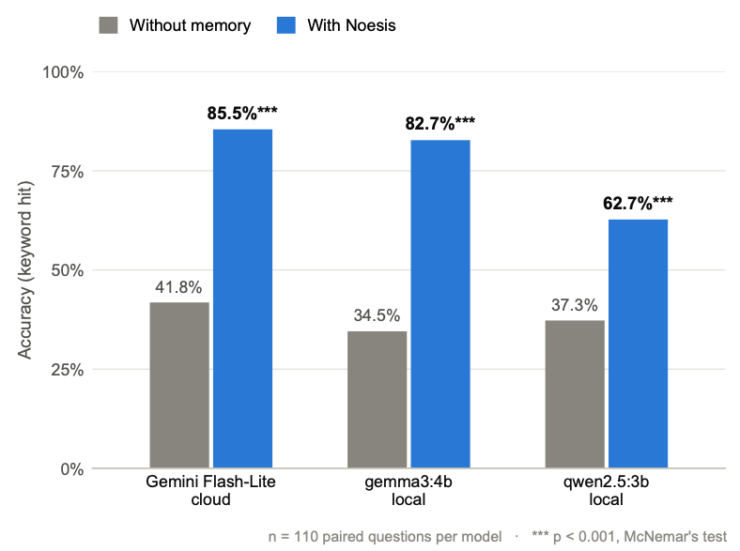
Figure 3. A/B accuracy across models ($n=110$ each). All improvements significant at $p<0.001$.
Table 3 and Figure 3 show the headline result. Three findings stand out. First, injection helps everywhere: all three models improve significantly, and memory hurt in only 10 of 330 paired answers (3.0%). Second, memory levels the field between local and cloud: with injection, gemma3:4b (4B parameters, local) reaches 82.7%, nearly matching Gemini Flash-Lite’s 85.5%, while its no-memory baseline (34.5%) trails Gemini’s 41.8%. Third, small models appear comprehension-capped: qwen2.5:3b goes through the same retrieval pipeline but reaches only 62.7%, which points to a model-capability ceiling rather than a retrieval failure; the saved runs do not record the injected context, so this is not yet confirmed.

5.2 RQ2: Semantic retrieval drives recall; gating keeps unverified thoughts out
Table 4. Ablation and baselines (50 queries, retrieval-layer).
Config | Recall@5 | MRR | Prec@5 | Leak
Noesis (full) | 100% | 1.000 | 96% | 10
w/o core-fact signal | 100% | 1.000 | 96% | 10
w/o recency signal | 100% | 1.000 | 96% | 10
w/o confidence gating | 100% | 1.000 | 88% | 29
w/o semantic retrieval | 49% | 0.160 | 100% | 0
Naive RAG | 100% | 1.000 | 88% | 29
Recent-window | 22% | 0.099 | 100% | 0
Random | 45% | 0.206 | 94% | 15

Removing semantic retrieval collapses recall (100%$→$49%), confirming it as the main source of recall (Table 4). Removing the confidence gate leaves recall intact but leaks 29 tentative thoughts versus 10—gating is what keeps unverified material out of the prompt. Core-fact and recency signals show no measurable effect in this query-driven suite; their value emerges on identity-relevant but topically unrelated queries, which this suite undersamples; testing them needs a dedicated query set.

5.3 RQ3: Cost stays flat while baselines explode
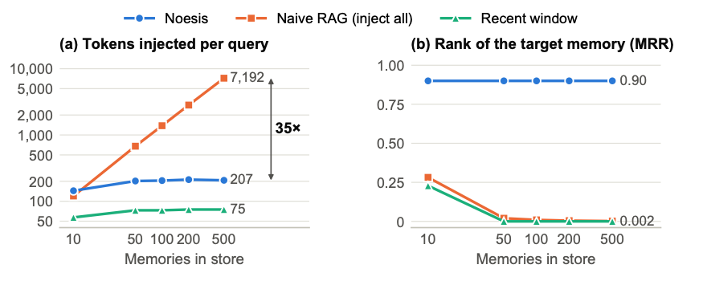
Figure 4. Scale behavior from 10 to 500 stored memories. (a) Noesis’s injected tokens stay flat ($∼$207) while naive RAG grows to 7,192 (35 times). (b) Noesis holds MRR at 0.90; naive RAG collapses to 0.002 as targets are buried; recent-window loses recall entirely past $n=10$.
Figure 4 sweeps memory size from 10 to 500 with 10 known targets embedded among fillers. Noesis’s injected cost is flat (144$→$207 tokens) because retrieval returns a small, confidence-gated set; the 1,200-token budget is never reached. MRR holds at 0.90: 9 of the 10 targets sit at rank 1, and the tenth is never retrieved. Naive RAG keeps recall only by injecting everything: 7,192 tokens at $n=500$, with the target buried near rank 500 (MRR 0.002). Recent-window recall collapses to 0% beyond $n=10$: the window forgets everything older. The methodological takeaway: recall alone is misleading; rank and token cost must be reported together.

5.4 RQ4: Cross-tool sharing vs. structural isolation
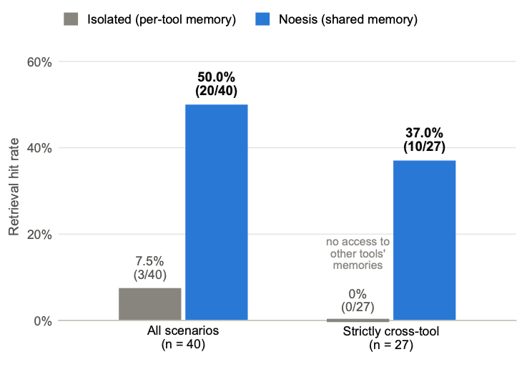
Figure 5. Cross-tool retrieval. Isolated per-tool memory scores 0% on strictly cross-tool queries by construction.
Of 40 scenarios, 27 state a stance in one tool and ask about it from another; in 7, the asking tool was one of two tools that stated it; and in 6, a third tool asks after two others stated it (Figure 5). On the 27 strictly cross-tool queries, Noesis retrieves 37% (10/27) and the isolated baseline 0%—not because it ranks poorly, but because the memory is not in its partition, so that 0% holds by construction. The 7 scenarios where the asking tool did see the stance are a fairer comparison: isolated memory retrieves 3 of 7 and Noesis 6 of 7. Over all 40 scenarios, Noesis retrieves 50% and the isolated baseline 7.5%. This is the structural argument: per-tool memory systems cannot share by design, and no amount of per-tool tuning closes the gap. Noesis’s misses trace to retrieval precision (the memory exists but ranks below top-$k$), not to sharing.

6 The Star Map Visualization
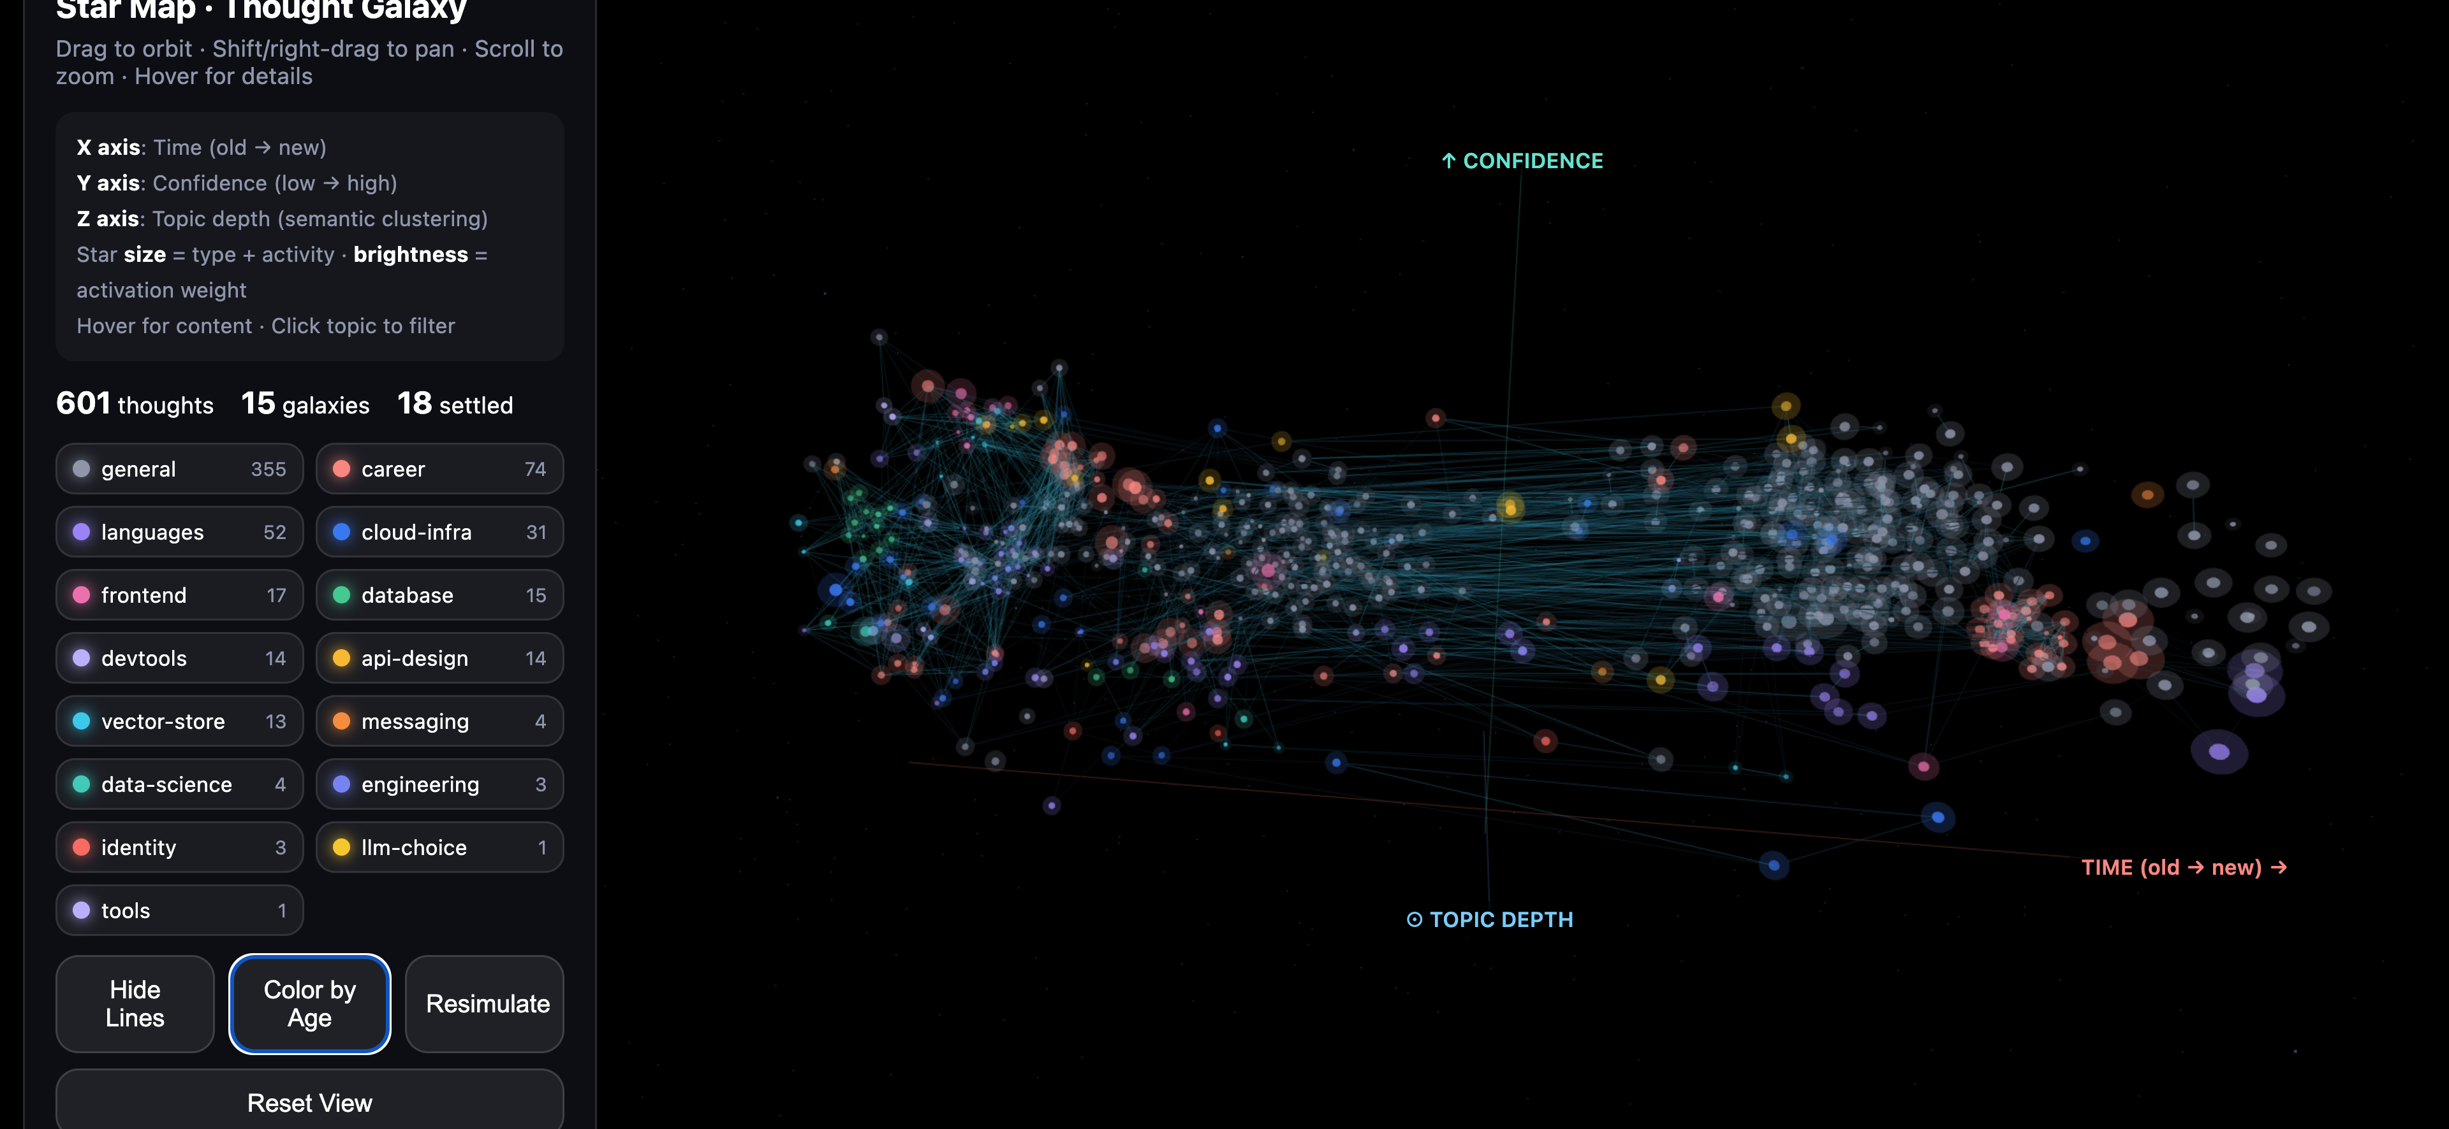
Figure 6. The star map. Semantic neighbors attract into volumetric constellations. Time runs from older (left) to newer (right), height reflects confidence, and color encodes topic; star size encodes type and activation weight, and brightness also tracks activation weight.
The stored memory graph is visualized as a galaxy (Figure 6). Each thought is a star placed by a short force simulation. Weak springs pull each star toward its creation time on the horizontal axis and its confidence on the vertical axis; semantic attraction pulls it toward its most similar neighbors (embedding cosine ≥ 0.45); and repulsion keeps stars from overlapping while pushing different topics apart. The springs are weak enough that attraction wins locally, so clusters form from embedding similarity while time and confidence stay readable at a glance; topic labels only decide which clusters repel. This makes the memory store inspectable rather than a black box: older thoughts sit to the left, settled ones sit high, and hovering a star shows its text and confidence. In the store shown, 355 of 601 thoughts fall into the catch-all “general” topic, which the extractor assigns when no known topic matches, and only 18 have settled, so the view exposes at a glance both how conservative the lifecycle is and how coarse topic assignment still is. The viewer is a local web tool shipped with the system; it opens the store read-only, so inspecting memory never changes it.

7 Discussion

When memory helps most.
Gains concentrate on questions that are unanswerable without personal context (job, stack, stances). On mainstream questions both groups often answer correctly, which compresses the measured gap on those items. Other factors push the other way (see Limitations), so these results should not be read as a bound in either direction.

Memory can close the local–cloud gap.
gemma3:4b posts the largest gain (+48.2pp; +139% over its baseline), approaching Gemini Flash-Lite once memory is injected. The benefit is not monotonic in model size: qwen2.5:3b gains least (+25.5pp), consistent with the comprehension ceiling in §5.1. Memory helps small local models most when they can use the injected context, which matters for privacy-sensitive and offline settings.

Retrieval precision is the current bottleneck.
The cross-tool misses and several A/B misses reduce to ranking failures, not architecture failures: the memory is stored but ranks below the cut. Improving ranking (rerankers, query expansion) is the highest-leverage next step. The supersession fix’s residual 7% is different: in both remaining leaks the detector never fired, once because “I now believe microservices are better” uses no listed replacement verb and names no known domain, and once because “I switched to Node.js” has the verb but Node.js is missing from the domain map. A broader mind-change detector is the matching fix.

Negative results.
I report that the supersession check initially never ran, so stale stances leaked 93% of the time until it was fixed (§3.3); that core-fact and recency signals showed no effect in my ablation suite; and that a 3B model appears comprehension-capped. I consider these findings part of the contribution.

8 Future Work

Thought branching.
When a new judgment deviates from history by more than a threshold ($δ=1−cos>0.45$), Noesis should create a branch linked via evolved_from rather than superseding, preserving the full trajectory of a stance. This enables metrics I cannot compute today: stabilization depth, branching rate, and post-branch divergence—a longitudinal record of how a user’s positions evolve.

Structured injection.
Replacing flat context lines with a structured user_thought_graph (anchor topic, trajectory with weights, cross-links) may improve the ability of small models to exploit injected memory, directly addressing the qwen2.5 comprehension ceiling.

Stronger evaluation.
LLM-as-judge scoring to complement keyword hits; distractor questions; a second cloud model to replicate the Gemini result; longitudinal deployment data beyond synthetic profiles.

9 Limitations
Scoring is keyword-hit, which is objective but coarse; semantic correctness may differ in both directions. Personas are synthetic; build/test alignment may overstate real-world gains, and real conversations are noisier. The cloud A/B uses one provider (Gemini Flash-Lite) and $n=110$ rather than the planned 150: free-tier rate limits stopped the 30 June run after 111 questions. A later session added 35 more, but because the gemini-flash-lite-latest alias may have pointed to a different model version by then, I use only the first 110 questions (22 complete profiles) from the single June run; all significance thresholds are still exceeded by wide margins. Retrieval-layer experiments measure what reaches the prompt, not final answer quality. The supersession detector relies on replacement verbs and a domain keyword map; paraphrased mind-changes outside its lexicon will be missed. The supersession fix was developed and validated on the same 30 scenarios, so its 93% → 7% result is in-sample; held-out, paraphrased mind-changes are needed to measure it fairly. The scale experiment’s naive-RAG baseline injects every stored memory; a top-k baseline under the same token budget would be a stronger comparison and has not yet been run.
Noesis also adds an attack surface. The local proxy sees every request, including provider API keys and full conversations; enabling cloud extraction sends conversation text to a third-party API, which weakens the local-first guarantee; and because a single firmly stated sentence already reaches provisional (§3.2), a planted or mistaken statement can enter future prompts. The confidence gate filters hedged statements but is not a defense against deliberate poisoning.

10 Conclusion
Noesis shows that what a memory system injects matters as much as whether it injects. A confidence lifecycle earns injection rights through repetition and consistency; selective, gated retrieval keeps cost flat as memory grows (35 times cheaper than naive RAG at $n=500$ with better ranking); and a shared per-user store makes cross-tool consistency possible where per-tool architectures are structurally bound to fail. The result is a local-first layer that makes a 4B local model answer personal questions about as accurately as a small cloud model (82.7% vs. 85.5% for Gemini Flash-Lite; no significant difference on this set)—and that keeps the user’s reasoning in the user’s own vault.
References
Asai, Akari, Zeqiu Wu, Yizhong Wang, Avirup Sil, and Hannaneh Hajishirzi. 2024. “Self-RAG: Learning to Retrieve, Generate, and Critique Through Self-Reflection.” International Conference on Learning Representations (ICLR).
Chhikara, Prateek, Dev Khant, Sparsh Aryan, et al. 2025. “Mem0: Building Production-Ready AI Agents with Scalable Long-Term Memory.” arXiv Preprint arXiv:2504.19413.
Fruchterman, Thomas M. J., and Edward M. Reingold. 1991. “Graph Drawing by Force-Directed Placement.” Software: Practice and Experience 21 (11): 1129–64.
Jiang, Zheng, Frank F. Xu, Luyu Gao, et al. 2023. “Active Retrieval Augmented Generation.” Proceedings of the 2023 Conference on Empirical Methods in Natural Language Processing (EMNLP), 7969–92.
Lewis, Patrick, Ethan Perez, Aleksandra Piktus, et al. 2020. “Retrieval-Augmented Generation for Knowledge-Intensive NLP Tasks.” Advances in Neural Information Processing Systems 33: 9459–74.
Maaten, Laurens van der, and Geoffrey Hinton. 2008. “Visualizing Data Using t-SNE.” Journal of Machine Learning Research 9: 2579–605.
Maharana, Adyasha, Dong-Ho Lee, Sergey Tulyakov, Mohit Bansal, Francesco Barbieri, and Yuwei Fang. 2024. “Evaluating Very Long-Term Conversational Memory of LLM Agents.” Proceedings of the 62nd Annual Meeting of the Association for Computational Linguistics (ACL).
McInnes, Leland, John Healy, and James Melville. 2018. “UMAP: Uniform Manifold Approximation and Projection for Dimension Reduction.” arXiv Preprint arXiv:1802.03426.
Mem0. 2025. “Introducing OpenMemory MCP.” Mem0 blog, May 13, 2025. https://mem0.ai/blog/introducing-openmemory-mcp.
Packer, Charles, Vivian Fang, Shishir G. Patil, Kevin Lin, Sarah Wooders, and Joseph E. Gonzalez. 2023. “MemGPT: Towards LLMs as Operating Systems.” arXiv Preprint arXiv:2310.08560.
Park, Joon Sung, Joseph C. O’Brien, Carrie J. Cai, Meredith Ringel Morris, Percy Liang, and Michael S. Bernstein. 2023. “Generative Agents: Interactive Simulacra of Human Behavior.” Proceedings of the 36th Annual ACM Symposium on User Interface Software and Technology (UIST).
Rasmussen, Preston, Pavlo Paliychuk, Travis Beauvais, Jack Ryan, and Daniel Chalef. 2025. “Zep: A Temporal Knowledge Graph Architecture for Agent Memory.” arXiv Preprint arXiv:2501.13956.
Wu, Di, Hongwei Wang, Wenhao Yu, Yuwei Zhang, Kai-Wei Chang, and Dong Yu. 2025. “LongMemEval: Benchmarking Chat Assistants on Long-Term Interactive Memory.” International Conference on Learning Representations (ICLR).
Xu, Wujiang, Kai Mei, Hang Gao, Juntao Tan, Zujie Liang, and Yongfeng Zhang. 2025. “A-MEM: Agentic Memory for LLM Agents.” Advances in Neural Information Processing Systems (NeurIPS).
Yang, Liangwei, Zhiwei Chen, Lixin Xia, Chen Yang, Yu Zhang, and Ben Kao. 2023. “PALR: Personalization Aware LLMs for Recommendation.” arXiv Preprint arXiv:2305.07622.
Zhong, Wanjun, Lianghong Guo, Qiqi Gao, He Ye, and Yanlin Wang. 2024. “MemoryBank: Enhancing Large Language Models with Long-Term Memory.” Proceedings of the AAAI Conference on Artificial Intelligence.

https://github.com/AngryKiwiWithLegs/Noesis

