Name: Lim Ngian Xin Terry (150496F), Daniel Chua Yee Chen (152112Y), Chin Hao Ming (154158D)
Comments:
Group: 5

Proposal/Report: Assignment 2 (Collaborative AI)
________________________________________________________________________

Instructions
Create 2 FSMs (minimum 3 state) each with trigger conditions and responses.
Design the FSMs to support or help each other in team play through message boarding.
Each FSM(its object) should send 1 message and respond to 1 message.
Responses can be seen via HUDs or other forms of suitable notifications.

States

When in Follow State,
If Health < 30%, & Shield < 10% Run.
If Shield > 80% & Attacker is Attacking or Attacker is Running or Support is Running, Defend.
If there are no Attacker or Support, Attack.

When in Defend State,
If Attacker not Attacking or Running and Support not Running and no Help Requests, Follow Attacker.
If Shield <= 10%, Follow Attacker.
If there are no Attacker or Support, Attack.

When in Follow or Defend State,
If a teammate requests for help, reply and guard them.
If there are no Attacker or Support, Attack.

When in Run State,
If health is > 70%, Follow Attacker.
If there are no Attacker or Support, Attack.

When in Attack State,
If there is an Attacker or Support, Follow.

Conditions

When in Follow State,
If Health < 30%, & Shield < 10% Run.
If Shield > 80% & Attacker is Attacking or Attacker is Running or Support is Running, Defend.
If there are no Attacker or Support, Attack.

When in Defend State,
If Attacker not Attacking or Running and Support not Running and no Help Requests, Follow Attacker.
If Shield <= 10%, Follow Attacker.
If there are no Attacker or Support, Attack.

When in Run State,
If Health is > 70%, Follow Attacker.
If there are no Attacker or Support, Attack.

When in Attack State,
If there is an Attacker or Support, Follow.

State Transition Diagram

Legend:
SUP – Support (Another Character)
ATK – Attacker (Another Character)
S – Shield
HP – Health

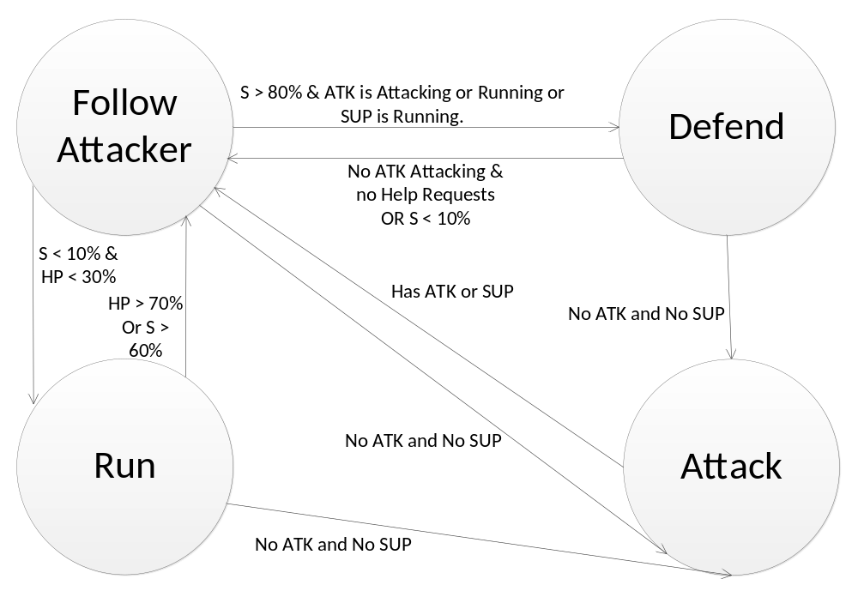
GUARDIAN

Attacker Finite State Machine (Terry)

States

When in Move State,
Move along path most likely to have enemies (A* Search).
If the distance to enemy < 8 units, Attack.
If the gun magazine is not full, Reload.

When in Run State,
Send Help Message.
If health > 80%, Move.
If health < 50% after 5 seconds, Move.

When in Attack State,
If distance to enemy > 15 units, Move.
If gun magazine is empty, Reload.
If health < 20%, 90% chance of Running.

When in Reload State,
If gun magazine is full, and go to previous state.

Conditions

When in Move State,
Move along path most likely to have enemies (A* Search).
If the distance to enemy < 8 units, Attack.
If the gun magazine is not full, reload.

When in Run State,
Send Help Message.
If health > 80%, Move.
If health < 50% after 5 seconds, Move.

When in Attack State,
If distance to enemy > 15 units, Move.
If gun magazine is empty, reload.
If health is < 20%, 90% chance of Running.

When in Reload State,
If gun magazine is full, go to previous state.

State Transition Diagram

Legend:
HP – Health
MAG – Gun Magazine
DE – Distance to Enemy

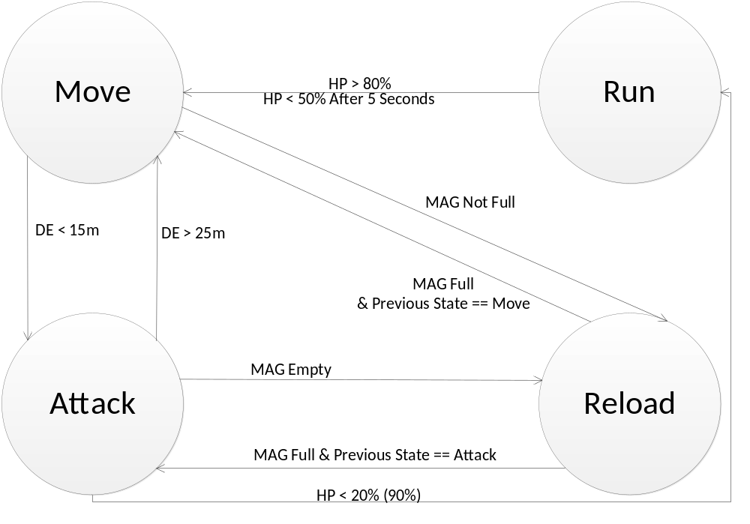
ATTACKER

Support Finite State Machine (Daniel)

States

In an RPG game when enemy is not within 5 units, support will follow,
When enemy is within 5 units, support will either buff or heal;
When teammate health is above 50% support will buff,
When teammate health is below 50% support will heal.
When support health is below 30% support will run.
When support health is below 30% and enemy not within 5 units, support will self-heal

Conditions

In an RPG game when enemy is not within 5 units, support will follow,
When enemy is within 5 units, support will either buff or heal;
When teammate health is above 50% support will buff,
When teammate health is below 50% support will heal.
When support health is below 30% support will run.
When support health is below 30% and enemy not within 5 units, support will self-heal

State Transition Diagram

FOLLOW
Legend:
D: distance from nearest enemy
THP: teammate health points
HP: Support HP

BUFF

HEAL
RUN
And
Self-Heal
HP<30%
D>5
D<5
THP<50%
THP>50%
HP=100%
SUPPORT
Gunner Finite State Machine (Daniel)

States

In an RPG game, gunner will patrol.
When another close-by enemy requests help, assist.
When enemy is within 5 units, gunner will attack.
When enemy escapes outside 5 units, gunner will chase.
When enemy escapes outside 10 units, gunner will patrol.
When ammo is 0, gunner will reload, when ammo is full(30) gunner will attack.
When enemy is 1 unit away, gunner might (20%) run,
when enemy is more than 2 unit away gunner will resume attack

Conditions

In an RPG game, gunner will patrol.
When another close-by enemy requests help, assist.
When enemy is within 5 units, gunner will attack.
When enemy escapes outside 5 units, gunner will chase.
When enemy escapes outside 10 units, gunner will patrol.
When ammo is 0, gunner will reload, when ammo is full(30) gunner will attack.
When enemy is 1 unit away, gunner might (20%) run,
when enemy is more than 2 unit away gunner will resume attack

State Transition Diagram

PATROL
Legend:
D: distance from nearest enemy
A: remaining ammo in magazine
R: help requested

R, D<20

Assist
D>10

CHASE
D<5

D<5

ATTACK
A = 30
D>5

RELOAD

A = 0
D<1 (20%)

D>2

RUN

GUNNER

Turret (Hao Ming)

States

When enemy in range (15units), attack.
When out of ammo, reload.
If enemy not in range (25units), idle.
When health below 30%, requests help from Brawler.

Conditions

When enemy in range, attack.
When out of ammo, reload.
If enemy not in range, idle.
When health below 30%, requests help from Brawler.

State Transition Diagram

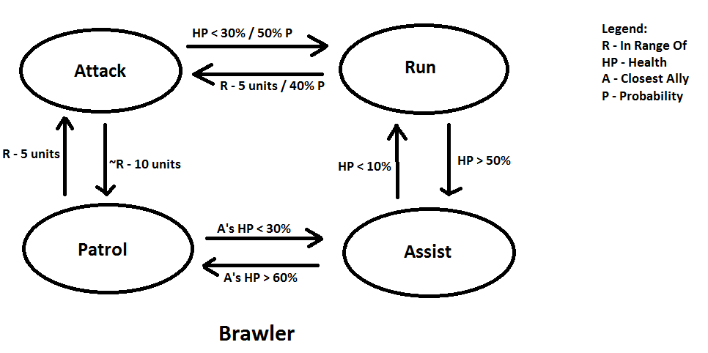

Brawler (Hao Ming)

States
When enemy in range (5units), attack.
When HP below 30%, run with 50% probability.
If enemy not in range (15units), patrol.
If enemy in range (5units) while Brawler is running, 40% chance to attack.
If closest ally health below 30%, assist.
If closest ally health above 60%, patrol.
If HP below 10% while assisting, run.
If HP above 50% while running, assist.

Conditions
When enemy in range (5units), attack.
When HP below 30%, run with 50% probability.
If enemy not in range (15units), patrol.
If enemy in range (5units) while Brawler is running, 40% chance to attack.
If closest ally health below 30%, assist.
If closest ally health above 60%, patrol.
If HP below 10% while assisting, run.
If HP above 50% while running, assist.

State Transition Diagram

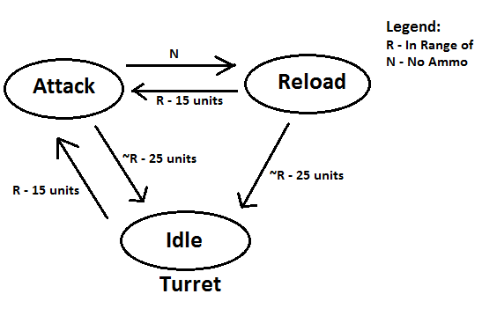

Additional Information

3 characters, the Attacker, Guardian, and Support are allies and fighting enemies together.

The Attacker can shoot enemies, but cannot move when attacking. The Guardian can deploy a short range shield around itself, which will block incoming enemy attacks. It can use this to defend itself and any allies within the shield’s range. However, the shield depletes as it absorbs damage. The shield regenerates over time. The Support can heal and buff one ally at a time. Healing restores health. Buffing the Attacker increases that Attacker’s bullet’s damage. Buffing the Guardian regenerates its shield faster.

There are 3 types of enemies. The Turret, which is stationary and a range attacker. The Gunner, which is a ranged attacker, and the Brawler, which is a close combat enemy.

Assignment 2 Add-ons:
Tile-based system
Path Finding
Additional cost so that AI can avoid certain characters
Obstacles
Message Board

Note: Message Board is mainly only active when the characters are low on HP. If the message board is not showing anything, just wait a while. It is not broken. ☺

Done:
1. Message Board (Daniel)
2. Improve on Healer’s FSM. (Daniel)
3. Improve on Gunner’s FSM. (Daniel)
4. Reply to Message Log (message board) after decrypting the message in Message Board. (Daniel)
5. A* path finding search (Terry)
6. Additional cost for A* search. Instead of just the shortest path, the characters may avoid or be attracted towards certain route due to vicinity of enemies or allies. (Daniel and Terry)
7. Tile Map System (Terry)
8. Obstacles (Terry)
9. Added Attack State for Guardian when there is no Attacker and Support left. (Role Change) (Terry)
10. Improve on Brawler’s FSM (Hao Ming)
11. Improve on Turret’s FSM (Hao Ming)

