Inventory Management System

Bottom End Report

February 01, 2015

Prepared for Chandler Janzen

by

Craig Irvine

Keenan Johnstone

Justin Fraser

Table of Contents

Change Log 2

1. Purpose 2

2. References 2

3. Overall System Interconnects 3

4. Front End 4

4.1. ParseXMLResponse Script 4

4.2. LoadBrowser Script 5

4.3. LoadLog Script 6

4.4. LoadItemData Script 7

5. Backend 8

5.1. IMSBase Class 8

5.1.1. IMSBase->VerifyData 8

5.1.2. IMSBase->GenerateXMLResponse 9

5.2. IMSLog Class 10

5.2.1. IMSLog->__construct 10

5.2.2. IMSLog->add_log 11

5.2.3. IMSLog->read_log 12

5.3. IMSSql Class 13

5.3.1. IMSSql->__construct 13

5.3.2. IMSSql->connect 14

5.3.3. IMSSql->command 15

5.3.4. IMSSql->prepare 16

5.3.5. IMSSql->exists 17

5.4. Base Scripts 18

5.4.1. CreateNewItem 18

5.4.2. RetrieveBrowserData 19

5.4.3. RetrieveItemData 20

5.4.4. RetrieveLog 21

5.4.5. AddNewClassData 22

5.4.6. ModifyItem 23

5.4.7. QueryAutocomplete 24

5.4.8. GeneratePurchaseReport 25

5.4.9. ReadOptions 26

5.4.10. ModifyOption 27

6. Database 28

# Change Log

|  |  |  |
| --- | --- | --- |
| Date | Version | Change |
| 01 February 2015 | 1 | Initial Submission |
|  |  |  |
|  |  |  |

# 

# Purpose

This report show in the details of all the modules required for Inventory Management System.

# 

# 

# References

<Statement of Work> EE495-201509-SOW-01A

Inventory Management System Specifications Version 3 (16 November 2015)

Inventory Management System Design Specifications Version 1 (19 November 2015)

# Overall System Interconnects

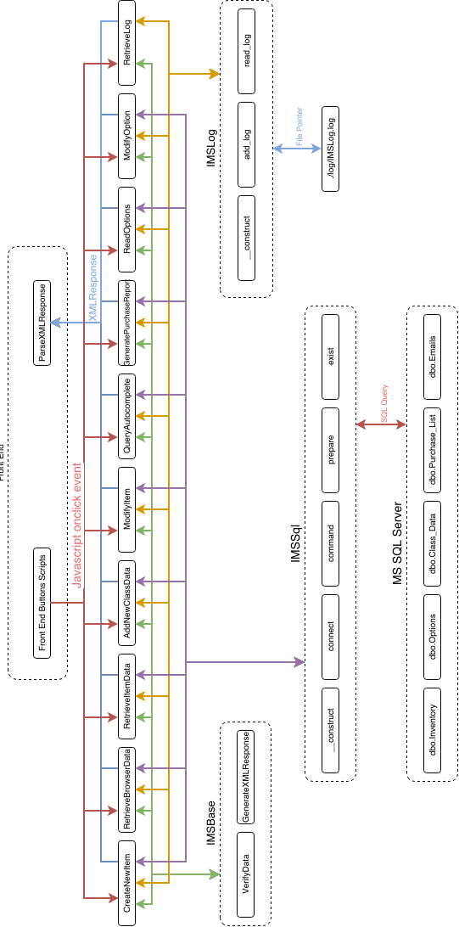

Figure 3-1 - System Interconnects

# Front End

## ParseXMLResponse Script

**Description:** Takes any XML response from the database and parses it into the appropriate format (such as the browser data into a table format).

**Inputs:** An XML Response

**Return Value:** The appropriate table or formatted response from the server

**Designer:** Keenan Johnstone

**Development Time:** 3 Hours



Figure 4-1 - ParseXMLResponse Flowchart

## LoadBrowser Script

**Description:** Calls the RetrieveBrowserData.php Script to return an XML response and then passes that to the ParseXMLResponse Script

**Inputs:** None

**Return Value:** id=”browser”

**Designer:** Keenan Johnstone

**Development Time:** 3 Hours

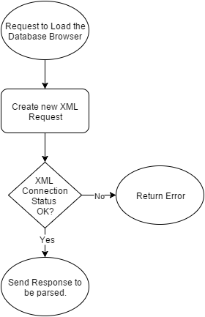

Figure 4-2 - LoadBrowser Flowchart

## 

## LoadLog Script

**Description:** Calls the RetrieveBrowserData.php Script to return an XML response and then passes that to the ParseXMLResponse Script

**Inputs:** None

**Return Value:** id=”log”

**Designer:** Keenan Johnstone

**Development Time:** 1 Hours

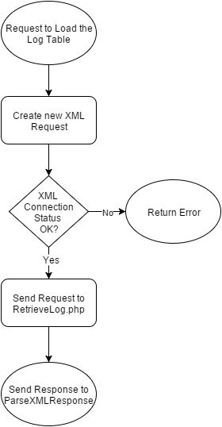

Figure 4-3 - LoadLog Flowchart

## 

## LoadItemData Script

**Description:** Calls the RetrieveItemData.php Script to return an XML response and then passes that to the ParseXMLResponse Script

**Inputs:** Item to be loaded

**Return Value:** id=”Itemdata”

**Designer:** Keenan Johnstone

**Development Time:** 1 Hour

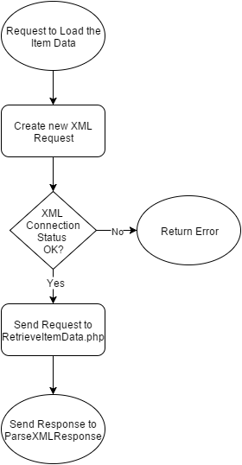

Figure 4-4 -LoadItemData Flowchart

# 

# Backend

## IMSBase Class

### IMSBase->VerifyData

**Description**: This function performs two checks on a data string passed to it to verify the proper data was passed from the front end.

**Inputs**: data - A string variable containing the data to check.

RegEx - A string variable containing a RegEx pattern to check the data against.

**Return** Value: Function will throw an Exception is either of the test fail otherwise it will return to calling function.

**Designer**: Craig Irvine

**Development Time**: 1 Hour

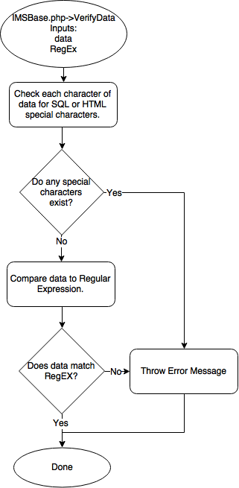

Figure 5-1 - IMSBase->VerifyData Flow Chart

### IMSBase->GenerateXMLResponse

**Description**: Generates a XML response document used for passing data from the backend scripts to the frontend GUI.

**Inputs**: Session ID - The ID for the calling front end session.

Status_array - An array that contains the status of the response within two members.

query_suggest_array - (Optional) An array that contains a list of suggestions for use with

the autocomplete feature.

q_access_array - (Optional) An array that contains the information of a single item for use

in the quick access feature.

browser_array - (Optional) An array that contains browser data generated from the

RetrieveBrowserData.php script.

log_array - (Optional) An array that contains the log data generated from the RetrieveLog.php script.

**Return Value**: A XML document is returned to sent to the frontend.

**Designer**: Craig Irvine

**Development Time**: 4 Hours

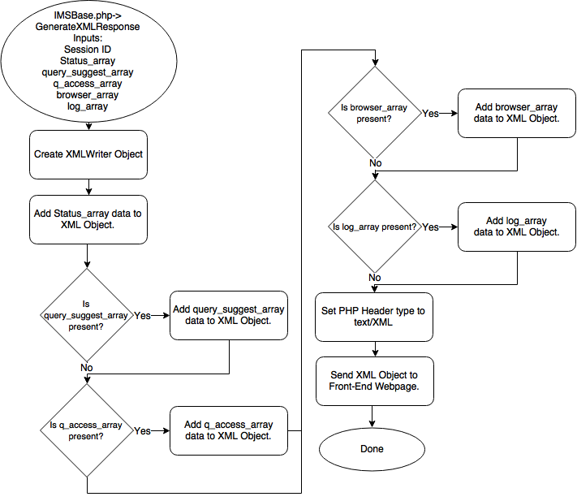

Figure 5-2 - IMSBase->GenerateXMLResponse Flowchart

## IMSLog Class

### IMSLog->__construct

**Description**: Constructor for the IMSLog class. Sets the local file pointer to a passed or default location.

**Inputs**: Log File Location - The location where the log file is to be saved and read from.

**Return Value**: No return value.

**Designer**: Craig Irvine

**Development Time**: 1 Hour

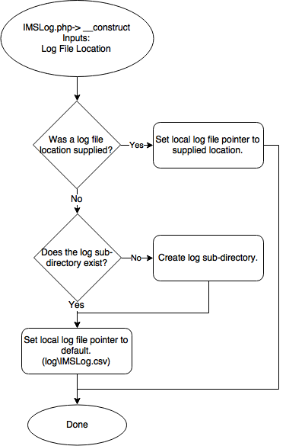

Figure 5-3 - IMSLog->__construct Flowchart

### IMSLog->add_log

**Description**: Adds a log entry to the log file.

**Inputs**: Session ID - The ID for the calling frontend session.

Log Level - The level of the log message, can be Information, Error, Warning, or Debug.

Message - The message to be logged.

**Returned Value**: None

**Designer**: Craig Irvine

**Development Time**: 1 Hour

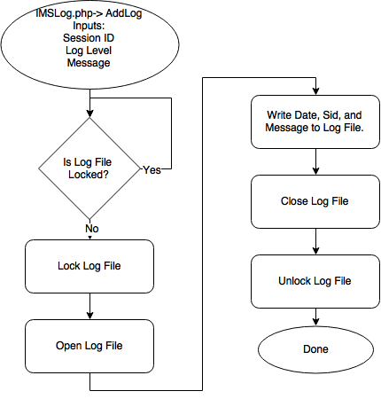

Figure 5-4 - IMSLog->add_log Flowchart

### IMSLog->read_log

**Description**: Reads the log file and retrieve entries related to the passed log level.

**Inputs**: Level Filter - A filter variable that set the log level to retrieve, can be Information, Error,

Warning, or Debug.

**Return Value**: Passes the log entries to the IMSBase->GenerateXMLResponse function.

**Designer**: Craig Irvine

**Development Time**: 1 Hour

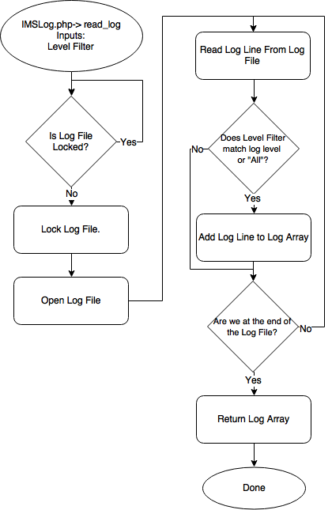

Figure 5-5 - IMSLog->read_log Flowchart

## IMSSql Class

### IMSSql->__construct

**Description**: A constructor for the IMSSql class. It sets local SQL server access variables then calls the connect function.

**Inputs**: server - The SQL server location

user - The username for logging into the SQL server.

password - The password for logging into the SQL server.

**Return Value**: The result of IMSSql->connect.

**Designer**: Craig Irvine

**Development Time**: 1 Hour

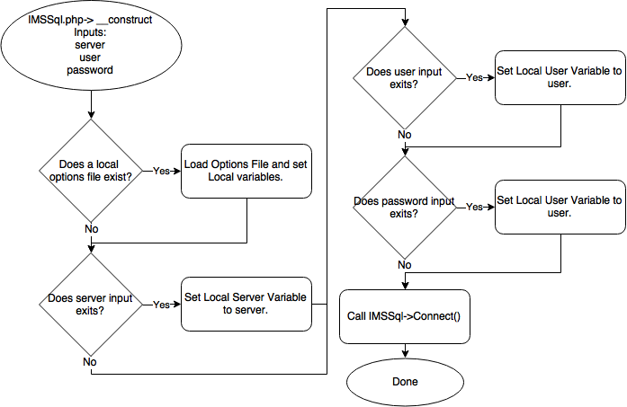

Figure 5-6 - IMSSql->__construct Flowchart

### 

### 

### IMSSql->connect

**Description**: Create a connection to the SQL server using a PDO object.

**Inputs**: None

**Return Value**: PDOException if PDO creation was unsuccessful, otherwise nothing.

**Designer**: Craig Irvine

**Development Time:** 1 Hour

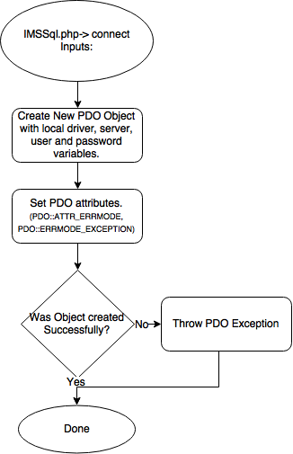

Figure 5-7 - IMSSql->connect Flowchart

### IMSSql->command

**Description**: Sends a SQL command to the SQL server to be executed.

**Inputs**: sql_command: A SQL command string.

**Return Value**: A PDOException error is thrown if an error occurs, otherwise nothing.

**Designer**: Craig Irvine

**Development Time**: 0.5 Hour

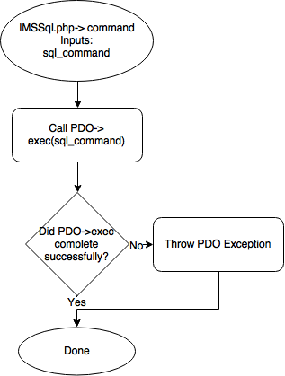

Figure 5-8 - IMSSql->command Flowchart

### IMSSql->prepare

**Description**: Creates a PDO::prepare statement and returns it to the calling script.

**Input**: SQLStatment - A string containing a SQL statement used to create the PDO::prepare object.

**Return Value**: A PDOExecption is thrown on error otherwise a PDO::prepare object is returned.

**Designer**: Craig Irvine

**Development Time**: 0.5 Hours

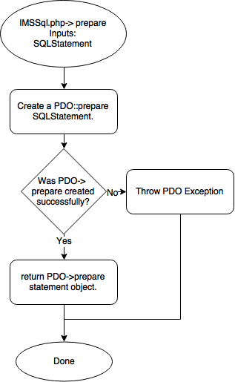

Figure 5-9 - IMSSql->prepare

### IMSSql->exists

**Description**: Checks to see if a part number already exists within the SQL database.

**Input**: partNumber - The item to look for in the database table.

table - The SQL table to look in.

**Return Value**: Is the part number exists within the table return true, else return false.

**Designer**: Craig Irvine

**Development Time**: 1 Hour

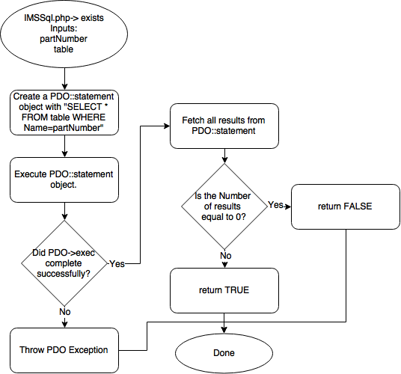

Figure 5-10 - IMSSql->exists Flowchart

## Base Scripts

### CreateNewItem

**Description**: Create a new item in the SQL database in the dbo.Inventory table.

**Inputs**: SID - The ID for the calling frontend session.

PartNumber - The part number of the item being created.

**Designer**: Craig Irvine

**Development Time**: 2 Hours

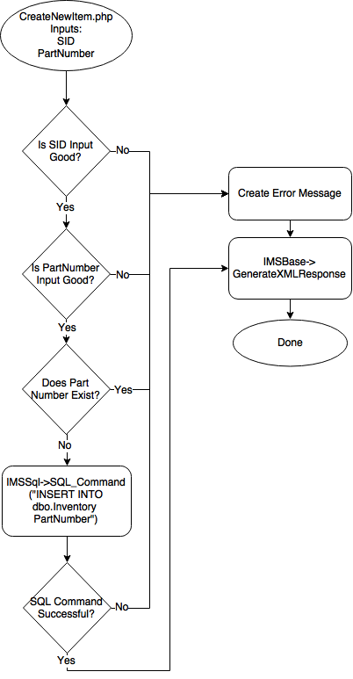

Figure 5-11 - CreateNewItem.php Flowchart

### RetrieveBrowserData

**Description**: Retrieves data for the browser second of the GUI with the ability to sort and filter the data.

**Inputs**: SID - The ID for the calling frontend session.

SortColumn - A string containing the name of column to sort.

SortDirection - A string containing ASC or DESC used to specify the sort direction.

Filter - A string containing a value to filter the data by.

**Return Value**: Returns an XML document with the results of the query.

**Designer:** Craig Irvine

**Development Time**: 2 Hour

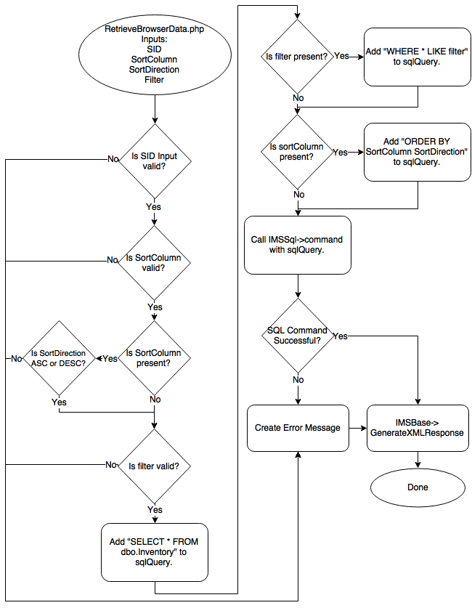

Figure 5-12 - RetrieveBrowserData.php Flowchart

### RetrieveItemData

**Description**: Retrieves data for a single item.

**Input**: SID - The ID for the calling frontend session.

PartNumber - A string containing the part number to retrieve data for.

**Return Value**: Returns an XML document with the results of the query.

**Designer:** Craig Irvine

**Development Time**: 1 Hours

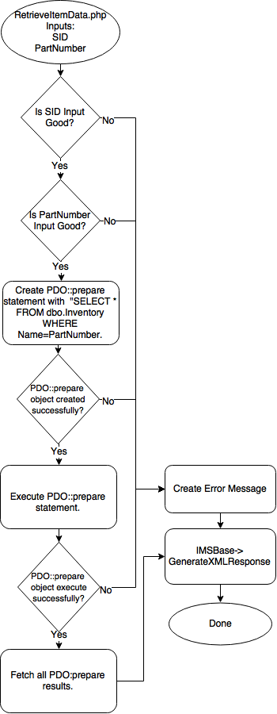

Figure 5-13 - RetrieveItemData.php Flowchart

### RetrieveLog

**Description**: Retrieve log entries for a specified log level.

**Inputs**: SID - The ID for the calling frontend session.

LogLevel - A string containing the log level requested, can be Information, Error, Warning,

or Debug.

**Return Value**: Returns an XML document with the results of the query.

**Designer:** Craig Irvine

**Development Time**: 1 Hour

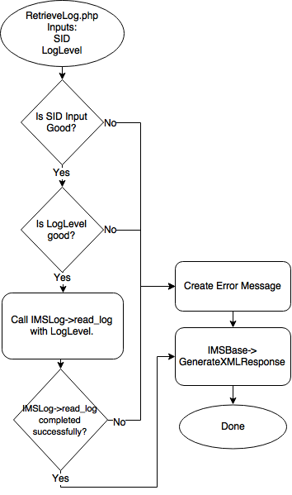

Figure 5-14 - RetrieveLog.php Flowchart

### AddNewClassData

**Description**: Add a new Record into the ClassData table.

**Inputs**:SID - The ID for the calling frontend session.

Class - A string containing the name of the class.

PartNumber - A string containing the part number needed.

Quantity - A positive interger contain the number of required parts.

Date - A string containing the date the parts are required by.

**Return Value**: Returns an XML document with status of the operation.

**Designer:** Craig Irvine

**Development Time**: 1 Hour

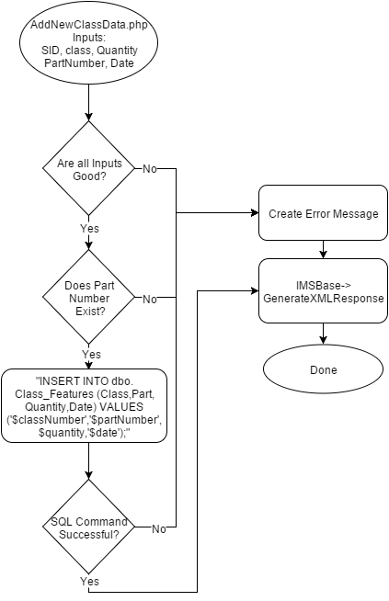

Figure 4-16 - AddNewClassData.php Flowchart

### 

### ModifyItem

**Description**: Modifies a single column value for a specified part number record.

**Inputs**:SID - The ID for the calling frontend session.

PartNumber - A string containing the part number needed.

field - A string containing the column to modify.

value - A string containing the value to modify to.

**Return Value**: Returns an XML document with status of the operation.

**Designer:** Craig Irvine

**Development Time**: 1 Hour

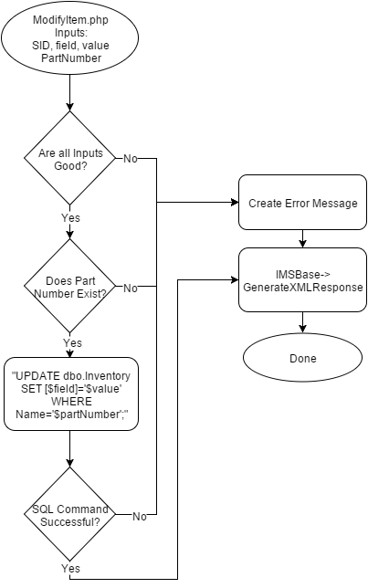

Figure 5-16 - ModifyItem.php Flowchart

### QueryAutocomplete

**Description**: Generates a list of item records that partially match a passed record.

**Inputs**:SID - The ID for the calling frontend session.

filter - A string containing a partial search value.

**Return Value**: Returns an XML document with a list of record that match the partial search value.

**Designer:** Craig Irvine

**Development Time**: 1 Hour

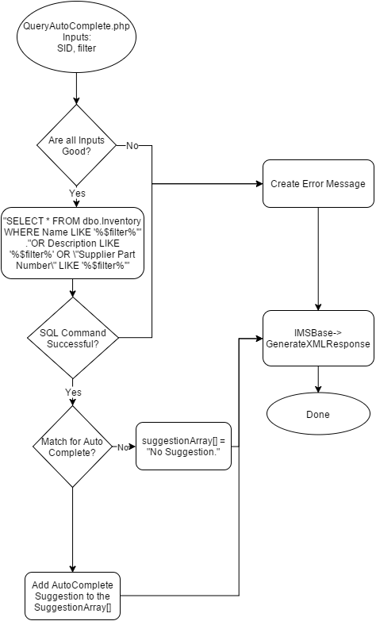

Figure 5-17 - QueryAutoComplete.php Flowchart

### GeneratePurchaseReport

**Description:** Populate Purchase List table with inventory items whose quantity is below threshold.

**Inputs:** SID -- the ID for the calling frontend session.

**Returns:** Returns an XML document with results of the query.

**Designer:** Justin Fraser

**Development Time:** 2 Hours

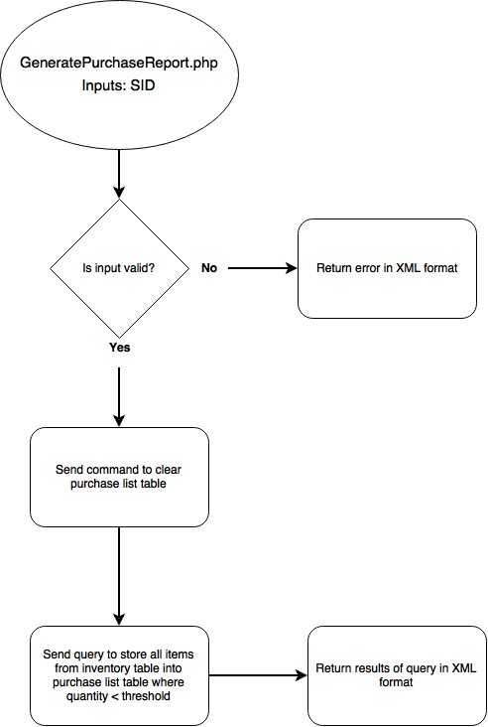

Figure 5-18 - GeneratePurchaseReport Flowchart

### ReadOptions

**Description:** Read IMS options.

**Inputs:** SID -- the ID for the calling frontend session.

**Returns:** Returns an XML document with results of the query.

**Designer:** Justin Fraser

**Development Time:** 2 Hours

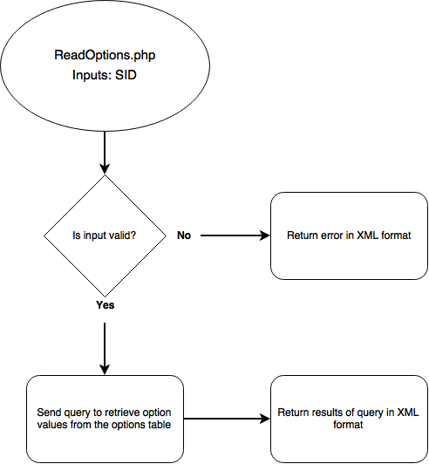

Figure 5-19 ReadOptions Flowchart

### ModifyOption

**Description:** Modify IMS options.

**Inputs:** SID -- the ID for the calling frontend session.

Option – the option to modify.

Data – value of the new option.

**Returns:** Returns an XML document with results of the query.

**Designer:** Justin Fraser

**Development Time:** 2 Hours

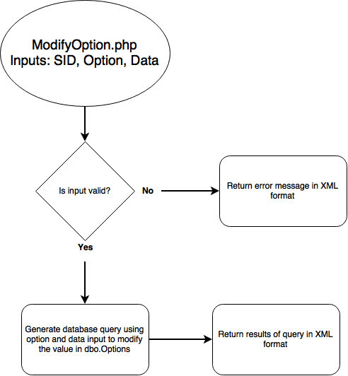

Figure 5-20 - ModifyOption Flowchart

# Database

**Description:** Back end interacts with the database which holds five tables of data. Currently, there are no relationships or dependencies between the tables in the database.

**Inputs:** queries or commands issued by the back end in the form of PHP scripts.

**Outputs:** rows of data on a successful query or an error message on an unsuccessful query to be handled by the back end.

**Designer:** Justin Fraser

**Development Time:** 20 Hours

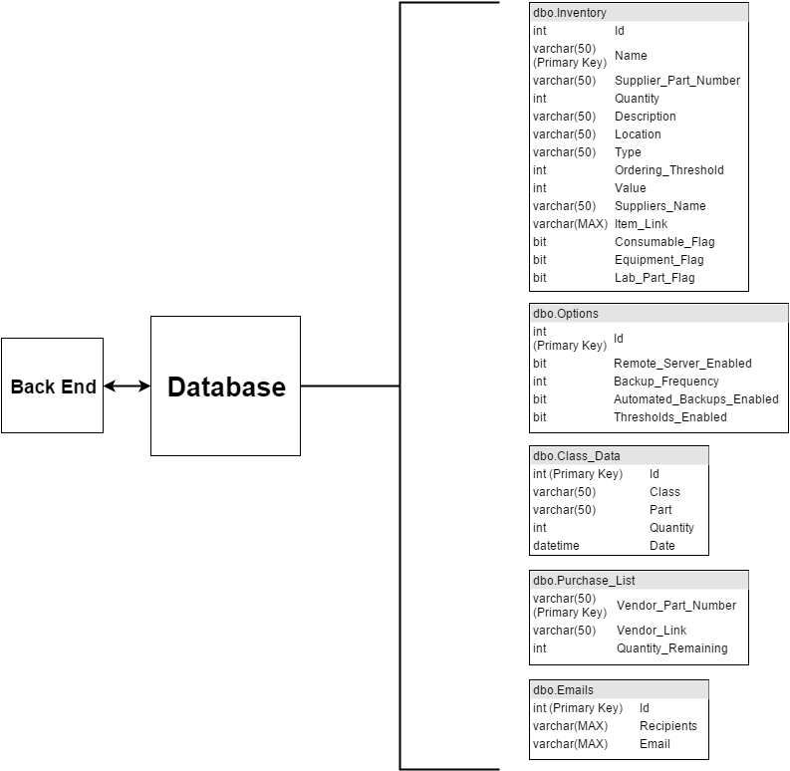

Figure 6-1 - Database layout