Miro workflow

https://miro.com/app/board/uXjVJQu5jAs=/

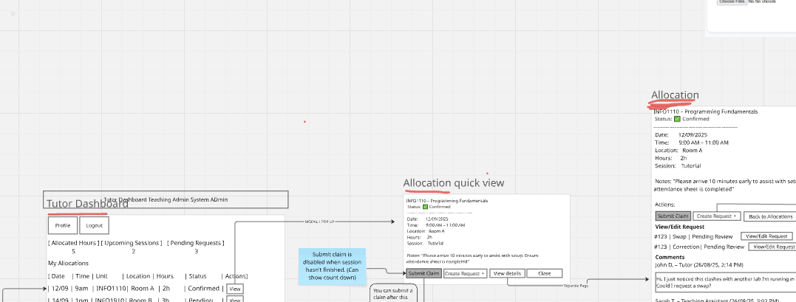

Must Do pages are outlined in red

Must Do:

Portal: portal.html

Tutor DashBoard: tutor-dashboard-demo.html

Allocation View: view_allocation.html

Unit Coordinator: DashBoard: new_UC_dash.html

System Admin: system_admin.html

Allocation Import Preview (accessible from system admin) : import_preview.html

KEY:
Red : Buttons
Bold : Pages

MVP use cases:

Use case 1: View detailed allocation
Preconditions:
Test allocation data loaded from database
Single test user with all roles signed in

User is initially on portal, user clicks on tutor dashboard, is directed to tutor dashboard page clicks on view next to an allocation row, user is presented with a modal quick view of allocation, user clicks on view details and is directed to Allocation View page.

Use case 2: Admin imports data
Preconditions:
Test allocation data loaded from database
Single test user with all roles signed in

User is initially on portal, user clicks on system admin, is directed to system admin page, clicks on bulk import allocations in top right hand corner

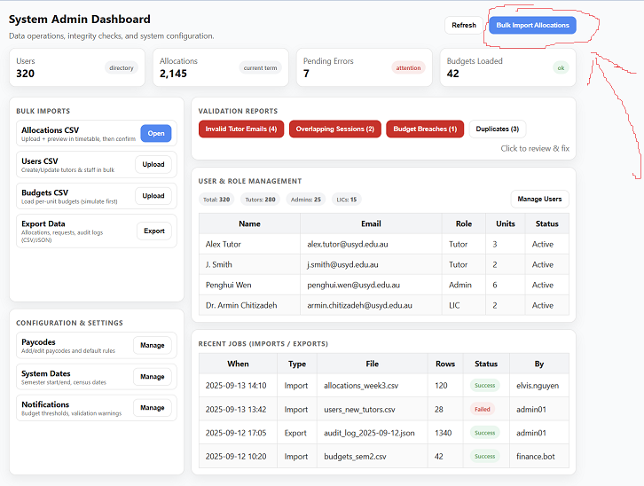

User is directed to Allocation Import Preview:

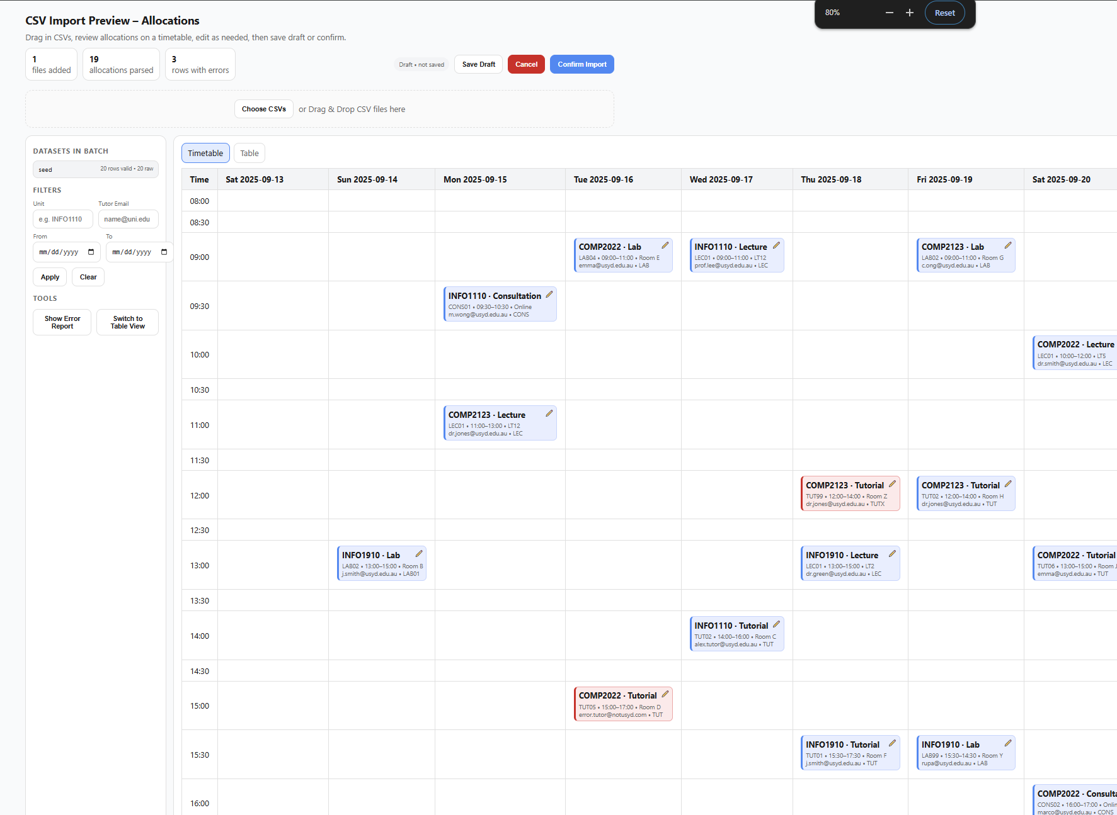

User clicks on choose csvs, and uploads data_s2_2025.csv, the system ingests the data into the database and reveals the updated time tables.

Use case 3: View unit coordinator dashboard
Preconditions:
Test budget data loaded from database
Single test user with all roles signed in

Initially user is on portal, clicks on unit coordinator dashboard, is directed to unit coordinator dashboard page. Views insights into budget tracking as appears on UC_dash.html

