Queue implementation

import java.util.Iterator;  
import java.util.LinkedList;  
  
public class QueueImpl<T> implements Iterable<T> {  
  
  
 @Override  
 public Iterator<T> iterator() {  
 return null;  
 }  
 private LinkedList<T> queueList = new LinkedList<T>();  
  
 public QueueImpl() {}  
  
 public QueueImpl(T firstElement){  
 addElement(firstElement);  
 }  
  
 public int howMany(){  
 return queueList.size();  
 }  
  
 public boolean isEmpty(){  
 return howMany() == 0;  
 }  
  
 public T checkFirst(){  
 if (isEmpty()){  
 throw new RuntimeException("Empty Queue of Names!");  
 }  
 return queueList.peekFirst();  
 }  
  
 public T removeFirstElement(){  
 if (isEmpty()){  
 throw new RuntimeException("Cannot remove element from an empty queue!");  
 }  
 return queueList.removeFirst();  
 }  
  
  
 public void addElement(T element){  
 if (element == null){  
 throw new RuntimeException("Cannot add null elements to the list!");  
 }  
 queueList.addLast(element);  
 }  
  
}

Queue Usage:

import java.util.Objects;  
  
public class Assignment1 {  
  
  
 QueueImpl newQueue = createQueue("str");  
  
 public QueueImpl createQueue(String type){  
 if (type.equals("int")){  
 QueueImpl<Integer> newQueue = new QueueImpl<>();  
 return newQueue;  
 }  
 else {  
 QueueImpl<String> newQueue = new QueueImpl<>();  
 return newQueue;  
 }  
 }  
  
  
 public String addInt(int number){  
 try {  
 newQueue.addElement(number);  
 return("Success");  
 }  
 catch (RuntimeException exception){  
 System.*out*.println("Error while adding element to the queue " + number);  
 return("Error");  
 }  
 }  
  
 public String peekFirst(){  
 try {  
 newQueue.checkFirst();  
 return("Success");  
 }  
 catch (RuntimeException exception){  
 System.*out*.println("Error while checking the first element of the queue");  
 return("Error");  
 }  
 }  
  
  
 public String removeElement(){  
 try {  
 newQueue.removeFirstElement();  
 return("Removed");  
 }  
 catch (RuntimeException exception){  
 System.*out*.println("Error while removing first element of the queue.");  
 return("Error");  
 }  
 }  
  
  
 public int checkSize(){  
 try {  
 return newQueue.howMany();  
 }  
 catch (RuntimeException exception){  
 System.*out*.println("Error while adding element to the queue");  
 return(-1);  
 }  
 }  
  
 public String checkEmpty(){  
 try {  
 if (newQueue.isEmpty()) {  
 return("Success");  
 }  
 else{  
 return("Not Empty");  
 }  
  
 }  
 catch (RuntimeException exception){  
 System.*out*.println("Error while checking if empty.");  
 return("Error");  
 }  
 }  
  
  
  
 public static void main(String[] args) {  
  
 Assignment1 assignment1 = new Assignment1();  
  
// for (int i = 0; i < 100; i+=2){  
// assignment1.addInt(i*i);  
// }  
 assignment1.checkSize();  
  
 assignment1.checkEmpty();  
  
 assignment1.peekFirst();  
  
 assignment1.addInt(1500);  
  
 assignment1.checkEmpty();  
  
 assignment1.checkSize();  
  
 assignment1.removeElement();  
 }  
  
  
}

**JUnit 5 Test Cases Implementation**

import org.junit.jupiter.api.AfterEach;  
import org.junit.jupiter.api.Assertions;  
import org.junit.jupiter.api.BeforeEach;  
import org.junit.jupiter.api.Test;  
  
  
  
class Assignment1Test {  
 Assignment1 assignment1 = new Assignment1();  
 QueueImpl newQueue = assignment1.createQueue("int");  
  
  
 @BeforeEach  
 void setUp() {  
 assignment1.addInt(10);  
 assignment1.addInt(11);  
 assignment1.addInt(12);  
 assignment1.addInt(15);  
 }  
  
 @AfterEach  
 void tearDown() {  
 for (int i = 0; i < assignment1.checkSize(); i++){  
 assignment1.removeElement();  
 }  
 }  
  
  
 @Test  
 void createQueue() {  
 RuntimeException thrown = Assertions.*assertThrows*(  
 RuntimeException.class,  
 () -> assignment1.createQueue("bool"),  
 "Expected assignment1.createQueue() to throw RuntimeException, but it didn't"  
 );  
 Assertions.*assertTrue*(thrown.getMessage().contains("string Or integer"));  
 System.*out*.println("Boolean test for createQueue() successfull!");  
  
 RuntimeException thrown2 = Assertions.*assertThrows*(  
 RuntimeException.class,  
 () -> assignment1.createQueue("short"),  
 "Expected assignment1.createQueue() to throw RuntimeException, but it didn't"  
 );  
 Assertions.*assertTrue*(thrown2.getMessage().contains("string Or integer"));  
 System.*out*.println("Short test for createQueue() successfull!");  
  
 RuntimeException thrown3 = Assertions.*assertThrows*(  
 RuntimeException.class,  
 () -> assignment1.createQueue("array"),  
 "Expected assignment1.createQueue() to throw RuntimeException, but it didn't"  
 );  
 Assertions.*assertTrue*(thrown3.getMessage().contains("string Or integer"));  
 System.*out*.println("Array test for createQueue() successfull!");  
  
 RuntimeException thrown4 = Assertions.*assertThrows*(  
 RuntimeException.class,  
 () -> assignment1.createQueue("long"),  
 "Expected assignment1.createQueue() to throw RuntimeException, but it didn't"  
 );  
 Assertions.*assertTrue*(thrown4.getMessage().contains("string Or integer"));  
 System.*out*.println("Long test for createQueue() successfull!");  
  
 QueueImpl tempQueue = assignment1.createQueue("str");  
 Assertions.*assertEquals*(tempQueue.getClass(), QueueImpl.class);  
 System.*out*.println("Class check test for createQueue() successfull!");  
 }  
  
  
 @Test  
 void addInt() {  
 int oldSize = assignment1.checkSize();  
 assignment1.addInt(1000);  
 int newSize = assignment1.checkSize();  
 Assertions.*assertTrue*(newSize > oldSize);  
 System.*out*.println("Test addInt() Successfull!");  
 }  
  
 @Test  
 void peekFirst()  
 {  
 Assertions.*assertEquals*("Success", assignment1.peekFirst());  
 System.*out*.println("Test peekFirst() Successfull!");  
 }  
  
 @Test  
 void removeElement() {  
 int oldSize = assignment1.checkSize();  
 Assertions.*assertEquals*("Removed", assignment1.removeElement());  
 int newSize = assignment1.checkSize();  
 Assertions.*assertTrue*(newSize < oldSize);  
 System.*out*.println("Test removeElement() Successfull!");  
 }  
  
 @Test  
 void checkSize() {  
 Assertions.*assertEquals*("Not Empty", assignment1.checkEmpty());  
 Assertions.*assertTrue*(0 != assignment1.checkSize());  
 System.*out*.println("Test checkSize() Successfull!");  
 }  
  
 @Test  
 void checkEmpty() {  
 Assertions.*assertEquals*("Not Empty", assignment1.checkEmpty());  
 int queueLen = assignment1.checkSize();  
 for (int i = 0; i < queueLen; i++){  
 assignment1.removeElement();  
 }  
 Assertions.*assertEquals*(0, assignment1.checkSize());  
 Assertions.*assertEquals*("Empty", assignment1.checkEmpty());  
 System.*out*.println("Test checkEmpty() Successfull!");  
 }  
  
}

Errors, faults and failures:

* The implementation of queue in this above example is a generic self-implemented queue with methods such as create, peekFirst element, removeFirst element, add new element.
* The Queue supports only two types, string and integer queues for the sake of simplicity in implementation.
* The class Assignment1 makes use of methods of the queue and has functions that can be used to populate the queue, remove elements, check length / size of the queue.
* The implementation of test cases is done using Junit version 5 which is the latest version.
* The Assignment1 class is utilized to create a queue to test the functions present in the class.
* The Test class consists of a setup and a teardown class that makes use of the created queue to repopulate and remove all elements from the queue at the start of every test function.
* Due to the mistake in implementation of test functions, the test cases failed with a runtime exception that is invoked on the QueueImpl class.
* In the checkEmpty test case, the queue was not empty and hence the test case was failing due to improper handling of removal of elements.
* The checkEmpty method failed the next time because of a mistake in the loop definition using assignment.checkSize() method in the for loop definition instead of saving the lenght of the queue in an integer variable causing the loop to run n / 2 times instead of n times for removing the elements in the queue.
* 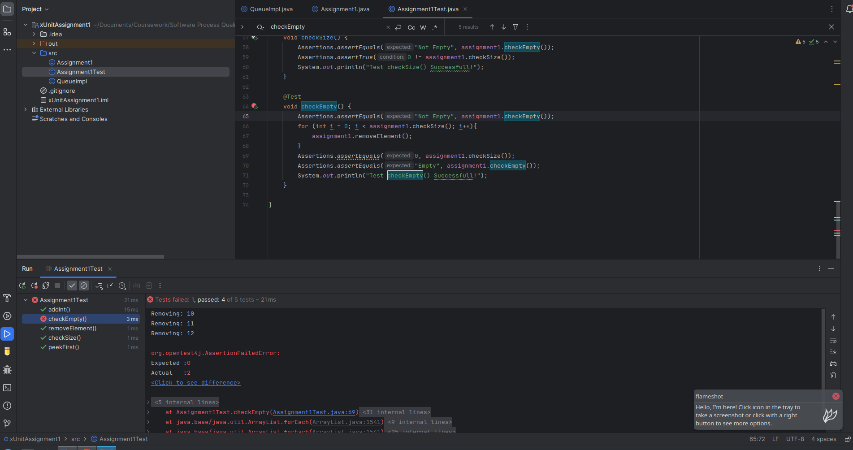
* 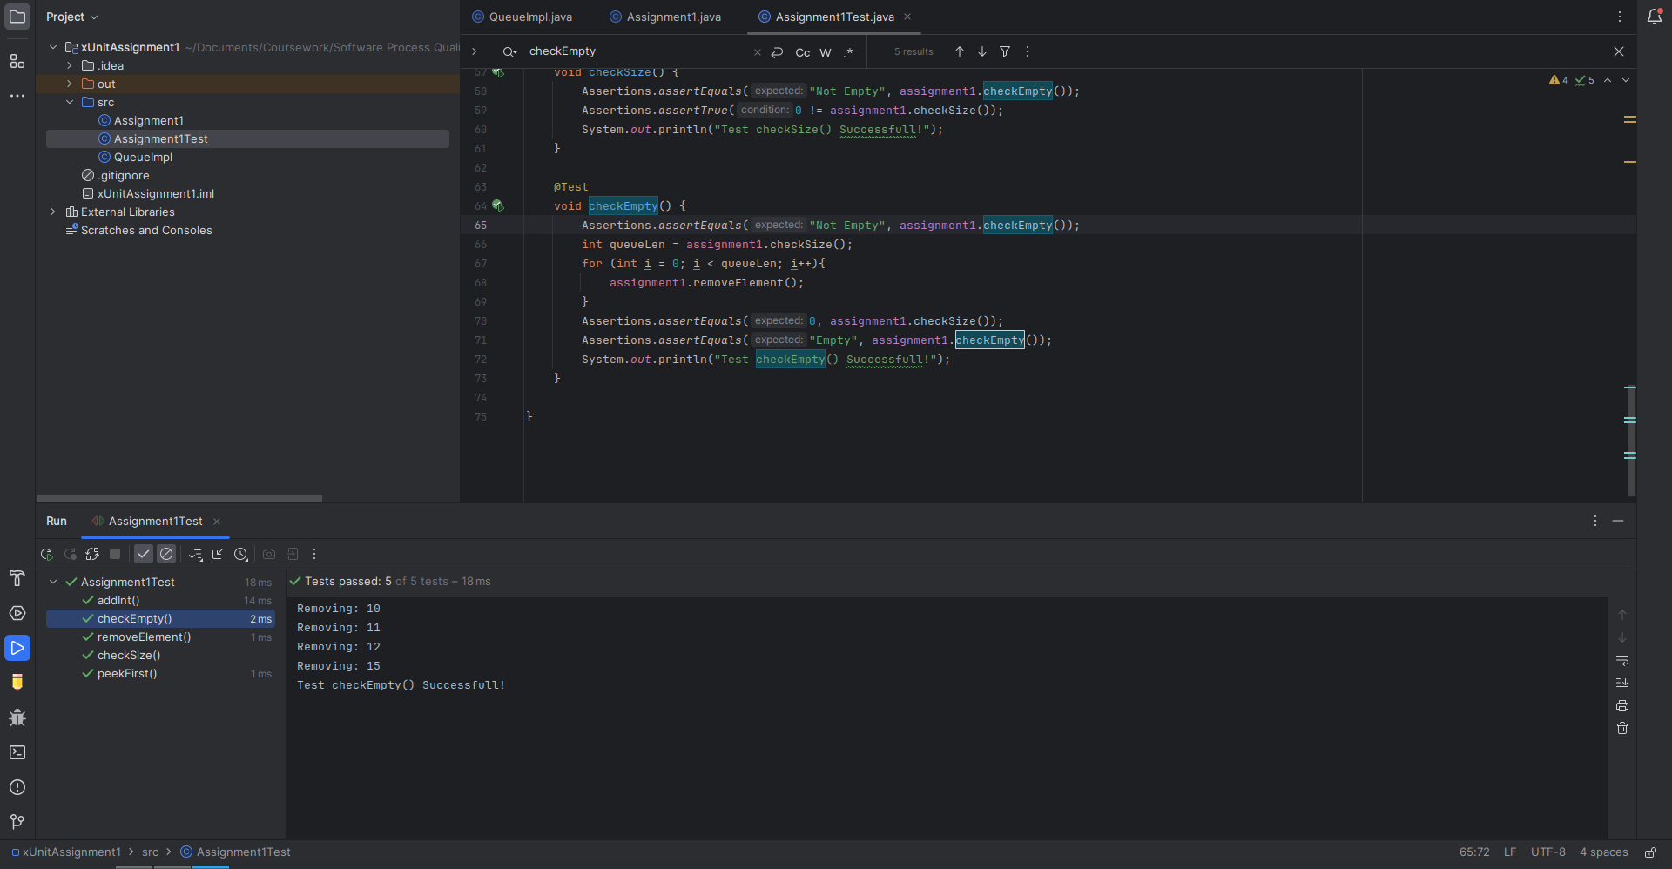
* Difficulty with implementing test for createQueue method for exceptions and other types of queues such as boolean or long.
* Checking the class of the created queue to check whether the class of the created queue is of valid QueueImpl class.

SAMPLE RUNS

|  |  |
| --- | --- |
|  |  |
|  |  |
|  |  |

