Real vs. Ideal Gases — Teacher Guide

Cover
Unit: Gas Laws — Lesson 01: Real vs. Ideal Gases East Meadow Schools × Valley Stream Central High School District Strategy chips: ACTIVE LEARNING · RESTORATIVE CIRCLE

Curated Resources (from East Meadow Scope & Sequence)

NYSSLS Standards
PS1-9 — Real gases may be included at conditions near STP. The relationships of the variables in the combined gas law may be described both qualitatively and quantitatively. The concept of an ideal gas is a model to explain the behavior of gases. A real gas is most like an ideal gas at low pressure and high temperature. This lesson introduces the ideal gas model as a model — a set of simplifying assumptions that lets us predict how pressure, volume, and temperature trade off for a fixed amount of gas. Students then identify the conditions under which a real gas deviates from that model: high pressure and low temperature, where particle volume and inter-particle attractions can no longer be ignored. Per the standard’s DO NOT TEACH note, this lesson never names the individual gas-law relationships by a scientist’s name; it treats the pressure–volume–temperature relationships qualitatively, as one combined behavior, and focuses on when the model works and when it breaks.
The Cross-Cutting Concept of Systems and System Models is the explicit lens. The ideal gas is not a real substance — it is a model with stated assumptions (point-sized particles, no attractions, perfectly elastic collisions). A scientific model is judged by where it holds and where it fails. Students practice the scientific move of stating a model’s assumptions and then predicting the conditions that violate them.

Phenomenon
A bright bunch of helium balloons is tied to a chair at a birthday party. The room is warm and the balloons ride high and round against the ceiling all evening. Overnight the heat shuts off and the room goes cold. In the morning the same balloons are smaller, wrinkled, and drooping — several have sunk halfway to the floor. Nobody untied them, nobody let any helium out, and the room is sealed. Same balloons, same gas, same night — but by morning they have shrunk and sunk. What changed while everyone was asleep?
The hook is deliberately everyday and a little melancholy (the morning-after-the-party image), and it sets up two ideas at once: a fixed amount of gas changes volume when temperature changes (the P-V-T relationship), and — for the sinking part — cold gas is denser, which previews where the simple model starts to strain. The “nobody touched them” framing forces students past “the helium leaked out” toward a particle-level explanation.

Javalab / Labs
- Crushing-can demo (teacher-led, ACTIVE LEARNING anchor): Heat a small amount of water in an empty soda can until steam pushes the air out, then invert the can quickly into a tray of cold water. The can collapses with a loud crunch. The steam condenses and the trapped gas cools, the inside pressure drops far below the outside atmospheric pressure, and the air outside crushes the can. This is the cooling → pressure drop → volume collapse chain made loud and visible — the same chain that quietly deflates the overnight balloons. Safety: tongs/heat gloves, eye protection, keep faces back; the can is hot and the collapse is sudden.
- Inverted-graduated-cylinder gas collection (student, hands-on): Collect a gas sample by water displacement under an inverted graduated cylinder, then warm or cool the trapped sample (warm hand vs. ice-water bath around the cylinder) and watch the trapped volume change. Students record the trapped volume at two temperatures and describe, qualitatively, how warming and cooling change the volume of a fixed amount of gas. No external URL is required; for a digital companion, a Javalab “gas particles in a box” simulation lets students drag temperature and volume sliders and watch particle speed and collision frequency respond, reinforcing the particle model behind the figures/real_vs_ideal_particles.png diagram.

Assessments
- Real vs. ideal gas conditions short response (district checkpoint, following lesson): students state the assumptions of the ideal gas model and identify the conditions (low pressure, high temperature) under which a real gas behaves most ideally, explaining why in particle terms.
- The Exit Ticket below is the formative check for this lesson: students choose which of two labeled containers holds gas behaving most ideally, justify the choice in particle terms, and write one sentence connecting the overnight-balloon phenomenon to the Systems-and-System-Models idea that a model holds only under stated conditions. See Answer_Key.docx.

Lesson Overview
Duration | 42 minutes (1 period)
NYSSLS link | PS1-9 (ideal gas as a model; real gas most ideal at low pressure and high temperature; P-V-T described qualitatively — do not teach gas-law names)
CCC focus | Systems and System Models — the ideal gas is a model with stated assumptions; it predicts well at low pressure / high temperature and deviates at high pressure / low temperature, where the assumptions (negligible particle volume, no attractions) break down
Strategy chips | ACTIVE LEARNING (crushing-can demo + inverted-cylinder hands-on; students predict, observe, and revise); RESTORATIVE CIRCLE (unit-opening circle — share a time something changed overnight while you weren’t watching)
Materials | Empty aluminum soda cans, hot plate or burner, tongs and heat-resistant gloves, tray of ice water, graduated cylinders, water trough, ice and warm-water baths, eye protection for all, figures/pressure_volume_curve.png and figures/real_vs_ideal_particles.png projected, a bunch of (optional) helium balloons for the hook
Safety | Crushing-can demo: hot can and steam — use tongs/gloves and eye protection, keep students back from the collapse, never seal the can airtight while heating. Inverted-cylinder activity: water on the floor is a slip hazard; no open flame near the water trough.
Prior knowledge | Kinetic molecular theory basics — gases are mostly empty space, particles move fast and randomly, temperature is related to average particle speed. Students should know pressure as collisions of particles against container walls. No prior gas-law calculation is required; this lesson is qualitative.
Lesson objectives — students can:
- State the simplifying assumptions of the ideal gas model: particles have negligible volume, no attractive forces between particles, and perfectly elastic collisions.
- Describe qualitatively how pressure, volume, and temperature trade off for a fixed amount of gas (volume falls as pressure rises at fixed T; volume falls as temperature falls at fixed P).
- Identify the conditions under which a real gas behaves most like an ideal gas (low pressure and high temperature) and the conditions under which it deviates (high pressure and low temperature).
- Explain, using Systems and System Models, why the ideal gas is a model that holds under some conditions and breaks down under others.

Phase 1 · Engage (0 – 10 min)

0–3 min · Opening Circle + Do Now
Begin with a brief Restorative Circle (2–3 min; see Strategy Spotlight). Everyone — teacher included — answers: “Share a time you came back to something the next morning and found it had changed all on its own — a balloon, a cut apple, a glass of soda, a puddle. What was different?” One round, one sentence each, pass is allowed. This grounds the lesson in everyday change-over-time and previews that conditions (temperature, time) quietly change physical things even when nobody touches them.
Then post the Do Now:
“A bunch of helium balloons is tied to a chair at a party. By the warm evening they ride high against the ceiling. Overnight the room turns cold. In the morning the same balloons are smaller, wrinkled, and sinking — nobody untied them and the room is sealed. In one sentence: what could have made the balloons shrink and sink overnight?”
Give students 2 minutes to write silently, then take two or three responses.
Anticipated student responses to Do Now:
- “The helium leaked out of the balloons.” — capture, but push gently: the room is sealed and nobody untied them — and a slow leak wouldn’t suddenly happen overnight when the room got cold. What else changed overnight?
- “It got cold, so the gas got smaller.” — exactly the thread to pull; affirm and ask what does cold do to the particles inside?
- “Cold air is heavier, so the balloons sank.” — strong intuition; validate. Cold gas is denser — we’ll connect that to the sinking specifically.

3–8 min · Phenomenon hook — the overnight balloons + crushing-can demo
Teacher actions. Show the balloon image (or real balloons). Then make the same cause-and-effect chain loud and visible with the crushing-can demo: heat a splash of water in a soda can until steam streams out, then flip it into cold water. The can collapses with a crunch. Tell students the can did not spring a leak — the gas inside cooled suddenly, the inside pressure dropped, and the outside air crushed it.
Sample teacher language:
“Nobody poked a hole in this can. Nobody untied those balloons. The only thing that changed in both cases is temperature went down. So here is the puzzle: how can cooling a fixed amount of gas — the same particles, none added, none removed — make the volume collapse?”
Anticipated student responses:
- “The cold made the gas shrink.” — affirm; sharpen in Phase 3 into the particle picture (slower particles, fewer/softer wall collisions, less push outward).
- “The steam turned back into water.” — excellent observation for the can; note it, and steer toward the trapped air that also cooled — both effects drop the inside pressure.
- “So the balloons cooled and shrank the same way?” — yes; that is exactly the link we’ll build evidence for.
Driving question (post on the board and leave it there):
Under what conditions does a fixed amount of gas behave in a simple, predictable way — and when does that simple picture start to break down?

8–10 min · Notice & Wonder + Turn-and-Talk #1
Two columns on the board: I notice… / I wonder…
Collect 3–4 responses about the balloons and the can. Then:
“Turn to your partner: in both the balloons and the can, nothing was added or removed and the only change was temperature dropping. So what is actually happening to the particles inside when the gas cools? Try to describe what the particles do differently.”
Target insight (leave open if no one lands it yet): cooling slows the particles, so they hit the walls less often and less hard — less outward push — and the volume shrinks. We’ll name the model behind this prediction in Phase 3.

Phase 2 · Explore (10 – 30 min)

10–15 min · Initial Model (silent / individual)
Prompt on the board:
“Before we name anything: draw the gas particles inside one warm balloon and the same gas inside the same balloon after it has cooled overnight. Show, with your drawing, what is different — how fast the particles move, how spread out they are, how often they hit the walls. Write one sentence predicting why the cooled balloon is smaller.”
Students draw and write silently for 3–4 minutes. This surfaces prior kinetic-molecular-theory knowledge and exposes the range: some students will draw slower, more crowded particles; others will (incorrectly) draw fewer particles, revealing the “the gas leaked / disappeared” misconception. That gap is instructional gold for the Explore activities.

15–24 min · Investigation Part 1 — Crushing-can + inverted-cylinder (ACTIVE LEARNING)
Hand out (or project) the worksheet. Run the ACTIVE LEARNING predict–observe–explain cycle on the two activities. Students commit a prediction in writing before each observation.
Activity A — Crushing can (teacher demo, students predict and record):
“Before I flip the can: predict on your sheet — will the can change, and if so, how? Why?”
Then perform the collapse. Students record what happened and revise their prediction.
Activity B — Inverted graduated cylinder (student hands-on):
Students collect a trapped gas sample under an inverted graduated cylinder by water displacement, then change its temperature (warm hand around the cylinder, then an ice-water bath) and record the trapped volume each time.
Condition | Trapped volume (mL) | What the particles are doing
Warm (hand / room)
Cold (ice bath)
Teacher facilitation language (circulate):
“You didn’t add or remove any gas between the warm reading and the cold reading — same particles trapped the whole time. So when the volume changed, what changed about how the particles move and hit the walls?”
“Predict before you cool it. Commit to a number or a direction on your sheet, then check. Being wrong on a prediction is data, not a mistake.”
Anticipated student responses during the activities:
- “The can crushed because the air got sucked out.” — gently redirect: nothing sucked the air out; the inside pressure dropped when the gas cooled, so the steady outside air pressure now wins and pushes the walls in.
- “The trapped volume got smaller in the ice bath.” — affirm; ask them to connect: slower particles → fewer/softer wall hits → less outward push → smaller volume at the same outside pressure.
- “Did some gas dissolve into the water?” — good critical question; a small amount can, but the dominant effect here is temperature changing particle motion. Keep the focus on the temperature variable.

24–30 min · Investigation Part 2 — Reading the P-V relationship
Project the pressure–volume curve and have students read it.
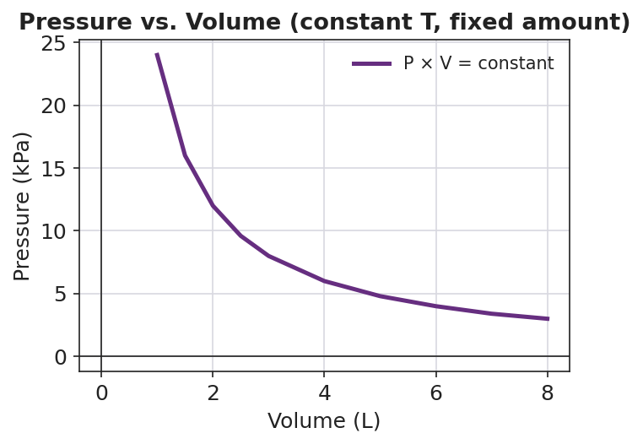
Line graph titled ‘Pressure vs. Volume (constant T, fixed amount)’: a smooth curve falling from upper-left to lower-right showing pressure on the y-axis in kPa decreasing as volume on the x-axis in liters increases; the curve is steep at small volumes and flattens at large volumes; for every point the product of pressure and volume is the same constant value, illustrating the inverse pressure-volume relationship of an ideal gas at fixed temperature.
Students answer, qualitatively (no law names):
- As volume increases, what happens to pressure? (It decreases.)
- At every point on this curve, multiply pressure × volume. What do you notice? (The product is the same — about 24 in these units — everywhere on the curve.)
- Why would squeezing a fixed amount of gas into a smaller volume raise its pressure? (Particles hit the walls more often when crowded into less space.)
Teacher facilitation language:
“Notice we are not naming any ‘law’ here. We’re just reading a relationship: for a fixed amount of gas at one temperature, pressure and volume trade off — push the volume down and the pressure climbs, and the product stays steady. The curve predicts that trade-off. The question for Phase 3 is: what kind of gas does this clean curve describe — and when does a real gas stop following it?”
Anticipated student responses:
- “P × V is always 24.” — exactly; this constant product is the signature of the inverse relationship. Don’t name it; just call it the trade-off.
- “So if I halve the volume, the pressure doubles?” — yes, for an ideal gas at constant temperature. Hold that thought — it’s a prediction from the model, and real gases bend it under extreme conditions.

Phase 3 · Explain (30 – 36 min)

30–33 min · Turn-and-Talk #2 + class consensus
“Look at your particle drawings, your crushing-can notes, your cylinder volumes, and the P-V curve. Turn to a partner: what one set of rules about gas particles would let us predict all of these — the shrinking balloon, the crushed can, the cylinder, and that smooth curve? List the simplest assumptions you’d have to make about the particles.”
Target consensus:
“If we pretend gas particles are tiny points that take up almost no space, don’t attract each other, and bounce off the walls without losing energy, then the only things that matter are how many particles there are, how fast they move (temperature), and how much room they have (volume). That set of pretend-rules predicts the trade-offs we saw.”

33–36 min · Vocabulary introduction (exactly 3 terms)
Sample teacher language:
“Let’s name the set of pretend-rules you just listed. When we treat gas particles as tiny points with no volume of their own, no attractions pulling them together, and perfectly bouncy collisions, we are using the ideal gas model. An ideal gas is not a real substance — it is a model, a simplified version we invent so the math and the predictions stay clean. Real oxygen, real helium, real carbon dioxide are real gases — they have actual particle volume and weak attractions, so they only approximately follow the ideal model. And the conditions where a real gas behaves most like the ideal model — particles spread far apart and moving fast — happen at low pressure and high temperature. Crowd the particles together (high pressure) or slow them down (low temperature) and the real gas starts to deviate, because now the particle volume and the attractions actually matter.”
Post the three terms on the board. Students fill them in on their notes.
Project the particle comparison and use it to anchor the vocabulary visually:
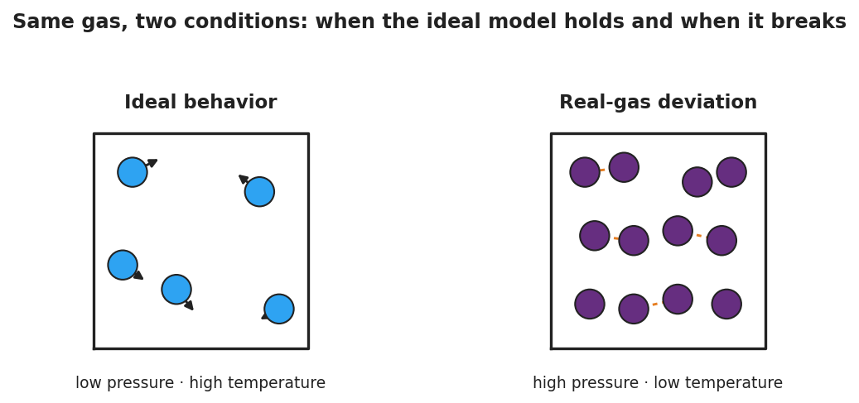
Two-panel particle diagram comparing gas behavior under two sets of conditions. Left panel labeled ‘Ideal behavior, low pressure, high temperature’ shows five widely spaced blue particles, each with a motion arrow, far apart in a large box. Right panel labeled ‘Real-gas deviation, high pressure, low temperature’ shows twelve crowded purple particles packed close together with short dashed orange lines linking several neighboring pairs to represent attractive forces that the ideal model ignores.
Discussion prompts to deploy here:
- “Looking at the two panels: in which one does it make sense to pretend the particles have no volume and no attractions?” — Expected response: the left one — particles are tiny relative to the empty space and too far apart to attract, so the ideal pretend-rules barely lose anything. On the right, the particles fill much of the box and are close enough to attract, so the assumptions break.
- “A real gas is most like an ideal gas under which conditions?” — Expected response: low pressure and high temperature (the left panel). That is exactly the PS1-9 statement.

Phase 4 · Elaborate (36 – 40 min)

36–39 min · Revise the model + Systems-and-System-Models expansion
Students return to their Initial Model (the warm-vs-cooled balloon particle drawings). They revise by adding: (a) a label noting that they were assuming an ideal gas (point particles, no attractions), and (b) one note on where that assumption would start to fail (if the balloon were squeezed very small or cooled to extreme cold, the helium particles’ own volume and faint attractions would matter).
Then run a Because/But/So sentence:
“The overnight helium balloons shrink and sink as the room cools.” “This happens because ______, but _______, so _______.”
Model one aloud:
“The overnight balloons shrink because cooling slows the helium particles, so they hit the balloon walls less often and less hard and the outside air presses the balloon to a smaller volume — but the helium model is ideal only while the particles stay far apart and fast — so at the everyday conditions of a cold room the ideal model still predicts the shrinking well, and we’d only see it break down if the gas were crushed to high pressure or chilled to extreme cold.”
Then have students write their own B/B/S for the crushed can.

39–40 min · Return to the phenomenon
“Return to our balloons. Using the word model, explain in one sentence why we can confidently predict that a sealed helium balloon shrinks overnight in a cold room — and one condition under which our prediction would start to be off.”
Target: “We model the helium as an ideal gas — tiny point particles with no attractions — and that model holds at the low pressure and ordinary temperatures inside a balloon, so it correctly predicts the volume shrinks as the gas cools; the model would start to be off only if the gas were squeezed to very high pressure or cooled toward extreme cold, where the particles’ real volume and attractions matter.”

Phase 5 · Evaluate (40 – 42 min)

40–42 min · Exit Ticket + Closing Reflection
Post or read aloud:
Two sealed steel tanks hold the same amount of nitrogen gas. Tank X is at high temperature and low pressure (particles spread far apart). Tank Y is at low temperature and high pressure (particles crowded close together). (a) In which tank does the nitrogen behave most like an ideal gas? Explain your choice in terms of the particles. (b) Name the three assumptions the ideal gas model makes about gas particles. (c) In one sentence, use the word model to explain why the ideal gas is useful even though no real gas is perfectly ideal.
Expected answers are in Answer_Key.docx. Note: the Exit Ticket uses nitrogen in steel tanks — deliberately different from the worksheet’s helium-balloon and oxygen-cylinder examples — so students must apply the reasoning to a new gas and context rather than recall a worked example.
Closing Reflection (SEL, 30 seconds):
“Today we used a model — a deliberately simplified picture — to explain something real. In one sentence: where else in your life do you use a simplified picture that works most of the time but breaks down under extreme conditions? Who or what helped you see that idea today?”
Collect worksheets; flag any student whose Initial Model showed fewer particles in the cooled balloon (the “gas disappeared/leaked” misconception) for a brief one-on-one check before the next lesson — the count of particles is fixed; only their speed and spacing change.

Common Misconceptions
- Misconception: “The balloons shrank because the helium leaked out overnight.” → Correction: The room is sealed and nobody untied them; a leak does not switch on just because the room cooled. The amount of gas is fixed. Cooling slows the particles, so they exert less outward push and the volume shrinks — no gas is lost. The particle count stays the same; only speed and spacing change.
- Misconception: “An ideal gas is just a really pure or perfect real gas.” → Correction: An ideal gas is not any real substance — it is a model with invented assumptions (point-sized particles, no attractions, perfectly elastic collisions). Real gases only approximate it. The model is a thinking tool, not a bottle on the shelf.
- Misconception: “Real gases never follow the ideal model, so the model is useless.” → Correction: Real gases follow the ideal model very closely under everyday conditions — low pressure and high temperature, like a balloon in a room. The model is extremely useful there; it only deviates noticeably at high pressure and low temperature.
- Misconception: “Higher pressure always makes a gas more ideal because the particles are closer to acting as one block.” → Correction: The opposite. High pressure crowds the particles so their own volume and their mutual attractions stop being negligible — that is exactly when the real gas deviates from ideal. Low pressure and high temperature are the ideal-behaving conditions.
- Misconception: “The can got crushed because something sucked the air out.” → Correction: Nothing pulled the air out. Cooling dropped the inside pressure below the steady outside atmospheric pressure, so the outside air pushed the can walls inward. It is a pressure imbalance, not suction.

Access & Differentiation
- ELL/ENL supports: Sentence frames for the Investigation and Exit Ticket: “When the gas got colder, the particles moved , so the volume got .” and *“A real gas acts most like an ideal gas when the pressure is ___ and the temperature is ___ because ___.”* Word-choice box displayed all period: {ideal gas, real gas, model, particles, pressure, volume, temperature, attractions}. Pair vocabulary with gestures: spread hands wide for low pressure / ideal, squeeze hands together for high pressure / deviation. The two-panel particle figure gives a non-verbal anchor — students can point to the panel rather than producing the full sentence first.
- IEP/SPED supports: Provide the particle figure pre-labeled so students match conditions (low P / high T vs. high P / low T) to panels rather than recalling them cold. Pre-fill the prediction column structure for the inverted-cylinder table so the student records only the observed volume and one particle note. Assign clear partner roles for the cylinder activity: one student manages the temperature change, one reads and records the volume. Offer the three ideal-gas assumptions as a checklist (point particles ▢ / no attractions ▢ / elastic collisions ▢) for the Exit Ticket.
- Extensions: (1) The same overnight balloons would shrink less if filled with a gas whose particles attract each other more weakly than helium’s — explain why helium is one of the most ideal-behaving gases. (2) Predict and explain: would a deep-sea diver’s air tank (very high pressure) hold gas that behaves more or less ideally than the air in the room? (3) Sketch what the P-V curve would look like for a real gas at very high pressure and explain in one sentence why it would bend away from the smooth ideal curve.

Strategy Spotlight
ACTIVE LEARNING — predict, observe, explain. Active learning replaces “watch the teacher and copy it down” with a cycle where students commit a prediction in writing, observe a result, and then revise their thinking. The research base (Freeman et al.’s meta-analysis on active learning in STEM; the East Meadow active-learning framework) is consistent: students who predict before they observe retain the conceptual model far better than students who passively watch a demo, because the surprise of a wrong prediction creates the cognitive hook the explanation hangs on.
How to run it in this lesson (Phase 2):
- Before the crushing-can collapse, every student writes a prediction: will the can change, how, and why? No prediction, no watching — the writing is the price of admission to the demo.
- Perform the collapse. Students immediately record what actually happened next to their prediction and note whether they were right.
- For the inverted-cylinder activity, students predict the volume direction (bigger or smaller) before cooling the trapped gas, then measure. The mismatch between “the gas should expand when I touch it” intuitions and the actual cooling result is where the learning lives.
- Debrief by asking what would have to be true about the particles for your observation to make sense — this turns the hands-on result into the model that Phase 3 names.
The crushing can is loud and a little startling on purpose: the affective spike (“whoa!”) is exactly the moment a committed prediction becomes memorable. Keep the prediction step non-graded and low-stakes so students take real intellectual risks.
Connection to Systems and System Models: the active-learning cycle is the modeling cycle in miniature — predict from a model, test against the world, revise the model’s range of validity. When students later state that the ideal gas model “holds at low pressure and high temperature but deviates at high pressure and low temperature,” they are doing exactly what they practiced with the can and the cylinder: naming where a model’s predictions match reality and where they stop.

NYSSLS Observation Checklist Crosswalk
# | Checklist item | Where it appears in this lesson
1 | Local/relatable phenomenon | Phase 1 — overnight helium balloons shrink and sink; crushing-can demo; return in Phase 4 with the model explanation of the balloons
2 | Turn and Talk (2–3×) | Phase 1 (TT#1 — what do the particles do as the gas cools?); Phase 3 (TT#2 — what simplest rules predict all our observations?)
3 | Students develop questions/models/procedures | Phase 2 Initial Model (warm-vs-cooled particle drawings); ACTIVE LEARNING predict–observe–explain on crushing-can and inverted-cylinder; Phase 4 model revision
4 | CCC defined and used | Lesson Overview · Systems and System Models; explicit in Phase 3 vocabulary (ideal gas as a model) and Phase 4 B/B/S + return-to-phenomenon
5 | ENL — ≤ 3 vocab, second half | Phase 3 — vocabulary introduced at 33–36 min: ideal gas / real gas / model
6 | Revisit phenomenon with evidence | Phase 4 — students return to the overnight balloons armed with the particle model, the cylinder volumes, and the P-V curve to explain why the gas shrank and where the model would break
7 | ENL/SPED supports | Access & Differentiation block: sentence frames, word-choice box, pre-labeled particle figure, pre-filled prediction table, partner roles, assumptions checklist
8 | Assessment check | Phase 5 — Exit Ticket (which tank is most ideal + why; the three model assumptions; one model-usefulness sentence)

Companion Materials
- Student_Worksheet.docx — the 5E student investigation (hand out at start of Phase 2)
- Student_Notes.docx — guided note-guide for vocabulary and the worked particle-model example
- Answer_Key.docx — answers to “Make It Make Sense” prompts and the Exit Ticket

Key Vocabulary (max 3)
- ideal gas — a model of a gas whose particles are treated as point-sized (negligible volume), exert no attractive forces on one another, and collide perfectly elastically; no real gas is perfectly ideal, but the model accurately predicts gas behavior at low pressure and high temperature
- real gas — an actual gas (such as helium, oxygen, or nitrogen) whose particles have real volume and weak attractive forces; a real gas behaves most like an ideal gas at low pressure and high temperature, and deviates from ideal behavior at high pressure and low temperature
- model — a deliberately simplified representation of a system, judged by where its predictions match reality and where they fail; the ideal gas is a model that holds under some conditions (low pressure, high temperature) and breaks down under others (high pressure, low temperature)

