Ions: Why Sodium Reacts but Sodium Ion Sits Still — Teacher Guide

Cover
Unit: Atomic Concepts — Lesson 05: Ions East Meadow Schools × Valley Stream Central High School District Strategy chips: HOCHMAN

Curated Resources (from East Meadow Scope & Sequence)

NYSSLS Standards
HS-PS1-1 — “Use the periodic table as a model to predict the relative properties of elements based on the patterns of electrons in the outermost energy level of atoms.” The East Meadow Scope & Sequence narrows this performance expectation to its ion-specific claim for this lesson: the number and charge of the stable ions that form from atoms in a group of the periodic table. Students predict, from an element’s group number alone, whether it forms a cation or an anion and what the magnitude of the charge will be. This is a direct application of the periodic-table-as-model idea: an atom’s column tells you its valence-electron count, and its valence-electron count tells you the stable ion it forms.
The Cross-Cutting Concept of Patterns is the explicit lens. Ion charge is not random — it is a repeating, predictable pattern tied to vertical position on the periodic table. Group 1 forms 1+ ions; Group 2 forms 2+; Group 17 forms 1−; Group 16 forms 2−; Group 18 forms none. Once students see the pattern, they can predict the stable ion of an element they have never studied, which is exactly the kind of model-based reasoning the standard demands. This lesson assumes students have already learned to count protons, neutrons, and electrons (Lesson 02) and to read valence electrons from the periodic table (Unit 04 of the model sequence).

Phenomenon
A pea-sized piece of sodium metal dropped into a beaker of water skitters across the surface, fizzes, ignites, and can pop with a bright yellow-orange flame — a genuinely violent reaction. Yet that same element, sodium, is something every student eats every day: it is half of the table salt (NaCl) on the cafeteria fries, dissolved harmlessly in the saline in their tears, and circulating safely in their own blood. Same element. One version explodes on contact with water; the other version is so calm we sprinkle it on food and swallow it.
The resolution is the heart of the lesson: the violent silver metal is sodium atoms (Na), each carrying a loosely held outer electron it is desperate to give away. The peaceful seasoning is sodium ions (Na⁺) — the same nuclei, but each has already lost that outer electron and reached a stable, full-shell arrangement. Once sodium has become an ion, it has nothing left to react away, so it sits quietly. The phenomenon makes “losing an electron” feel consequential rather than abstract: an electron’s worth of change is the difference between an explosion and a snack.

Javalab / Labs
- Ion-formation diagrams (core activity): Students draw before/after Bohr-style shell diagrams for sodium and chlorine, physically crossing out the lost electron on Na and adding the gained electron to Cl, then writing the resulting charge. Use the rendered figures figures/na_atom.png, figures/na_cation.png, figures/cl_atom.png, and figures/cl_anion.png as the projected models and the answer reference. A Javalab “Bohr model / electron shell” simulator can be used as an optional digital warm-up so students can add and remove electrons and watch the shell fill, but no external URL is required — the printed diagrams carry the lesson.
- Predict-the-charge from group number (core practice): Using only the periodic table (no memorization), students fill a table: element → group number → valence electrons → gain or lose? → ion symbol and charge. This is the central NYSSLS skill and the spine of the Investigation.

Assessments
- Ion formation and charge quiz (district checkpoint, following lesson): students predict the ion charge for elements in Groups 1, 2, 13, 15, 16, 17, and 18 from group number, write correct ion symbols, and explain in one sentence why metals form cations and nonmetals form anions.
- Exit Ticket (Phase 5): three items — predict the ion of magnesium (Mg) from its group; predict the ion of sulfur (S) from its group; and one sentence, using the word ion, explaining why Na⁺ in table salt does not react with water the way Na metal does. The Exit Ticket elements (Mg and S) are deliberately distinct from the worksheet practice (Na, Cl, K, O, Ca, F). See Answer_Key.docx.

Lesson Overview
Duration | 42 minutes (1 period)
NYSSLS link | HS-PS1-1 — number and charge of stable ions that form from atoms in a periodic-table group
CCC focus | Patterns — ion charge repeats predictably down each group; group number sets the valence-electron count, which sets the stable ion an atom forms
Strategy chips | HOCHMAN — appositive sentence to define ion crisply; Because/But/So sentence in Phase 4
Materials | Periodic Table / 2025 NYS Chemistry Reference Tables (one per student), colored pencils or two pen colors for electron diagrams, the four projected figures (na_atom.png, na_cation.png, cl_atom.png, cl_anion.png), optional video of sodium-in-water reaction, table salt sample on the demo table
Safety | Do not demonstrate live sodium-in-water in a standard classroom — show a projected video. The table salt on the demo table is food-safe. Standard lab safety applies.
Prior knowledge | Lesson 02 (counting protons, neutrons, electrons); Unit 04 of the atomic-concepts sequence (reading valence electrons and group number from the periodic table). Students should be able to draw a Bohr/shell diagram for a neutral atom before this lesson.
Lesson objectives — students can:
- Define an ion as a charged atom and explain that the charge comes from a mismatch between protons and electrons.
- Draw the formation of a cation and an anion by removing or adding the correct number of electrons and stating the resulting charge.
- Predict, from an element’s group number alone, whether it forms a cation or an anion and the magnitude of its charge.
- Explain, using the Patterns CCC, why elements in the same group form ions of the same charge.

Phase 1 · Engage (0 – 10 min)

0–3 min · Opening Circle + Do Now
Begin with a brief community-building opening circle (2–3 min). Everyone — teacher included — answers in one sentence: “Name something that completely changes how it behaves after one small change — a phone after you charge it, water after it freezes, a person after one cup of coffee. What came to mind?” One round, no judgment. This primes the lesson’s core idea: one tiny change (losing or gaining a single electron) can completely change how a substance behaves.
Then post the Do Now:
“Pure sodium metal dropped in water explodes. But you eat sodium every day in table salt and it does nothing dangerous. Write one sentence: how can the same element, sodium, be both an explosive and a safe seasoning?”
Give students 2 minutes to write silently, then take two or three responses.
Anticipated student responses to Do Now:
- “Maybe the salt isn’t really sodium — it’s mixed with something.” — partly true (salt is NaCl), but probe: the sodium is still in there; what changed about the sodium itself?
- “The salt version is a different form of sodium.” — exactly the productive idea; today we name that different form and explain what makes it different.
- “I don’t know — I thought sodium was always dangerous.” — validate the surprise; that tension is what today resolves.

3–8 min · Phenomenon hook — same element, opposite behavior
Teacher actions. Show the projected video (or describe vividly) of a pea of sodium metal skittering, fizzing, and igniting on water. Then hold up the table salt on the demo table.
“Same element on the periodic table — atomic number 11, sodium — in both cases. In the beaker it is so reactive it bursts into flame on contact with water. In this shaker it is so calm we eat it. Nothing changed about the nucleus: still 11 protons either way. So what did change between the dangerous version and the safe version?”
Anticipated student responses:
- “The electrons changed.” — excellent; that is precisely it, and we will make that exact and visible in Phase 2.
- “One is a metal and one is a compound.” — true and useful; the salt is a compound because the sodium has changed into a charged form that bonds with chlorine. We will get there.
- “The safe one already reacted, so it’s done.” — strong intuition; “done reacting” is a good plain-English version of stable — hold that thought.
Driving question (post on the board and leave it there):
Why does sodium metal react violently with water, but sodium ion sits peacefully in table salt?

8–10 min · Notice & Wonder + Turn-and-Talk #1
Two columns on the board: I notice… / I wonder…
Collect 3–4 responses. Then:
“Turn to your partner: the nucleus has 11 protons in both the explosive metal and the safe salt. If the protons didn’t change, what must have changed to make the safe version behave so differently? Name the specific particle.”
Target insight (leave open if no one lands it): the number of electrons changed. The protons are fixed; the only thing that can differ is how many electrons surround the nucleus. We name that charged result formally in Phase 3.

Phase 2 · Explore (10 – 30 min)

10–15 min · ABCs Activity — build the two versions of sodium before the formal definition
Before any formal vocabulary is introduced, students compare two shell diagrams of sodium and reason about the difference. Project figures/na_atom.png and figures/na_cation.png side by side.
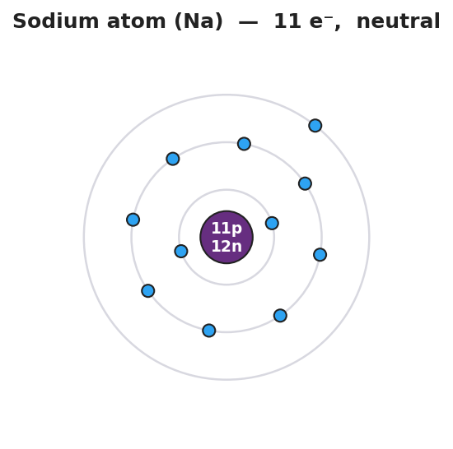
Bohr shell diagram of a neutral sodium atom: a central purple nucleus labeled 11p 12n surrounded by three electron shells holding 2, 8, and 1 electrons for a total of 11 electrons; the single outermost electron sits alone in the third shell; titled ‘Sodium atom (Na) — 11 e⁻, neutral’.
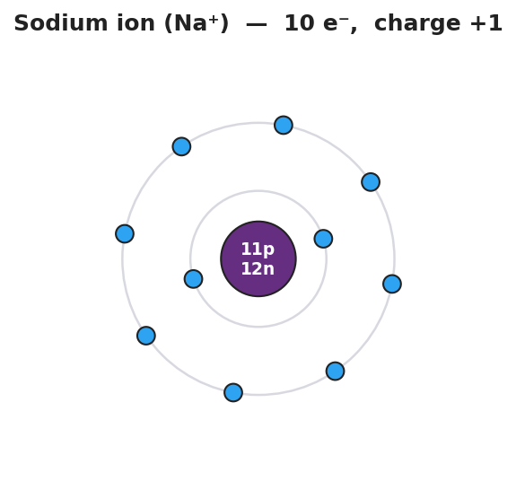
Bohr shell diagram of a sodium ion: the same central purple nucleus labeled 11p 12n but now surrounded by only two electron shells holding 2 and 8 electrons for a total of 10 electrons; the lone outer electron is gone and the outer shell is now full; titled ‘Sodium ion (Na⁺) — 10 e⁻, charge +1’.
The task (students reason before any term is named):
“Look at these two pictures of sodium. The nucleus is identical — 11 protons, 12 neutrons — in both. Count the electrons in each. What is different? What happened to the lonely outer electron in the second picture?”
Part 1 — Count and compare table (students fill in):
 | Protons | Electrons | Outer shell | Overall electric charge?
Left picture (Na) | 11 | 11 | 1 electron, not full
Right picture (Na⁺) | 11 | 10 | 8 electrons, full
Teacher facilitation language (circulate):
“In the left picture, count the protons and the electrons. 11 and 11 — they balance, so the atom has no overall charge. Now the right picture: still 11 protons, but only 10 electrons. Do the positives and negatives still balance? What is left over?”
“Look at that single outer electron in the left picture. It’s all alone in the third shell, far from the nucleus. If sodium could get rid of just that one electron, what would its outer shell look like? Look at the right picture — the third shell is gone and the second shell, with 8 electrons, is now the full outer shell.”
Anticipated student responses during ABCs:
- “The right one is missing an electron.” — yes; where did it go, and what does losing a negative electron do to the overall charge? (It leaves a net positive.)
- “It has more protons than electrons now, so it’s positive.” — exactly the target reasoning; 11 positives, 10 negatives, net +1.
- “The outer shell got full.” — crucial observation; full outer shells are stable, which is why sodium wants to lose that electron. That is the link to the phenomenon.

15–22 min · Initial Model — do the same reasoning for chlorine
Prompt on the board. Project figures/cl_atom.png and figures/cl_anion.png.
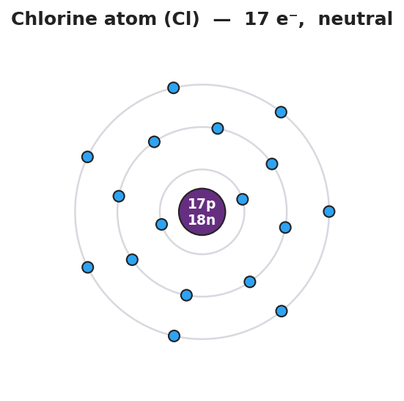
Bohr shell diagram of a neutral chlorine atom: a central purple nucleus labeled 17p 18n surrounded by three electron shells holding 2, 8, and 7 electrons for a total of 17 electrons; the outer shell has 7 electrons and one open space; titled ‘Chlorine atom (Cl) — 17 e⁻, neutral’.
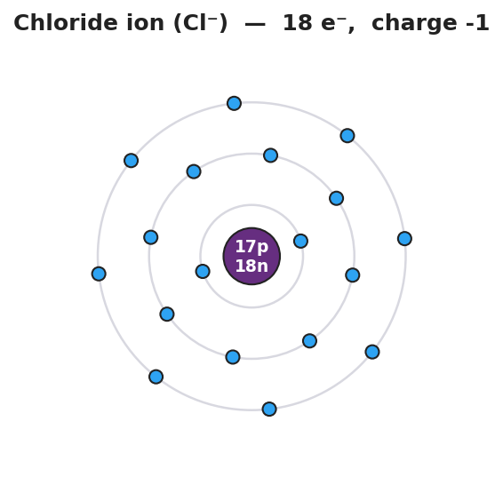
Bohr shell diagram of a chloride ion: the same central purple nucleus labeled 17p 18n but now surrounded by three electron shells holding 2, 8, and 8 electrons for a total of 18 electrons; the outer shell is now full with 8 electrons; titled ‘Chloride ion (Cl⁻) — 18 e⁻, charge -1’.
“Chlorine has 17 protons and 17 electrons. Its outer shell holds 7 electrons — one short of a full shell of 8. Sodium got stable by losing one electron. What is the easiest way for chlorine to get a full outer shell? Draw it, count the electrons, and decide the overall charge.”
Students work individually for 3 minutes, then compare with a partner.
Target reasoning:
Chlorine gains 1 electron → outer shell goes from 7 to 8 (full). Now 17 protons, 18 electrons → 17 positives, 18 negatives → net charge −1.
Teacher facilitation language:
“Sodium lost an electron because it had only one to get rid of — easy. Chlorine has seven; getting rid of seven is hard, but gaining one to reach eight is easy. Atoms take the cheapest path to a full outer shell. What does gaining a negative electron do to chlorine’s overall charge?”
Anticipated student responses:
- “Chlorine should lose 7 to empty the shell.” — reasonable but harder; gaining 1 to fill the shell is far easier. Atoms take the path of least change — and 7 to gain vs. 7 to lose, gaining 1 wins.
- “If it gains an electron it becomes negative.” — exactly; one extra negative with the same protons gives a net −1.
- “So sodium loses and chlorine gains — and then they’d attract each other?” — beautiful prediction; opposite charges attract, which is exactly why Na⁺ and Cl⁻ stick together as salt. (Bonding is the next lesson — bank this insight.)

22–30 min · Investigation — predict ion charge from group number
Groups of three or four work through a structured practice set. Each student fills in the table individually, then compares with the group. The key move: use only the periodic table — no memorization.
Practice set (distributed as a half-sheet or written on the board):
For each element, find its group, count its valence electrons, decide whether losing or gaining is easier to reach a full outer shell (8, or 2 for the first shell), and write the ion.
Element | Group | Valence e⁻ | Lose or gain? | Ion formed
Na (sodium) | 1 | 1 | lose 1 | Na⁺
K (potassium) | 1 | 1 | lose 1 | K⁺
Ca (calcium) | 2 | 2 | lose 2 | Ca²⁺
O (oxygen) | 16 | 6 | gain 2 | O²⁻
F (fluorine) | 17 | 7 | gain 1 | F⁻
Cl (chlorine) | 17 | 7 | gain 1 | Cl⁻
Teacher facilitation prompts (circulate):
“For K, look only at the group number. Group 1 — how many valence electrons? One. Same situation as sodium: lose the one, become 1+. You didn’t have to memorize anything; the column told you.”
“For Ca in Group 2, there are two valence electrons. Losing two is easier than gaining six, so calcium loses both and becomes Ca²⁺. Notice the charge magnitude matches the number of electrons lost.”
“For O in Group 16, count valence electrons: six. Gaining two (to reach eight) is easier than losing six. Two gained negatives → O²⁻. What pattern do you see between the group and the charge for the nonmetals?”
Anticipated student responses:
- “Group 1 is always 1+, Group 2 is always 2+.” — yes! That is the Patterns CCC; the charge repeats down the whole column.
- “For oxygen I want to write O⁶⁺ because it has 6 valence.” — common error; oxygen does not lose 6, it gains 2. Redirect: which is the shorter path to a full shell of 8 — lose 6 or gain 2? Gain 2 → O²⁻.
- “Why is fluorine 1− but oxygen 2−?” — fluorine has 7 valence (needs 1), oxygen has 6 (needs 2). The number it must gain becomes the magnitude of the negative charge.

28–30 min · Reconnect + surface the pattern
Bring groups back together. Ask one group to read their completed table aloud. Then ask the class:
“Look down the column for Group 1: Na⁺, K⁺ — same charge. Look at Group 17: F⁻, Cl⁻ — same charge. What rule could you write that predicts the ion of any element from its group, even one you’ve never studied?”
Surface the key idea: metals on the left have few valence electrons and lose them to form positive ions; nonmetals on the right are close to a full shell and gain electrons to form negative ions. The group number predicts the charge, and elements in the same group form ions of the same charge. This is the pattern the standard requires.

Phase 3 · Explain (30 – 36 min)

30–33 min · Turn-and-Talk #2 + class consensus
“Look back at your four diagrams — Na, Na⁺, Cl, Cl⁻. Turn to your partner: in every case the nucleus never changed. Only the electrons changed. So where does the charge of an ion actually come from? Say it in one precise sentence.”
Target consensus: an ion’s charge comes from a mismatch between the number of protons (positive) and the number of electrons (negative). The nucleus is untouched; gaining electrons makes a net negative, losing electrons makes a net positive. The size of the mismatch is the size of the charge.
“And why do atoms bother changing at all? What did all four of our ions have in common in their outer shell?”
Target: every ion reached a full, stable outer shell (8 electrons, or 2 for very small atoms). That stability is the reason ions form — and the reason Na⁺ no longer reacts.

33–36 min · Vocabulary introduction (exactly 3 terms)
Sample teacher language:
“Let’s name what we’ve been building all period. A charged atom — an atom that has lost or gained electrons so its protons and electrons no longer balance — is called an ion. Here is the Hochman appositive move to lock that definition in. An appositive is a phrase set off by dashes that renames the noun next to it. Say this with me:
An ion — an atom that has gained or lost electrons and now carries an electric charge — forms when an atom reaches a stable full outer shell.
The phrase between the dashes defines ‘ion’ inside the sentence. You will use this structure on the Exit Ticket.”
“There are two kinds of ion, and the names tell you the sign. A cation is a positive ion — it forms when an atom loses electrons, so protons now outnumber electrons. Sodium losing one electron became Na⁺, a cation. (A useful memory hook: the ‘t’ in cation looks like a plus sign, ca+ion.) An anion is a negative ion — it forms when an atom gains electrons, so electrons now outnumber protons. Chlorine gaining one electron became Cl⁻, an anion.”
Post the three terms on the board. Students fill them in on their notes. Note: metals (left side) tend to form cations; nonmetals (right side) tend to form anions — exactly the pattern from the Investigation.
Discussion prompts to deploy here:
- “Magnesium is in Group 2. Cation or anion, and what charge?” — Expected response: cation, Mg²⁺ — it loses its 2 valence electrons (more protons than electrons → positive).
- “An atom gains 2 electrons. Cation or anion? What sign?” — Expected response: anion, negative — gaining electrons gives more negatives than positives. The sign always follows the direction of electron change.

Phase 4 · Elaborate (36 – 40 min)

36–39 min · Revise the model + Appositive + Because/But/So expansion
Students return to their sodium diagrams from Phase 2. They annotate: label Na⁺ as a cation, label Cl⁻ as an anion, and write the proton/electron count that produces each charge. Then they write an appositive sentence and a Because/But/So sentence.
Appositive sentence (model on board):
“A cation — a positive ion formed when an atom loses electrons — has more protons than electrons.”
Ask students to write a parallel appositive for anion:
“An anion — _______________________________ — has more _______ than _______.”
Then run a Because / But / So sentence about the phenomenon. Starter on the board:
“Sodium metal reacts violently with water, but sodium ion (Na⁺) in salt does not.”
Model one aloud:
“Sodium metal reacts violently with water because each sodium atom has a single loosely held outer electron it readily gives away, releasing energy but in table salt the sodium has already lost that electron and become the ion Na⁺ with a full, stable outer shell so there is no loosely held electron left to give away and the sodium ion simply sits there peacefully.”
Then have students write their own B/B/S using one of these starters:
- “Chlorine atoms are reactive, but chloride ions (Cl⁻) in salt are stable…” (hint: Cl gained one electron to fill its outer shell)
- “Elements in Group 1 all form 1+ ions…” (hint: same valence-electron count → same charge)
Anticipated student responses:
- “Because Na⁺ already gave away its electron.” — good start; push for the so: “so it has a full outer shell and nothing left to react away.”
- “Because Group 1 elements all have one valence electron.” — excellent; push for the so: “so they all lose that one electron and form a 1+ ion — the same charge down the whole group.”

39–40 min · Return to the phenomenon
“Return to our opening contrast: explosive metal versus safe seasoning. Now you have the vocabulary. In one sentence using the word ion, explain why the sodium in your french fries does not catch fire when it touches the water in your mouth.”
Target: “The sodium in salt is a sodium ion (Na⁺) — it already lost its reactive outer electron and reached a stable full shell, so unlike sodium metal it has nothing left to react with water.”
“That single electron is the whole story. Lose it, and an explosive metal becomes a safe seasoning. That is the power of an ion.”

Phase 5 · Evaluate (40 – 42 min)

40–42 min · Exit Ticket + Closing Reflection
Post or read aloud:
(a) Magnesium (Mg) is in Group 2. Predict the ion it forms — does it lose or gain electrons, and what is the ion symbol and charge? (b) Sulfur (S) is in Group 16. Predict the ion it forms — does it lose or gain electrons, and what is the ion symbol and charge? (c) In one sentence using the word ion, explain why the Na⁺ in table salt does not react with water the way sodium metal does.
Note: the Exit Ticket uses Mg and S — elements not practiced on the worksheet (which used Na, K, Ca, O, F, Cl) — so students must apply the group-number pattern, not recall a memorized answer. Expected answers are in Answer_Key.docx.
Closing Reflection (SEL, 30 seconds):
“Today one electron’s worth of change turned an explosive into a seasoning. In one sentence: what is one idea that surprised you today, and who — a partner or a moment in the activity — helped it click?”
Collect worksheets; note which students wrote ion charges with the correct sign (cation +, anion −) versus students who got the magnitude right but the sign wrong. Sign direction (lose → +, gain → −) is the main conceptual stumbling block — target those students at the start of the next lesson.

Common Misconceptions
- Misconception: “When an atom becomes an ion, the number of protons changes.” → Correction: The nucleus never changes during ion formation. Protons and neutrons stay fixed; only electrons are lost or gained. Sodium atom and sodium ion both have 11 protons and 12 neutrons — the figures show identical nuclei. Changing protons would change the element itself, which is a nuclear process, not ion formation.
- Misconception: “Losing electrons makes an atom negative.” → Correction: Electrons are the negative particles. Losing a negative leaves a net positive (a cation); gaining a negative makes a net negative (an anion). The sign of the ion is opposite to the direction you’d first guess — losing makes positive. Tie the sign explicitly to the proton/electron count: more protons than electrons → positive.
- Misconception: “Oxygen is in Group 16, so it forms a 6+ or 6− ion.” → Correction: Group 16 means six valence electrons, but the ion charge comes from how many electrons the atom must gain or lose to reach a full shell of eight — not the group number itself. Oxygen gains 2 (the shortest path) and forms O²⁻, not O⁶⁻. For nonmetals, charge magnitude = (8 − valence electrons).
- Misconception: “Atoms can lose or gain any number of electrons.” → Correction: Stable ions form by taking the shortest path to a full outer shell. Sodium loses 1 (not 7); chlorine gains 1 (not loses 7). This is why elements in the same group form ions of the same predictable charge — the path length is set by the group’s valence count.
- Misconception: “Noble gases (Group 18) form ions easily too.” → Correction: Group 18 elements already have full outer shells, so they have no driving force to lose or gain electrons. They do not normally form ions at all — which is exactly why they are unreactive. Their stability is the goal every other atom is chasing.

Access & Differentiation
- ELL/ENL supports: Ion-prediction template pre-printed with column headers (Element | Group | Valence e⁻ | Lose or gain? | Ion) and a sentence frame: *“___ is in Group , so it ___ electron(s) and forms a ___ ion with a charge of ___.”* Word-choice box displayed on the board throughout: {ion, cation, anion, valence electron, gain, lose, charge}. Pair vocabulary with gestures: open hand pushing away for “lose” (cation), open hand pulling in for “gain” (anion). Color-code the figures consistently (lost electron crossed out in one color, gained electron added in another).
- IEP/SPED supports: Pre-fill the group number and valence-electron count for each practice element so the periodic-table lookup is removed as a barrier; the student’s task is the conceptual step (lose vs. gain, and the resulting sign). Provide the four printed ion-formation figures so students can trace the electron change physically rather than recall it. Offer a two-choice scaffold (“This atom will [lose / gain] electrons”) before asking for the full ion symbol. Sentence starters for the Exit Ticket.
- Extensions: (1) Predict the ions formed by aluminum (Al, Group 13 → Al³⁺) and nitrogen (N, Group 15 → N³⁻); explain why Group 13 and 15 ions carry a charge of 3. (2) Sodium ion (Na⁺) and neon (Ne) both have 10 electrons in a 2,8 arrangement — they are isoelectronic. Explain what that means and why Na⁺ is stable. (3) Predict the formula of the compound formed when a Group 2 cation meets a Group 17 anion (e.g., Ca²⁺ and Cl⁻ → CaCl₂); explain how the charges determine the ratio.

Strategy Spotlight
HOCHMAN — Appositive sentence. The Hochman Writing Method (Judith Hochman and the Writing Revolution) treats sentence-level writing as a thinking tool. For this lesson the featured technique is the appositive, a noun phrase set off by dashes (or commas) that renames or defines the noun it follows. The appositive is ideal for the term ion because the concept is easy to state loosely (“a charged atom”) but precise only when the cause of the charge is embedded — and the appositive forces that precision into a single sentence.
The target appositive for this lesson:
An ion — an atom that has gained or lost electrons and now carries an electric charge — forms when an atom reaches a stable full outer shell.
This sentence does three things at once: (1) names the term, (2) defines it with its mechanism (gained or lost electrons) between the dashes, and (3) states the reason it happens (the drive toward a full outer shell) in the main clause. A student who can write and say this sentence — not just recite “a charged atom” — has integrated why ions form, which is exactly what the standard’s “patterns of electrons” language demands.
How to run it in this lesson (Phase 3 → Phase 4):
- Post and read aloud the model appositive sentence together (Phase 3 vocabulary).
- Ask students to write a parallel appositive for cation and anion: “A cation — a positive ion formed when an atom loses electrons — has more protons than electrons.” This forces them to embed the proton/electron mismatch (the cause of the sign) inside the definition.
- In Phase 4, cold-call two or three students to read their anion appositive aloud. Check: does the dashed phrase correctly define the term and name the electron change that produces the charge?
Why the appositive fits ions: The danger with ions is that “charged atom” hides the mechanism. The appositive makes students state the mechanism (lost/gained electrons) every time they use the word, so they cannot define an ion without recalling why it is charged. That habit transfers directly to bonding and formula-writing in the next unit, where sign and magnitude must be correct.
CRSE connection: The opening circle prompt (something that changes behavior after one small change — a charged phone, frozen water, a person after coffee) invites students to bring everyday transformations from their own lives into the science. The phenomenon itself uses table salt — a substance in every kitchen and on every cafeteria tray — so an abstract atomic-scale idea (electron transfer) is grounded in food students eat daily. Honoring that out-of-school knowledge makes the science feel continuous with students’ lived experience rather than confined to the lab.

NYSSLS Observation Checklist Crosswalk
# | Checklist item | Where it appears in this lesson
1 | Local/relatable phenomenon | Phase 1 — sodium metal (explosive) vs. sodium ion in table salt (safe seasoning students eat); return in Phase 4 with the french-fries framing
2 | Turn and Talk (2–3×) | Phase 1 (TT#1 — protons didn’t change, so what did?); Phase 3 (TT#2 — where does an ion’s charge actually come from?)
3 | Students develop questions/models/procedures | Phase 2 ABCs (count/compare Na vs. Na⁺ before any term); Initial Model (build Cl⁻ diagram independently); group Investigation (predict ions from group number)
4 | CCC defined and used | Lesson Overview · Patterns, explicit in Phase 2 reconnect (charge repeats down a group), Phase 3 vocabulary, and Phase 4 B/B/S (Group 1 all 1+)
5 | ENL — ≤ 3 vocab, second half | Phase 3 — vocabulary introduced at 33–36 min: ion / cation / anion
6 | Revisit phenomenon with evidence | Phase 4 — students return to the salt-vs-metal contrast armed with the Na vs. Na⁺ diagrams and the full-shell stability evidence
7 | ENL/SPED supports | Access & Differentiation block: ion-prediction template, sentence frame, word-choice box, gestures, pre-filled group numbers, two-choice scaffold
8 | Assessment check | Phase 5 — Exit Ticket (predict Mg and S ions from group number; one-sentence ion explanation of the phenomenon)

Companion Materials
- Student_Worksheet.docx — the 5E student investigation (hand out at start of Phase 2)
- Student_Notes.docx — guided note-guide for vocabulary and the worked ion-formation example
- Answer_Key.docx — answers to “Make It Make Sense” prompts and the Exit Ticket

Key Vocabulary (max 3)
- ion — an atom (or group of atoms) that has gained or lost one or more electrons, so that its numbers of protons and electrons no longer balance and it carries a net electric charge; the nucleus is unchanged — only electrons move
- cation — a positive ion, formed when an atom loses one or more electrons so that protons outnumber electrons; metals (left side of the periodic table) tend to form cations, e.g., Na⁺, Ca²⁺
- anion — a negative ion, formed when an atom gains one or more electrons so that electrons outnumber protons; nonmetals (right side of the periodic table) tend to form anions, e.g., Cl⁻, O²⁻

